5/19/2018 Shavuot and the Royal Wedding

5/20/2018, is the Feast of Shavuot according to the Jewish Calendar, and also the Day of Pentecost according to the Christian religion.

An Ancient Royal Wedding Ceremony

Few people know that a wedding ceremony occurred between Israel and YaHuWaH Elohim on the 50th day of ancient Israel's departure from the land of Egypt.

That ancient 50th day wedding ceremony corresponds to the modern Israeli Feast of Shavuot, and the Christian Day of Pentecost.

The terms of the contract in that ancient wedding ceremony between YaHuWaH Elohim and His chosen people are known as the Ten Words, or the Ten Commandments, and other instructions (Hebrew - torah).

Exodus 19:1 In the third month, when the children of Israel were gone forth out of the land of Egypt, the same day came they into the wilderness of Sinai.
2 For they were departed from Rephidim, and were come to the desert of Sinai, and had pitched in the wilderness; and there Israel camped before the mount.
3 And Moses went up unto Elohim , and YaHuWaH called unto him out of the mountain, saying, Thus shalt thou say to the house of Jacob, and tell the children of Israel;
4 Ye have seen what I did unto the Egyptians, and how I bare you on eagles’ wings, and brought you unto Myself.
5 Now therefore, if ye will obey My voice indeed, and keep My covenant, then ye shall be a peculiar treasure unto Me above all people: for all the earth is Mine:
6 And ye shall be unto Me a kingdom of priests, and an holy nation. These are the words which thou shalt speak unto the children of Israel.
7 And Moses came and called for the elders of the people, and laid before their faces all these words which YaHuWaH commanded him.
8 And all the people answered together, and said, All that YaHuWaH hath spoken we will do. And Moses returned the words of the people unto YaHuWaH .

Note that the elders of the people said "I do" in verse 8 above. They accepted the terms of the covenant, and entered into covenant relationship with the King of the Universe on that 50th day.

Accompanying the Bride

Moses led the tribes of Israel out of Egypt and into the wilderness to the wedding location at Mt. Sinai.

The modern counterpart of Moses leading the children of Israel out of Egypt to their wedding with YaHuWaH Elohim is the father of the bride walking his daughter down the aisle at her wedding ceremony.

Another Royal Wedding Ceremony

On 5/19/2018, with the Jewish Feast of Shavuot (Pentecost) begining at sunset, there was a royal wedding ceremony in the United Kingdom between Prince Harry, son of Charles, Prince of Wales, and the american born bride Meghan Markle.

The close proximity of a royal wedding having modern global attention with YaHuWaH 's Feast of Shavuot, where an ancient royal wedding was also involved, indicates the need for our closer investigation.

The Bride

Note that the modern royal bride, Meghan Markle, was born in Los Angeles, California, the "City of the Angels", on 8/4/1981, exactly 20 years to the day after the alleged birth of President Barack Hussein Obama on 8/4/1961.

That means that Meghan Markle was also born on the 1st day of the 21st year (3 x 7 years) from the birth of President Barack Obama.

Their conceptions are calculated to be about 280 inclusive days before their births and also follow with the same 20 year spacing.

The graphic below shows some of this conception and birth information concerning the bride:

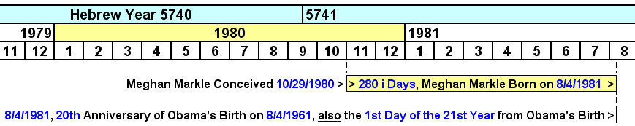

The Bride and the Iran Hostage Crisis

The bride was conceived during the 444 day Islamic Iran hostage crisis. Her calculated conception date reveals a precise 1 prophetic year, 360 day, prophetic relationship with the Iran Hostage Crisis as noted in the graphic below.

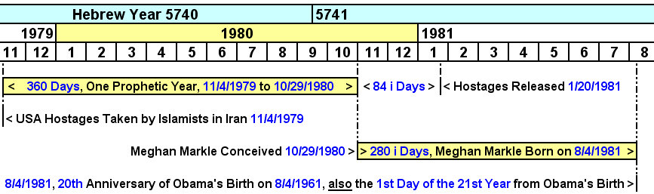

The Iran Hostage Crisis in the 40th Year

The number 40 in the bible is related with the time of testing. Israel spent 40 years in the wilderness being tested, and YaHuShua spent 40 days in the desert fasting before entering His ministry.

The graphic below shows how the beginning of the Iran Hostage Crisis on 11/4/1979 relates with the beginning of Ramadan in the 40th year from 1979.

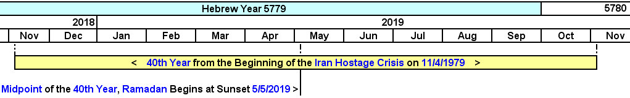

Now Back to the 5/19/2018 Royal Wedding and Shavuot

Because Meghan Markle's father didn't attend the royal wedding on the eve of Shavuot 5/19/2018, Charles, Prince of Wales, ushered the bride down the aisle.

We note that there's a relationship between the birth of the modern jewish State of Israel, which observes Shavuot, and the birth of Prince Charles in the graphic below:

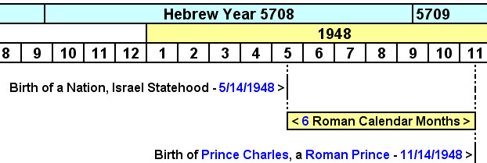

Above: Prince Charles was born precisely 6 months to the day after the birth of the modern State of Israel. Being born precisely on the opposite side of the year from Israel's birth might be an indication from YaHuWaH Elohim, who ordains births and deaths, that this noble person will oppose Israel.

The Presentation of the Bride

We saw above how that Moses accompanied the Bride out of Egypt and all the way to Mt. Sinai and presented her to YaHuWaH Elohim on the 50th day. The 50th day later became known as the Feast of Shavuot, or Pentecost (there is another complete message here for Christians and the Bride of Christ).

We know that Charles, Prince of Wales, was declared to have received his power from the Red Dragon at his investiture ceremony on 7/1/1969.

Just an observation - The groom Prince Harry has red (Hebrew - adam) hair.

Below is a graphic depicting the presentation of the bride on the eve of Shavuot, 5/19/2018, by the Prince empowered by the Red Dragon (Hebrew - Adam Serpent) and the 70th birthday anniversary of Charles, Prince of Wales, 1/2 prophetic year (180 i days) later on 11/14/2018:

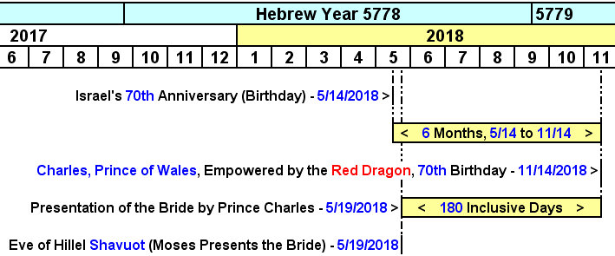

Above: There are 180 i days from the presentation of the bride by Charles, Prince of Wales, empowered by the Red Dragon, on the eve of Shavuot to the date directly opposite the year from Israel's 70th Statehood anniversary.

Summary

The royal marriage on 5/19/2018 on the eve of Jewish Shavuot and Christian Pentecost was a sign to the United States of America and the rest of the world.

There are timely inter-connections shown in the graphics above between Shavuot, the State of Israel, Prince Charles, Islam, President Obama, and the bride, Meghan Markle.

The general overall symbolic significance of the above information is that a new set of laws are being accepted by a royal bride. The new bride is symbolic of Christianity.

The new laws are related with Charles, Prince of Wales, and his quiet historical association with Islam. These new laws are opposed to the Word of YaHuWaH Elohim.

The American Christian Protestant bride Meghan Markle, symbolic of the peoples of the United States, agreed to observe the new Islamic laws currently being instituted in England. She has refused to accept instructions concerning family organizational structure as mandated by YaHuWaH Elohim. One indication of her rejection of YaHuWaH 's truth is her involvement in gender equality (feminist) issues.

The similarities and relationships noted above between biblical and contemporary events should merit our attention, concern, and further observation as England and the world unfortunately go down the tubes via Islam and godless socialism.

Please keep in mind that in the Hebrew culture that was established by YaHuWaH Elohim Himself, the father of the groom selects the bride (helper) for his son.

Our heavenly Father tells us what He likes and doesn't like in His Torah (Word). If we don't like His revealed will for us, the will of Adam's Dragon is the other option. The one empowered by the Red Dragon will gladly accompany you to complete your vows to the Prince if your heavenly Father refuses to attend the wedding.

