***Know Christ! Grow in Faith! Serve Others!***

**Mission Statement** of LTUMC (adopted 6/5/2024)

**WELCOME—ANNOUNCEMENTS Mary Fulton**

**JOYS AND CONCERNS**

**INVITATION TO WORSHIP/OPENING PRAYER Pastor Rod**

**PRELUDE Jenny Claybaugh, Jane Wildermuth**

**SONG LEADER Diane Lewis, Jason Brunson**

**LITURGIST Tracey Notestine**

**\* Indicates To Please Stand If Able**

**\*Call to Worship:** Psalm 111:1-4, 10c NLT *Modified*

L: Praise the LORD!  
***P: We will thank the LORD with all our heart as we meet with His godly people.***

L: How amazing are the deeds of the LORD!

***P: All who delight in Him should ponder them.***

L: Everything He does reveals His glory and majesty.

***P: His righteousness never fails.***

L: He causes us to remember His wonderful works.

***All: How gracious and merciful is our LORD! Praise Him forever!***

\***Hymn  *How Majestic Is Your Name* # 2023 FWS**

**Unison Prayer****:** *Excerpts from Romans chapter 7 and Psalm 51*

***Holy God, hear our heart’s plea rather than see the actions of our lives that bring dishonor to us and to You. We confess that sometimes the very thing we want to do to honor You turns into something that neither of us want. Unfortunately, we shame ourselves and damage Your Holy Name. Forgive us, we pray. Have mercy on us, O God, because of Your unfailing love. Because of Your great compassion, blot out the stain of our sins. Wash us clean from our guilt. Purify us from our sin and give us back our joy again that we may rejoice in Your Glory forever. Amen***

**Scripture Reading:** **Romans 6:6-11**

**PRAYERS OF THE PEOPLE Diann Brower**

Lord’s Prayer: ***Our Father who art in heaven, hallowed be thy name. Thy kingdom come, thy will be done on earth as it is in heaven. Give us this day our daily bread, and forgive us our trespasses as we forgive those who trespass against us. Lead us not into temptation, but deliver us from evil. For thine is the kingdom, and the power, and the glory forever. Amen.***

**\*WORSHIPPING GOD WITH TITHES & OFFERINGS/DOXOLOGY**

**\*Prayer of Thankfulness: *Accept these gifts, O God, as testimonies of our love for You and our desire to serve You. Let these offerings be an affirmation that we are bound to one another as Your people. In Your generous name we pray. Amen.***

**Children’s Message:** *Let the Children come forward*

**\*Hymn**  ***My Tribute* #99 UMH**

**Prayer for Illumination:** *By: Ken Nash from Disciplines 2021, page 264*

***Jesus, Lord and Savior, thank you for community and personal moments with You. They are a gift from heaven, allowing us to walk in that great intimacy with You. Amen!***

**Scripture****:**  *Romans 7:14-8:2 NLT*

**Message:** *“I Only Have One Problem” By Pastor Rod*

**Response:** *As the Holy Spirit leads*

**\*Hymn:*****Because He Lives*****#364 UMH**

\***BENEDICTION & SENDING** *Our “World” Is Our Mission Field*

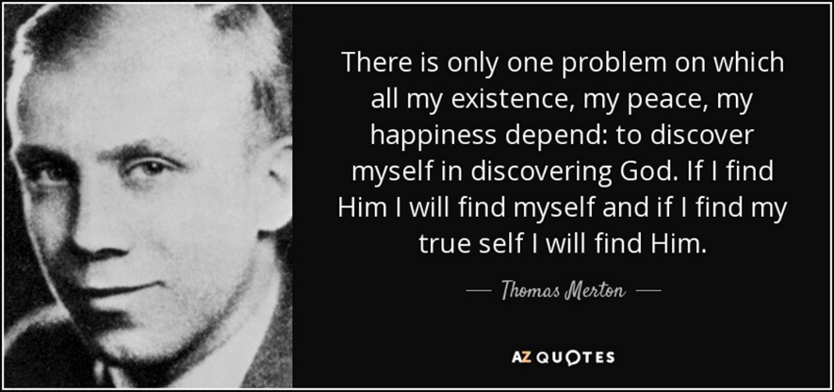

**THOSE ASSISTING IN CREATING OUR SERVICE:**

**Musicians: Jenny Claybaugh, Jane Wildermuth**

**Sound/Video: Andy Wildermuth, Kathy Berg**

**Online: Tracey Notestine, Sandy Shaner**

[***http://www.facebook.com/LewistownTrintyUnitedMethodistChurch***](http://www.facebook.com/LewistownTrintyUnitedMethodistChurch)

***Church Office email: ltumc8088@gmail.com***

**Ushers: Don Lewis, Bill Fulton, Denny Stryker, Lynn Snipes, Mike Brunson, Jason Brunson**

**Internet Prayer Chain: Lorna** [**Brunson—doone53@centurylink.net**](mailto:Brunson—doone53@centurylink.net)

**All-Call Prayer Chain: Julia Armstrong—Call her at 937-844-7964**

**Bulletin Insert Items: Rosemary Levan—937-722-7935 or** [**rlevan1338@gmail.com**](mailto:rlevan1338@gmail.com)

***Please change your WIFI setting to reflect these changes in service.* New Internet logins: Church Building—login into Mesh2025. Password is basiccartoon424. *We apologize for any inconvenience in connecting***

**Adult Sunday School Class Leader/Lay Leader: Mary Fulton**

**Sunday School Superintendent/VBS/God’s Team: Diane Lewis**





***July 20, 2025***

*Thank You for Choosing to Worship Christ*

*with Us Today!*

**LEWISTOWN-TRINITY UNITED METHODIST CHURCH**

**In-Person Worship Service – 11:00 – 8088 CR 54, Lewistown**

**Address: P.O. Box 90, Russells Point, Ohio 43348**

**Worship with us on Facebook**

***http://www.facebook.com/LewistownTrintyUnitedMethodistChurch***

**Rod Brower, Pastor**

**His Contact Info: 740-727-9999 –** [**pastorrodb@gmail.com**](mailto:pastorrodb@gmail.com)

***Know Christ! Grow in Faith! Serve Others!***