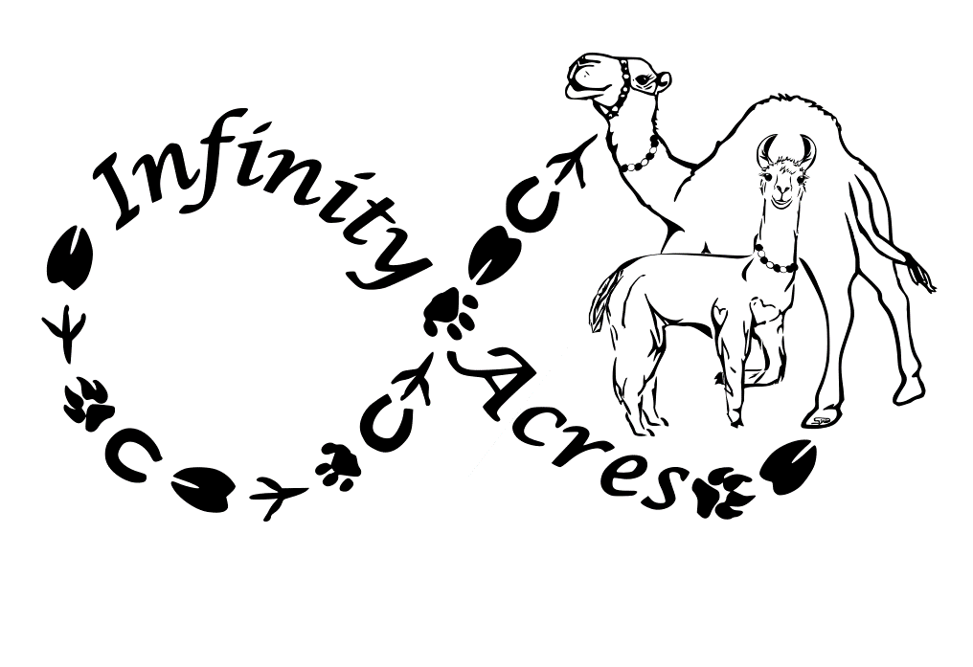
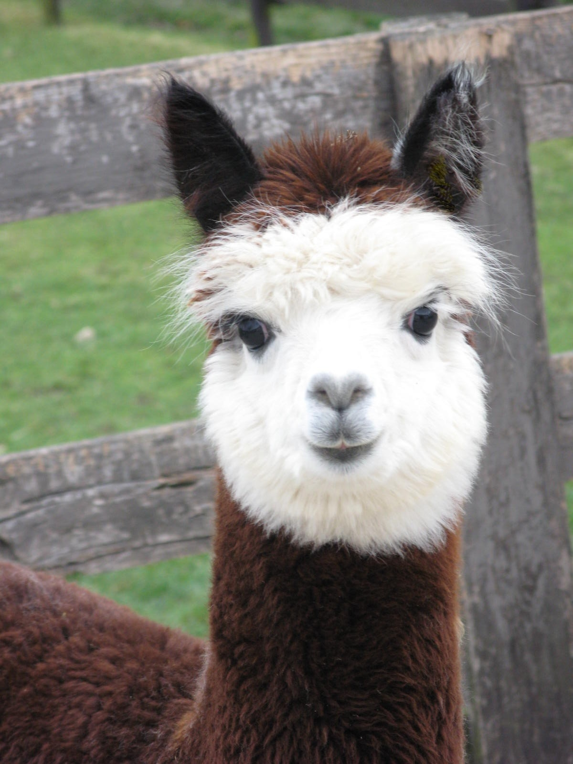
Rick & Laura Steere
136 Joppa Rd
Ridgeway, VA 24148
276-358-2378
infinityacresva@gmail.com
www.InfinityAcres.org
501-C-3 Non-Profit
Love Grows Here
TAX EIN # 47-2390562

The Mission of Friends of Infinity Acres Ranch (FOIAR) is to provide educational and interactive opportunities for the community utilizing Animal Assisted Therapies and Interactions. FOIAR provides programs for the public and specializes in services for individuals with disabilities using domestic and exotic animals to encourage physical, emotional, and psychological well-being.

INFINITY ACRES RANCH SPRING CARNIVAL FUNDRAISER VENDOR APPLICATION

EVENT DATE: 6/5/21
EVENT TIME: 11:00 A.M. – 3:00 P.M. (need to be set up by 10 please)
LOCATION: INFINITY ACRES RANCH
SET UP TIME: AVAILABLE FRIDAY PM OR SATURDAY 9:00 – 10:00am
VENDOR TABLE CONTRIBUTION: CASH OR CHECK EVENT is RAIN OR SHINE:
Donated items will promote vendor through the Door Prize Announcements & social media

Name: ______________________________________________________________________________

Address: ______________________________________________________________________________

City: ________________________________________________ State: ____________

Zip: ___________ Phone: ___________________________________

Email: (MUST INCLUDE): ______________________________________________Website:______________________

Vendors need to provide their own table, chair & cover (pop ups are encouraged).
Limited space available under big tent: Limited electric available. Call Laura if either of these are needed. 276-358-2378

**Vendors who submit their application AND payment prior to MAY 8, 2021 will be guaranteed their space. Applications received after 5/9/21 will be served on a first come basis.

Fees: __________ $25 per space – Space Size 10x10
__________ $35 per space under our big tent
__________ $ 5 extra per space for electricity
Amount Enclosed: ______________

Description of Booth/Merchandise/Brand/Information/Craft:_________________________________________________________________________________

- The FOIAR reserves the right to decline any application.
- Vendors participate at their own risk for liability, theft or damage.

Mail application and check to: Friends of Infinity Acres Ranch 136 Joppa Rd, Ridgeway, VA 24148
AGREE TO TERMS:
SIGNATURE ______________________________________________________________________ DATE_____________________________

