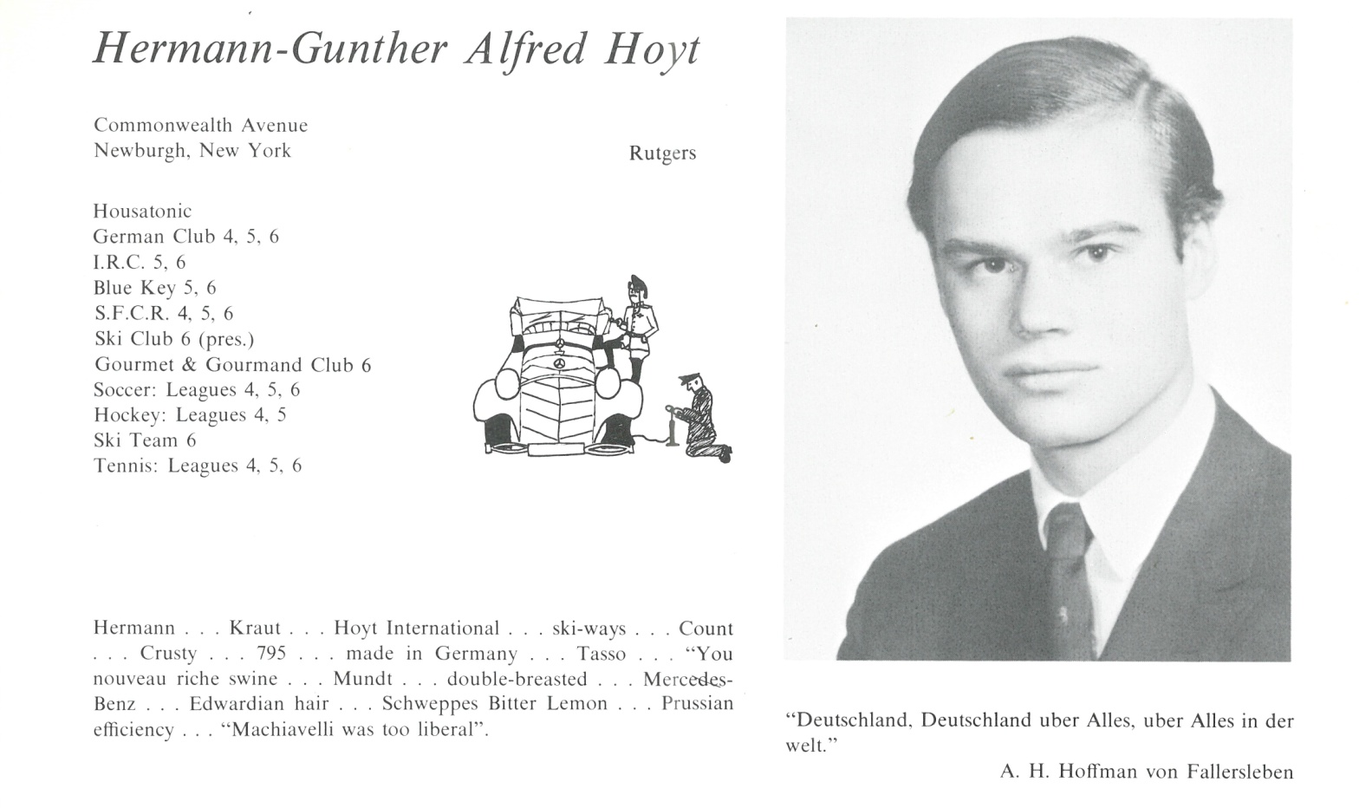

Gunther A. Hoyt

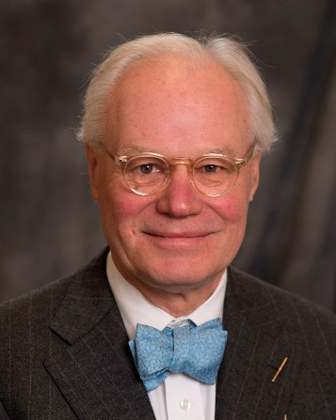Gunther Hoyt is the president of Gunther Hoyt Associates ‒ a global business consulting firm that specializes in plastics equipment and machine components.

Hoyt has played important leadership roles in the internationalization of the plastics industry, and in the progress of SPI: The Plastics Industry Trade Association. He assisted in the creation of the SPI Components Division.

He has chaired two NPE trade shows and was inducted into the Plastics Hall of Fame during the NPE 2012 trade show. NPE has been a plastics industry leader for more than 70 years. Participants include buying teams from 100 countries and more than 20,000 companies, comprising the entire global plastics supply chain and the full range of end-user markets. His company led the exhibit sales program for the NPE 2015 plastics exposition for Europe, Japan, Korea, and Taiwan.

He was previously the executive vice president of Xaloy Inc. where he spearheaded the establishment of distribution networks and direct sales operations in North America, Europe, China, Japan, and other Asian countries. He also played a key role in setting up manufacturing and customer service facilities in Thailand.

During his time at Xaloy Inc., Hoyt headed the development and successful introduction of the first tungsten carbide-based bimetallic barrel alloy, which is now an industry standard. He also participated in the construction of micro-alloy backing steels for bimetallic cylinders that allow increased processing pressures, and tungsten carbide-coated, twin-screw barrel sets, now an industry standard for processing lead-free PVC.

He received both his bachelor’s degree and master’s degree in German language and literature from Rutgers University. Hoyt is a passionate daily cyclist and skier. He has been a lifelong classic car enthusiast and regularly drives a 1937 Packard Coupe around Roanoke. He has been a member of Classic Car Club of America since 1986, and is now a regional director. His car hobby takes him yearly to Europe for tours and shows.



______________________________________________________________

______________________________________________________________ ______________________________________________________________ ______________________________________________________________ ______________________________________________________________ ______________________________________________________________ ______________________________________________________________ ______________________________________________________________ ______________________________________________________________

Attach Picture in .jpg Format

______________________________________________________________

______________________________________________________________

___________________________________________________________________________________ _________________________________________________________________________________________________________________________________________________________________________________________________________________________________________________________________________________________________________________________________________________________________________________________________________________________________________________________________________________________________________________________________________________________________________________________________________________________________________________________________________________________________________________________________________________________________________________________________________________________________________________________________________________________________________________________________________________________________________________________________________________________________________________________________________________________________________________________________________________________________________________________________________________________________________________________________________________________________________________________________________________________________________________________________________________________________________________________________________________________________________________________________________________________________________________________________________________________________________

___________________________________________________________________________________