PRESENTED BY

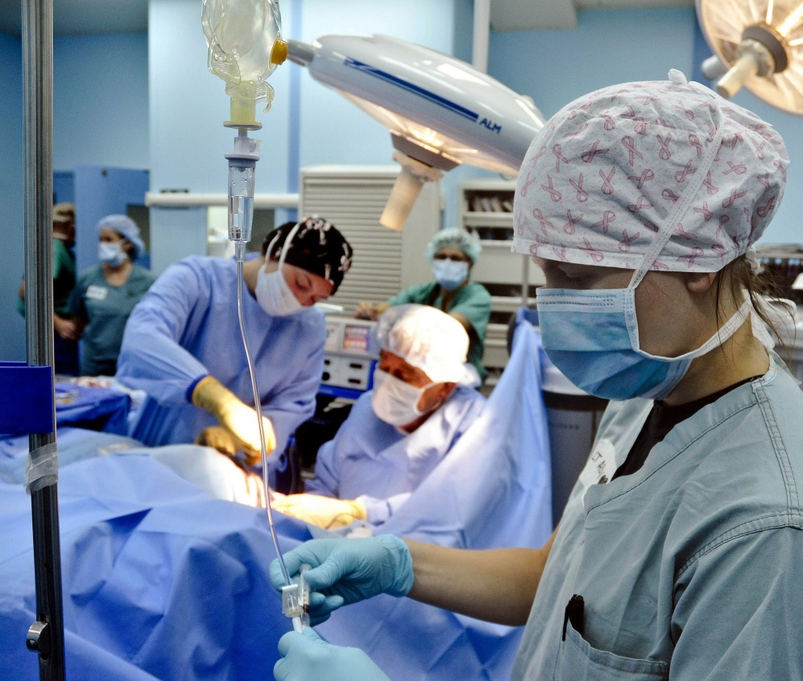ACLES

American College of

Lower Extremity Surgeons

With



Presence Saint Joseph Hospital is approved by the Council on Podiatric Medical Education as a provider of continuing education in podiatric medicine. Presence Saint Joseph

Hospital has approved this activity for a maximum of 40 continuing education contact hours



*ACLES DIAMOND SPONSOR*

MAY 3-6, 2018 LIVONIA MARRIOTT • LIVONIA, MI

Presented by ACLES • American College of Lower Extremity Surgeons

in collaboration with Presence Saint Joseph Hospital • Chicago, Illinois

Unparalleled excellence in medical education

Past attendees will tell you: the annual ACLES 40-Hour Program is a medical educational experience like no other! You’ll find no other course in foot and ankle surgery compares with the high-level collegial experience an ACLES meeting provides. You’ll train and consult with the nation’s leading educators and practitioners of lower extremity medicine and surgery in a relaxed, intimate environment that promotes engagement between presenters and attendees.

The 40-hour program features regular opportunity for one-on-one learning in structured lecture sessions, discussions, and workshops. Course content addresses every aspect of lower extremity surgery, from diagnosis to post-operative care.

The wide-ranging content enables experienced professionals to stay current with trends and developments in the field, and allows most physicians to acquire their annual requisite CME credits in a single weekend.

Who should attend? Podiatrists, Orthopedic Surgeons

Osteopaths

…who perform surgery of the foot, ankle or leg, their support teams, and other allied professionals with an interest in lower extremity surgery.

Only 200 conference spaces are available

Be sure to reserve your place now — register TODAY!

In Collaboration with 

*Presence Saint Joseph Hospital is approved by the Council on Podiatric Medical Education as a provider of continuing education in podiatric medicine. Presence Saint Joseph Hospital has approved this activity for

a maximum of 40 continuing education contact hours.





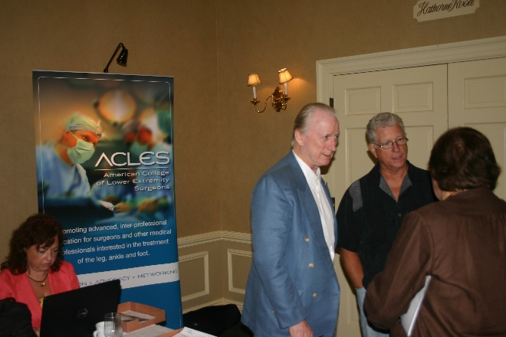

*FACULTY AND COURSE SCHEDULE*

THURSDAY MAY 3rd

7:00 – 7:30 AM REGISTRATION

7:30AM – 8:30am LELAND JAFFE DPM

Preventative medicine "Harnessing the Power of Nutrition to Prevent / Treat Chronic Diseases"

8:30-9:00 FRANK ROSENBLAT MD

Infectious disease

9:00-10:00 ALAN JACOBS, DPM, MS

Podiatric Dermatology Essentials

10:00-11:00 RICHARD BENJAMIN DPM

Distal Phanangectomy - A Different Approach

11:00-12:00 ALAN JACOBS, DPM, MS

Podiatric Dermatology Essentials con’t

NOON – 1:00 PM LUNCH

1:00 – 1; 45 PM JOHN TOTH ESQ

“Anatomy of a Lawsuit and State License Issues.”

PICA Risk Management and Electronic Medical Records

Attending this session will earn you a 10% discount on your PICA malpractice insurance

1:45-2:45 BRANDON GUMBINER DPM

Updates on the Treatment of Hallux Limitus

2:45 – 3:00 PM BREAK/DISCUSSION

3:00-4:00PM Brandon Gumbiner DPM

Perioperative Pitfall s: The Treatment, Management, and Prevention of Surgical Complications

4:00 – 5:00 PM

LELAND JAFFE

Harnessing the Power of Nutrition To Prevent / Treat Chronic Diseases II

5:00 – 5:15 PM BREAK/DISCUSSION

5:15 – 9:30 PM Dinner Meeting

WILLIAM J. SARCHINO, DPM, FAPWHc

PRESENTS DINNER, CASE PRESENTATIONS, AND ROUND TABLE DISCUSSIONS IN WOUND CARE, RESIDENCY POSTERS/PAPERS

Featuring moderators William Sarchino, David Novicki, Sheldon Goldstein, D.P.M.

*Presentations listed Last page

G. Dock Dockery, DPM, FACFAS, who likes to be called “Dock”, graduated from the Ohio College of Podiatric Medicine in Cleveland, Ohio, as Valedictorian, and performed a surgical residency in foot and ankle surgery at the Waldo Podiatric Surgical Residency Program in Seattle. He is a Fellow and Past Board of Directors of the American College of Foot & Ankle Surgeons. He is a Fellow of the American Society of Foot & Ankle Dermatology, the American College of Foot and Ankle Orthopedics and Medicine and the American College of Foot and Ankle Pediatrics. Dr. Dockery is Board Certified in Foot and Ankle Surgery by the American Board of Foot & Ankle Surgery and is Board Certified in Podiatric Orthopedics by the American Board of Podiatric Medicine.  He is a Distinguished Practitioner in the Podiatric Medicine and Surgery Division of the National Academies of Practice.  He was voted “One of America’s 175 Most Influential Podiatrist” of 2006 and voted as “Movers and Shakers: America’s Most Influential Podiatrists” in 2012, by the Podiatry Management Magazine Editors & Advisors. Dr. Dockery is the author of Color Atlas and Text of Forefoot Surgery, Mosby Publishers, 1992; Cutaneous Disorders of the Lower Extremities, W.B. Saunders Publisher, 1997; Color Atlas of Foot & Ankle Dermatology, Lippincott-Raven, 1999; and, Lower Extremity Soft Tissue & Cutaneous Plastic Surgery, 2nd Edition, Elsevier Science, 2012. He has published more than 140 scientific articles in peer-reviewed medical journals and he founded the International Foot & Ankle Foundation for Education and Research in 1979 and is currently the Chairman of the Board and the Director of Scientific Affairs of that organization.

Stephen A. Mariash, DPM Fellow, American College of Foot & Ankle Surgeons

 Board Certified in Foot & Ankle Surgery, American Board of Foot & Ankle Surgery

 Residency, Atlanta Hospital, (PSR-36), 1988-91

 Faculty and Board of Medical Advisors, International Foot & Ankle Foundation for Education and Research

Faculty, American Academy of Foot & Ankle Osteosynthesis

Practice:  St. Cloud Orthopedic Associates, St. Cloud, MN

Allen Mark Jacobs, DPM

Dr. Jacobs is a 1973 graduate of the Pennsylvania College of Podiatric Medicine. He completed his residency in surgery at Monsignor Clement Kern Hospital for special surgery in Warren, Michigan in 1975. Dr. Jacobs is in private practice in St. Louis, Missouri and is an adjunct associate professor at St. Louis University School of Medicine. He is board certified in reconstructive surgery of the foot and ankle by the American Board of Podiatric Surgery, and is a Fellow of the American College of Foot and Ankle Surgeons. For 25 years, Dr. Jacobs served as a Director of Podiatric Surgical Residency Training, and has also served as a contributing editor to the Journal of Foot Surgery, and as the Scientific Chairman of the American Podiatric Medical Association. He has published over 80 scientific articles in various publications and 17 chapter contributions in various textbooks. He is a nationally recognized author, researcher and a noted authority of surgery of the foot.

.

Leland Jaffe, DPM, FACFAS, CWSP Diplomat, American Board of Foot and Ankle Surgery

Board Certified in Foot Surgery

Fellow, American College of Foot and Ankle Surgeons

Assistant Professor

Dr. Wm. M. Scholl College of Podiatric Medicine

Rosalind Franklin University of Medicine and Science

12- present: Council on Podiatric Medical Education, ABPM Residency

David Novicki DPM assistant professor of surgery, Yale University School of Medicine, Department of orthopedics and rehabilitation. Current chairman of the Board of Trustees, Temple University School of Podiatric medicine. Past president of the American College of foot and ankle surgeons. Past president of the American Board of foot and ankle surgeons.

Bryan C. Markinson, DPM is the Chief of Podiatric Medicine and Surgery and Associate Professor in the Leni and Peter W. May Dept. of Orthopedic Surgery of the Icahn School of Medicine at Mount Sinai in New York City

Dr. Markinson graduated from the New York College of Podiatric Medicine, in 1981. He is certified by the American Board of Podiatric Medicine. Always interested in podiatric dermatology, he served as a Fellow from September 1993 to June 1995 in the department of Dermatopathology at the University of Medicine and Dentistry in New Jersey, under the direction of W. Clark Lambert, MD, PhD. Shortly thereafter, Dr. Markinson founded the Podiatric Pathology service at the Mount Sinai School of Medicine. Currently he is also an instructor in the Department of Dermatologic Surgery and Team Member of the Skin Cancer and Melanoma Unit of the Tisch Cancer Center.

He is a frequent lecturer nationally on various aspects of podiatric dermatology and nail pathology. In 2004, he was elected to the Board of Trustees of the Council for Nail Disorders, a position he still holds.

He has been a consultant to Bako Podiatric Pathology Laboratories since its inception, and several pharmaceutical companies in the dermatology space.

His areas of special interest are skin and nail fungal infections, pedal melanoma, soft tissue masses, pedal dermatitis, longitudinal melanonychia, and podiatric dermatological risk management.

Richard Benjamin DPM, FACLES, DABLES

Private Practice; The Villages, Fl.

 Consultant/Attending Podiatric Surgeon

Ladistan Clinic, Kiev, Ukraine

James DeJesus DPM Dr DeJesus is Board certified by the American Board of Podiatric Surgery. He is currently the Chief of Podiatric Surgery at St Mary’s Hospital in Waterbury Connecticut. He is also the site director at Naugatuck Valley Surgical Center for the Yale Podiatric Surgical Residency program. He is on the executive board for Naugatuck Valley Surgical Center in Waterbury and also co-manager for the surgical center. Dr. DeJesus is a graduate of St John’s University in New York where he received his pharmacy degree. He graduated from the New York College of Podiatric Medicine in 1987 and completed his Podiatric surgical residency in 1989 in West Haven Connecticut. Dr. Dejesus is vice-president of the Connecticut Podiatric Medical Association. He is a member of the American College of Foot and Ankle Surgeons and the American Society of Podiatric Surgeons. Dr. DeJesus has lectured at various seminars nationwide and has moderated several foot and ankle instructional cadaver labs for foot and ankle surgeons, residents and representatives of orthopedic appliance companies. He is an active consultant for Arthrex Corporation and is on the medical education faculty of Arthhrex Distal Extremity Division.

William J Sarchino DPM, FAPWHc ,FACLES,DABLEPresident of the American College of the lower extremity surgeons. Residency director, Southwestern Vermont Medical Center.

FRIDAY MAY 4thH

7:30 – 8:30AM Elloit Udell DPM

The management of Non Adherence in the Geriatric Population

8:30-9:30 JAMES DEJESUS, DPM

Current Surgical Management of First Ray Pathology Current Concepts on the Management of Digital Deformities

9:30 – 9:45 AM BREAK/DISCUSSION

9:45-10:45 ROBERT GIERING MD

10:45-11:00 BREAK/DISCUSSION

11:00-12:00 FRANK ROSENBLAT MD

Infectious disease

12:00-1:00 LUNCH

1:00 – 3:00 DOCK DOCKERY DPM

4% Alcohol Injections for Nerves & Plantar Lesions

Pediatric and Adult Toenail Conditions

3:00 – 3:15 PM BREAK/DISCUSSION

3:00 – 6:00 IRA WEINER DPM, NADEER A. PIRANI MD

Vascular reconstruction for the at risk extremity

Vein therapy for chronic wounds

Wound care with vascular support Update on Charcot with the use of internal and external fixation

Ira Weiner DPM Las Vegas, NV, Has developed and co-developed a number of innovative podiatric surgical techniques. In addition to his surgical practice with Genesis Vascular Healthcare, He-co directs the North Vista Hospital Wound Care Hyperbaric Oxygen and Limb Salvage program. He is also adjunct professor at Avalon University School of Medicine and Universidad Autonoma de Guadalajara, a consultant for Mimidix Biologics and a panel member for Orthofix Trulock. Diplomate, ABLES, ACHCA <,UHMS

Nadeer A. Pirani MD FRCPC

American Board of Radiology, American Board of Vascular Medicine, Vascular &Interventional Radiology CAQ, Royal Collage of Physicians and Surgeons, USMLE/LMCC, Full Reg British Columbia

Research Objectives: Diagnostic Radiology/Cardiovascular Imaging, Clinical Vascular & Interventional Therapies, Interventional Oncology/ Minimally Invasive Tumor Therapies, Wound Care, Hyperbaric & Vascular Medicine

John Toth Esq has more than 30 years of experience in the defense of medical, podiatric and dental malpractice claims; Member of the Standing Committee on Character and Fitness, Michigan State Bar Presidents; 1995 to present; Vice-Chair of rating from Martindale-Hubbell since 1996 and, beginning in 2009, he has been designated as a “Super Lawyer” by Thomson Reuters. From 2008 to the present, Business Magazine as a “Top Lawyer,” along with being recognized in the New York Times “Top Attorneys in Michigan.”  From 2011 to the present, he has also been named in Best Lawyers in America® (Woodward/White, Inc.), in the field of Medical Malpractice Law-Defendants; advocate-member of the American Board of Trial Advocates 2016 to present

Sheldon J. Goldstein, D.P.M. Diplomat; American Board of Lower Extremity Surgeons Founder and Chief; Division of Podiatric Medicine and Surgery, McLaren Oakland Hospital Founder and Clinical Director; McLaren Oakland Hospital, Podiatric Residency Training Program PGY-3 1999 – present

Associate Clinical Professor in Podiatric Medicine and Surgery, Michigan State University – College of Osteopathic Medicine Lansing, Michigan

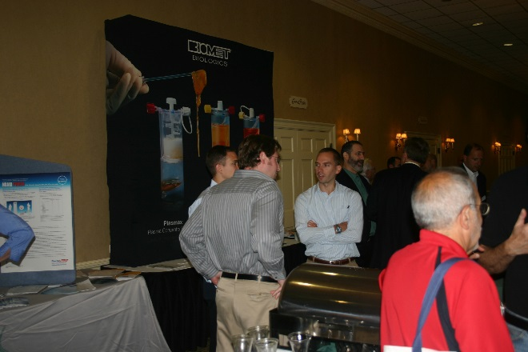

SATURDAY MAY 5TH

7:30 – 8:30 AM SCOT ROMAN DPM

Intramedullary Fixation in Hammertoe Corrective Surgery

8:30 – 9:30 AM **JAMES WANG DPM**

**Use of Mini Rail External Fixation in the Treatment of Lower Extremity Deformity Correction and Trauma”**

9:30-9:45- Break Discussion

9:45-11:00 DOCK DOCKERY DPM

Excision vs. Flaps for Lesions

5th Toe Procedures

11:00 –12:00 STEVE MARIASH DPM . Challenging HAV Case

Tailor Bunion Deformity

12:00– 1:00 PM LUNCH

1:00-3:00 BRYAN MARKINSON DPM

 Dermoscopy of the Foot

3:00-3:15 BREAK/DISCUSSION

3:15-4:30 STEVE MARIASH DPM

Common Cases That Really Weren't

Post Op Nausea and Vomiting

4:30-6:00m DAVID NOVICKI DPM

1) Orthobiologics

2) The Rheumatoid foot

3) New concepts involving heel pain treatment

Workshop Sawbones

11 am

With

James Wang Sat May 5th Minirails

BREAKOUT SESSION

1:00 – 5:00 PM WOUND CERTIFICATION EXAM

ACLES is proud to offer the opportunity to acquire certification as ”Physician Certified in Wound Healing”. The Council for Medical Education Testing (CMET) is the most recognized certification of its kind in wound care, and the only organization providing physician-specific certification for all prescribing physicians (MD, DO and DPM). To register, see details on the registration form, facing page.

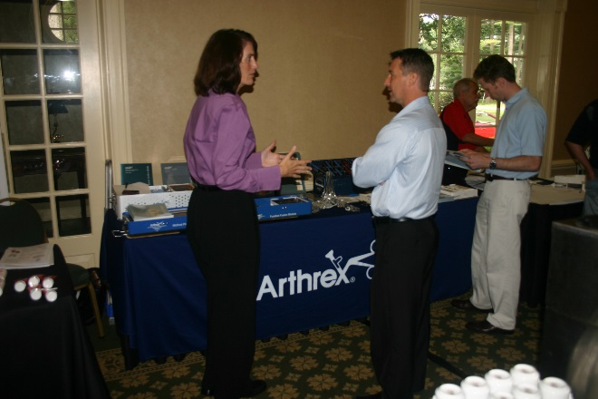

Thursday evening Residency Prresentations:

Jeffrey Pantano DPM, PGY 1 received his doctor of podiatric medicine from Kent State University College of Podiatric Medicine, OH, in May 2016 and currently practicing as a Resident under Dr. Sarchino a Southwestern Vermont medical center. Dr. Pantano will be lecturing on a case discussion about a patient with Mastocytosis and perioperative considerations.

Suzanne McGuire DPM PGY2 resident at Southwestern Vermont Medical Center.  She is a graduate of The Ohio College of Podiatric Medicine and will be presenting on on the Surgical Outcomes of BME Speed Triad Staple for Chevron Osteotomy.

Evan Yoo DPM PGY2 received his undergraduate degree from University of Washington - Seattle and is a graduate of Barry University School of Podiatric Medicine. Resident, Southwestern Vermont Medical Center. Our research focuses on surgical outcomes of BME speed triad staple for Chevron Osteotomy. McCamie DeArmon DPM PGY1 at Southwestern Vermont Medical Center. She graduated from Kent State University College of Podiatric Medicine. Her presentation will be Diabetic Limb Salvage: A Case Against First line TMA.

Allen Wang, DPM PGY2 Lateral Ankle Sprains McLaren Oakland School college of Podiatric Medicine Sean Nagle, DPM PGY2 Misdiagnosed Dermatofibroma McLaren Oakland Western University of Health Sciences

Andrew Miller, DPM PGY1 Compartment Syndrome of the Foot California School of Podiatric Medicine

Paul Constantino, DPM PGY1 Pilon Fractures Associate of Foot, Healthcare Associate School College of Podiatric Medicine

SUNDAY MAY 7TH

7:30 – 9:00 AM Elliot Udell DPM

New drugs and modalities for the management of chronic pain Syndromes

9:00 – 9:15 AM BREAK/DISCUSSION

9:15 – 11:00 AM RICHARD BENJAMIN DPM

Case Presentations - What Would You Do? - 60 MInutes

Rationale:  There are many surgical options for each condition presented to the surgeon.  What is the right procedure for your patient considering all the factors?

11:00 AM –1:00PM BRIAN GOLDSTEIN DPM

Infectious disease, alternative to antibiotics

1:00 – 1:30 PM Discussion

1:30 PM MEETING ADJOURNS

Workshop #1 Ex Fix minirail fixation Saturday