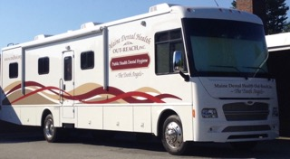
Maine Dental Health Out-Reach, Inc.
Tooth Angel Program
2019-2020 Dental Consent Form

Dental Hygiene Services: screening, x-rays, prophylaxis (dental cleaning), fluoride application, sealants, temporary fillings, antimicrobial liquid silver diamine fluoride, oral hygiene instruction, re-mineralization application & referrals to outside care
Dentist Services (when available at school): exam, local anesthesia (to numb up the tooth and gum), restorative care (included but not limited to) fillings, stainless steel crowns on baby molars, pulpotomys (nerve treatment), extractions of infected non-savable teeth and extraction of over retained baby teeth (baby teeth that will not come out on their own)

Student’s Name: Last____________________________________________First________________________________
Mailing Address: ___________________________________________Town____________________ Zip Code________
Student’s Date of Birth: ______ / ______ /___________ Age: ________ Male Female
Parent/Guardian Phone: 1._______________________ home / cell 2. _____________________ home / cell / work
School: ______________________________________Teacher: _________________________________Grade _______
PAYMENT OPTIONS:
Student’s MaineCare Number: ____ ____ ____ ____ ____ ____ ____ ____ A
Traditional Dental Insurance: Staple a photocopy of the front and back of the insurance card to this form. If not attached, MDHO will be unable to process this form.
Cash Payer: Staple a check to this form, payable to MDHO for the Dental Hygiene Services listed above Fee: $145.00
MEDICAL INFORMATION:
Circle medical diagnosis: ADD, ADHD, Anxiety, Autism, Bleeding Disorders , Cancer, Depression, Diabetes, Heart Problems Kidney Disease, Liver Disease, Oppositional Defiant Disorder or Other: ________________________________________________________
Medications: _______________________________________________________________________________________________
List allergies: dairy (milk casein), dye, environmental, food, gluten, latex, medication, or other: _____________________________
Epi-Pen at school? Yes / No Does your child require ANTIBIOTICS prior to dental procedures? Yes / No
Last Dental Appt.: Month _____ Year _____ By Whom: Tooth Angel Program (us) Other (name)* ______________________
Dental Concerns? _____________________________Has your child been dismissed from the above practice? Yes / No
Consent: By signing this document, you are giving MDHO, Inc. permission to treat your child for the above services and you confirm that you have read MDHO’s Policy Disclosures and the Dental Consent to Treat Statement, as described on the back side of this paper.
Parent/Guardian Name (Print) _____________________________________________________________ Date: _______________
Parent/Guardian Consent to Treat Signature ________________________________________________ Date: _______________
MDHO, Inc. HIPAA Policy Disclosure: This personal information will not be shared with anyone other than the person listed on the “Parent/Guardian Consent to Treat” (page 1), without a HIPAA request form. If you would like a copy of MDHO, Inc.’s HIPAA Policy, you may obtain one from the school nurse or download it from our website: www.mdhoi.org

Dental Consent from Parent/Guardian to Treat Statement: I give MDHO, Inc. permission for this child to receive dental hygiene services by a MDHO, Inc. public health dental hygienist. I understand that the dental hygiene services that will be received do not take the place of an examination by a dentist.
I also give permission for my child to be treated when a MDHO, Inc dentist is in the van, at their school. I understand that a referral will be sent home if the MDHO, Inc. dentist is unable to complete all of the dental work my child needs.
Permission is also granted to obtain necessary, confidential information needed, from the people listed below, in order for my child to receive dental hygiene services.
This includes information needed from/to the following: 1. The school nurse 2. The school staff (if there is no nurse available) 3. The previous dentist 4. The dentist MDHO, Inc. is referring this child to.
I also give permission for MDHO, Inc. to share information provided on the consent form with the school nurse.

I understand it is my responsibility to contact MDHO, Inc. @ 377-7003, if my child has a dental appointment in another office prior to being seen at school, and I understand that if my child does not qualify for these services, the parent/guardian will not be contacted and the consent form will be shredded.

MaineCare Temporary Filling Policy: “It is very important that you understand that this is not a permanent fix to the dental problem your child has. You need to take your child to a dentist for the proper care. If your child does not see a dentist, their condition could get worse.“

Photo Consent: By signing below, I give permission for MDHO, Inc. to take a photo of my child. I understand this photo may be used on their website (www.mdhoi.org), in grant applications and reports, in the MDHO, Inc. brochure, as well as, other media purposes to promote the services that MDHO, Inc. provides.
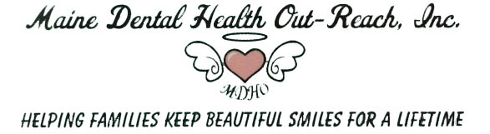 Parent/Guardian Photo Consent Signature __________________________________________________ Date: ______________

