The Chosen Bible Study FAQs
To watch The Chosen -Series 1 by episode can be done in many free ways.
- IPhone, IPAD, or Android go to the Apple Apps Store or Google Play Store and search : The Chosen. An app that looks like this: 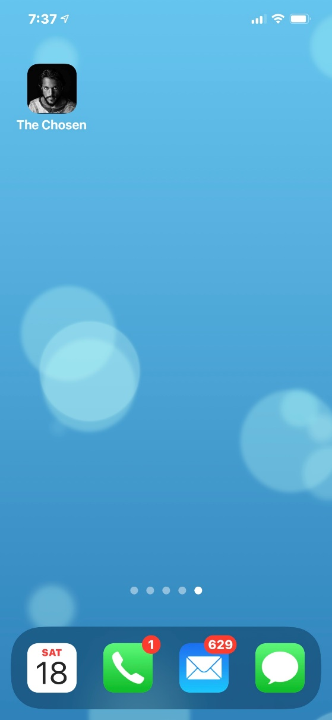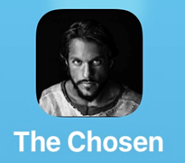

- When you open the App it looks like this: 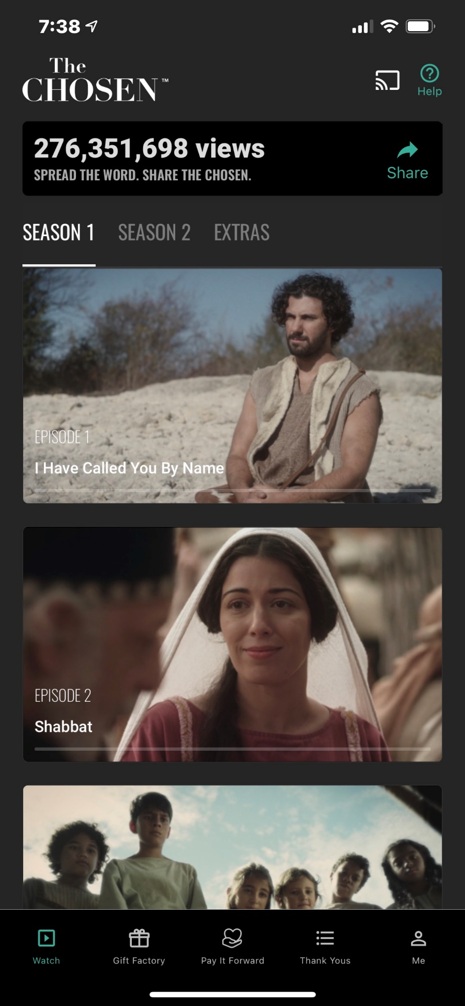
- You can then start watching on your phone or press the square next to the info button on top right and it will let you choose if you would like to air play over Roku, Chromecast, or any other smart TV
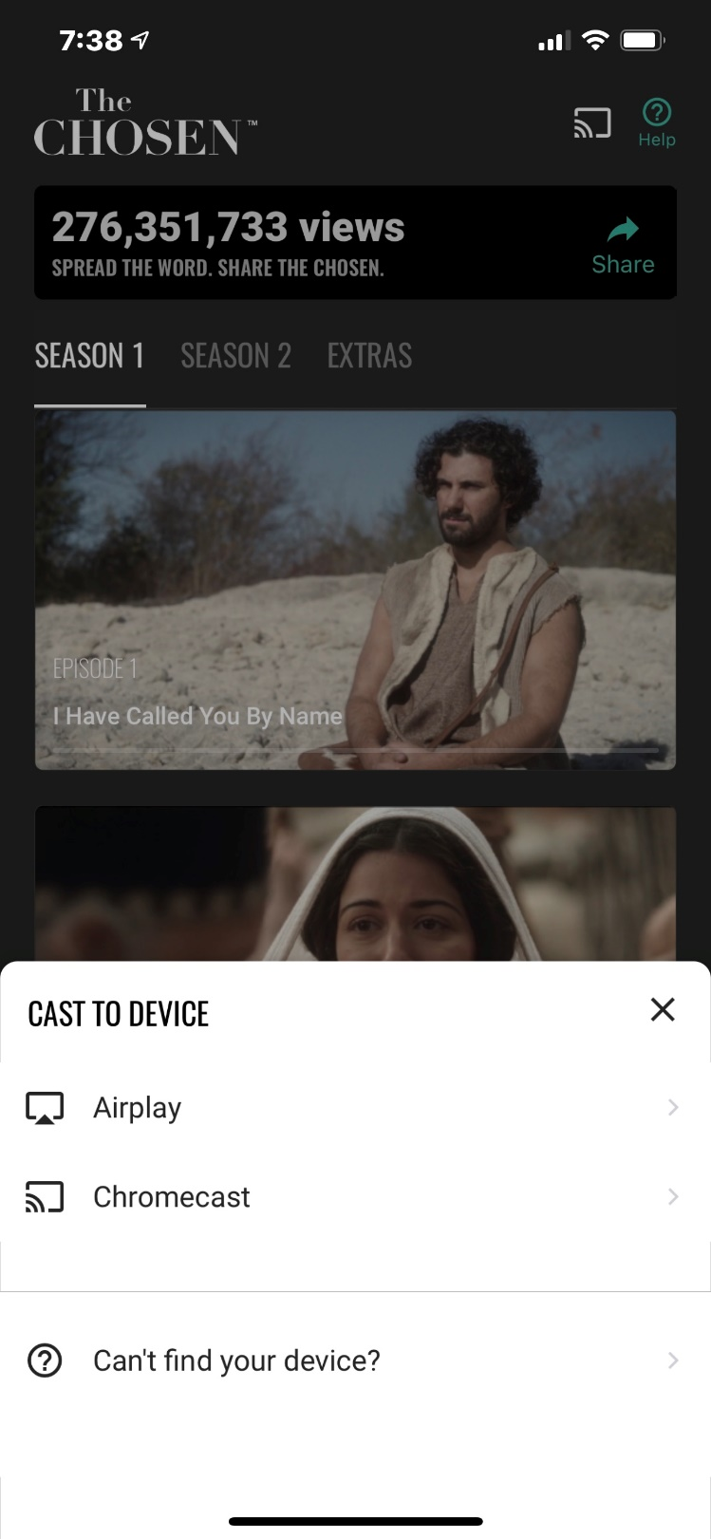
- To watch on you computer there are several ways to view for free.
  - Open google or preferred internet browser and type in TheChosen.tv
  - This will take you to the AngelStudios hub where you can watch any of the episodes and seasons for free. The website looks like this: 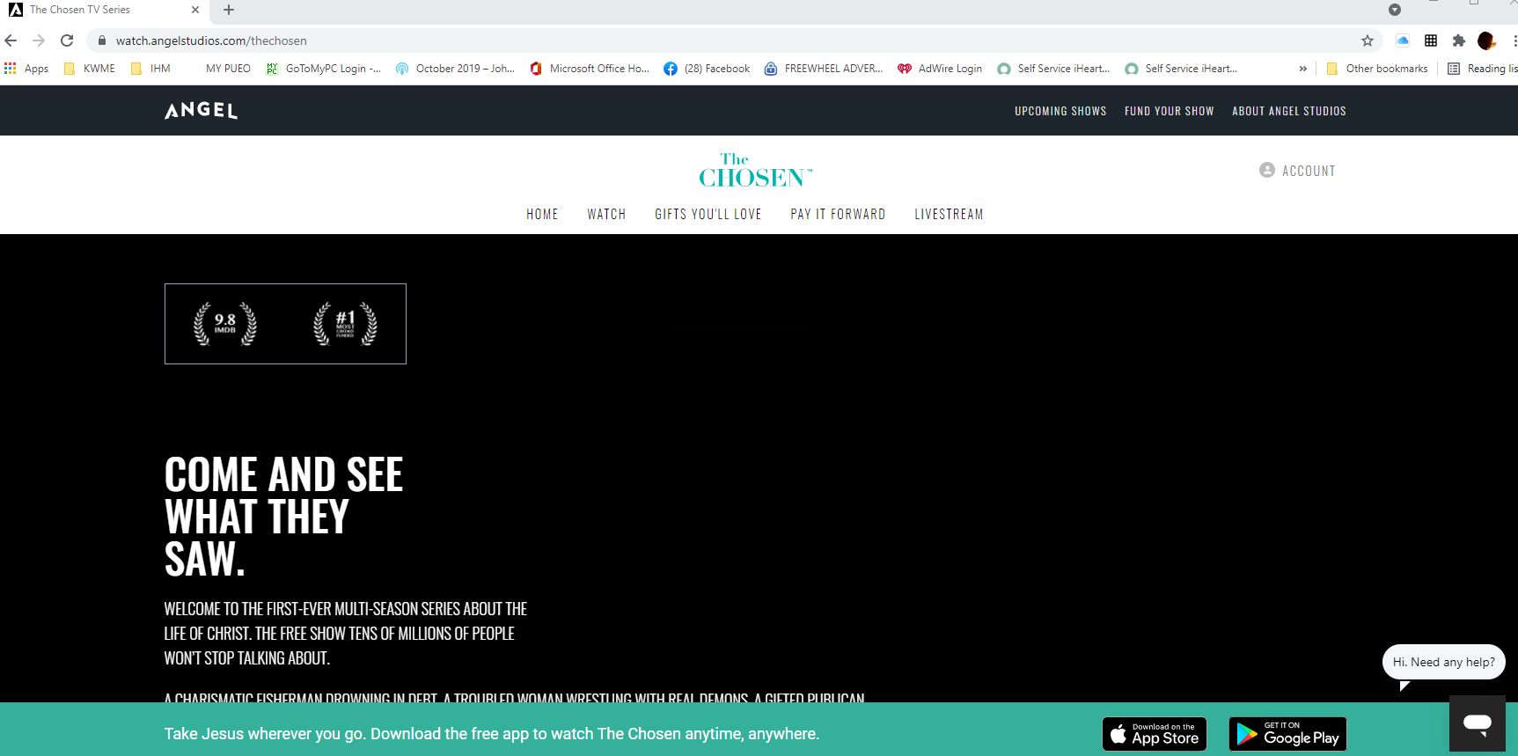

Click watch and scroll down and choose the season and episode.
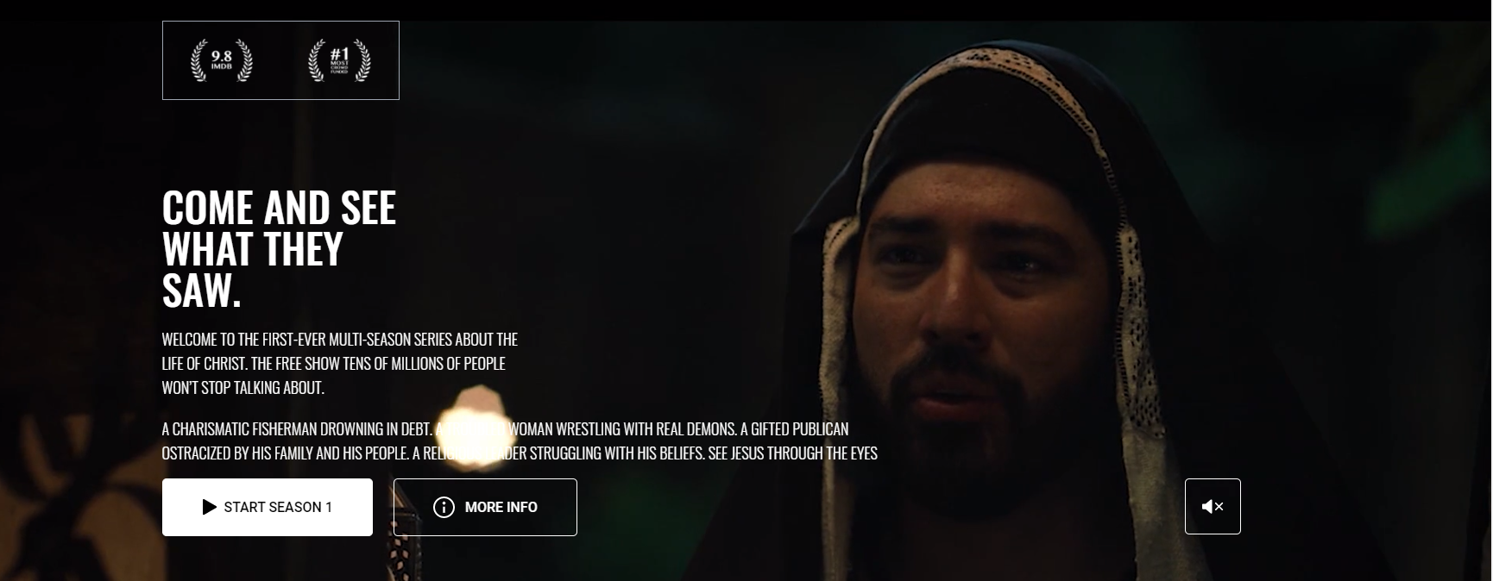

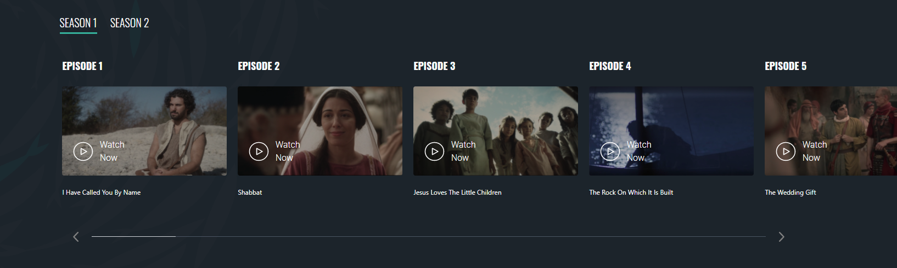

If you connect your TV with an HDMI cord you can watch on your TV that way as well!
This is the recommended sight that streams and downloads with no issues.

Another free way to watch is to go to YouTube.
You can Type in on YouTube Search
The Chosen Season 1 episode 1 – and so forth for each episode. This is not a guaranteed quality like the Angel Studios App- but some may prefer to go YouTube.

These are all Free ways to watch each episode on your timeline. It is recommended that you watch the episode First and then do the Homework Assignments. This will give you a deeper understanding and appreciation for scripture and relating to what is God telling you in this episode.

Paid ways of watching:
PureFlicks does have the Season One of the Chosen Available. There is a month trial for free but then requires a subscription. Again- if you already have the service then you can login and start watching. If you don’t then use the free App or steaming sight.
Tips for better Viewing:
- Turn on the Subtitles. This helps in getting not missing any dialogue. It can be turned on in the App, Online, or on your TV.

- Turn your brightness up or TV on a higher video setting. This is done in cinema format – high quality. So for example the very first episode begins in the dark looking at stars- so again its not the whole movie and it does help to have the subtitles on so you don’t miss anything.

- There are little extras after the video that give you some insight from the direct, writer and actors. These are very insightful and give a little more explanation on things that maybe you might not have thought of…

Enjoy- I hope you find this study enriching- seeing how God Chose each and everyone of us- just like Mary, Simon Peter, Nicodemus, James, and Matthew. We are called and Chosen!

