RMGA in-person Membership Meeting:

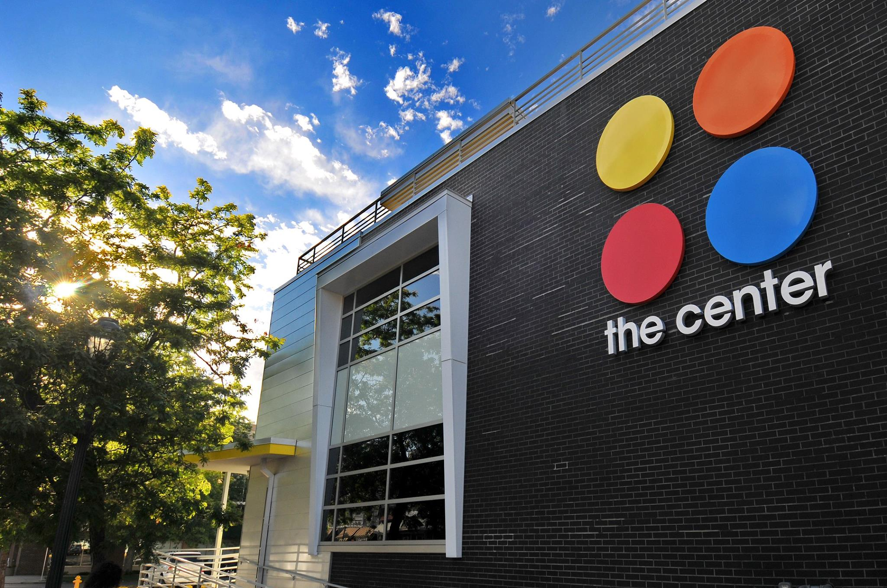
We have brought back live, in person meetings. The only thing missing is you! Please join us Monday, October 10th 2022 at the Center on Colfax 1301 E Colfax Ave; Denver, CO 80218 at 6 PM.
The Center serves members of the LBGTQ community of Colorado. It sponsors the Pride Weekend Celebrations and parade in June and provides services year-round. David Duffield is the Director of the History Project that collects and archives oral histories of the community, provides walking tours, curates museum exhibits and shares stories to a wider audience. He will be giving a presentation on some of the activities of the project as well as sharing information regarding the types of services available and if possible, a tour of the facility. As a bonus, hear about the wild historical event in Denver Crimefighting history that took place on the site around a 100 years ago.
The importance of diversity and inclusion was made repeatedly at the Colorado Tourist Office’s Governors Conference this year. This is especially relevant to the foreign travelers the CTO hopes to lure back to Colorado. The RMGA needs your attendance and support if we are to continue live programming. Please join us.

