Mars UP Church
Come Holy Spirit, Come
Before the Service – Speak to God!
During the Service – Let God speak to you!
After the Service – Speak to each other!

Leader: He is Risen!
People: He is Risen indeed!

(*Please stand, if able)
Welcome and Mars Messages

Prelude

Apostles’ Creed
I believe in God the Father Almighty, Maker of heaven and earth; and in Jesus Christ His only Son our Lord; who was conceived by the Holy Ghost, born of the Virgin Mary, suffered under Pontius Pilate, was crucified, dead and buried; He descended into hell; the third day He rose again from the dead; He ascended into heaven, and sitteth on the right hand of God the Father Almighty; from thence He shall come to judge the quick and the dead. I believe in the Holy Ghost, the holy catholic church; the communion of saints; the forgiveness of sins; the resurrection of the body; and the life everlasting. Amen.

Gloria Patri
Glory be to the Father, and to the Son, and to the Holy Ghost. As it was in the beginning, is now and ever shall be,
world without end.
Amen. Amen.

The
Lord’s Prayer

Our Father,
who art in heaven,

hallowed be Thy
name,

Thy kingdom come,
Thy will be done,
on earth
as it is in heaven.

Give us this day
our daily bread;

and forgive us
our debts,
as we forgive
our debtors;

and lead us not
into temptation,
but deliver us
from evil.

For Thine
is the kingdom,
and the power,
and the glory,
forever. Amen.

The Doxology

Praise God
from whom
all blessings flow;
praise Him
all creatures
here below;
praise Him above,
ye heavenly host;
praise Father, Son,
and Holy Ghost.
Amen.

Choral Introit Chancel Choir
“Easter Alleluia!”

The Call to Worship
Leader: How joyful it is, to celebrate the good news of
God’s love!

People: We are called to be Easter people!

Leader: Darkness cannot claim us!

People: Fear cannot bind us!

Leader: Christ is risen!

People: Christ is risen, indeed!

Pastoral Invocation

*Hymn 361 (vs. 1,2,5)
“Worship Christ, the Risen King”

Children’s Chat

Choral Anthem Chancel Choir
“Alleluia, He Has Risen!”

Scripture Luke 24:1-12

Morning Message Rev. Brian Hauser
“Come On In”

*Hymn 367
“Christ the Lord is Risen Today”

Prayers of the People

Doxology

*Offering Prayer
Offertory Response Chancel Choir
“All Things Come of Thee”

Communion Hymn 358
“Because He Lives”

Communion
INVITATION TO THE TABLE
L: The Lord be with you.
P: And also with you.
L: Lift up your hearts.
P: We lift them to the Lord.
L: Let us give thanks to the Lord our God.
P: It is right to give our thanks and praise.
L: It is indeed right and our greatest joy… who forever sign to the glory of your name.
P: Holy, Holy, Holy Lord, God of Power and Might. Heaven and earth are full of your glory; Hosanna in the highest, blessed is He who comes in the name of the Lord. Hosanna in the highest.
L: You are Holy, O God of Majesty… Great is the mystery of faith.
P: Christ had died, Christ is risen, Christ shall come again.
(The leader continues)
THE LORD’S PRAYER
THE WORDS OF INSTITUTION
THE BREAKING OF THE BREAD, THE POURING OF THE CUP, DISTRIBUTION OF THE ELEMENTS
PRAYER OF THANKSGIVING

*Hymn 368
“He Lives”

*Benediction

Church Staff
Rev. Brian Hauser
Pastor
pastor@mars-up.org
724-689-3412

Ms. Jamie Daugherty
Choir Director & Organist
JamieD0714@gmail.com

Mrs. Shelly Bocheff
Administrative Assistant
marsup@mars-up.org

AV TEAM
Alma Staskiewicz, Lisa Barbour, Marie Matthews, Bill Guesman, John Ivory, Keith Nichols, Mike Bocheff, Herb Wellman

Mars United Presbyterian Church

232 Crowe Ave
PO Box 805
Mars, Pennsylvania 16046
724-625-1365
www.mars-up.org
marsup@mars-up.org

Church Office Hours:
Mon -Thurs from 9 a.m. -2:30 p.m.
*Postlude

Flowers are presented to the Glory of God and in honor of our grandchildren, Bradley, Ryan Rose, CeCe, Olivia & Sybil by Diddy Pap and Nunnie Matthews

Morning Worship:
10:00 am

2nd Sunday of Easter

Prayer of Preparation
Lord, we come to you today with so many things on our hearts.

You call us to be in relationship of trust and love with you and you offer healing to us for those portions of our lives that are broken and injured.

Help us to be open to your mercy and healing love. For we ask this in Jesus’ Name.
AMEN.

Mars United Presbyterian Church
Welcome!

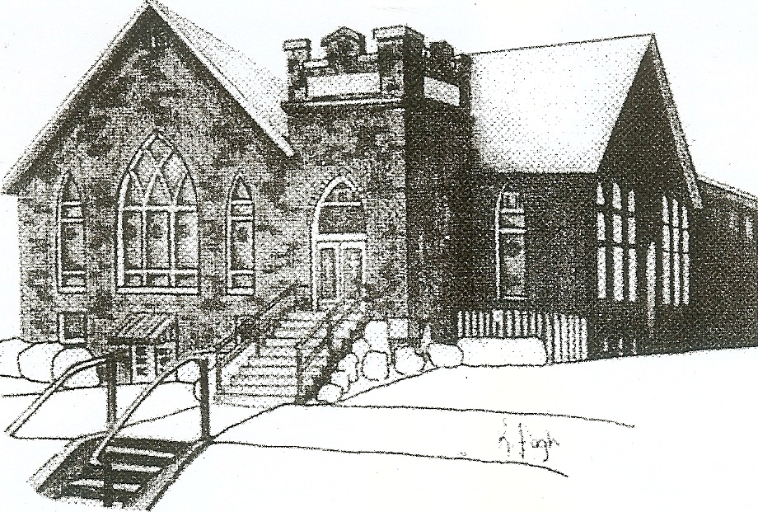
We are your hometown church: Faithful to Tradition, Loving in Fellowship, & Reaching for Tomorrow!

April 24, 2022
Humor Sunday

We welcome you and we are glad you’ve chosen to Worship with us today!

CALENDAR: April 24, 2022 – May 1, 2022

Church Office Hours: Monday -Thursday from 9 a.m. – 2:30 p.m.

Today, April 24, 2022
VOLUNTEERS☺

LAST SUNDAY’S In-House ATTENDANCE: 97

LAST SUNDAY’S OFFERING:
Operating Funds: $5792.00
Kindness Offering: $650.00
Mission: $50.00
Bldg: $10.00
Total: $6502.00

Tarry N Talk Hosts
Christian Ed/Mission Outreach
9:00 a.m. Sunday School Hour
10:00 a.m. THE MORNING WORSHIP SERVICE
1:00 pm Youth Group
Monday, April 25, 2022
6:30 pm GriefShare
7:00 pm Boy Scouts
Tuesday, April 26, 2022
9:00 am A team
7:00 pm AA
Wednesday, April 27, 2022
9:00 am Material Girls
6:00 pm Girl Scouts
7:00 pm Chancel Choir Rehearsal
Thursday, April 28, 2022
Friday, April 29, 2022
Saturday, April 30, 2022
Sunday, May 1, 2022 Communion
9:00 am Sunday School Hour
10:00 am THE MORNING WORSHIP SERVICE
11:15 am Deacon Meeting

Welcome to all who are Worshiping with us today!
Guests
We sincerely hope our service is a blessing to you. We ask that our guests please take a few minutes to complete one of the Connect Cards found in the pew holder.

Should you have questions regarding any aspect of our church, including membership, please contact Pastor Brian or the church office during the week at 724-625-1365. Thank you for being with us today.

PRAYER – JOYS & CONCERNS
Lou Beckwith Kennedy (Great Granddaughter of Marlene Edwards
Jan Balentine (sister of Karen Purvis) Paige Barbour (daughter of Andrew and Steph Barbour)
Reid Christopher Hall (June Stirling’s nephew) Maria Elizabeth McKaveney (June Stirling’s niece)
Lindy McCartney (Lisa Barbour’s Sister) Chuck Kennedy
Patty Jackson Isabel Boynton
Nancy Govan

ANNOUNCEMENTS
Bulletins are printed Thursday mornings; let us know if you have an announcement…

COMBINED WORSHIP SERVICE On Sunday, May 1st we will have a combined Worship service with St. John’s Lutheran Church. Our Youth Group will be participating in the worship. The Sacrament of communion will also be offered this Sunday.
MOTHER’S DAY PROGRAM will be during the worship service on Sunday, May 8th. Alma’s Angels will be performing with a small program from the Sunday School children. Flowers will be given to the Ladies of the church.

SPAGHETTI DINNER FUNDRAISER My School preschool will be holding a Spaghetti Dinner fundraiser on Sunday May 15th from 4pm until 7pm in the church Fellowship Hall. The fundraiser is for Skyla Patora who is fighting Myelodysplastic Syndrome, a type of bone marrow cancer. All proceeds go directly to the family for medical bills. They will also have a basket raffle. Any questions please contact the office or see Pastor Brian.

VACATION BIBLE SCHOOL “MONUMENTAL” Registration for VBS is available now online at www.mars-up.org. June 26th thru June 30th 6:00 to 8:30 pm. SPECIAL OPENING SUNDAY AFTERNOON- Families join us for a HOT DOG BEAN kickoff at 5:00 pm in MUP Fellowship Hall

