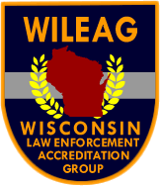
WISCONSIN LAW ENFORCEMENT ACCREDITATION GROUP
Challenging Wisconsin’s Law Enforcement Agencies to Pursue Excellence

Mark Ferguson, President
Chief of Police
Glendale Department
5909 N. Milwaukee River Pky.
Glendale, Wisconsin 53209
Tel: (414) 228-1753
E-mail: m.ferguson@glendalewi.gov

February 1, 2021

Use of Force Policy Certifications - Update

The COPS Office has removed the January 31st deadline for Use of Force policy certifications to receive DOJ discretionary grant funding.

The new requirement is that an agency must be in the process of becoming certified as complying with safe policing practices at the time of making a grant application. Being in the process of receiving certification means that the agency has submitted a request for certification and their policy to WILEAG.

Agencies that are in the process of certification and that are selected to receive discretionary grant funds must be certified by the time they accept the grant award.

WILEAG will continue to accept requests and certify an agency’s use of force policy in compliance with the mandatory safe policing requirements. WILEAG will forward agency certification information to the COPS Office upon their request.

Should you have any questions about the certification process please contact the WILEAG Executive Director at executive.director@wileag.info or myself.

Thank you,

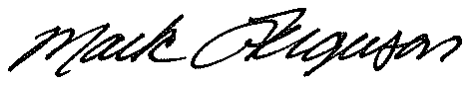

Mark Ferguson, President
Wisconsin Law Enforcement Accreditation Group
m.ferguson@glendalewi.gov

