

**Shropshire Wheelchair & Posture Service Referral Form**

Guidance for completing this form:

This referral form is for NEW clients/patients – For clients already known to Shropshire Wheelchair & Posture Service, please call to make a re-referral, completion of a referral form is not required.

**Please ensure that all details are filled out and as much information as possible is included to ensure minimum delay.**

Please return this form by email[**shropcom.swaps@nhs.net**](mailto:shropcom.swaps@nhs.net)or address **Shropshire Wheelchair & Posture Service,** **Rehabilitation Centre, Lancaster Rd, Harlescott, Shropshire, SY1 3NJ**

If you have any questions please don’t hesitate to contact us on **01743 444051**

**SHA no:**

**Is the client aware of this referral?** Yes  No

**Client’s details**

|  |  |  |  |
| --- | --- | --- | --- |
| Title |  | Surname |  |
| Forename & Middle Name |  | Gender | Male  Female |
| Date of birth |  | NHS number |  |
| Ethnicity |  | Telephone/Mobile number |  |
| Postcode |  | Email |  |
| Address |  | English speaking? | Yes  No |
| If ‘no’ please state language spoken: |  |
| Preferred communication method? |  | | |

**Next of kin details**

|  |  |  |  |
| --- | --- | --- | --- |
| Name |  | Relationship to client |  |
| Telephone number |  | Best person to contact | Client  Next of kin  Other, please specify: |

**GP details**

|  |  |  |  |
| --- | --- | --- | --- |
| GP name |  | GP telephone number |  |
| GP surgery |  | GP address |  |

MC900217366[1]

Ver: 02/22

Date:

NHS No:

Client Name:

**Other professionals**

|  |  |  |  |
| --- | --- | --- | --- |
| Name |  | Professional status |  |
| Telephone number |  | Address |  |

|  |  |  |  |
| --- | --- | --- | --- |
| Name |  | Professional status |  |
| Telephone number |  | Address |  |

**Please include any more professionals in comments section at the end of the form**

**Risk**

|  |  |
| --- | --- |
| Do you have any knowledge of incidents that may affect staff visiting the client alone (e.g. alcohol misuse, incidence of violence)? | Yes  No (if ‘yes’ please provide brief details)  Details: |

**Medical information**

|  |  |  |
| --- | --- | --- |
| Diagnosis/ medical history and  Date of diagnosis |  | |
| Does the client have sensory impairments? i.e. visual, hearing, perceptual difficulties | | Yes  No (if ‘yes’ please provide brief details)  Details: |
| Does the client have cognitive difficulties? | | Yes  No (if ‘yes’ please provide brief details)  Details: |
| Does client have any communication difficulties? | | Yes  No (if ‘yes’ please provide brief details)  Details: |

**Referral information**

|  |  |
| --- | --- |
| Client’s transfer technique: | Independent  Assisted  Hoisted  Details: |
| Current equipment: (do they have a wheelchair? Private/NHS) |  |
| Time spent in the wheelchair: |  |
| How does/will client mobilise indoors? |  |



Ver: 02/22

Date:

**Environment**

NHS No:

Client Name:

|  |  |  |  |
| --- | --- | --- | --- |
| Who does/will the client live with? |  | Type of accommodation |  |
| Internal access door widths |  | External access  (e.g. lift/ ramp/steps) |  |
| Any restrictions in the home environment? |  | | |

**Pressure care**

|  |  |
| --- | --- |
| How long will the client sit in the wheelchair at any one time? (approx.) |  |
| Does the client have any current/history of pressure sores? | Yes  No  Details: |
| Does the client have any current issues with continence? (Catheterised etc.) | Yes  No  Details: |
| Can the client independently weight shift to relieve pressure? | Yes  No  Details: |

**Client’s measurements**

|  |  |  |  |  |  |
| --- | --- | --- | --- | --- | --- |
|  | **m/cm** | **ft/in** |  | **kg** | **st/lb** |
| Height |  |  | Weight |  |  |

|  |  |  |  |  |  |
| --- | --- | --- | --- | --- | --- |
|  | **cm** | **in** |  | **cm** | **in** |
| Hip Width (A) |  |  | Upper Leg Length (B) |  |  |
| Lower Leg length (C) |  |  | Base to shoulder (D) |  |  |

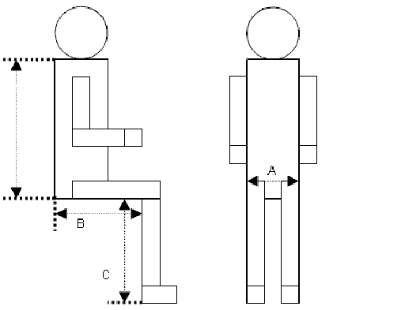

MC900217366[1]

Ver: 02/22

Date:

NHS No:

Client Name:

**What is the assessment needed for?**

Cushion/Pressure issues

Powered wheelchair

Tick as many boxes as necessary, indicating priority:

Buggy

Attendant Pushed Wheelchair

Postural management

Self-Propelled Wheelchair

Voucher

Left hand controls

Right hand controls

**Please tick appropriate left or right hand controls**

**What is the wheelchair needed for?**

2: Semi-permanent/occasional indoor need

1: Permanent mobility needs (i.e. NO walking ability)

3: Regular social needs (for day centre/part of care package)

4: Medical Emergency

|  |  |  |
| --- | --- | --- |
| **ANY COMMENTS OR FUTHER INFORMATION:**  (**Include hospital discharge date**, **days client may not be available etc**.) |  | Ver: 12/19 |
| **Delivery options**  Self-collect - Shrewsbury (Shropshire Community Centre)  Deliver (if you select this option, it will extend the lead time)  If address is different from client’s usual residence please include here:  **Referrer information**   |  |  |  |  |  |  |  |  |  |  |  | | --- | --- | --- | --- | --- | --- | --- | --- | --- | --- | --- | | Completed by: | | | |  | | | | Date: | |  | | Signed: | |  | | | | Authorised referrer number: | | |  | | | Profession: | | |  | | | | | | | | | Address: | |  | | | | | | | | | |  | | | | | | | | | | | | Email: |  | | | | Telephone number: | |  | | | | |  |  |

MC900217366[1]

Ver: 02/22

Date:

NHS No:

Client Name:

**For office use only**

MC900217366[1]

Ver: 02/22

**Triage notes:**

**Clinician: Date:**

Ver: 01/20