**Sail AwayWith Ocean City AARP 1917**

**October 7-19, 2025**

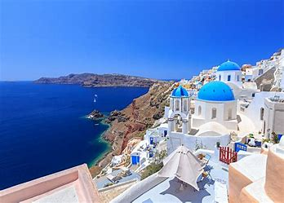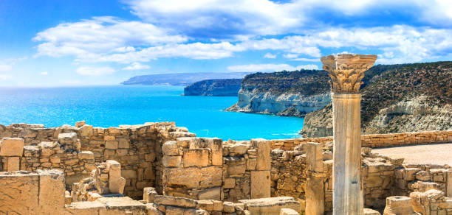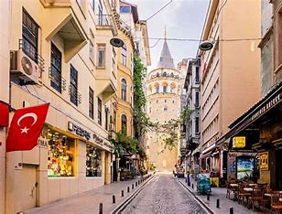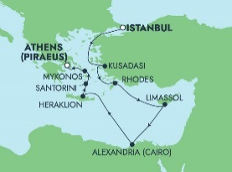

**Please join your friends for a fabulous adventure on Norwegian Cruise Lines’s newest Ship, “The Viva.” This beautiful and modern ocean liner went into service just last year. The ship features many amenities for a special vacation: beautiful staterooms; numerous dining options; entertainment from music to comedy to dancing to casinos; beautiful pools and spa.**

**We’ll depart October 7 in time to begin our adventure in Istanbul the day before we sail. It will allow some free time to explore nearby sights in this fascinating city. This exciting cruise offers an amazing itinerary. We depart from Istanbul, Turkey and sail to Kusadassi, Turkey (Ephesus); Rhodes, Greece; Limassol, Cyprus; Alexandria, Egypt (2 days); Crete, Greece; Santorini, Greece; Mykonos Greece; and Athens, Greece. These exotic destinations offer glimpses into civilizations of our distant past and the beautiful scenery abounds.**

**Please visit the website for all the great details about accommodations and destinations at** [**https://www.ncl.com/cruises/10-day-greek-isles-from-istanbul-to-athens-santorini-rhodes-and-mykonos**](https://www.ncl.com/cruises/10-day-greek-isles-from-istanbul-to-athens-santorini-rhodes-and-mykonos)

**The prices quoted include ship accommodations, and airfare per double occupancy stateroom : Balcony: $5,213.96 Ocean view: $4,457.96 Inside: $4,386.86; Studio, $3,002.82 a 106 sq ft room for 1.**

**Add on packages: Plan A**, **$350; Unlimited adult drinks, 4 nights specialy dining, internet service, $100 onboard credit. Plan B, $0 charge; internet service, picture package and $200 onboard credit. BOGO round trip airfare for $1,500 for 2. Two booked studios qualify for BOGO airfare**

**Deposit options: $150.00, fully refundable if cancelled by June 1; or “Double deposit,” $150 deposit credited as $300, non-refundable, but it will be held on account and can be applied to a future booking if you must cancel. No refunds after June 1, 2025. Trip must be paid in full by June 1, 2025.**

**The Travel committee will not handle your booking nor will we collect any money for the trip**. We’ll provide you with the pertinent information to book directly with NCL. Please note: feel free to invite whomever you want. However, we will want their names and contact information. If they are not National AARP members, there is a $7.00 fee due our chapter. A national member can join our chapter for the same $7.00 for all of 2025. **Depending on response, we may book transfers to and from our US airport.**

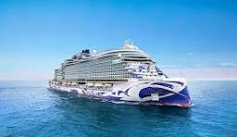 **When you are ready to book or if you have a specific question that only NCL can answer, please contact Fran Smith at 410-726-6166 and** [**frans524@yahoo.com**](mailto:frans524@yahoo.com) **or Dottie Pinto at 410-422-3525 or** [**beachpinto@gmail.com We**](mailto:beachpinto@gmail.com%20We) **will provide you with our group ID and our agent info.**

*66 or email at* [*frans524@yahoo.com*](mailto:frans524@yahoo.com) *or Dottie Pinto at 410-422-3525 or* [*beachpinto@gmail.com*](mailto:beachpinto@gmail.com) *with any questions you may have about the trip or for the information to make your reservation*