***Know Christ! Grow in Faith! Serve Others!***

**Mission Statement** of LTUMC (adopted 6/5/2024)

**WELCOME—ANNOUNCEMENTS Mary Fulton**

**JOYS AND CONCERNS**

**INVITATION TO WORSHIP/OPENING PRAYER Pastor Rod**

**PRELUDE Jenny Claybaugh, Jane Wildermuth**

**SONG LEADERS Diane Lewis, Jason Brunson**

**LITURGIST Don Lewis**

**\* Indicates To Please Stand If Able**

**\*Call to Worship:**  *Psalm 100 NLT*

L: Shout with joy to the LORD, all the earth!  
***P: Worship the LORD with gladness. Come before Him, singing with joy.***

L: Acknowledge that the LORD is God! He made us, and we are His.

***P: We are His people, the sheep of His pasture.***

L:Enter His gates with thanksgiving; go into His courts with praise. Give thanks to Him and praise His name.  
***All: For the LORD is good. His unfailing love continues forever, and His faithfulness continues to each generation.***

\***Hymns: He Touched Me**

**Something Beautiful *(twice thru)***

**Unison Prayer:  *Prayer of Saint Thomas Aquinas, #530, UMC Book of Worship***

***Give us, O Lord, steadfast hearts, which no unworthy thought can drag downward, unconquered hearts, which no tribulation can wear out, upright hearts, which no unworthy purpose may tempt aside. Bestow upon us also, O Lord our God, understanding to know You, diligence to seek You, wisdom to find You, and a faithfulness that may finally embrace You; through Jesus Christ our Lord. Amen.***

**Scripture Reading:** *2 Timothy 4:-6-8*

**Prayers of The People Diann Brower**

Lord’s Prayer: **Our *Father who art in heaven, hallowed be thy name. Thy kingdom come, thy will be done on earth as it is in heaven. Give us this day our daily bread, and forgive us our trespasses as we forgive those who trespass against us. Lead us not into temptation, but deliver us from evil. For thine is the kingdom, and the power, and the glory forever. Amen.***

**\*WORSHIPPING GOD WITH TITHES & OFFERINGS/DOXOLOGY**

**\*Prayer of Thankfulness: *Accept these gifts, O God, as testimonies of our love for You and our desire to serve You. Let these offerings be an affirmation that we are bound to one another as Your people. In Your generous name we pray. Amen.***

**Children’s Moments** *(Junior Church following)*

**\*Hymn**  ***More Like You***

**Prayer for Illumination**

***Living God, thank You for Your grace and the gift of Your loving mercy. Help us to understand how to let go of painful memories and find rest in Your presence and power. Help us learn the secret of casting our cares on You and leaving them there. Amen***

**Scripture** *Philippians 3:4b-14, 16 NLT*

**Sermon** *Forgetting the Past* Pastor Rod Brower

**Response to the Word: As The Holy Spirit leads**

**\*Hymn:*****My Hope Is Built***

\***BENEDICTION & SENDING** *Our “World” Is Our Mission Field*

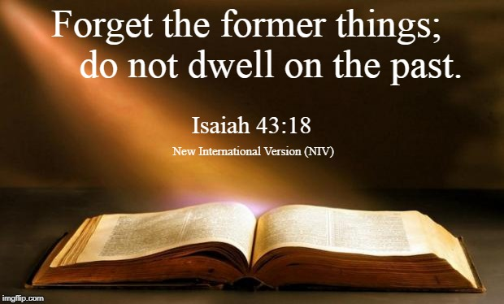

**THOSE ASSISTING IN CREATING OUR SERVICE:**

**Musicians: Jenny Claybaugh, Jane Wildermuth**

**Sound/Video: Andy Wildermuth, Kathy Berg**

**Online: Tracey Notestine, Sandy Shaner**

[***http://www.facebook.com/LewistownTrintyUnitedMethodistChurch***](http://www.facebook.com/LewistownTrintyUnitedMethodistChurch)

***Church Office email: ltumc8088@gmail.com***

**Ushers: Don Lewis, Bill Fulton, Denny Stryker, Lynn Snipes, Mike Brunson, Jason Brunson**

**Please send Bulletin Insert information to Lorna Brunson.**

**Internet Prayer Chain: Lorna Brunson—doone533@gmail.com**

**All-Call Prayer Chain: Julia Armstrong—Call her at 937-844-7964**

***Please use WIFI setting for the Community Center while we are worshipping there.* Internet login: TPLink_70B0. Password is 15310477. *We apologize for any inconvenience in connecting. Please don’t use your internet during worship. It slows down our Facebook feed.***

**Adult Sunday School Class Leader/Lay Leader: Mary Fulton**

**Sunday School Superintendent/VBS/God’s Team: Diane Lewis**





***Forgetting the Past!***

**October 12, 2025**

*Thank You for Choosing to Worship Christ*

*with Us Today!*

**LEWISTOWN-TRINITY UNITED METHODIST CHURCH**

**In-Person Worship Service – 11:00 – 8088 CR 54, Lewistown**

**Address: P.O. Box 90, Russells Point, Ohio 43348**

**Worship with us on Facebook**

***http://www.facebook.com/LewistownTrintyUnitedMethodistChurch***

**Rod Brower, Pastor**

**His Contact Info: 740-727-9999 –** [**pastorrodb@gmail.com**](mailto:pastorrodb@gmail.com)

***Know Christ! Grow in Faith! Serve Others!***