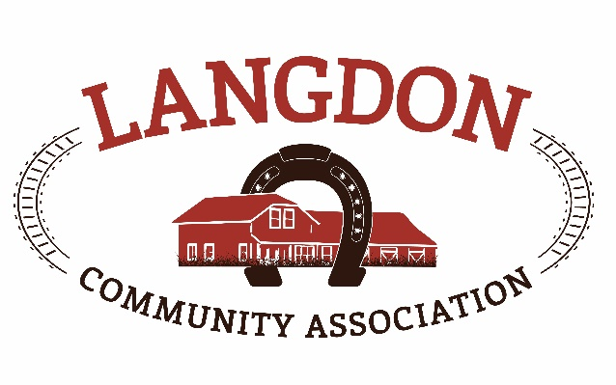
Langdon Community Association
Box 134
Langdon, AB T0J 1X0
www.goodlucktown.ca

LCA Meeting – January 17, 2021
Location: Teams Call

In Attendance:
Chrissy Craig – Chair
Jessica Smythe – Vice Chair
Tom Craig – Capital Projects
Nicole Porquet-Seitz – Director
Crystal Upstone – Events
Brian Ferguson - Treasurer
Corrie Carrobourg – Director
Nicki Black – Secretary
Heather Miller - Fiedlhouse
Dave Miller
David

Meeting called to order at 1933

- Approval of Agenda:
  - Motion to approve the agenda with additions: Heather and Corrie
- Approval of Minutes:
  - Motion to approve the minutes from December 6, 2020: Jessica & Nicole

- Reports See Below reports
Next LCC meeting – February 21, 2021, 6:30 – 7:30pm, before LCA meetings.

- Standing Business
  - Tasks review – reviewed and updated
  - Risk Management – by laws to be approved at AGM in March and policies will be reviewed at next meeting.
  - Succession Planning –link sent to member to update in Sharepoint.
  - Education – Online Federation of Calgary Communities resources and education class for new board members or new board positions. Courses have been sent out and free to register. Chrissy will forward current courses available.
  - Strategic Planning – details sent to board for review
  - Langdon Community Campus – Waiting on RVC Rec Master plan. Currently does not show centre to include ice surface. Unlikely to be on the new diamonds until June, grass needs to be established. Tom has requested a copy of the deficiency plan to keep tabs on the progress. Tennis court bid went out for the design scope and build. Good response with 5 bidders showing interest. David would like to volunteer and help guide and advise when dealing with contracts and building, etc. Bids are due January 22, 2021.
  - Newsletter content – use content from previous meeting notes.

- Discussion
- Accountant – current accountant has gone back 7 years and got all accounting up to date for filing taxes. Tax deadline will be June 30th each year. Quote for $1000 + gst to prepare and submit 2020 taxes. Accountant is aware of grants available and will advise and guide accordingly.
- Sponsorship package – sent out with agenda for members to review. If anyone has any updates or changes, please send them to Chrissy. Two businesses have already shown interest to donate and sponsor for this year.
- LCA / LRC Merger – The LRC’s mission was to build a rec center with ice in the community. They currently only have two members and are looking to merge with the LCA. The LRC is a registered charity. Should we merge, both organizations would form a new entity and keep the charitable status vs the LCA’s non-profit. We will still be able to run as we currently do and take on the same tasks and community activities. The merged organization would qualify for more grants and would be able to issue receipts for donations. This would involve more paperwork that accountants would be able to cover. The merger would need to be handled by a professional and the LRC would apply for a grant to cover those costs. Need board approval to start the process.
- Project List for 2021 – new Fieldhouse front doors (current safety concern), paint interior of FH, paint / stain pergola and fence, repair chain-link fence around rink, look in to wear and tear of FH decking, deck hand rail to be replaced (warranty). List to be made readily available.
- Fieldhouse Cleaner – nothing currently in place as contract was broken when AHS closed community spaces. Approach Diane to see if she would be available to return on opening and have clear contract in place.
- AGM – date changed from March 7th to March 14th at 7pm.
- Memberships – memberships currently do not bring in any revenue and we are not looking at it to be a source of revenue going forward. We however do require membership numbers, especially when applying for grants and sponsorships. All families that belong to any user groups should pay a $5 membership for the year.
- Library update – the town of Cereal, AB has shut down their library and are generously donating its contents (books, shelves, computers, etc) to Langdon. In order to do so a formal and registered Langdon Library Society has been formed by various community members to take this all on. A business case has been created to present to RVC in a special meeting. Various locations are being considered, with one main one being the soon to be old fire hall. One concern is that a “super net” required for the computers in the library, and not sure if this will be available in town. Any interest to volunteer or be involved, please contact Corrie.
- Motions
  - Approved by email – none
  - Approved at meeting – Motion to have memberships set at $5 per family and will be a new requirement for registrations and booking of the facilities – Jessica, second Tom and all in favour.
  - Approved at meeting – Motion to start the process to look in to the merger of the LCA and LRC to see if it would be beneficial - Jessica, second Corrie and all in favour.
  - Approved at meeting – Motion to approve paying the accountant his quoted amount of $1000 + gst to file the LCA’s 2020 taxes – Chrissy, second Jessica and all in favour.

Adjourned 2054h

Reports
Events report –
Funds development report –
Communication report –
Parks report – Rink is running well and waiting for another cold snap to flood again.
Program report –
Fieldhouse report –
Capital Projects Report –
Bingo Report –

Future Meeting (calendar invites sent to your goodlucktown.ca emails)
All meetings at 730pm at The Fieldhouse unless noted

Next meeting February 21, 2021

