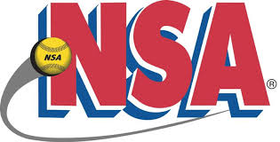 NSA Mr Freeze Tournament 
Plex South-Ft Wayne, IN
January 12-13, 2019

18u Pool

- Ft Wayne Lady Spiders 1-1-0 (6)
- NW Ohio Heat Nation 1-1-0 (1)
- GR Diamonds 1-1-0 (4)

Sat 1:00 PM Field #2 Ft Wayne Lady Spiders vs NWO Heat Nation 1-0
Sat 2:15 PM Field #2 Ft Wayne Lady Spiders vs GR Diamonds 5-0
Sat 3:30 PM Field #2 NWO Heat Nation vs GR Diamonds 4-0

All pool games are 60 minutes, drop dead, revert back if not a complete inning

The 18u tournament will include a double elimination bracket

