Grand Water and Sewer Service Agency

Request for Proposals – Chlorination Equipment

Objective

Grand Water and Sewer Service Agency (GWSSA) is seeking proposals from qualified entities to supply and install new chlorination equipment at two locations in its culinary water system. The new systems are needed to replace existing systems at these locations. Proposals will include all necessary equipment, installation, integration coordination, startup, and operation and maintenance materials for two complete chlorination systems.
Further details on the scope of work, system characteristics, and proposal requirements are provided in the following sections.

Scope of Work

The selected vendor will provide and install two complete chlorination systems replacing existing chlorinators at two locations in the culinary water system. The existing systems are on-site generation. The following types of systems will be considered:
- On-site generation
- 12.5% sodium hypochlorite
- Calcium hypochlorite
Gas chlorine systems will not be considered for these sites.
Vendor shall supply all components needed for complete and functioning systems, assuming no components of the existing chlorinators can be utilized. New systems shall also include analyzers, new tanks, and containment.
Vendor shall be responsible for complete installation of the new systems. This includes disassembly and disposal of the existing systems. Vendors will be responsible for startup of each system and will coordinate with the owner’s SCADA integrator to incorporate data and control signals from the new systems to the owner’s SCADA equipment.
Vendor shall also provide operation and maintenance materials to the owner, including material safety data sheets for raw materials owner will deal with.
Vendor shall provide spare parts for key components of the systems.

System Characteristics

The new chlorinator systems will replace existing systems in the George White Well building and the Chapman/Spanish Valley Well building. Characteristics of each of these systems are outlined below. Water from these sources has no chlorine demand. Dosing will typically be limited to the amount required to achieve a residual of 0.6 ppm but must be able to meet state requirements at the flow rates indicated.
The George White Well building chlorinators treat water from George White Well #4 and George White Well #5. The chlorinator here must be able to accommodate flow rates from 500 gpm to 1,750 gpm. The existing chlorination equipment at the George White Well building is shown in Figure 1 below. The chlorination room pictured has inside dimensions of 9’x 10’.

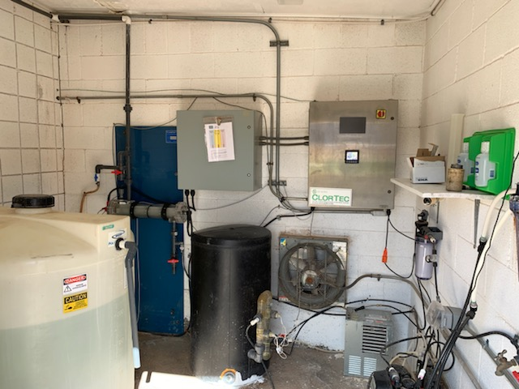

Figure 1 – George White Well Building

The Chapman/Spanish Valley Well chlorinators treat water from the Chapman and Spanish Valley wells. The chlorinator here must be able to accommodate flow rates from 200 gpm to 1,800 gpm. The existing chlorination equipment at the Chapman/Spanish Valley Well building is shown in Figure 2. The chlorination room pictured has inside dimensions of 11’x22’.

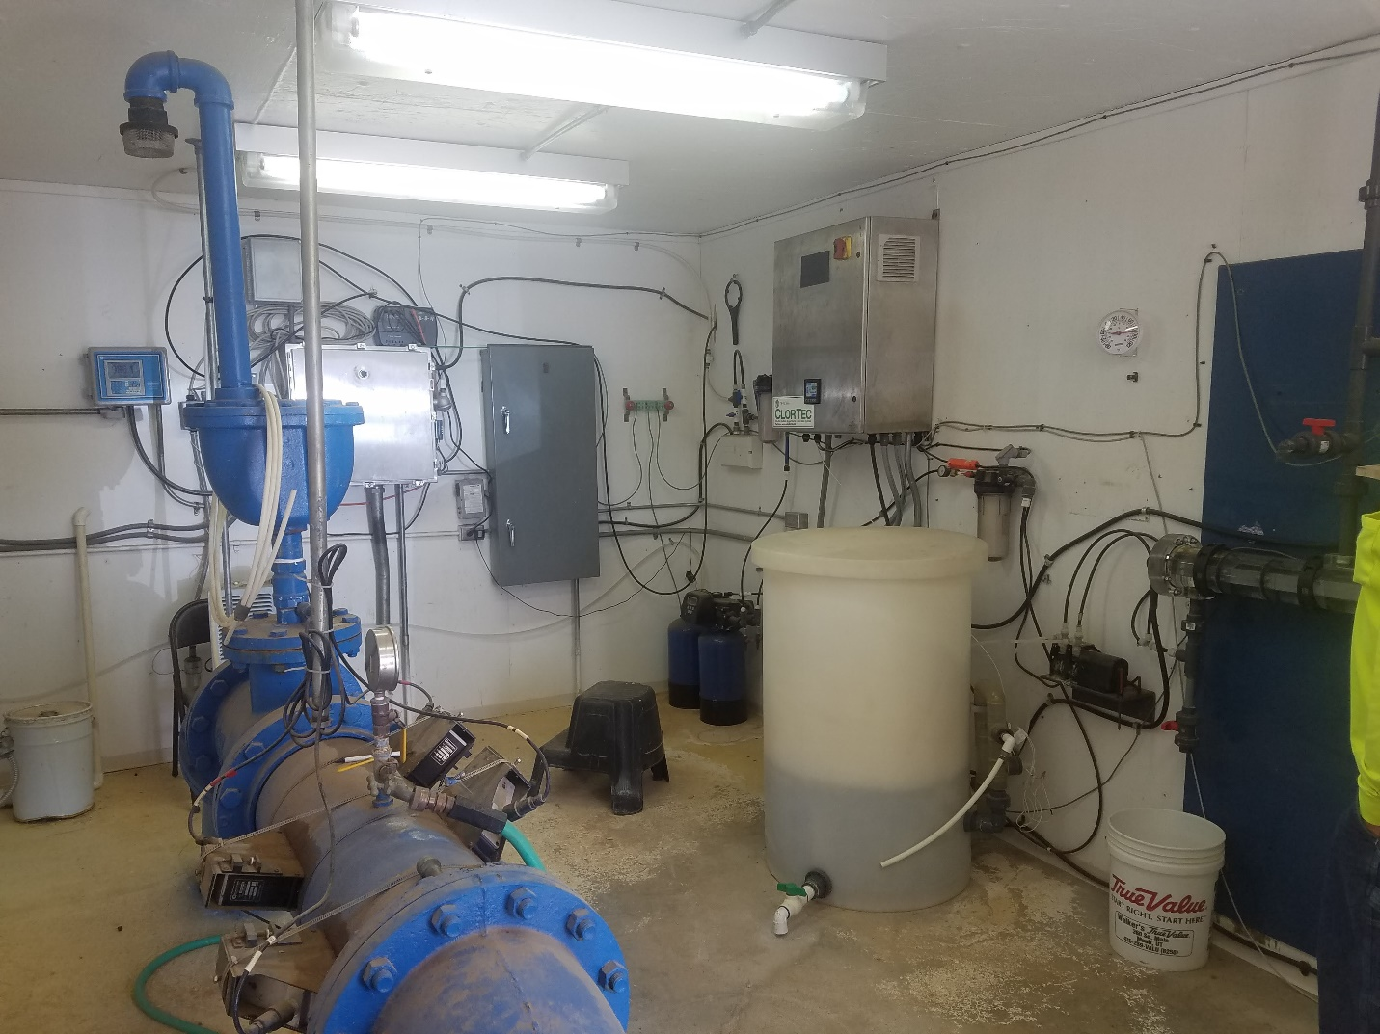
Figure 2 – Chapman/Spanish Valley Well Building

For the purposes of this proposal, total annual water demand will be 365 million gallons for each of the next ten years.
All components typically included in SCADA I/O must include 4-20 mA inputs and outputs to allow for continuous remote monitoring and control.
Further questions on system conditions will be addressed up until one week prior to the proposal deadline.

Proposal Requirements

Proposals shall address each of the following items:
Proposed Equipment –
Each proposal shall include detailed descriptions of all the equipment to be provided and installed by the vendor. This will include both major and minor components, i.e. pumps, tanks, containment, control panels, wiring, piping, etc. This section should also include a list of similar installations in the area or elsewhere with operator references for each.
Initial Costs –
Proposals must include detailed breakdowns of all initial costs for each new system. This will include equipment, installation, startup, any required testing, instrumentation and controls integration, and an initial supply of chemical to run the system for a minimum of 6 months. Initial costs must also include removal and disposal of the existing systems. All initial costs, whether or not specifically noted here, must be included in this section.
Projected 10-year Operating Costs –
All proposals must detail typical annual operating and maintenance costs for each of the next ten years. This will include chemical supplies, replacement parts and equipment, regular/scheduled maintenance, and an allowance for service calls based on typical system performance. Projections will be based on the system characteristics identified in the previous section.
Typical Operation –
Proposals should address typical day-to-day operation for the proposed chlorination systems. This should address everything that operators will need to do to keep the systems going and mitigate risk of failures. This section should address whether the systems include proprietary parts or processes that require exclusive replacement parts or service personnel. Ease of operation is key to the success of these systems.
Schedule –
Each proposal should include an anticipated schedule for when each system could be operational. Schedule should detail lead time on equipment, removal of existing systems, installation of the new systems, and controls integration. Minimal downtime is crucial and preference will be given to proposals that minimize outages in the high demand times.
Sealed proposals will be accepted at the Grand Water and Sewer Service Agency office at the following address:
GWSSA
3025 E Spanish Trail Road
Moab, UT 84532

The selection panel will review proposals and score each for the categories outlined. Reviewers will score each proposal from 1 to 5 in each category. The highest scoring proposal will be selected.

Vendor | Initial Costs | 10-year Costs | Typical Operation | Schedule | Total
A
B
C
D

There will be a mandatory pre-proposal meeting and site tour at the Grand Water and Sewer Service Agency office at 2:00 pm on March 31, 2020.

Proposals will be accepted up until 5:00 pm on April 13, 2020. Deadline for questions is 5:00 pm on April 7, 2020.

