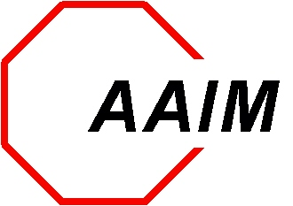

Alliance Against Intoxicated Motorists
Woodfield Grove, Suite 131 870 East Higgins Road Schaumburg, IL 60173
(847) 240-0027 Toll free (888) 240-0027
Fax (847) 240-0028 www.aaim1.org

Summer 2017

Dear Friend of AAIM:

The Alliance Against Intoxicated Motorists is hosting its 27th annual benefit on Saturday, October 21, 2017. Proceeds from the benefit help support AAIM’s Victim Assistance Fund.

Every year AAIM invites defendants to share their story regarding the tragic choice they made to drink and drive and how that choice changed their life and the lives of others. We encourage you write your story in 500 words or less and return it to the AAIM office by Monday, September 25, 2017. If your story has been published in our benefit book in the past, we understand the story has not changed; however, please take the time to update the story and your journey through this difficult time. Please return your story to the AAIM office by the deadline date.

If you have access to a computer, you may e-mail your story directly to info@aaim1.org.

Warm Regards,
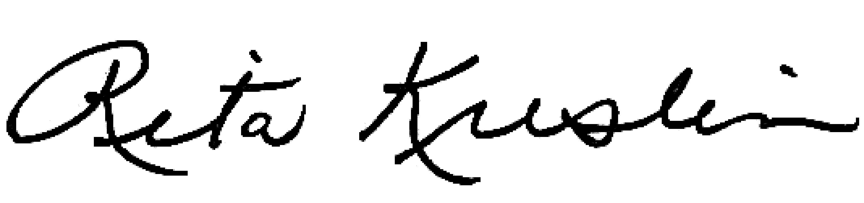

Rita Kreslin
Executive Director

