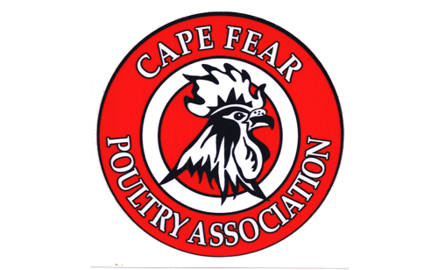
CAPE FEAR POULTRY ASSOCIATION
MEMBERSHIP FORM

DATE__________________________________

MEMBERSHIP STATUS: ______ACTIVE/PARTICIPATING _______SUPPORT OF CLUB

FIRST NAME__________________________________________LAST NAME______________________________________

ADDRESS: ____________________________________________________________________________________________

CITY: ______________________________________________________ STATE: ___________ ZIP: __________________

HOME PHONE: ___________-____________-_________________ CELL: ___________-____________-___________

E-MAIL: ______________________________________________________________________________
DO YOU WISH TO RECEIVE EMAILS ______ YES ______ NO
** SIGNATURE: _________________________________________________________________________________
**By signing you give CFPA permission to share your e-mail and or phone #’s with other members,
show exhibitors, and to post club pictures on our Facebook page and Club website.

SPONSORED BY: _________________________________________________________________________________________

SPOUSE OR SIGNIFICANT OTHER (IF APPLICABLE) __________________________________________________________

CHILDREN UNDER THE AGE OF 18
NAME DATE OF BIRTH

___________________________________________________ ____________________________

___________________________________________________ _____________________________
___________________________________________________ _____________________________

WHAT TYPE/BREEDS OF POULTRY DO YOU NOW OWN? ________________________________________________

_____________________________________________________________________________________________________

_____________________________________________________________________________________________________

WHAT TYPE/BREEDS OF POULTRY DO YOU WANT IN THE FUTURE? _____________________________________

_____________________________________________________________________________________________________

MEMBERSHIP DUES ARE: $20.00 PER YEAR FOR FAMILY. $12.00 FOR INDIVIDUALS.
JUNIOR (NOT IN A FAMILY MEMBERSHIP) DUES ARE $8.00 PER YEAR UNTIL AGE OF 18.
ALL MEMBERSHIPS ARE RENEWABLE BY JANUARY 1ST EACH YEAR

PLEASE MAKE CHECK OR MONEY ORDER PAYABLE TO CFPA
MAIL TO: CFPA c/o Donna Worthington, 118 Kincalf Lane, Macclesfield, NC 27852

