**ARE YOU READY!!!!!**

**LABOR DAY WEEKEND**

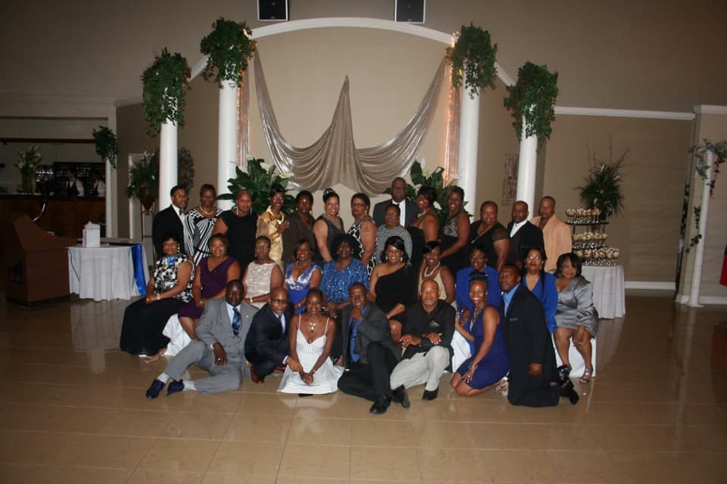

**FRIDAY, AUGUST 30, 2019**

**THRU**

**SUNDAY, SEPTEMBER 1, 2019**

**THE EVENT OF THE CENTURY**

**40TH**

**YEAR**

**\*\*\*CLASS REUNION\*\*\***

**\*\*\*MCKINLEY CLASS OF 1979\*\*\***

**MCKINLEY CLASS OF 1979**

**40TH YEAR REUNION ITINERARY**

**Friday, August 30, 2019**

**1:00 PM – Campus Tour & Photo in front of the school**

**McKinley High School**

**\*\*\* WE ARE ASKING EVERYONE TO PLEASE WEAR THEIR ROYAL BLUE CLASS POLO. IF YOU DO NOT HAVE THE ROYAL BLUE POLO PLEASE WEAR MCKINLEY ATTIRE\*\*\***

**3:00 PM – Tour of Alumni Center**

**8:00 PM - 12:00 AM – MEET & GREET (CLASS MEMBERS ONLY)**

**THEME: 70’S – “WE’RE GONNA PARTY LIKE IT’S 1979”**

**\*\*WE’RE BRINGING THE 70’S BACK\*\***

**LOCATION: ANY OCCASIONS BANQUET HALL**

**10565 FLORIDA BOULEVARD**

**BATON ROUGE, LA 70815**

**\*\*DRESS ATTIRE** - 70’S – (WE ARE ASKING EVERYONE TO COME DRESSED IN THEIR 70’S ATTIRE)**

**It’s time to pull out the….. BELL BOTTOMS, GAUCHOS, PLATFORM SHOES, POLYESTER LEISURE SUITS, AFROS, MOOD RINGS, LARGE HOOP EARRINGS……FOR A BLAST FROM THE PAST….**

**\*\*\*COME TAKE A TRIP WITH US\*\*\***

**THERE WILL BE PRIZES FOR THE BEST DRESSED, MOST ORIGINAL ATTIRE…….**



**MCKINLEY CLASS OF 1979**

**40TH YEAR REUNION ITINERARY**

**Saturday, August 31, 2019**

**REUNION BANQUET**

**“PROM NIGHT”**

**THEME: “A MOMENT BACK IN TIME”**

**TIME: 8:00 PM– 12:00 AM**

**LOCATION: MCKINLEY ALUMNI CENTER**

**BATON ROUGE, LA**

**ATTIRE: SEMI-FORMAL**

**\*\*\*DRESS TO IMPRESS\*\*\***

**(NO BLUE JEANS OR TENNIS SHOES)**

**THERE WILL BE A PROFESSIONAL PHOTOGRAPHER ON SITE CAPTURING THE MOMENTS!!!**

**COST:**

**8x10 - $20.00**

**5x7 - $10.00**

**\*\*\*PAYMENTS CAN BE MADE VIA CASH, DEBIT OR CREDIT CARDS AND CASH APP\*\*\***

**\*\*\*NO PERSONAL CHECKS WILL BE ACCEPTED\*\*\***

**MCKINLEY CLASS OF 1979**

**40TH YEAR REUNION ITINENRARY**

**Sunday, September 1, 2019**

**CHURCH**

**&**

**FAMILY PICNIC**

**THEME: “WE ARE ONE”**

**CHURCH: New Ark Baptist Church**

**1344 Terrace Street**

**Baton Rouge, La**

**Breakfast will be served at 8:00 am**

**Service begins at 9:30 am**

**\*\*\*\*You may wear whatever you choose to church\*\*\*\***

**PICNIC:**

**Location: Johnson Courtyard**

**5055 Hollywood Street**

**Baton Rouge, La**

**PLEASE WEAR YOUR REUNION SHIRT. WE WILL BE TAKING OUR CLASS PICTURE PROMPTLY AT 2:00 PM. WE ARE ASKING EVERYONE TO PLEASE BE THERE NO LATER THAN 1:30!!!**

**COST:**

**8x10 - $20.00**

**\*\*\*PAYMENTS CAN BE MADE VIA CASH, DEBIT OR CREDIT CARDS AND CASH APP\*\*\***

**\*\*\*NO PERSONAL CHECKS WILL BE ACCEPTED\*\*\***