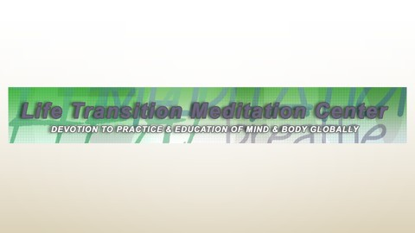
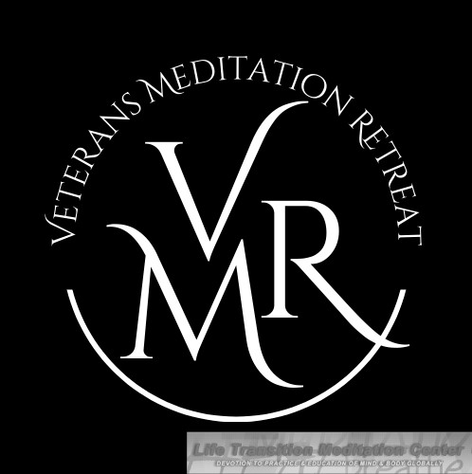
For Veterans By Veterans

LIFE
TRANSITION MEDITATION CENTER

NO FEE !! EVERY VETERAN FULLY FUNDED!
There is no cost to the Veteran, transportation to and from The Clyde and all accommodations are paid for from generous donations and grants.

ALL VETERANS WANTED!
All veterans are welcome regardless of discharge status, gender, ethnicity, Two-Spirited, and LGBTQIA+

DETAILS TO APPLY
Go to the website and email or download the application to participate in the Veterans Meditation Retreat.

PLANNING YOUR TRIP
Once your application is submitted the Veterans Meditation Retreat (VMR) Volunteers will work with you to plan your trip to The Clyde Hotel.

SCAN FOR RETREAT APPLICATION

FOR MORE INFO, CONTACT US
VETERAN MEDITATION RETREAT

WHEN: October 13-16
WHERE: The Clyde Hotel in Albuquerque, NM WHY: To introduce Meditation healing tools

Phone Number
505-982-4183
Email Address
info@lifetransition.com
Website
lifetransition.com

