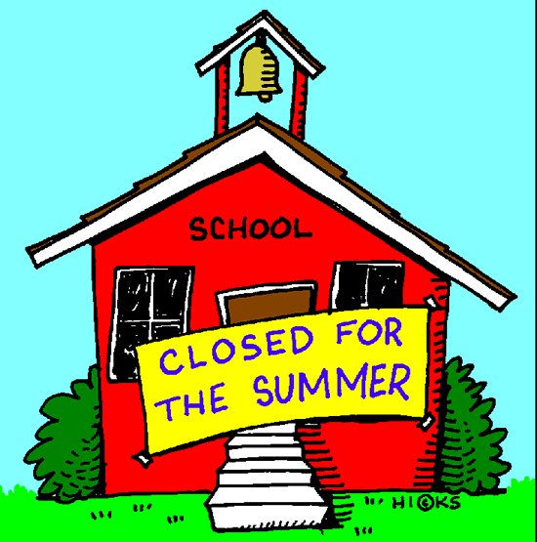

June 14, 2019

Dear Parents:

Dismissal was at 11:30 today. It's been a busy school year. Graduations have come and gone once again. Now as always, we get a chance to recharge those batteries over the summer and enjoy the summer sunshine and warm summer breezes.

Before dismissal today, we held our final Awards Ceremony recognizing those students with Perfect Attendance and Honors in Academic Achievement.

In the next week or two, please be on the lookout for your child's Summer Reading list found on our website www.saintpaulschoolcranston.org

Once again we will be having our Open House for everyone on Tuesday, August 27 from 9:00 - 2:00 for any new or existing parents along with their child who will be attending who wish to stop in to meet with their child's teachers from Pre-K to Grade 8. With the 1st full day of school starting on Wednesday, August 28, this would be a wonderful opportunity to review what will be expected of them throughout the school year. If you cannot come at this time, you can always schedule a meeting with your teacher at anytime if you have any concerns or questions (or at our all-day Parent/Teacher Conferences on Wednesday, October 2).

Both Mrs. Sanberg (Mrs. Keane will be away) and I will be here on limited hours throughout the summer on Monday-Tuesday & Wednesday's from 9:00-2:00 starting on Monday, June 24. Each of us will be taking some days off so please check the school calendar on our website or call ahead just in case you were thinking of stopping by.

I'll be sending out a Welcome Back letter sometime in August going over more details on the school year ahead-such as our Open House, etc. As for now, let's just relax and enjoy summertime in Rhode Island!

Mr. Corry

