ActiveCaptain visited Newark on August 2nd. The ActiveCaptain database has one goal in mind - provide a place where boaters can freely share information. Please check out their website at activecaptain.com.
There are now 100,000 boaters accessing the ActiveCaptain data. Marina data, reviews, local knowledge, anchorages, and hazards are being added and updated a thousand times a day.
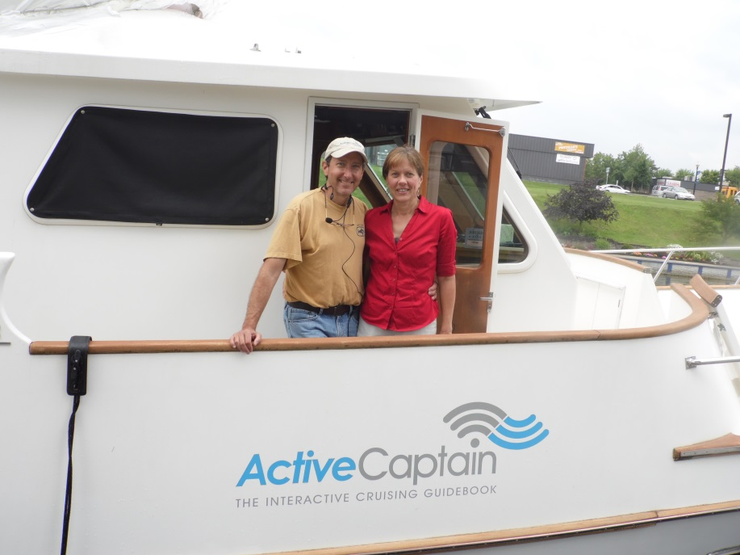
Jeffrey and Karen Siegel on “ActiveCaptain” docked at Port of Newark,

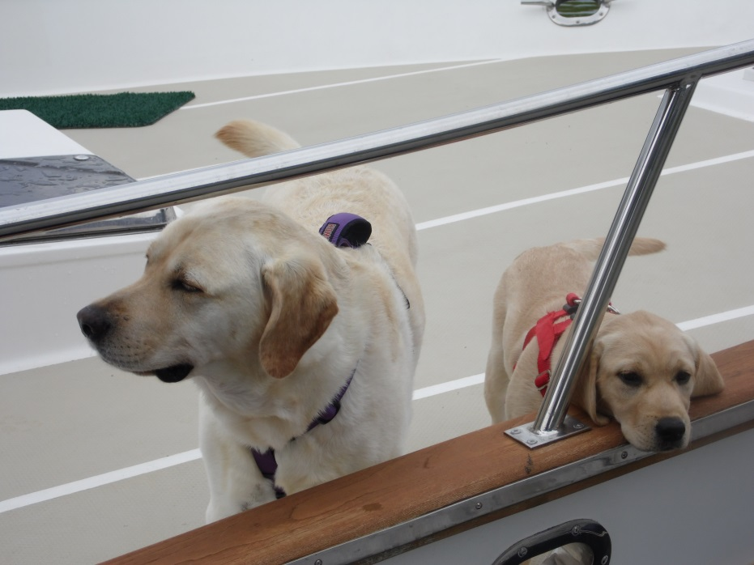
Crew members Dee Dee and Dylan say “hello”.

