RSAI 2020
Legislative Digest
September 2020

About RSAI
Visit the RSAI home page to find out more: www.rsaia.org
The Rural School Advocates of Iowa began our advocacy journey in January, 2013, bringing together school leaders into an organization with the specific charge to collaborate and promote legislation that strengthens rural education for students, by building a voice for students and educators in Iowa. RSAI advocates for students in rural schools to assure a fair, equal and quality education. This group of over 100 member districts continues to grow in both size and relevance.
RSAI is comprised of four quadrants of the state, known as the SE, SW, NE and NW regions. Each elects a representative to the RSAI Leadership Group and to the RSAI Legislative Group.
RSAI is recognized as a state affiliate of the National Rural Education Association: www.nrea.net
RSAI Leadership Group and Terms
NW: Bob Olson, Clarion-Goldfield/Dows, Superintendent, robert.olson@rsaia.org (Retired June 30, 2020) Thanks to Bob as an original founder of RSAI, active in leadership since 2013.
NW: Justin Daggett, Manson NW Webster, Superintendent, jdaggett@manson-nw.k12.ia.us (Sept. 2023)
SE: Laurie Noll, Fairfield, Superintendent, laurie.noll@fairfieldsfuture.org (Sept. 2023)
NE: Nick Trenkamp, Central, Superintendent, nicholas.trenkamp@rsaia.org (Sept. 2021)
SW: Paul Croghan, Nodaway Valley & CAM Superintendent, paul.croghan@rsaia.org (Sept. 2022)
Dan Peterson*, Central Dewitt Superintendent, dan.peterson@cd-csd.org (Sept. 2021)
Dennis McClain*, Clay Central Adair Casey/Guthrie Center, Superintendent, dmcclain@acgcschools.org (Sept. 2022)
Duane Willhite*, North Fayette Valley, Superintendent, dwillhite@nfv.k12.ia.us (Retired June 30, 2020) At-large seat vacant, to be elected at Oct. 21, 2020 annual meeting

RSAI Legislative Group (one-year term without term limits) supports RSAI’s policy development and advocacy! includes at large members above * plus:
SW – Tim Mitchell / Riverside Superintendent reappointed for 2021
NE – Barb Schwamman / Osage and Riceville Superintendent reappointed for 2021
SE – Joel Pedersen / Cardinal Superintendent reappointed for 2021
NW – Scott Williamson / Laurens Marathon, Sioux Central, Clay Central Everly Superintendent (2020)
NW - Brian Johnson, Prairie Valley & Southeast Webster Grand Superintendent (2021)

Professional Advocates
Margaret Buckton, margaret@iowaschoolfinance.com, (515) 251-5970 Ext. 1
Dave Daughton, dave.daughton@rsaia.org, (641) 344-5205
Additional RSAI Member Benefits

RSAI offers additional member benefits, such as free licensure checks for prospective or current employees through the National Association of State Directors of Teacher Education and Certification, NASDTEC, Clearinghouse. The Iowa Department of Education School Leader Update, June 2018, explains the value:
“Why is the Clearinghouse important? Since most adverse actions taken against an educator’s certificate are not prosecuted as criminal offenses, the educator's misconduct will not show up in a traditional criminal background check. By including the NASDTEC Clearinghouse in its screening of certified and non-certified applicants, a school district can make fully informed hiring decisions.”

Corporate Sponsors


Special thanks to BoardWorks, Inc., for supporting RSAI members via corporate sponsorship in RSAI. In addition to financial support for sponsor membership, BoardWorks also provides their engaging and interactive content/instructional lesson support to RSAI member districts at a discounted rate. Contact jen@iowaschoolfinance.com to learn more. Visit the BoardWorks website at www.boardworkseducation.com.

Collaborations
RSAI is a member of the Iowa Rural Development Council (IRDC). IRDC’s mission is to advance the interests of rural Iowa through strong partners and collective resources. Learn more at www.iowardc.org.

Table of Contents

About RSAI, Leadership and Legislative Group Members Page 2
RSAI 2020 Legislative Priorities & Status Page 5
Legislative Session Approval and Veto Process Page 8
Executive Summary: 2020 Session in Review Page 9
Revenue Projections and Taxes Page 10
Funding Formula History Resource Page 18
National Rural Education Association (NREA) Page 18
Tax Bills Impacting State or Local Revenue Page 19
Significant Appropriations/School Funding Acts Page 20
Policy Bills Impacting Schools Page 30
Governor’s Proclamations Impacting Schools Page 39
Links to the Governor’s Disaster Proclamations Page 40
ISFIS Memo on COVID-19 Metrics Page 42
Near Misses and Concerns Page 60
2020 RSAI Priorities and Position Papers Page 65
Advocacy and Other Legislative Resources Page 69
DE Reports Page 69
Bill List – Index by Bill Number Page 72

RSAI 2020 Legislative Priorities & Status
The following 2020 Legislative Priorities originated as key priority issues during the 2019 Summer RSAI Regional meetings. The Legislative Group reviewed and refined the Regional meeting activity, then submitted this language to the RSAI members at the annual meeting. The members at the annual meeting approved the following slate of priorities on Oct. 16, 2019. The RSAI 2020 Annual Meeting is scheduled for Oct. 21, 2020, at the FFA Enrichment Center, DMACC Ankeny Campus, 4:30 p.m., including a working dinner. An electronic option will be available. See the RSAI website meeting tab for more information: http://www.rsaia.org/

Key:
Mission Accomplished

Some Action, but More is Needed

No Progress Made

Status of this year’s activity is summarized:
SF 2142 was approved by 51 House members with 46 voting no and the Senate passed it on March 9, 31:17, sending it to the Governor (signed on March 12). Set the SSA at 2.3% for FY 2021, second highest increase in 11 years, yet below the RSAI ask of 3.75%. When Session reconvened after COVID closure, RSAI requested the 2.3% remain intact, and it did.
- Adequate School Resources: RSAI supports adequate base funding. The increased per pupil cost known as SSA is especially critical to rural students due to economies of scale, distance from school/opportunities, mandates, the need for AEA support, and the ability to attract and retain staff. Rural schools depend on an investment of meaningful new resources to prepare students for a successful future. The rate of increase in SSA should be no lower than anticipated growth in state revenue (adjusted for legislated tax cuts), should keep up with other economic factors such as personal income or state gross domestic product over the long term, should maintain a balance of state and local property taxes, provide predictability, and be set timely to assure adequate notice for budget planning and staffing. The SSA rate for the 2020-21 school year should be set no lower than 3.75%, if the revenue adjustment controlling for tax cuts is lower than 3.75%.
SF 2164 was approved, passed the House 98:1 and passed the Senate 48:0. The bill provides an increase of $7.3 million compared to FY 2020, bringing the transportation total to $26.3 million. Adds $10 to the minimum State Cost Per Pupil to close the gap to $155, at an estimated increase in State school aid of $5.3 million and a decrease to property taxes of $3.6 million. In prior years, the gap was closed by $5 per pupil. RSAI requested an accelerated approach which they delivered.

- Formula and Transportation Equity: RSAI supports formula and transportation equity. The Legislature should accelerate the commitment to close the $165 gap between the state and district cost per pupil within ten years and continue transportation equity support, bringing down all districts to no more than the state average per pupil transportation cost, without requiring burdensome reporting requirements from school districts.
- Educator Shortage and Quality Instruction: RSAI supports maximum flexibility to hire staff to provide great instruction and support to all Iowa students. RSAI supports: 1) district flexibility to meet offer and teach requirements, 2) teacher or other staff shortage loan forgiveness programs and incentives to encourage staff to work in rural schools, 3) a special education generalist credential to teach special education across all grades, 4) creation of a Public Service strand in Iowa’s CTE system to prepare Iowa’s future teaching workforce, 5) continued state support of Iowa Learning Online (ILO), 6) flexibility to hire retirees without a negative IPERS impact, 7) elimination of barriers to licensure for teachers and administrators, and 8) allow associate degree for substitutes. The BOEE should accept evidence other than strict transcripts to show skill mastery for administrators from other states.
HF 2629 Future Ready Workforce provides for computer science which may be delivered exclusively online.
SF 2310 Online Learning allows financial literacy, world languages and computer science taught exclusively online under certain conditions. Also allowed use of federal funds for AEA online learning program.
HF 2359 Praxis test eliminated as an entrance exam to enroll in a college teaching program.
HF 2454 allows AA degree for some CTE teachers.
BOEE Admin. Rules allowed for AA degree for substitutes. Governor’s declaratory order expanded that flexibility.
HF 2627 requires licensure reciprocity with other states with 1 year of experience.
- Student Mental Health: RSAI supports increased access to and funding for mental health services for children. In addition to adequate funding for AEA services and access to other service providers, an array of services should also include telehealth services received at school. The state, Medicaid and insurance providers should not pass on administrative or billing work to schools, and schools should not be mandated to be providers of mental health services for children.
SF 2261 Telehealth Services in schools creates a process for delivery of services without the school being in the bill processing role.
SF 2360 Classroom Management/Therapeutic Classrooms mirrors federal law in Least Restrictive Environment and sets up a grant process for additional therapeutic classrooms.

- Opportunity Equity for Low SES: RSAI supports resources for at-risk students. Resources should be based on need, such as the percentage of students eligible for Free and Reduced Price Lunch (FRPL), in addition to enrollment of the district. The current disparity in dropout prevention capacity, (some districts held to 2.5% and others allowed to access up to 5% of regular program district cost) is arbitrary, based on history no longer relevant to supporting student needs. All school boards should be able to realize the full 5% dropout prevention funding. The formula must further recognize the disproportionate cost of providing equal educational opportunities to low-income students. School districts should be granted spending authority for FRPL eligible students’ fees mandated to be waived by state and federal law.
Despite the School Finance Interim Committee recommending and the House Education Committee approving a bill, HF 2490, the study of the impact of poverty on education and funding formula options to meet the needs of students did not advance out of House Appropriations Committee. A bill also approved in the House Education Committee, HF 2497, would have allowed SBRC to grant spending authority up to 5% for Dropout Prevention (DoP), but died in the House Appropriations Committee. Bills were introduced in both chambers to begin the conversation with the House carrying them further along the way than in the Senate.
- Sharing Incentives and Efficiencies: Rural students benefit from opportunities to achieve efficiencies, share capacity to operate, and redirect resources to educational programs. Whole Grade Sharing Incentives and Reorganization Incentives should be extended and Operational Sharing Incentives expanded, including the addition of a school resource officer position (SRO) to generate weighting, to provide capacity to school districts to improve educational outcomes for students.
Although the Gov.’s Future Ready Workforce bill originally added a work-based learning coordinator position for operational sharing, it was removed from the final version of the bill. RSAI was also asking for SRO position to be added.
- Quality Preschool: RSAI supports full funding of quality preschool. Due to changing demographics in rural Iowa, significant transportation costs, and lack of quality day care access, preschool should be fully funded at the regular student count at 1.0 per pupil cost, rather than 0.5 student weighting.
HF 2460 would have allowed districts to serve and count young 5-year-olds in PK, was approved by the House Appropriations Committee, but did not get approval of the full House.
- School Safety: Rural schools need the resources, training and support necessary for Iowa student and staff safety at school, including additional funding for security personnel and training to protect against active shooter and other emergency situations presenting harm.
SF 284 would have added School Resource Office (SRO) position to operational sharing, but did not move forward. SF 2155 would have allowed additional ISL funds to pay for one SRO per district, although approved in the Senate Education Committee, did not advance out of the Senate Ways and Means Committee.
- Bonding Capacity: RSAI supports a simple majority, 50% plus 1, voter approval for school bond issues.
No positive action except defeat of a proposal to limit bond issue elections to the November school board election which failed to advance in the House Local Government Committee.

Key:
Mission Accomplished
Some Action, but More is Needed
No Progress Made

Legislative Session Approval and Veto Process
The 2020 Legislative Session drew to a close on June 14, 2020, after a long hiatus due to Corona virus that closed the statehouse from March 16 through June 3. Although 2,067 bills were introduced in the Iowa Legislature this Session, 169 pieces of legislation made it to the Governor’s desk.
This Digest details legislation enacted by the 2020 Legislature and signed or vetoed by the Governor. The 2020 Session is the second of a two-year biennium of the 88th General Assembly, with an election in November 2020 pending. The information section of this digest includes position papers on issues of key interest to Iowa schools that guided RSAI advocates during the Session. RSAI encourages members to share these resources with candidates on both sides of the political spectrum during the Interim and leading up to the election.
Process for Signature: The Governor has 30 days to review all legislation passed by the Legislature in the closing days of the Session:
- Bills received by the Governor during the last three calendar days of session (except Sundays) must be signed or vetoed within 30 calendar days. Governor Reynolds completed her approval/veto action on June 30, well before the July 14 deadline.
- The Governor may exercise three types of vetoes: the veto, item veto, and pocket veto.
  - Veto indicates the Governor’s disapproval of an entire bill.
  - Item veto may be used only for bills which appropriate funds. This action strikes a specific item of an appropriations bill.
  - Pocket veto occurs when the Governor fails to take action within 30 calendar days on a bill received within the last three calendar days of session (except Sundays). The entire bill fails to become law in this situation. This rule is in contrast to the process during the Session prior to the last three days, wherein lack of action within three days means the bill becomes law.
- The Legislature may petition to convene a special session, which requires signatures of 2/3rds of the legislators. Additionally, the Iowa Constitution requires a 2/3rds majority vote in both chambers to override a veto.

Executive Summary - 2020 Session in Review
2020 will be a year to remember! The legislative experience, in retrospect, seemed like two distinct Sessions; pre-COVID and post-COVID. During the pre-COVID period, this was an exciting year of advocacy for the Rural School Advocates of Iowa, as several RSAI priorities saw substantial progress! RSAI members were effective in building urgency and making progress through continued transportation/formula equity, additional flexibility in providing coursework for students, and telehealth services for students delivered at school. Many proposals that could have negatively impacted public schools, such as vouchers, state revenue reductions, election limitations and unfunded mandates were effectively held at bay. Much work remains in key areas of quality teaching/teacher and other staff shortages in rural Iowa, funding and flexibility for Iowa school districts. Advocates will likely have to continue to ward off private school choice expansion in the future, which shifts students and resources away from public schools. The COVID-19 interruption focused the Legislature on approving appropriations bills and key policy bills of importance in the final 10 days of the 2020 Session. RSAI engaged in those key policy areas, such as online learning, school closures and telehealth services at school. Nonetheless, this year’s tally of education bills which made progress but did not become enacted is unusually large. Many ideas will carry forward to future policy-making, and their future success will be impacted based on the results of the 2020 November election and make-up of the Iowa House and Senate.
State Revenues and the Economy: State General Fund Revenue Estimates for the FY 2020 budget year were lackluster, with projected growth set at 1.6%. With the FY 2019 estimate of 4.6% and nearly full employment in Iowa, it’s not the economy that is primarily responsible for a lower FY 2020 revenue estimate. The impact of tax reform enacted in the 2018 session was felt in the lower income tax revenue projections despite some increasing sales tax revenue projections. The REC met on May 29 just prior to the June 3 reconvening of the Legislature to consider the impact of COVID-19 closures on the Iowa economy. They made the following changes to their prior estimates:
- Reduced the FY 2020 estimate by $149.5 million (1.0% increase compared to FY 2019)
- Reduced the FY 2021 estimate by $360.1 million (0.8% decrease compared to the revised FY 2020 estimate)
With full cash reserves and economic emergency funds anticipated at the close of FY 2020, a significant surplus, and promise of significant federal assistance to help with COVID-19 impacts, the Legislature was able to set a mostly status quo budget despite the revenue reductions, but for the increases in education funding completed in March. Other states have anticipated a much greater impact of COVID on their state revenues, but Iowa is in a much better financial position.
The REC typically meets quarterly, next in October, then in December, when they will set the revenue estimate for the 2021 and 2022 fiscal years. That estimate will bind the Legislature’s and Governor’s budget limitations for the 2021 Session.
Online Learning and COVID Flexibility: SF 2310 was signed by the Governor on June 29, one day before districts’ return-to-learn plans were due to the DE. The bill provided for online learning, return to learn plans for districts to transition from brick and mortar to hybrid and required virtual learning, and created some flexibility for districts regarding teacher licensure, offer and teach requirements, use of professional development funds and instructional time. RSAI had advocated for some public health metrics to be included in the bill for school boards to consider in determining when to transition between various instructional methods, but those metrics were not included in the bill. Lack of specific measures in the bill left those metrics in the Governor’s hands, as she continued the state of public health emergency proclamation on July 17, 2020. Subsequent DE guidance released July 30 required a 14-day positivity rate of at least 15% and 10% student absence in order to request permission from the DE to provide a hybrid option with less than 50% of learning in person or a 100% required remote learning (virtual). The DE has stated that those requests, if granted, will only be approved for two-week periods, at which time, school districts must apply to continue the model. A key metric not included in the Governor’s proclamation or the DE’s guidance, of particular concern to rural schools, is the attendance of staff and capacity for staff to fully support in-person learning if there is a local COVID outbreak. RSAI members have continued to express concerns about bus drivers, food service, substitutes, teachers, custodians, and other staff for whom a 14-day quarantine could leave in-person learning at 50% of more unviable at some point this year.
Education Policy Focus on Equity: SF 2164, Transportation and Formula Equality, built on prior year’s efforts to address these two issues, was completed early in the Session, before the Covid-19 interruption. It increased the commitment to transportation equity through the formula, also growing the transportation pot by the 2.3% SSA for the first time, and further closed the formula gap from $165 to $155 per pupil.
Education Policy Focus on Mental Health/Behavioral Health: significant subcommittee and committee meeting time were spent perfecting bills in the areas of behavioral health including SF 2261 Telehealth Services in Schools and SF 2360 Classroom Management/Therapeutic Classroom Grants. Both of these bills will help schools address the needs of students, however, funding was delayed for the classroom grants until the 2022 fiscal year. No additional FY 2021 student mental health funding was committed beyond the continuation of $2.1 million to the AEAs for educator training regarding children’s mental health in HF 2643 Omnibus Appropriations.
Relative Context of PK-12 as a Priority: the increase in the state cost per pupil, known as State Supplemental Assistance, SSA, (formerly known as Allowable Growth) was set at 2.3% and signed by the Governor March 12, a bit beyond the Feb. 14 (30-day) deadline in Iowa law for enacting SSA. This amount is the second highest increase in eleven years and exceeded the REC revised revenue growth estimate of a -0.8% (a decrease in revenue) for the 2021 Fiscal Year. With additional investments in transportation and formula equity, new flexibility for on-line learning and other policies, and a status quo budget for most of the rest of state government, this was a good year for public schools.

Revenue Projections and Taxes
Much of the following information comes from the Legislative Services Agency’s END OF SESSION BUDGET RECAP, LSA Fiscal Update, June 26, 2020
Despite the challenges associated with the declining State tax revenues that stemmed from the COVID-19 economic slowdown, the 2020 General Assembly passed a balanced budget for FY 2021 and revised the FY 2020 General Fund budget. The information below provides a summary of the status of the State’s General Fund budget for FY 2020 and FY 2021.
Revenue Estimating Conference (REC). The REC met on May 29, 2020, and lowered the FY 2020 and FY 2021 revenue estimates by 1.8% and 4.4%, respectively. This represents revenue reductions of $149.5 million for FY 2020 and $360.1 million for FY 2021, compared to the FY 2021 March estimates.
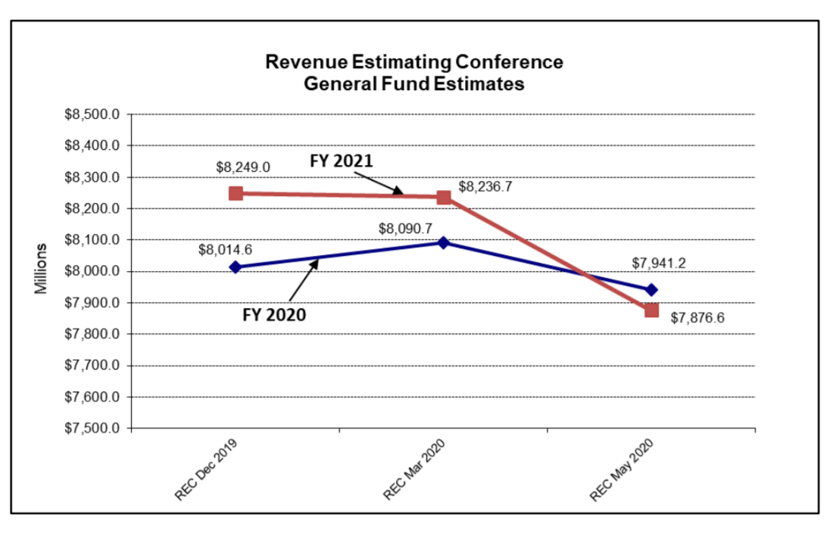
Fiscal Year 2020 Budget. The total resources available for the FY 2020 General Fund budget are estimated at $8.132 billion. This includes the May REC estimate of $7.941 billion, revenue adjustments passed by the 2020 General Assembly of negative $4.5 million, and a carryforward balance of $195.6 million. In addition, the General Assembly passed supplemental appropriations totaling $185.6 million for FY 2020, which included a $70.0 million appropriation to the RIIF to eliminate the estimated shortfall in the Fund, due to the mandatory closure of the casinos. Other significant supplemental appropriations included $89.0 million for the Medicaid program and $21.0 million to assist local governments with flood mitigation. The General Fund ending balance for FY 2020 is estimated at $312.9 million.
Fiscal Year 2021 Budget. The total resources available for the FY 2021 General Fund budget are estimated at $8.085 billion, which is a reduction of $47.5 million (0.6%) compared to FY 2020. This includes the May REC estimate of $7.877 billion, net revenue adjustments passed by the 2020 General Assembly of negative $39.1 million, and a carryforward balance of $247.3 million. The expenditure limitation for FY 2021 was $8.006 billion, which is 99.0% of the total available resources.
The General Assembly appropriated a total of $7.779 billion from the General Fund for FY 2021, which is a reduction of $45.9 million (0.6%) compared to the revised FY 2020 appropriations after factoring in the supplemental appropriations. The FY 2021 appropriations are also $227.4 million below the expenditure limitation. The General Fund ending balance for FY 2021 is estimated at $311.3 million (Table 2).
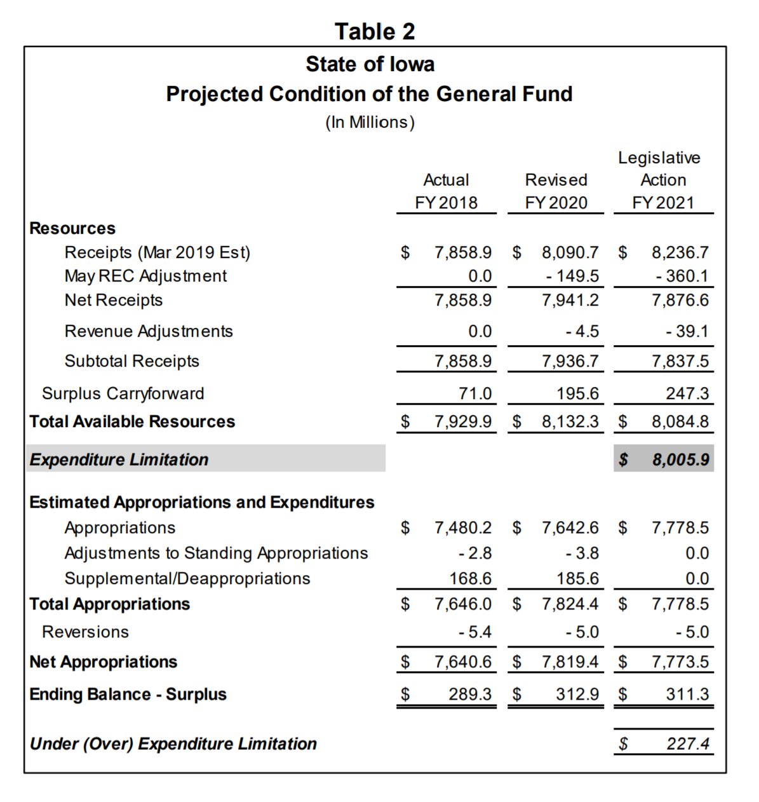
The General Assembly passed HF 2641 (Department of Revenue Omnibus Bill), which is estimated to reduce General Fund revenues by a net total of $41.9 million in FY 2021 (Table 3). The Bill reduces revenues from personal and corporate income taxes and the State sales/use tax.
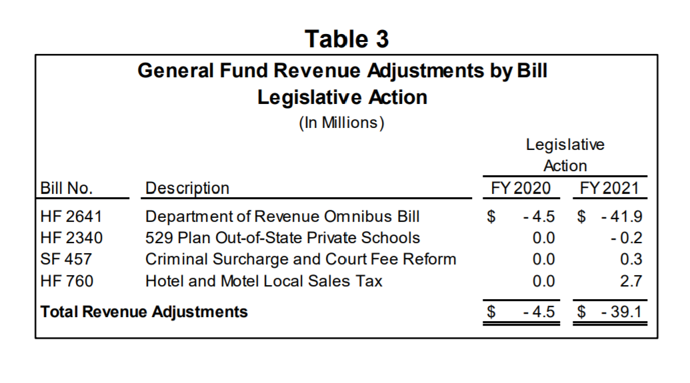
Significant General Fund Appropriations. For FY 2021, there were numerous increases and decreases for State agencies and programs (Table 4). The two programs that received the largest increases were State Foundation School Aid and the State Children’s Health Insurance (Hawk-I) Program. SF 2142 (Supplemental State Aid Act) was signed into law on March 12, 2020, and increased the State cost per pupil (SCPP) by 2.3%. The majority of the FY 2021 General Fund appropriations for State programs’ and agencies’ operations were status quo compared to FY 2020.
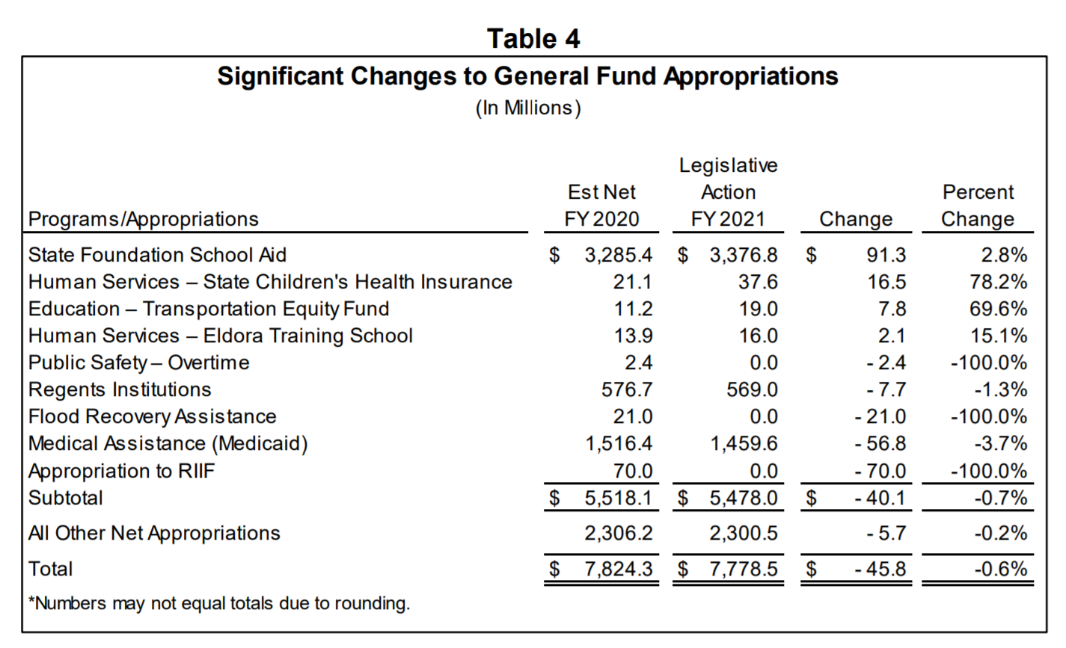
State Reserve Funds. The combined balances in the State’s reserve funds are estimated to total $783.7 million for FY 2021, which fills the reserves to the statutory maximum of 10.0% of the adjusted revenue estimate. The estimated FY 2020 reserve funds ending balance is $17.0 million less than the statutory maximum due to a transfer of $17.0 million from the Economic Emergency Fund to the Small Business Disaster Recovery Financial Assistance Program to provide financial assistance to small businesses affected by the COVID-19 pandemic (Table 5).
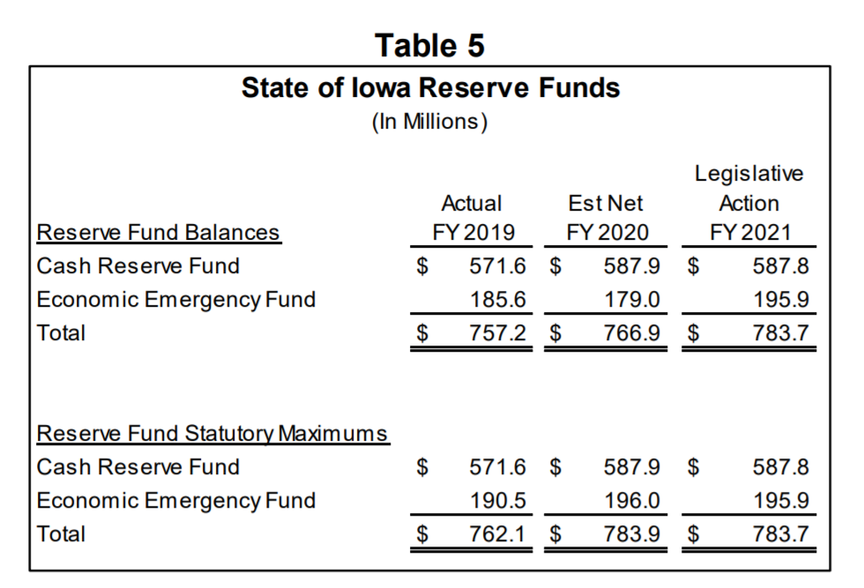
The combined balances in the State’s reserve funds are estimated to total $783.7 million for FY 2021, which fills the reserves to the statutory maximum of 10.0% of the adjusted revenue estimate. The estimated FY 2020 reserve funds ending balance is $17.0 million less than the statutory maximum due to a transfer of $17.0 million from the Economic Emergency Fund to the Small Business Disaster Recovery Financial Assistance Program to provide financial assistance to small businesses affected by the COVID-19 pandemic (Table 5).

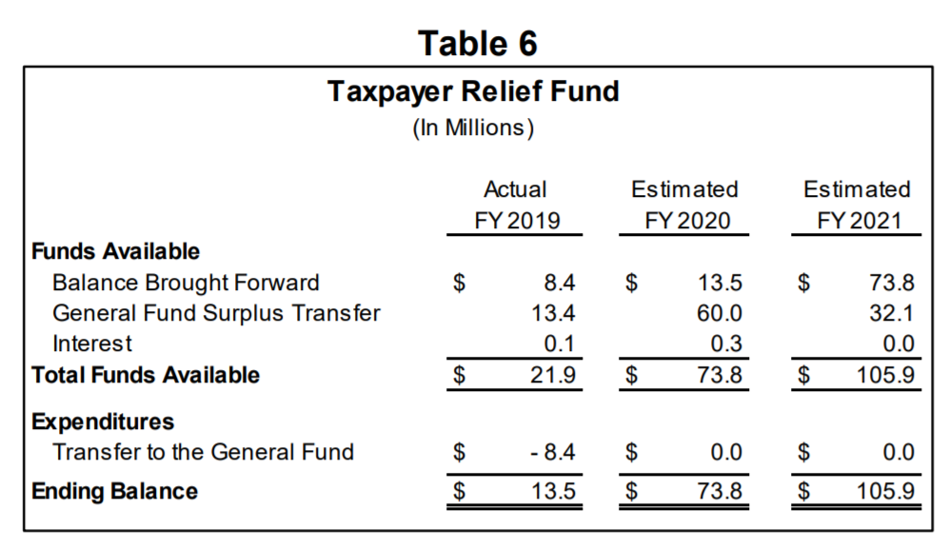
Taxpayer Relief Fund. The Taxpayer Relief Fund is estimated to have a balance totaling $105.9 million in FY 2021 (Table 6). The Fund has an estimated carryforward balance of $73.8 million and is estimated to receive an additional $32.1 million from the FY 2020 General Fund surplus. The moneys in the Taxpayer Relief Fund can only be spent pursuant to an appropriation by the General Assembly for purposes of providing tax relief to Iowans.

Final note on tax cuts: School funding in Iowa is about 40-42% of the state General Fund budget. If revenues are intentionally reduced further, RSAI’s first concern is that there is too little revenue growth left to provide additional funds to education. Additionally, PK-12’s proportional share of any reduction would be about 42%. For the legislature to protect education against reductions, the rest of the budget will have to endure another cut in order to hold education harmless.

RSAI is concerned that AEAs, universities, community colleges, human services, law enforcement and other state government services that support Iowans will be further unable to assist the families and communities that comprise our school districts. RSAI encourages school leaders to ask candidates running for the House, Senate and Governor’s office and at the Federal level, too, how they intend to balance the budget and provide sufficient revenue growth to ensure adequate funding for education in the coming years as continued tax reductions are considered.

This last chart on the next page, also from the Fiscal Update, details other funds appropriations, which provide context to the prior note. PK-12 funding is 42% of the state general fund, but the state general fund isn’t the totality of resources available to the Legislature to fund services and programs for Iowans.
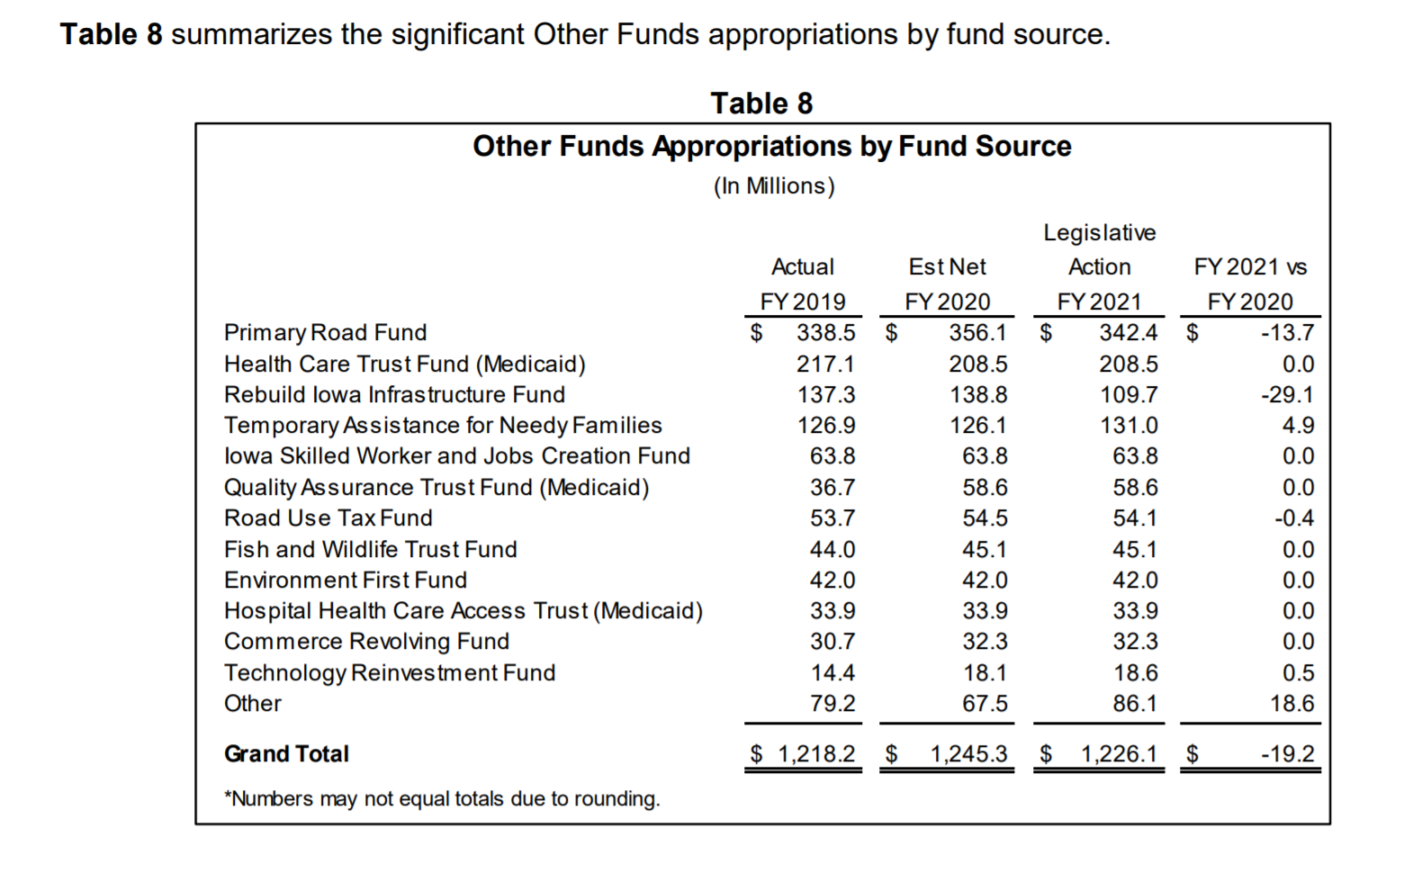
LSA Fiscal Update, END OF SESSION, June 26, 2020: https://www.legis.iowa.gov/docs/publications/BL/1137979.pdf

In an apples-to-apples comparison of state expenditures by NASBO (the National Association of State Budget Officers), Iowa spends relatively less of total resources on education than many states in our region and below the USA average.
Iowa ranks third from the bottom of the Plains States ranking only ahead of Nebraska and South Dakota and well below the national average. This chart which ISFIS compiled from data in the NASBO Report shows Iowa’s public education expenditures as a percentage of all total funds, for FY 2016-FY 2019. Find the report issued in November of 2019 here: https://www.nasbo.org/reports-data/state-expenditure-report
Tax Credits: With estimated low revenue growth over the last few years, legislators and advocates for state appropriations have been looking more closely at tax credits. Tax credits reduce revenues that would otherwise be collected by the state. Significant growth in tax credits over several years has outpaced state revenue growth and state general fund spending growth, but has leveled off in the last three years. A predictable and substantial state revenue base is necessary for adequate funding in public schools, and all state government services. The balancing of the budget will take increased taxes, decreased expenditures or increased revenues by lowering the level of tax credits.
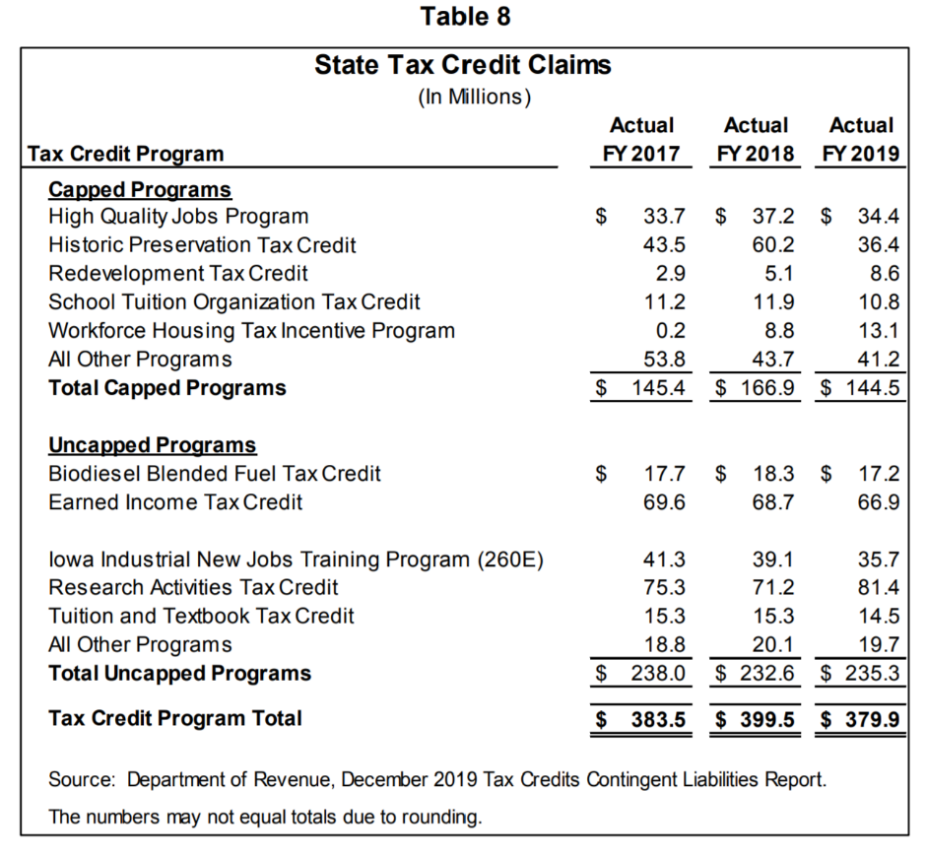
State Tax Credit Expected Claims Projection: With continued revenue estimate adjustments as revenues have lagged expectations, attention has been directed to tax credits. This chart from the LSA’s analysis of the Governor’s budget recommendations for 2021 provides some context.
This estimate indicates some leveling off of the growth. Table 8 summarizes the actual tax credits that were claimed against State taxes from FY 2017 through FY 2019.
(Note: FY 2017 Tax Credit Program Total was $332 million. The FY 2021 estimate is 28% higher than FY 2017, which is an average annual growth rate of 7%, compared to the state cost per pupil increase that has averaged 1.6% over the last four years.)

The Iowa Department of Revenue publishes a Tax Credit Contingent Liabilities Report three times yearly. Find those reports (the most recent is May 29, 2020) on their website here: https://tax.iowa.gov/may-2020-tax-credits-contingent-liabilities-report

This report includes Figure 2, which shows the growth in total tax credit Contingent and Expected Liability, including both capped and uncapped tax credits:

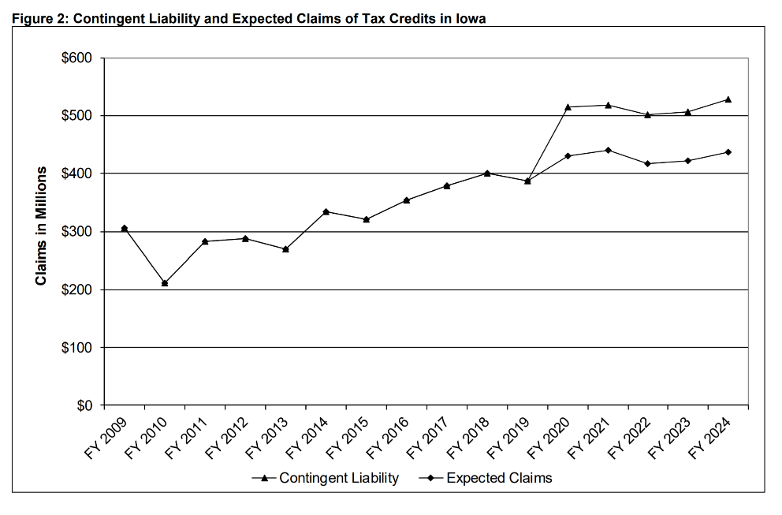

Funding Formula History Resource
Funding Formula History: The LSA published an Issue Review, State School Aid — Historical Context and Trends, 1967-1982, which is a good reminder of how far the formula has come over several decades. The Issue Review provides an overview of the early history of the Iowa school aid formula, beginning with the precursor funding available until the mid-20th century, the creation of the formula in the late 1960s and early 1970s, and a brief review of the considerations taken into account through 1982. One clear observation is the increasingly important role the state has undertaken in lowering property taxes and increasing the state contribution, which has continued since. Find the Issue Review here: https://www.legis.iowa.gov/docs/publications/IR/865393.pdf
Funding Formula Changes: The June 11, 2014 edition of the LSA’s Fiscal update also includes a reference to historical changes in school finance funding provisions. The LSA document reflects legislative action through the 2014 Legislative Session. The document provides a brief summary of the provisions from 1971 to 2014 and is available on the LSA website at: https://www.legis.iowa.gov/docs/LSAReports/k12Education/PublicSchlFunding_LawChanges_1971_to_Present.pdf
National Rural Education Association (NREA)

NREA Affiliate: Rural School Advocates of Iowa, as the state affiliate of the National Rural Education Association, includes Iowa rural school board members, administrators, and teachers in a network of over 3000 nationwide who advocate for rural schools, conduct rural education research, and share successes and challenges.
The NREA (National Rural Education Association) was originally founded as the Department of Rural Education in 1907. It is the oldest established national organization of its kind in the United States. Through the years it has evolved as a strong and respected organization of rural school administrators, teachers, board members, regional service agency personnel, researchers, business and industry representatives, and others interested in maintaining the vitality of rural school systems across the country. Find out more about NREA on their web site www.nrea.net.
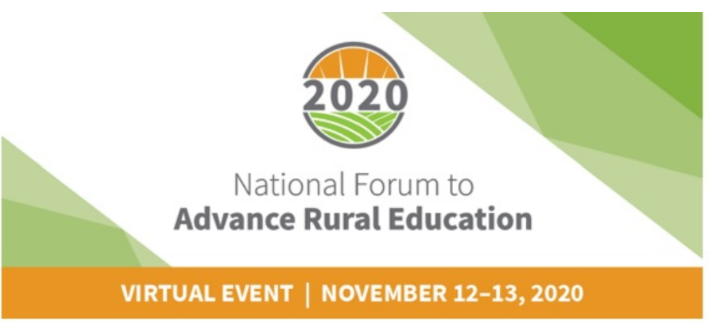
2020 National Forum to Advance Rural Education will be virtual this year, from Nov. 12-13. Be sure to save the date for the 112th NREA Convention and Research Symposium. The event theme is Recovery, Renewal and Resistance: 21st Century Education in Rural America. The virtual delivery model will allow many school leaders to experience this conference from home in 2020. Find out more about the agenda or register here: https://www.battelleforkids.org/events/rural-education-forum

Legislative Digest
Bills Enacted in the 2020 Session
Enrolled Bills: The following bills impacting Education have been signed by the Governor unless there is a note detailing veto action. The Enrolled bills explained below are organized into Tax bills, Appropriations bills and Policy bills.
A list of bills that received action but were not enacted follows under the Near Misses & Pending Issues section of this Digest. For access to the complete text and effective dates of all legislation approved or vetoed by the Governor, check the enrolled bills link on the legislative website.
Tax Bills Impacting State or Local Revenues

There were four bills that impact State General Fund Revenues, with the largest impact coming from HF 2641 Department of Revenue Omnibus Bill. This chart details the four bills and associated impact, from the LSA’s End of Session General Fund Balance Sheet found here: https://www.legis.iowa.gov/docs/publications/EOS/1137900.pdf

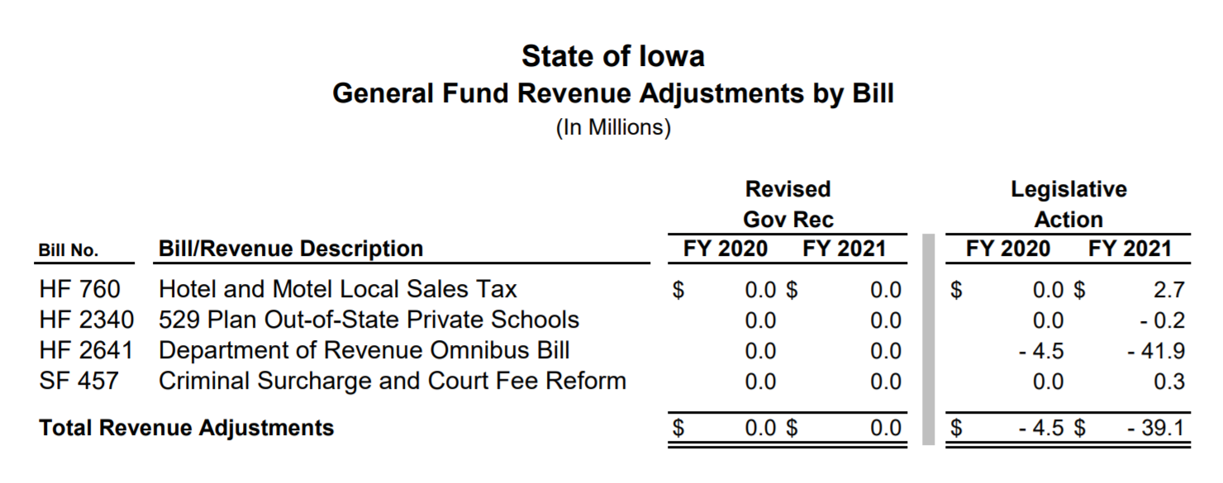

HF 2641, Department of Revenue Omnibus Bill, contains 26 divisions, many of which are estimated to have no fiscal impact on the state’s general fund or SAVE fund or school income surtax. In addition to the reductions in State General Fund revenue, shown in the chart below, the sales tax exemptions are projected to reduce school infrastructure tax collections by $0.5 million per year and local option sales tax collections by $0.5 million per year, with both impacts beginning FY 2021. A minor reduction in the income tax surtax for schools is also projected. Expansion of the School Tuition Organization Tax Credit, which provides scholarships for nonpublic school students, is shown to grow by another $4.1 million by FY 2025. The bill was approved 45:2 in the Senate, 75:17 in the House, and signed by the Governor on June 29. RSAI was registered as undecided on an earlier version of this bill.

The Fiscal Note for the bill, https://www.legis.iowa.gov/docs/publications/FN/1137811.pdf, shows those provisions with fiscal impact on state general fund revenues:
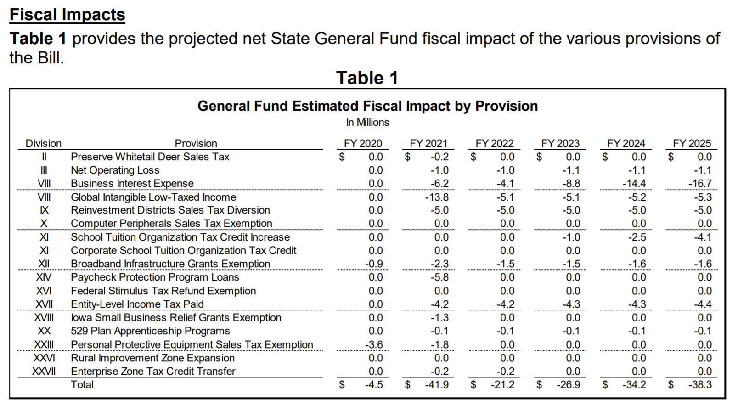

Significant Appropriations/Funding Legislation Impacting School Budgets
State School Aid: SF 2142 set a 2.3% increase in the state cost per pupil, also known as the state supplemental assistance (SSA) rate. RSAI specifically requested an increase no lower than 3.75%, to make up for many years of low growth rates. RSAI originally registered opposed to the Senate’s starting point of 2.1%, changed our registration to undecided with the House amendment at 2.5% and encouraged the Senate to accept the House position. They eventually compromised at 2.3%. This is the second highest increase in 11 years. RSAI’s request and the Legislature’s compromise predated the COVID-19 closure.
The bill was approved at 2.3% on March 4, two weeks beyond the statutory deadline for enacting SSA, which is 30 days after release of the Governor’s budget. Governor Reynolds signed the bill on March 12. With significant additional resources invested in SF 2164, Transportation and Formula Equity, below, despite unknown COVID-19 economic consequences, the Legislature kept these investments in schools in place for the 2020-21 school year. Given Iowa’s economic situation, this package demonstrates the Legislature’s priority of public schools.
The following details of SF 2142 come from the Fiscal Note here:
https://www.legis.iowa.gov/docs/publications/FN/1132471.pdf
- Establishes a 2.30% State percent of growth rate to be applied to the State cost per pupil (SCPP) for FY 2021 (See Table 1 from the fiscal note below for the total increase of the state cost per pupil, including the $10 per pupil increase to close the gap in per pupil inequity from SF 2164.)
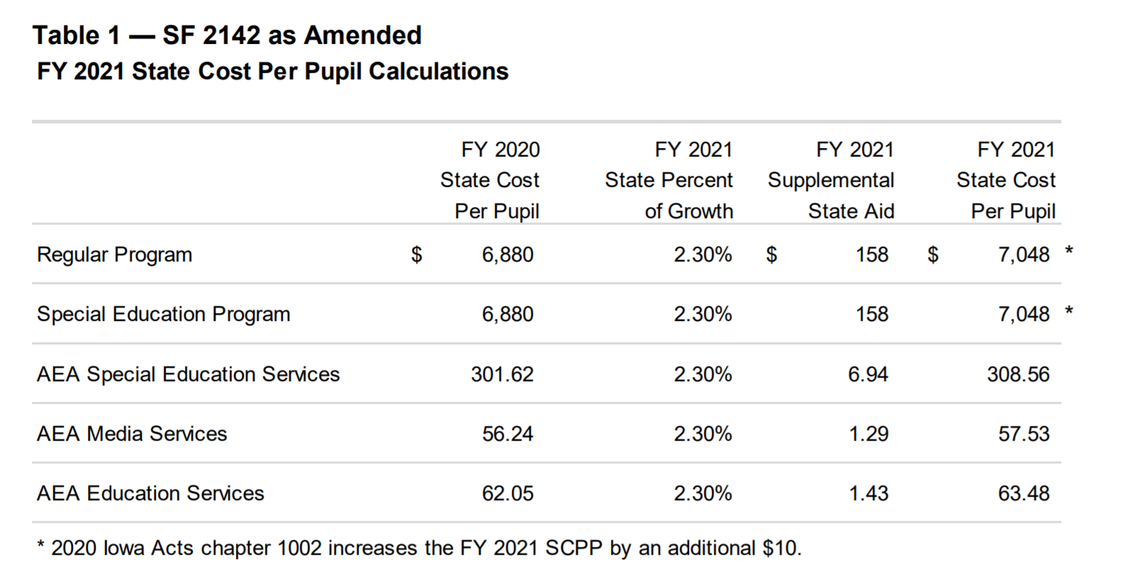
- Establishes a 2.30% State percent of growth rate to be applied to each of the State categorical cost per pupil amounts and to the standing appropriation for the Transportation Equity Fund for FY 2021 (See the table below for per pupil increases in each of the categorical fund areas.)
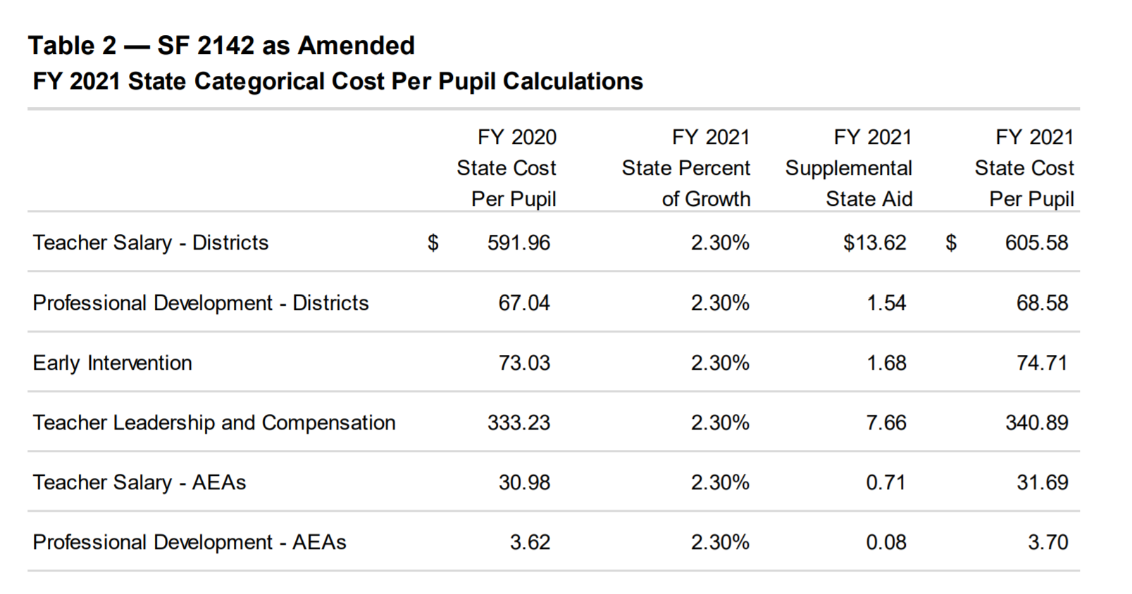
- Provides additional property tax replacement funding based on the per pupil increase that results from the establishment of the State percent of growth in FY 2021. The bill requires the additional levy portion of the FY 2021 state cost per pupil amount to remain frozen at $750 per pupil, regardless of the per pupil increase for FY 2021. Without enactment of this provision, the increase in the FY 2021 state cost per pupil due to the State percent of growth will include a per pupil property tax increase equivalent to one-eighth (12.5%) of the total per pupil increase. The total state investment in the PTRP grows to over $75 million with this action.
- Additionally, the Transportation Equity Fund allows for the standing appropriation to the Transportation Equity Fund to grow at the same rate as the categorical State percent of growth, although it is not technically considered a categorical supplement. The Transportation Equity Fund appropriation is not included in the combined district cost or in the total State aid appropriation.
Fiscal Impact of SF 2142
The following table provides the estimated fiscal impact of the three provisions of SF 2142 as amended: State supplemental aid, State categorical rate, and PTRP implementation. These provisions include:
- Restoration of the $15.0 million reduction in State aid to the AEAs. Under current law, the reduction will total $7.5 million (a statutory reduction implemented annually). $15 million was later removed in the Standings Appropriations bill, SF 2408, enacted just prior to the COVID-19 closure of the Legislature, signed by the Governor on March 17, therefore the total reduction to the AEA stands at $22.5 million.
- $75.1 million in PTRP funding, an increase of $12.4 million (19.80%) compared to FY 2020.
- $552.8 million for the State categorical supplements for school districts and AEAs, an increase of $14.9 million (2.78%). This includes:
  - $313.4 million for teacher salary supplement (districts & AEAs).
  - $35.6 million for professional development supplement (districts & AEAs).
  - $36.6 million for early intervention supplement.
  - $167.3 million for teacher leadership supplement.
- $88.1 million for preschool formula funding, an increase of $2.0 million (2.31%) compared to FY 2020. The preschool formula funding is included in the State aid amount but is not included in the combined district cost total.
- $8.3 million in budget adjustment funding for 106 qualifying districts, a decrease of $1.5 million (15.59%) compared to FY 2020. The budget guarantee adjustment is calculated at the school district level so that school districts receive 101.00% of their previous year’s funding. The budget guarantee adjustment is funded entirely through property taxes.
- Total property tax funds generated through the school aid formula are estimated to be $1.612 billion, an increase of $49.1 million (3.14%) compared to FY 2020.
- Total State aid (reflecting the total school aid funding level for school districts and AEAs generated through the school aid formula) is estimated to be $3.392 billion, an increase of $106.3 million (3.24%) compared to FY 2020.
The ISFIS New Authority Calculator shows what 2.3% means for your district’s Regular Program Cost. Access the New Authority Calculator on the ISFIS home page here.
This table, also from the Fiscal Note, shows the various components of the school foundation formula with state, property tax and per pupil impacts. Please note: This table includes a restoration of a long-standing $15 million cut to the AEAs. The Standings Bills, SF 2408, detailed below, reinstates the cut.
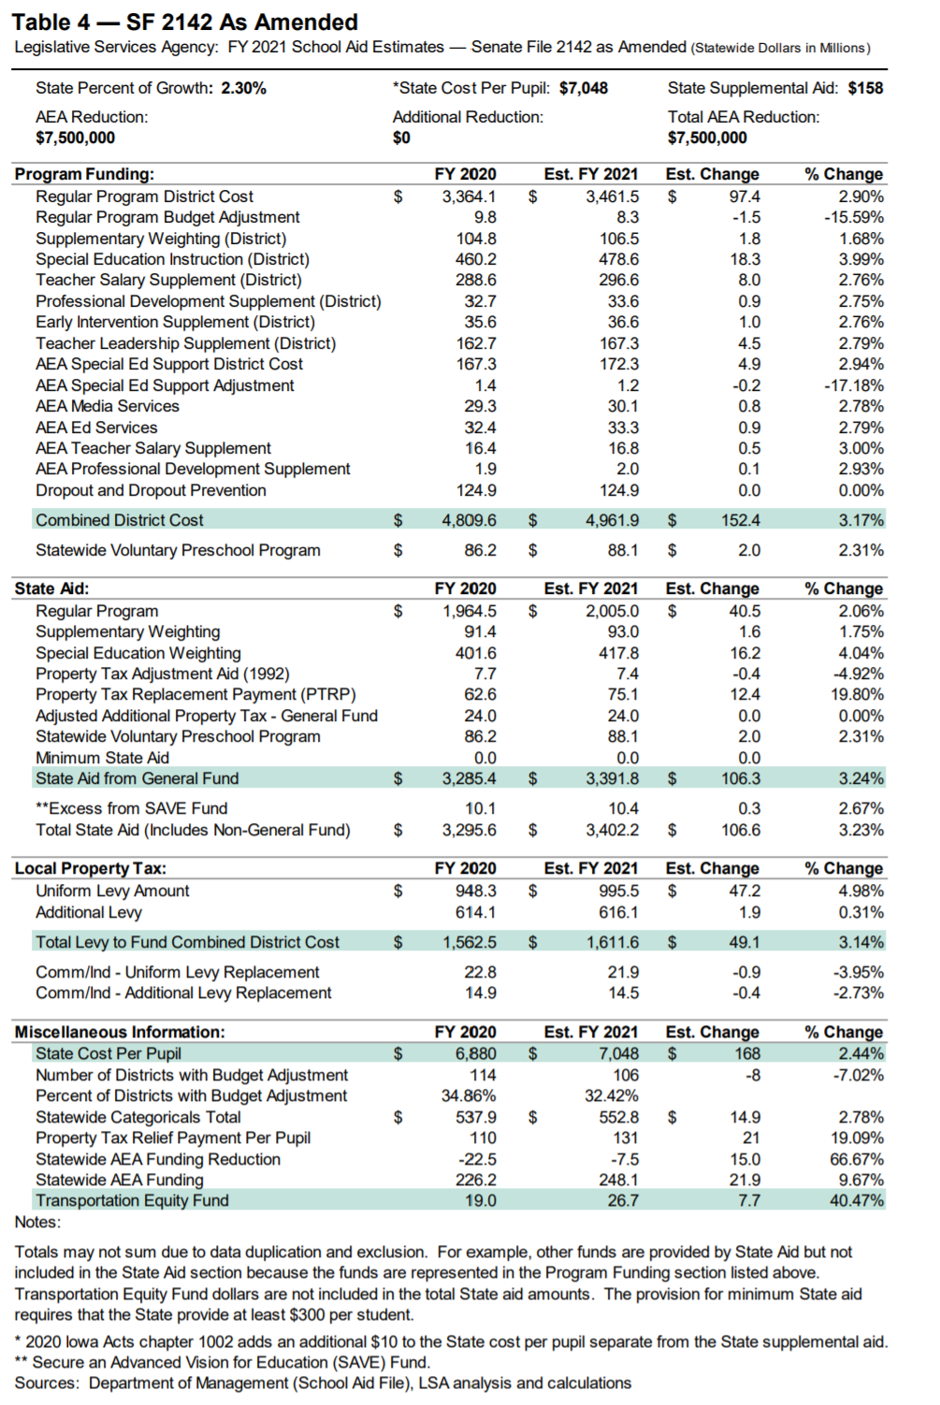
Source: LSA Fiscal Note https://www.legis.iowa.gov/docs/publications/FN/1132471.pdf
Transportation and Formula Equity: SF 2164 was approved in the Senate 48:0, the House 98:1; and was signed by the Governor on Feb. 25. RSAI was in support.
“We live in a disruptive, technologically-driven economy, and if we aren't preparing our students to succeed in the 21st century, then we are failing them,” said Gov. Reynolds in her press conference regarding signature on Feb. 25, 2020. “This legislation will help Iowa’s many rural school districts absorb transportation costs and put more money into the classroom. Education is always a top priority, and we will continue to look for ways to provide every school, educator, and student with the tools for success.” The following information comes from the LSA Notes on Bills and Amendments (NOBA) https://www.legis.iowa.gov/docs/publications/NOBA/1129902.pdf dated Feb. 11, 2020:

The bill appropriates a total of $31.5 million from the General Fund for FY 2021. The funding includes:
- An estimated increase in State school aid of $5.3 million and a decrease to property taxes of $3.6 million due to an increase to the State cost per pupil of $10 per pupil to close the foundation formula equity gap.
- Specifies that the regular program State cost per pupil for FY 2021 is the amount calculated using the State supplemental aid (SSA) rate, plus an additional $10 per pupil.
  - The adjustment in this Section reduces the maximum difference between the State cost per pupil and the maximum district cost per pupil to $155.
  - Districts that have a higher district cost per pupil will receive State aid replacement for funds that would have been generated through property taxes.
  - Districts whose district cost per pupil is the same as the State cost per pupil will receive additional spending authority.
- Increases the General Fund standing appropriation to the Transportation Equity Fund to $26,253,088 in FY 2021.
  - This is an increase of $7,253,088 as compared to estimated FY 2020. This increase would be in addition to any other increase based on the categorical State percent of growth for FY 2021.
  - Specifies that the standing appropriation to the Transportation Equity Fund in Section 2 of this Bill may grow at the same rate as a categorical under the categorical State percent of growth beginning in FY 2022.
  - Fiscal Impact: Under current law (since the SSA rate for FY 2021 hadn’t yet been enacted) the State percent of growth for FY 2021 is 0.00%, and there would be no change in FY 2021 from the estimated FY 2020 General Fund appropriation to the Transportation Equity Fund of $19,000,000. The estimated fiscal impact for FY 2021 based on various State percents of growth would be:
    - 1.00% — An estimated increase of $190,000.
    - 2.00% — An estimated increase of $380,000.
    - 3.00% — An estimated increase of $570,000.
Omnibus Appropriations: HF 2643 was introduced on Jun 10 and received final approval on June 14, approved in the Senate 30:17, the House 51:41; and signed by the Governor on June 30. RSAI was not registered on the bill. (Governor Reynolds vetoed two sections of the 130 sections of the bill, unrelated to school issues.) The bill appropriates a total of $4,321.9 billion of state General Fund appropriations for FY 2021, which is a decrease of $73.9 million compared to estimated net FY 2020. The bill also authorizes $729.0 million from other funds, which is an increase of $13.7 million compared to estimated net FY 2020. Specific appropriations important to school leaders include the following:
- Appropriates $160.4 million for property tax credits. That’s short $5.3 million, which they appropriate from the Taxpayer Relief Fund.
- Creates a property tax fix for school district property value adjustment made on appeal if at least $100,000 and 2% of property value (Bondurant-Farrar schools)
- The Education Budget Line Items are tracked in the LSA’s NOBA found here:
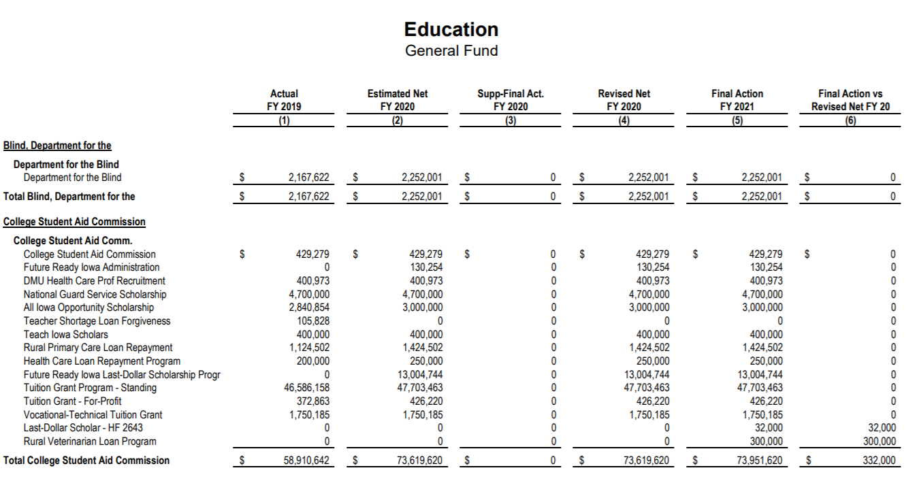
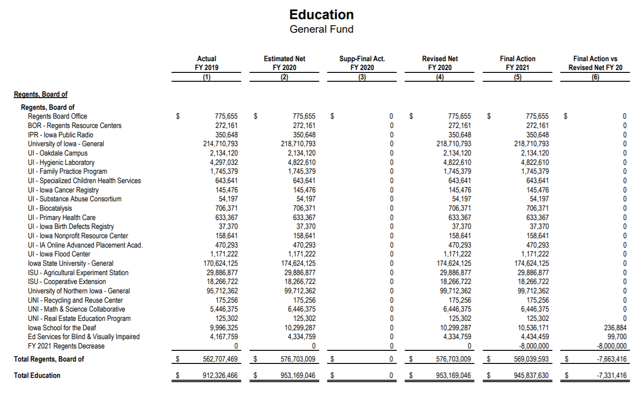
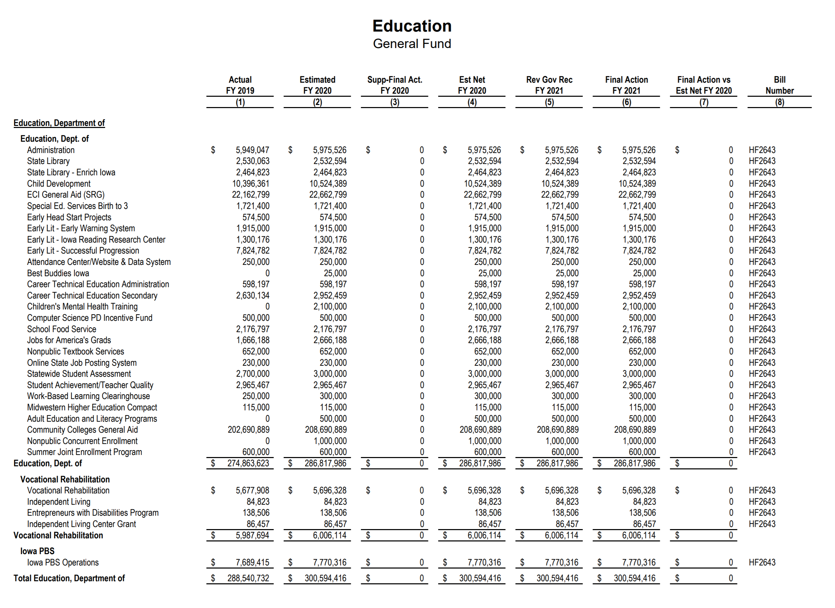
Policy language in HF 2643 impacting education and specific notes about certain line-item appropriation detail includes the following (sources: LSA NOBA and Iowa Department of Education Summary of Legislative Changes Impacting Schools 2020):
- Specifies that any funds remaining from the $1.0 million FY 2020 General Fund appropriation to DE for payments to the community colleges for concurrent enrollment of nonpublic students do not revert at the end of FY 2020, but will remain available for expenditure through FY 2021.
- Allows for an adjustment in State foundation aid in FY 2021 for school districts that have received an assessed value reduction by a local board of review or property assessment appeal board in assessment year (AY) 2018 (Bondurant-Farrar). This is estimated to increase the FY 2021 State foundation aid General Fund appropriation by an estimated $254,000.
- Career and Technical Education Secondary: Appropriates $2,952,459, which will be distributed to the 15 Regional Planning Partnerships to be spent on allowable uses specified in statute pursuant to Iowa Code chapter 258. The partnership will determine how to allocate these funds between the allowable uses and include this information in the partnership's multi-year plan. The multi-year plan is voted on by the full membership, which includes a representative of each school district in the partnership's region.
- Student Achievement and Teacher Quality: Appropriates $2.9 million to support the following programs: National Board Certification, Career Development, Teacher Development Academies, Iowa’s Teacher of the Year Program, Teacher Leadership Technical Assistance, and the Fine Arts Mentoring Program.
- Statewide Clearinghouse to Expand Work-Based Learning: Appropriates $300,000 for support, management and promotion costs associated with the expansion of the Iowa Clearinghouse for Work-Based Learning as part of the Future Ready Iowa initiative. The Clearinghouse allows employers to post projects online for K-12 schools to provide more students with authentic, professional learning experiences. Businesses, nonprofits and others have posted at least 133 projects, with more being developed.
- Statewide Assessment: Appropriates $2.7 million for school districts and $300,000 for accredited nonpublic schools to reduce the cost associated with the Iowa Statewide Assessment for Student Progress (ISASP). The appropriation will be distributed by the Department to Iowa Testing Programs on behalf of school districts and accredited nonpublic schools. School districts and accredited nonpublic schools will pay any remaining cost for the state assessment.
- Postsecondary Summer Classes for High School Students: Appropriates $600,000, as part of the Future Ready Iowa initiative, for resident high school students to attend a community college for college-level classes taught by a community college-employed instructor during the summer through a contractual agreement between the community college and the school district. DE has posted guidance, which includes an overview of the summer college credit program, on the Department’s Senior Year Plus webpage.
- Attendance Center Performance/General Internet Site and Data System Support: Appropriates $250,000 for the continued development and implementation of the Iowa School Performance Profiles.
- Online State Job Posting System: Appropriates $230,000 to DE for the administration of the TeachIowa.gov online job posting system. DE, as well as public school districts, charter schools, and AEAs, are required to post all job openings on the system. Accredited nonpublic schools may participate at no charge.
- Successful Progression of Early Readers: Continues the appropriation of $7,824,782 to the DE for distribution to school districts to provide intensive instructional services for the Successful Progression of Early Readers program.
- Early Warning System for Literacy: Appropriates $1,915,000 for DE to administer and distribute to school districts and accredited nonpublic schools an early warning assessment system that allows teachers to screen and monitor student literacy skills from PK-6th grade. DE is also permitted to charge school districts and accredited nonpublic schools a fee for the system, which is determined by dividing the remaining costs to purchase the statewide license for the school year by the number of students assessed under the system in the current fiscal year.
- Iowa Reading Research Center (IRRC): Appropriates $1,300,176, which will be used for carrying out the IRRC’s seven priorities in the areas of evidence-based literacy interventions, reading assessment, and intensive summer reading programs. The funding will also support collaborating with AEAs and providing ongoing professional development to improve teachers’ knowledge of and ability to implement effective literacy practices.
- Computer Science PD Development Incentive Fund: Appropriates $500,000 for the Computer Science Professional Development Incentive Fund. School districts, accredited nonpublic schools and AEAs can apply to DE for funds to provide teachers professional development in computer science or to provide tuition reimbursement for teachers seeking an endorsement in computer science. DE will post the updated guidance and application on www.educateiowa.gov and expects applications will open late summer to early fall.
- Children’s Mental Health School-Based Training and Support: Appropriates $2.1 million for the continuance of school-based children’s mental health support, including mental health awareness training for educators. This includes:
  - $1.2 million to the AEAs to provide mental health awareness training for educators and schools;
  - $750,000 to identify a range of approaches to best meet the mental health needs of students and to strengthen community support for students; and
  - $150,000 to maintain a clearinghouse of mental health resources for use by schools and community providers.
- Best Buddies Iowa: Appropriates $25,000 to create opportunities for one-to-one friendships, integrated employment, and leadership development for students with intellectual and developmental disabilities.
- Adult Education and Literacy Programs: Appropriates $500,000 to be distributed as grants to community colleges for the purpose of adult basic education programs for students requiring instruction in English as a second language.
- Nonpublic School Concurrent Enrollment Payments to Community Colleges: Appropriates $1 million to the Department for the nonpublic concurrent enrollment program, which allows accredited nonpublic schools to contract directly with a community college to deliver courses through concurrent enrollment. The bill adds non-reversion language to the appropriation (noted above), allowing DE to retain unspent funds for up to one additional fiscal year.

Standings Appropriations: SF 2408 was approved in the Senate 43:0, the House 93:0; and signed by the Governor on Mar. 17. RSAI was registered in support, primarily because of the instructional-hours provisions. The bill has many actions impacting all of state government, but the following are specific to schools as detailed in the LSA’s NOBA found here: https://www.legis.iowa.gov/docs/publications/NOBA/1133470.pdf:
- Limits the FY 2021 General Fund appropriation to the DE for nonpublic school transportation to $8.2 million. Requires the appropriation to be prorated if the claims exceed the appropriation. This represents no change compared to the funding level for FY 2020. Without this action limiting the appropriation, current law would otherwise increase the standing appropriation by $2.6 million compared to the FY 2021.
- Suspends the General Fund standing appropriation of $14.8 million for the Instructional Support Program for FY 2021. (Iowa law still requires state contribution to ISL. However, the Legislature has opted out of their contribution since FY 2010.)
- Reduces the FY 2021 State school aid funding to Area Education Agencies (AEAs) by $15.0 million. (This underfunding of the AEAs has been in place for over a decade, first implemented during the great recession.)
- Waives the instructional time requirements for school districts and accredited nonpublic schools that close before April 12, 2020 to prevent the spread of COVID-19. Repeals the school instructional time waivers, on July 1, 2020 (further instructional time provisions related to the 2020-21 school year are detailed in SF 2310 below). See RSAI’s letter to the Governor and Legislature supporting the instructional time waiver provisions here.

The following additional provisions of SF 2408 provided authority for the Governor and Department of Management to operate during the COVID-19 closure of the Legislature, in concert with the Legislative Council for some additional approvals.
- Provides an FY 2020 General Fund supplemental appropriation of $89.0 million to the Department of Human Services (DHS) for the Medicaid program.
- Provides an FY 2020 General Fund supplemental appropriation of $1.7 million to the DHS for the Healthy and Well Kids in Iowa (HAWK-I) program.
- Provides an FY 2020 General Fund supplemental appropriation of $526,000 to the University of Iowa Hygienic Laboratory.
- The Act allows any unexpended funds remaining at the end of FY 2020 to carry forward for expenditure in FY 2021. Appropriates an amount up to 10.0% of the FY 2020 in the Economic Emergency Fund to be used for purposes approved by the Governor. Ten percent of the FY 2020 Economic Emergency Fund balance is equal to $19.6 million.
- Provides a contingent appropriation equal to the maximum balance of the Economic Emergency Fund to the DOM in the event that the appropriation of 10.0% of the Economic Emergency Fund is insufficient. The appropriated funds may be used for purposes approved by the Governor and the Legislative Council. The maximum balance in the Economic Emergency Fund in FY 2020 is $196.0 million.
- Requires the Department of Management (DOM), in consultation with the Legislative Services Agency (LSA), to identify the FY 2020 line-item appropriations and standing appropriations, including appropriations from federal and nonstate sources, and the entities that received the appropriations.
- Suspends limitations on the Governor's authority to transfer funds between General Fund line item appropriations beginning with the effective date of this Act and ending August 31, 2020.
SF 2360 Classroom Management and Therapeutic Classrooms Appropriations: appropriations in the fiscal year beginning July 1, 2021, $500,000 to DE to develop and distribute standards and professional development, $1,582,650 for the therapeutic classroom incentive, and $500,000 for transportation claims. See SF 2360 bill description below for policy details. RSAI was registered in support, primarily because of the least restrictive alternative and other policy considerations detailed below.

Policy Bills Impacting Schools
SF 2082 DE Technical Corrections: this bill makes changes to reflect current practice, eliminates duplicative language in the Iowa Code, and modernizes language, all technical (nonsubstantive) corrections. The bill updates titles of members of the Child Development Coordinating Council, updates language on school district agency funds to name them custodial funds, updates provisions on special education related to open-enrollment and to shared-time provisions, and updates language on electronic access offered by the State Library. The bill was approved by the Senate, 48:0, by the House 98:0, and signed by the Governor on June 1. RSAI was registered in support of the bill.

SF 2261 Telehealth Services in a School Setting: this bill expands opportunities for students to access mental health services with a licensed professional mental health provider by offering parent/guardians access to services through an electronic encounter in the school setting. Public schools, accredited nonpublic schools, or AEAs can provide a secure, confidential, private area to conduct telehealth services. The schools are spared the duties related to billing as that is done by the mental health care professional directly through insurance, Medicaid or to parents. RSAI included the provision of telehealth services at school as a legislative priority in both the 2019 and 2020 Legislative Sessions. The DE’s 7/17/2020 2020 Legislative Session Summary of Changes Affecting Schools stated that the DE will provide additional guidance. The bill includes the following specifications:
- Defines terms
- Allows schools, nonpublic schools and AEAs to contract with a mental health professional to provide screenings
  - Requires written parent consent
  - Consent must allow for disclosure to school if MH Professional believes there is a credible threat to health and safety of students
- Allows MH professional to conduct an initial behavioral health screening and then refer a student if:
  - MH professional notifies the parent of the screening results
  - MH professional notifies the student’s primary care provider with parent consent (if none, MH professional may provide list of primary care providers)
- Establishment of provider-patient relationship
  - MH professional using telehealth is required to establish a provider-patient relationship with the students
  - Provider-patient relationship commences when:
    - Student seeks MH assistance with parent consent
    - MH professional agrees to take on the patient’s diagnosis and treatment
    - Student’s parent agrees to have the student treated
  - Defines how a provider-patient relationship is established (through in-person encounter, consultation with primary care provider, or through telehealth following standard of care and student’s parent is present)
    - Requires parent to consent after the relationship is established
    - School district is required to keep consent form
- Sets up expectations for process of telehealth behavioral health services at school
  - provide a secure, safe, confidential and private room and necessary technology
  - maintain parent consent forms, required annually
  - maintain scheduling requests for services and provide student access to the room by a nurse or other appropriately trained school or AEA employee
  - provide info to the student about how and to whom to report inappropriate behavior by a MH professional
  - provide access to the student’s parent to participating in the sessions
- Regarding prescriptions, records, liability:
  - prohibits the school, nonpublic school or AEA from access to or handling of student medical records or for billing for the services provided
  - prohibits a MH professional from prescribing new medication during a telehealth session. The professional is allowed, however, to initiate a new prescription, alter the dosage of an existing prescription, or discontinue a prescription for treatment of a behavioral health condition after consultation with the parent.
  - requires a MH professional to notify the parent of the time and place for each session and specify means available for the parent to participate.
  - prohibits protected health information (medical records and billing), created by the MH professional or primary care provider, from being shared or disclosed with the school unless disclosure is necessary to prevent or lessen a serious and imminent threat to the health or safety of the students or to a clearly identifiable person(s) and the MH professional determines the student has the apparent intent and ability to carry out the threat.
  - protects employees, the MH provider and the school board from liability for any injury arising from the provision of voluntary behavioral health screenings or services in accordance with this chapter, provided acting reasonably and in good faith and in accordance with these provisions.
- Regarding billing and insurance coverage:
  - prohibits insurance from denying coverage solely due to provision of services at school
  - doesn’t mandate that insurance pay for uncovered services or require an insurance company to pay a provider that has not entered into a provider agreement with the insurance company or prevent application of any other provision of a policy, contract or plan.
  - applies to third-party payment provider policies, contracts or plans in Iowa after Jan. 1, 2021.
RSAI was registered in support, with telehealth explicitly mentioned in the RSAI child mental health priority language.

SF 2310 Online Learning and COVID Flexibility: this bill ends the state Iowa Learning On-line Initiative and authorizes the AEAs, in collaboration with other schools and AEAs, to offer on-line classes. Makes changes to the duties of the State Board of Education (BOE) and the DE. Requires AEA classes to meet established standards. Requires schools to pay AEAs for the on-line course work. Allows the DE to waive requirements for two additional subjects to be offered by school districts, if the district cannot offer them after good faith efforts. See DE guidance issued 7/17/2020 here. The following details the bill’s 19 subdivisions, with (RSAI comments in italics). Additionally, significant sections impacting in-person learning as the primary method of instruction are underlined:
- Requires state BOE rules regarding offer and teach (256.11 subsection 17) and online learning provider approval (256.17) and new district online learning options (new section 256.7 subsection 32)
- Requires online learning coursework to be rigorous, high-quality, aligned with Iowa core standards/content and meet the national standards of quality for online courses, and taught by an Iowa licensed teacher with specialized training or experience in online learning (including but not limited to AEA’s PD project for online learning, teacher preservice or comparable coursework).
- Allows DE and the AEAs to also develop and offer online learning meeting those same standards and requires DE to approve private providers (there is no requirement for DE to approve local online courses outside of the accreditation process).
- Offer and Teach Section: Removes world language, financial literacy and computer science from physical offer and teach requirements (in school buildings) and allows those to be taught exclusively online. Retains the ability for districts to offer up to two of the other offer and teach requirements online if a good faith effort is made but you cannot hire a teacher or fewer than 10 students typically register for the course. Allows the DE to waive provision of two additional courses annually if a good faith effort is made but you cannot hire a teacher. Requires that the waived course be provided by an online alternative (developed by the district, working with another district or AEA, or working with a private provider approved by the DE).
- Allows districts to offer their own online learning, work with other districts or AEAs. These locally developed courses must be aligned and taught by an Iowa licensed teacher. Also allows districts to engage a private provider, whose courses must also align and be approved by DE. Find approved providers here: https://educateiowa.gov/pk-12/educational-technology/online-learning)
- Requires districts to report via the CSIP a list and description of on-line coursework for enrolled students. (Does not require districts to report all online courses offered, just those to which students are enrolled).
- Allows DE/AEAs to establish an online coursework and platform with general funds or available federal funds – doesn’t require schools to use it, but allows both public and private schools to access courses. (Does not state that public school students can access the courses without the district offering them. DE is working to provide CANVAS at no cost to districts and to nonpublic schools and Home School students this year, paid with federal funds.) The legislation otherwise requires districts to pay for courses accessed from the platform.
- Allows a district to provide instruction primarily over the internet if provided in accordance with an approved Return-to-Learn (RTL) plan, in response to a proclamation of a public health disaster emergency (Governor’s Proclamation) which satisfies the instructional time requirements (either days or hours) regardless of the nature, location or medium of instruction if the RTL plan includes the minimum number of days/hours, as long as the remote learning is compulsory. Requires that district RTL plans must contain provisions for in-person instruction and provide that in-person instruction is the presumed method of instruction.
- Allows funding flexibility for additional instructional time above the minimum days/hours, approved by board resolution for Professional Development (PD) Supplement funds used for 36 hours of PD outside of the instructional day. Requires hour for hour exchange (one hour of instruction replaces one hour of PD collaboration). All PD requirements of Iowa Code Chapter 284 are waived for the funds used for instruction. (Additionally, although not included in the legislation, the Governor’s July 17 proclamation allows virtual instruction in place of making up snow days.)
- Allows a parent to notify the district by July 15, 2020 of an open enrollment request to a public online academy, based on health condition of student/family/caretaker and doctor’s note.
- Requires districts to provide Competent Private Instruction (CPI), Home School Assistance Program (HSAP) and Dual Enrolled to students whose parent requests it, including textbooks/supplementary materials, on the same basis as provided to enrolled students. (Does not require districts to provide virtual courses taught by school teachers to CPI or HSAP students.)
- If the Governor proclaims a public health emergency, the bill allows local boards to authorize closure of the school district or any school attendance center due to outbreak of COVID-19. Encourages school districts to follow CDC guidelines, consult with IDPH, and states that local leaders may consult with local board of health with determining social distancing measure or authorizing a school closure. Prohibits waiver of instructional time requirements for school closure unless the districts provides compulsory remote learning. States that, unless explicitly authorized in a proclamation of the governor related to COVID-19, the district shall not take action to provide instruction primarily through remote-learning opportunities. (This bill did not include specific time limitations or metric thresholds that must be reached to trigger closure decisions. Those elements were added by the Governor during public health state of emergency declarations.)
- If the board of directors determines at any time during the 2020-21 school year that a remote learning period is necessary, requires the board to ensure that teachers/staff are available to support students, engage in PD, perform other job-related functions during the regular required contract hours.
- Defines a student that does not participate in compulsory remote learning as truant, unless enrolled in CPI or IPI per parent notification prior to July 1, 2019. Allows a student with significant health concern to report to the district and requires the district to provide accommodation via remote learning.
- Teacher endorsement waiver: if every reasonable and good faith effort is made to employ a licensed teacher with specific grade level or subject endorsement, and the district cannot employ such a person and cannot develop or provide online program for that area, allows the district to request and DE to waive the teacher endorsement requirements. (In the Governor’s July 17 proclamation, the Governor additionally expanded flexibility of requirements for substitute teachers. Those expansions were introduced during the Iowa Board of Education Examiners board meeting on Aug. 5, 2020. Find the specifics of these expansions at this link on the BOEE website.)
- Social Distancing: in implementing social distancing policies included in the RTL plan, the board shall, to the extent possible, provide in-person instruction for core academic subjects.
- Requires schools to make reasonable accommodations for remote learning for a student or family’s significant health condition that increases the risk of COVID-19, including written confirmation from the doctor.
- Notwithstanding any other provision to the contrary, a district may provide instruction primarily over the internet in accordance with a RTL plan submitted by the district to the DE in response to a proclamation of public health disaster emergency explicitly addressing school closures, issued by the Governor related to COVID-19, without regard to whether the district is approved to provide instruction primarily through continuous remote-learning opportunities. (Must use licensed teacher and maintain evidence of alignment with core)
- Requires a school district savings report; includes beginning balances for July 1, 2020, any savings due to closure from July 1, 2019 through June 30, 2020, and specifically mentions transportation, the number of employees laid off listed by staff position and whether they received Unemployment Insurance, and any Spring or Summer programs canceled or otherwise impacted. The DE will include requests for information in this Fall’s data collection.
RSAI was registered as undecided, although clearly supported the offer and teach provisions and the local control of school boards to follow RTL plans. The bill passed the Senate 49:0, the House 92:6, and was signed by the Governor on June 29, 2020.
SF 2356 Dyslexia Specialists, Training and Board: this bill requires state BOE in collaboration with Iowa Reading Research Center (IRRC) to adopt rules prescribing standards and procedures for approval of teacher prep programs and an advanced dyslexia specialists endorsement issued by BOEE. Requires IRRC to approve a program before DE approval. Requires BOEE to adopt rules for the endorsement. Passed by the House 98:0, by the Senate 48:0, and signed by the Governor, June 17, 2020. Here are the details:
- Requires DE to have one FTE Dyslexia consultant by July 1, 2024
- Establishes an Iowa Dyslexia Board and specifies membership
- Requires an annual report/recommendations by Nov. 15
- Repeals the Board July 1, 2025
- Requires AEAs to have a dyslexia specialist, subject to appropriation, but absent an appropriation, encourages the AEAs to have such a specialist
- Requires licensed AEA employees other than coaches to complete the IRRC dyslexia overview module by July 1, 2024 and requires all new licensed employees to complete the module within one year of hire date.
- Defines dyslexia
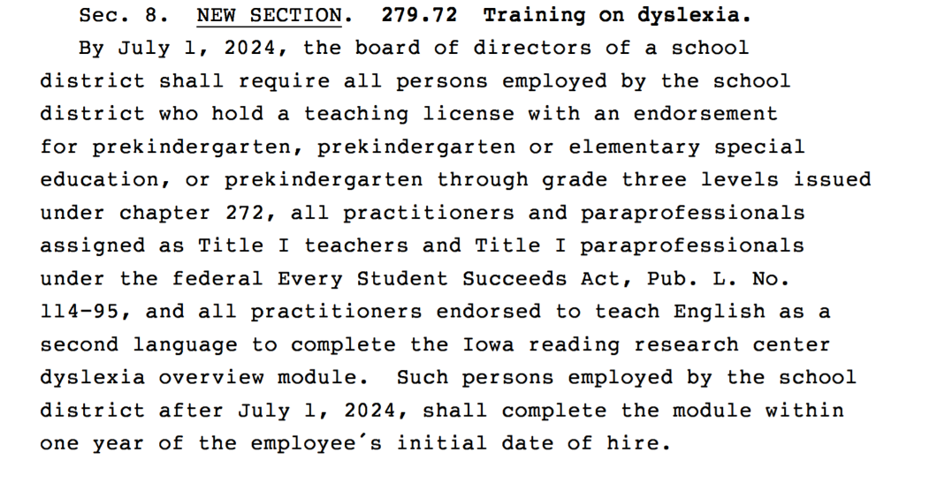
- Requires school boards to require that certain employees must complete the IRRC dyslexia overview module by July 1, 2024 and new hires within their first year thereafter. See Sec. 8 of the bill which specifies to whom this training requirement applies.

RSAI was initially registered opposed to the bill. When the legislature limited the training mandate, delayed the implementation, and provided the course free through the IRRC, we changed our registration to undecided. The bill was approved by the House 98:0, but the Senate 48:0 and signed by the Governor on June 17.
SF 2360 Classroom Management and Therapeutic Classrooms: this bill addresses classroom management, room clears, best-practice training, least restrictive environment and creates a pilot program for expansion of therapeutic classrooms. Here are the details:
- Best practice and Training: requires the DE to define appropriate and inappropriate responses to behavior, including standards, guidelines and expectations, and requires DE and AEAs to create professional development on least restrictive environment and the teacher preparation programs, by July 1, 2023, to include this content in teacher prep.
- Therapeutic Classroom Grants: creates a grant process to fund start-up therapeutic classroom programs. DE develops grant application and selection/evaluation criteria. Requires distribution of grant funds to small, medium and large districts. Uses a formula weighting at the upper range of intended slots:
    - for programs intended to serve 1-5 students weighting of 1.5 X 5;
    - for programs intended to serve 6-10 students, weighting of 1.5 X 10;
    - and for programs intended to serve 11-15 students, weighting of 1.5 X 15.
Establishes a Therapeutic Classroom Incentive Fund in the state treasury.
- Special Education Application: Requires special education provisions in law to apply to students with Individual Education Plans (IEPs) in therapeutic classrooms.
- Transportation Reimbursement: creates a process to reimburse for transportation costs to the classroom for public and nonpublic students in such classrooms for whom transportation is not included in an IEP, if over 30 miles. The bill requires school districts to submit claims by June 15 and the DE to provide reimbursement by July. The bill requires the DE to prorate reimbursements if claims exceed appropriated amounts. Delays the appropriation for transportation reimbursement to the year beginning July 1, 2023. Subtracts the transportation costs and associated reimbursement from the calculation for transportation equity payments.
- Defines a therapeutic classroom: a classroom designed for the purpose of providing support for any student whose emotional, social or behavioral needs interfere with the student’s ability to be successful in the current educational environment, with or without supports, until the student is able to return to the current education environment, with or without supports, including but not limited to the general education classrooms.
- Softens Least Restrictive Environment Requirements: changes Iowa Code language on LRE to be consistent with federal IDEA law. Current Iowa law is more restrictive; Iowa Code 256B.2(2)(a) currently requires that to the maximum extent possible, children requiring special education shall attend regular classes and shall be educated with children who do not require special education. The bill strikes “to the maximum extent possible” and replaces it with “consistent with the LRE requirements under IDEA”. The bill also changes the standard from whenever “possible” to whenever “appropriate”, that supports for special education students be provided in the inclusive classroom rather than separately.
- Accountability: adds to the code of professional rights, responsibilities, practices and ethics two additional conditions that could trigger a licensure investigation; 1) the failure of an administrator to protect the safety of staff and students or meet mandatory reporter obligations and 2) the refusal of a practitioner to implement provisions of an IEP/BIP or habitual nonparticipation in professional development.
- Special Education Provision: prohibits IEPs and behavior intervention plans (BIPs) from requiring room clears to calm the student. Requires IEPs to be consistent with federal law.
- Classroom Environment/Staff Response: allows room clears only if necessary to prevent or terminate an imminent threat of bodily injury to a student or another person in the classroom. Requires the principal to notify parents of the classroom cleared, by end of the school day but at least within 24 hours, but prohibits identification of students either directly or indirectly involved in the event. Requires the principal to request that the parent of the student causing the room clear meet with the principal, the teacher and other appropriate staff. Requires the classroom teacher to call for and be included in a review and potential revision of the student’s IEP or BIP. Allows the AEA to provide the parent with information about individual or family counseling services available in the area.
- Reporting: requires a classroom teacher to report any incident of violence or assault to the principal. Requires each school district to report to the DE an annual count of all instances of violence, property damage or assault by a student (in a school building, on school grounds or at a school sponsored event) and to report any time a student is referred for the use of or transfer to a therapeutic classroom. The report must include demographic information of victims and perpetrators, disaggregated information on race, gender, national origin, age, grade level, and disability, plus any other data necessary to comply with federal ESSA requirements. Requires reports to comply with FERPA (student records protections). The DE is required to submit an annual report to the General Assembly by Nov. 1.
- Immunity Provisions: provides immunity from civil or criminal liability and whistle-blower protections for school staff (teachers and administrators) who report incidents of violence or assault. Grants an employee immunity from any disciplinary action by the employer or the BOEE imposed as a result of the physical contact if the employee reasonably, in the course of the employee’s job, came into contact with the student in accordance with the provisions of this bill. Applies the state’s whistle-blower protections to a teacher or administrator who submits a report in accordance with this section or reports an incident of violence or assault to local law enforcement in good faith and without fraudulent intent.
- Rules: requires the State Board of Education to adopt rules to implement this section and allows for emergency rulemaking, such emergency rules being effective immediately.
- Civil Protection Standard: to prevail in a disciplinary action alleging a violation of this section or related school policy, requires the party bringing the action shall prove the violation by clear and convincing evidence.
- Appropriations: appropriates for the fiscal year beginning July 1, 2021, $500,000 to DE to develop and distribute standards and professional development, $1,582,650 for the therapeutic classroom incentive, and $500,000 for transportation claims.
RSAI was registered in favor of this bill and worked with many stakeholders and legislators to continually improve it along the way. Special thanks to the many legislators that served on subcommittees as this bill moved through the process due to their inclusive and thoughtful, bipartisan conversations! We also appreciate all of the stakeholder groups working on this bill. The bill was approved by the Senate, 48:1and by the House 95:3 and signed by the Governor on June 29, 2020.

SF 2400 Broadband Changes: this bill provides a structure for determining areas Iowa needing high speed internet and a process for providing federal (and potentially other) resources to provide incentives to expand Internet access for Iowans. The bill:
- allows the state’s chief information officer (CIO) to deem an area without sufficient high-speed broadband access as a targeted service area by rule.
- deems an underserved area as an area in a targeted service area that does not have high speed broadband service.
- makes changes in determining areas where broadband services are unavailable.
- changes the fund name to the Empower Rural Iowa Broadband Grant Fund.
- caps the use of money in the fund for administration.
- adds retroactive provisions on reversion.
- allows awards of up to 35% of the project cost, if the project will meet certain speeds.
- allows the consideration of whether a grant request could have been for more money when awarding grants.
- deems that broadband service only be facilitated.
- gives the CIO the duty to give grant-writing assistance to information technology providers.
- makes conforming changes and other definition and language changes.
- establishes reserves for allocation for projects with different download speeds.
- allows the CIO to distribute federal COVID aid related to broadband service.
The House passed the bill 96:0, the Senate agreed 49:0 and the Governor signed it on June 25. RSAI was registered in support of this bill.
HF 2340 Educational Plan Spending: this bill allows parents to use 529 savings plans in order to save and spend tax free resources on special education elementary and secondary schools outside of Iowa. The fiscal note estimates that this would initially cost the state general fund a loss of $175,000 annually, lowering to $140,000 long term. The bill was passed unanimously in both chambers and signed by the Governor on June 29. RSAI is undecided.
HF 2359 Teacher Prep/Praxis Test: this bill removes the requirement that students applying to the college of education must have a minimum test score on the Praxis I to be admitted, and also eliminates the mandate for teacher prep programs to administer the test before entrance into the prep program. However, if a teacher preparation program offers the test, they are required to report scores to the DE by August annually. The ability to attract minority students and bilingual students to teaching was often mentioned as a significant rationale for moving this bill forward. The bill was passed the House 98:0 and the Senate 49:0, and was signed by the Governor on June 25. RSAI supports.
HF 2418 School Budget Calculations: this bill requires the DE to notify the BOEE if, after being notified by a school or AEA, the DE determines that an error in an education data survey caused the BOEE to make an incorrect determination on a license. Requires the Executive Director of the BOEE to initiate corrective action. The bill also allows late dropout prevention budget requests to be considered by the SRBC, if application to SBRC is made by March 1 of the year preceding the budget year. This would apply to districts who missed the January application deadline. The bill is retroactively applicable to March 1. The Senate passed the bill 49-0; the House agreed 98:0 and the Governor signed it on June 25. RSAI supports.
HF 2454 Community College Instructors: this bill allows a community college instructor to teach CTE courses if the instructor has a bachelor's degree with 18 credit hours in the CTE field or an associate degree if that is the final degree in the CTE field and 3,000 hours of relevant work experience. The bill was passed by the House 98:0, by the Senate 46:0, and signed by the Governor on June 01, 2020. RSAI was registered in support.

HF 2565 Setoff Procedures: this bill allows a public entity including political subdivisions to work with the Iowa Department of Revenue (DOR) to identify a debt owed to the public entity and have DOR withhold funds from future income tax returns to repay the debt. We are still looking into whether there is identifying information other than a parent’s social security number (such as name, birthdate and address of a dependent student) to identify the parent’s responsibility for the debt. The bill was passed unanimously in both chambers and signed by the Governor on June 17. We will look into the application for schools. Stay tuned. RSAI did not register to lobby on this bill.

HF 2585 Deaf/Hard of Hearing Terminology: this bill replaces the terms “hearing impaired” and “deaf” with “hard of hearing” and “deaf or hard of hearing”. We expect some changes down the road from DE as these terms are updated in documents, standards and instructional supports. RSAI did not lobby this bill. The bill was approved in the House 97:0, in the Senate 47:0 and signed by the Governor on January 25.

HF 2627 Licensing Qualifications: this bill relates to the regulation of professional licensure in Iowa, including the recognition of out-of-state professional licenses and stated disqualification provisions for criminal convictions. Most of the bill goes into Iowa Code section 272C, so does not apply to licenses regulated by the BOEE (Iowa Code 272), however, there are several provisions that specifically do apply to licensed school employees:
- allows the BOEE to issue a license without deficiencies and without additional testing to applicants who have held a license in another state for at least one year, who have established residency in Iowa, and who have passed the required assessments in their state.
- adjusts the criteria for licensure denials based on past criminal activity.
The provisions regarding reciprocity are effective on Jan. 1, 2021. The bill was approved by the House 62:35 and by the Senate 32:17 and signed by the Governor on June 25. RSAI was registered as undecided on an earlier version of the bill with concerns about BOEE fees reductions, but with those provisions removed, RSAI supported the final version of the bill.
Administrative Rules Update: The Iowa Board of Educational Examiners had a discussion at their meeting Aug. 5, regarding proposed administrative rules to implement HF 2627(details are included on page 30 of the board packet found here: https://boee.iowa.gov/sites/default/files/meetings/agendas/2020-07/05aug2020packet_0.pdf
Here's the specific proposal for administrative rules regarding administrator licensure reciprocity:
18.6(3) License without deficiencies. An applicant under this section shall be granted an Iowa administrator license and will not be subject to coursework deficiencies if the following additional requirements have been met: 1. Verification of Iowa residency, or, for military spouses, verification of a permanent change of military installation. 2. Valid or expired administrator certificate or license in good standing without pending disciplinary action from another state, valid for a minimum of one year, exclusive of a temporary, emergency or substitute license or certificate. Endorsements shall be granted based on comparable Iowa endorsements, and endorsement requirements may be waived in order to grant the most comparable endorsement.
HF 2629 Future Ready Iowa: this bill was a priority of Governor Reynolds. Earlier versions of the bill included a new position added to operational sharing incentives for a work-based learning coordinator, which was removed from the bill and not included anywhere else, and offer and teach flexibility, which was eliminated from the bill and included in SF 2310. In the final version, the bill does the following:
- establishes an Apprenticeship Development Fund to encourage sponsors of apprenticeship programs with 20 or fewer apprentices to maintain apprenticeship programs in high-demand occupations.
- establishes the Iowa Child Care Challenge Fund in policy to encourage businesses, nonprofits and other partners to establish or expand local child care facilities through new construction or renovations.
- requires high schools to offer at least one-half unit (one semester) computer science course by July 1, 2022. (SF 2310 allows the computer science course to be taught exclusively online to meet offer and teach requirements.)
- requires middle and elementary schools to offer computer science instruction in at least one grade level each by July 1, 2023.
- requires the DE and districts and nonpublic schools to develop K-12 computer science plans by July 1, 2022.
- requires the DE to convene a computer science work group to develop recommendations to strengthen computer science instruction and for the development and implementation of a statewide campaign to promote computer science to K-12 students and to the parents and legal guardians of students. The work group is required to submit its findings to the General Assembly by July 1, 2021.
- expands eligibility for the Future Ready Iowa Skilled Workforce Last Dollar Scholarship Program
- lifts the current annual 23-credit cap for concurrent enrollment through the Senior Year Plus program and postsecondary enrollment options.
The Senate approved 49:0. The House approved it 97:0. The Governor signed it on June 25. RSAI registered as undecided.
Governor’s Proclamations and Emergency Health Declaration Provisions Impacting Schools
March 15, 2020 Instructional Time Waiver Signed by the Governor: Governor Reynolds recommended closure of all public and private K-12 schools in Iowa until April 13, 2020 to contain the spread of COVID-19. (The number of COVID cases in Iowa rose to 22.) This proclamation also allowed local school boards to hold public virtual meetings, with connections via phone, ZOOM, or other virtual method, suspended requirements for fire drills.
Pre-COVID DE guidance prohibited virtual instructional days to count in the minimum number of mandated days (180) or hours (1,080) of instruction. Schools districts advocated for waiver from a requirement to make up any days closed due to containment of COVID-19. RSAI’s statement was sent to the Governor and Legislative Leaders on March 16 requesting relief from the mandate to make up instructional days. The Legislature included relief of the mandate through April 13 in SF 2408 and extended authority to the Governor to waive the requirement for additional days beyond April 13 through July 1, 2020. RSAI registered in favor of Division VI of the bill regarding instructional days.
March 23 Governor Reynolds request for a Presidential Major Disaster Declaration for COVID-19, opening the door for federal assistance and lifting a $5 million cap on federal funds.
April 2, 2020 Continued School Closure through April 30.
April 17, 2020 Schools to Remain Closed for the Remainder of the School Year: The order included an expectation that schools offer continuous learning opportunities and specifically cancelled spring sports activities.
May 13, 2020 Begin Opening Businesses: with appropriate social distancing, some restrictions on business are softened, but baseball and softball are still prohibited.
June 25, 2020 Summer Sports Allowed: Extends Public Health Proclamation but allows school softball and baseball, with appropriate social distancing. Iowa is the only state in the nation to allow summer sports.
July 17, 2020 RTL Plans 50% in-person: Governor Reynolds extends the public health emergency, defines RTL plans as compliant with SF 2310 expectations of primarily not remote learning to mean 50% of instructional time must be in person over every two-week period.
July 30, 2020 COVID Metrics for School Closure: Governor Reynolds proclamation and corresponding DE guidance outline requirement that 15% of COVID tests be positive in a county and 10% student absence before either a hybrid plan with less than 50% of instruction is in person or 100% virtual required learning will be allowed.
August 21, 2020: Sporting events allowed if social distancing is practiced and in-person instruction is continued to be prioritized. Allows a school district to provide primarily remote learning only under the following circumstances: parent consent, approved temporary school building or district closure, temporary remote learning for individual students or classrooms, temporary remote learning because of inclement weather, and temporary remote learning because of damage caused by derecho natural disaster. This proclamation also allowed retired teachers to come back into the classrooms as substitutes or teachers of record without having to fulfill the four-months period for a bonafide IPERS retirement.
August 27, 2020: Governor strongly encourages all Iowans two or older to wear masks or other face covering when in public settings, especially in circumstances when it is not possible to remain six feet away from others outside their household, unless it is unsafe to do so because of health or disability.
Governor's Disaster Proclamations
Links to all of the Governor’s Disaster Proclamations through August 21, 2020 are found at https://coronavirus.iowa.gov/pages/proclamations.
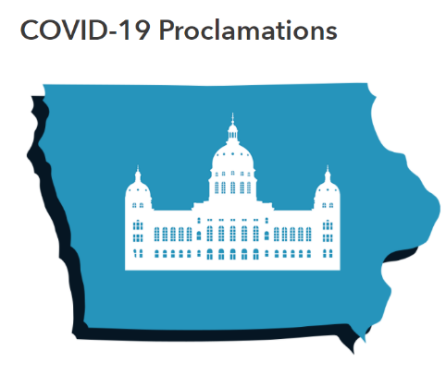
State resources have been activated and deployed to assist with the ongoing disaster at no cost to local jurisdictions. State resources include equipment, personnel, technical assistance/guidance, supplies, and essential services to provide assistance in the form of traffic control, security, vaccines, transportation, and other emergency response and recovery capabilities.
- Proclamation of Disaster Emergency signed 08/27
- Proclamation of Disaster Emergency signed 08/21
- Proclamation of Disaster Emergency signed 07/24
- Proclamation of Disaster Emergency signed 07/17
- Proclamation of Disaster Emergency signed 06/25
- Proclamation of Disaster Emergency signed 06/10
- Proclamation of Disaster Emergency signed 05/26
- Proclamation of Disaster Emergency signed 05/20
- Proclamation of Disaster Emergency signed 05/13
- Proclamation of Disaster Emergency signed 05/06
- Proclamation of Disaster Emergency signed 04/27 Part 1, Part 2, Part 3
- Proclamation of Disaster Emergency signed 04/24
- Proclamation of Disaster Emergency signed 04/16
- Proclamation of Disaster Emergency signed 04/10
- Proclamation of Disaster Emergency signed 04/06
- Proclamation of Disaster Emergency signed 04/02
- Proclamation of Disaster Emergency signed 03/31
- Proclamation of Disaster Emergency signed 03/26
- Proclamation of Disaster Emergency signed 03/22
- Proclamation of Disaster Emergency signed 03/19
- Proclamation of Disaster Emergency signed 03/17
- Proclamation of Disaster Emergency signed 03/13
- Proclamation of Disaster Emergency signed 03/09

ISFIS Memo on COVID-19 Metrics

August 26, 2020 (data updated to September 2, 2020)
Dear ISFIS Subscribers,
As school starts, Iowa’s return-to-school plan has two metrics which may trigger requests to move to a hybrid option with less than 50% in person learning or 100% virtual (required continuous learning) model. The 15% test positivity rate has both false positives (may create a false sense of urgency if there’s a very low incidence of COVID in the population) and false negatives (may create a false sense of security if there is a high incidence of COVID in the population but many well people are tested). Student absence, 10% or greater, due to COVID is a second indicator in the state plan. It may be more or less information depending on if you have credible access to the symptoms of absent students, but that doesn’t acknowledge staff capacity should you have a staff outbreak or need for quarantine.
Just like other decision-making, COVID metric analysis is better with multiple pieces of data. In student achievement, you minimally want proficiency, growth, and gap analysis, plus point in time and over time, to get a more complete picture. In school finance, unspent authorized budget, UAB trend, percent of general fund spent on staff, solvency ratio, again, point in time and over time, provide a more complete picture than one or two metrics in isolation.

At the end of this memo is the text from an article from ABC News, Aug. 10, 2020 https://fivethirtyeight.com/features/when-can-schools-safely-reopen-the-answer-is-part-science-part-guesswork/ that includes discussion by health experts and comparison of big picture state metrics to inform decision-making. It’s a good piece that explains in common language the intricacies of the necessary data to inform decisions and the importance of local context.

We’ve done a good scan of other state return-to-school plans in the nation, the CDC guidance, the recommendations of health experts, and other data experts, so we can provide you with additional metrics to consider to inform your decision, should your district hit the metrics in Iowa’s plan or should you be short of those measures but have reason to apply for a waiver due to other factors, so you can make the case with data. Here is what we found:

Common Elements in State Plans to Reopen Schools:
Categories of Community Spread: Most states have 3 or 4 categories of COVID spread typically based on multiple measures (Low, Moderate, High and sometimes Low, Moderate, High, Severe)
Most state plans reviewed allow in person or hybrid in the low category, hybrid or 100% virtual in the moderate, and often require 100% virtual in high and severe categories. Oregon has a unique rural school district exception (when very rural/small districts have a positive rate of tests but few actual cases, may continue in person learning based on local board decision).
Primary Measures:
- Incidence of Active Cases (typically per 50,000 or 100,000 population, typical range is from 3-5%, but no higher than 10% when this metric is used)
- Test Positivity Rate (percentage of tests conducted that were positive, typical range is 5%, a few at 10%, Iowa the highest at 15%)
- Trends (direction of the data, increasing or decreasing, over the last week or two weeks – sometimes the trend to reopen is also included, that there must be downward evidence of improvement for 14 consecutive days or with metrics dropping below what is considered a safe incidence or positivity rate before school reopens, rather than a fixed time window)
- Student Absence (sometimes stated as COVID-like symptoms or illness) or just Absence/COVID symptoms which may also include Staff capacity
Other measures used in local decisions recommended in state plans:
- Hospitalization admissions related to COVID
- Number of hospital patients on ventilators
- Nursing home cases
- Deaths
- Staff Absence

Data Sources:
Most states have data dashboards, typically at the county level, sometimes at the zip code level, some with the ability to click on neighboring counties to see how they are faring.
For Iowa, the data source maintained by Iowa Department of Public Health, has a button you can click on daily to check the 15% positivity threshold. https://coronavirus.iowa.gov/pages/percent-school-district-positive-analysis UPDATE: As of Sept. 20, 11 counties are above 15% and 2 counties within a percent of the threshold. These counties contain 87 of Iowa’s 327 school districts (26%).
This site also has positive active case counts per 100,000 population, which is a measure of disease incidence. https://coronavirus.iowa.gov/pages/case-counts We still don’t know if this data set is reporting everything consistent with how other states are doing it. One state plan made an assumption that for every positive active case in a county, there was likely another positive active case that wasn’t reported.
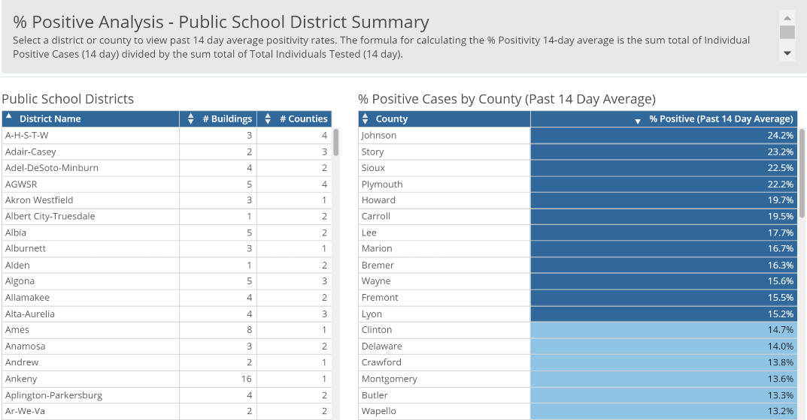
Updated picture of Sept. 2, 2020 % positive report color codes those counties which are above the 15% benchmark. It reports the last 14-day positivity rate, but does not show any history, so there is no way to determine the trend.

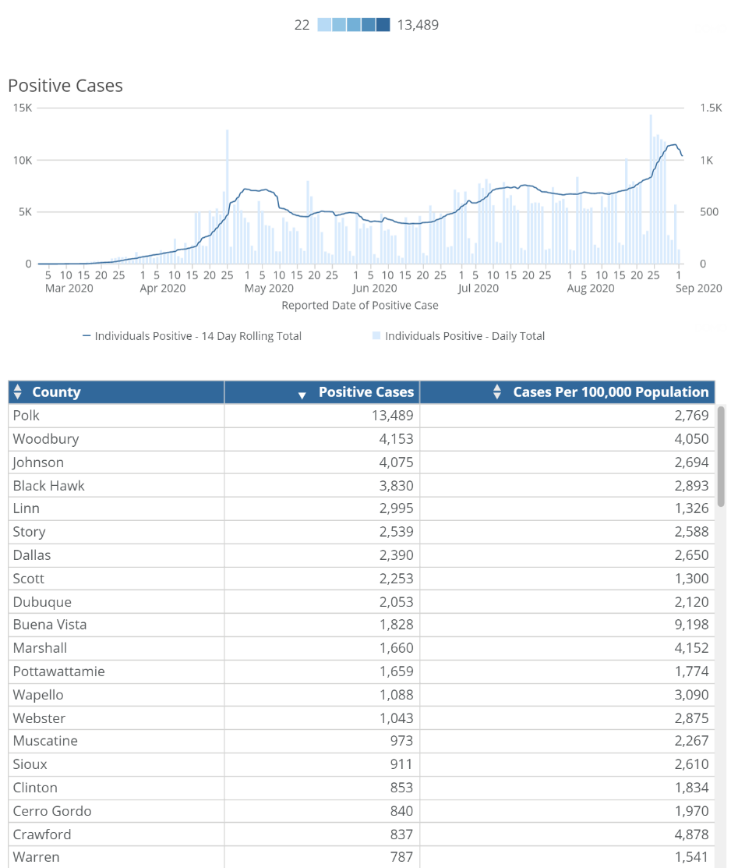
Update: The picture of today’s (Sept. 2) incidence report shows the top 20 counties by number of active cases and also shows that statistic per 100,000 population.
The graph shows the statewide trend.

The six of the top seven counties on this list are under further restrictions from the Governor’s latest order to close bars and stop serving alcohol in restaurants after 10:00 PM:

Click on the county in the database, and you can see the trend for the county.

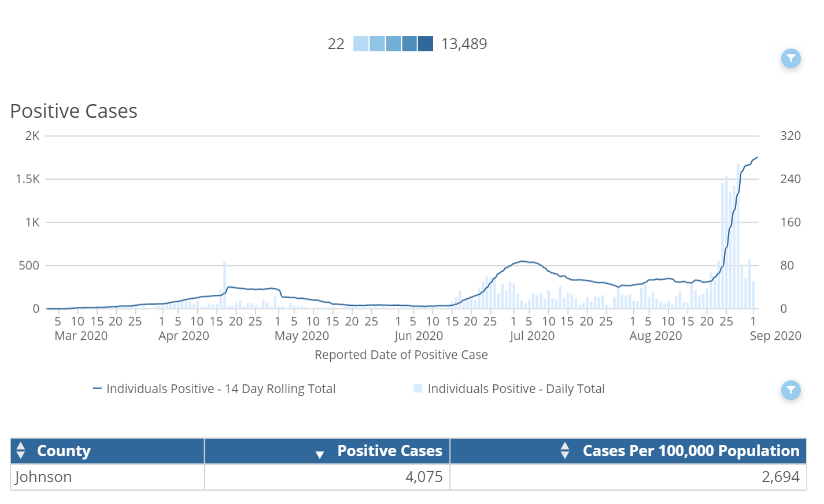

Johnson County’s trend is pictured here (as of Sept. 2.)

Other Data: credible sources to confirm or support your request for change to instructional model.
IowaCOVID Tracker is a great source, compiled and updated daily by a former Iowa Department of Public Health expert with help from Iowa State University expertise. https://iowacovid19tracker.org/ Contact Information: Email: sara.anne.willette@gmail.com Facebook: http://facebook.com/sara.anne.miller Twitter: @amethystarlight
This is one of the sources that has shown differences compared to the IDPH data but explains on their site where the data comes from and what’s included. This link shows the percent positivity history that is not included on the IDPH site above by county, so you can see the trends. https://iowacovid19tracker.org/active-infections/
Update Sept. 2: Butler County in Northeast Iowa, for example, at 13.2% positivity, shows this trend of active cases increasing whereas Crawford County at 13.9%, shows a much less aggressive trend. Trend is a key component of decision-making regarding the urgency for social distancing and the decision to go 100% virtual (required continuous learning) for school district to slow the community spread while protecting students, staff and their families:
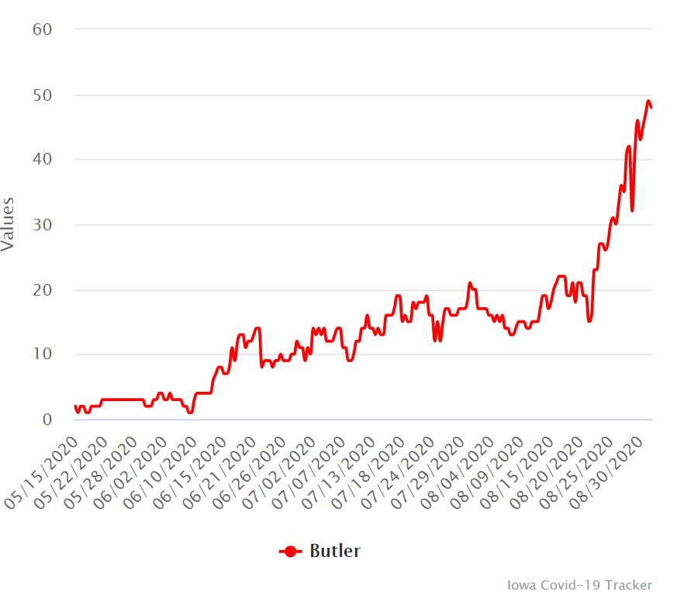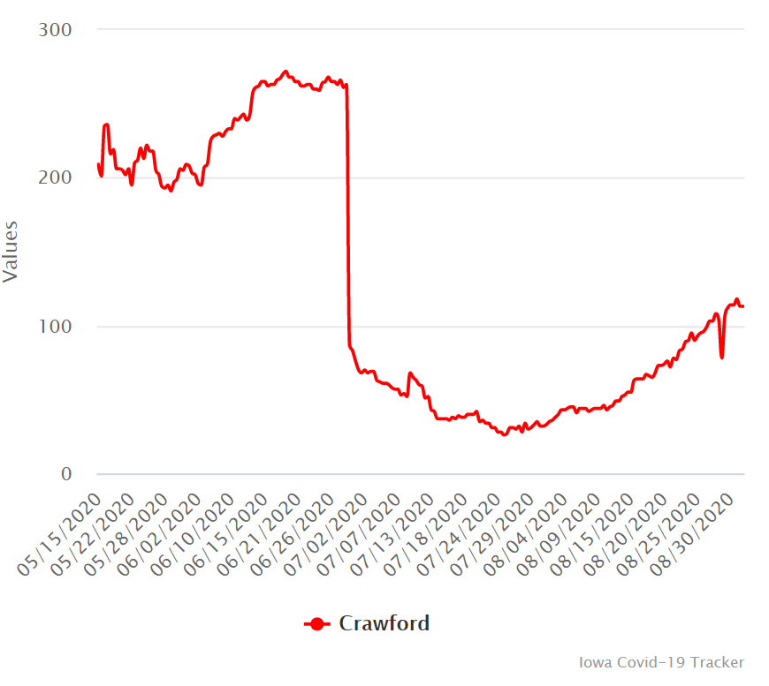
Attendance: Both student and staff attendance are critical indicators for both the need of students to have virtual options and the ability of districts to get students to school (transportation employees) and educate them while there (teachers) and keep them safe (custodians and school nurses).

Working with Others:
School district leaders are already connecting with local county public health experts, but capacity differs county to county. When there is conflicting information from two or more county recommendations for your next steps, engage with the Iowa Department of Public Health for assistance, including contact tracing burdens that should not disproportionately fall on school districts. Districts are also encouraged to connect with the DE to brainstorm ideas about social distancing possibilities within a hybrid plan.

Schools can also work together with other districts in the county or region, to get on the same page in understanding the data, although local school characteristics may dictate different responses to the same information.
CDC recommendations: SF 2310 encourages school districts to consult with IDPH, county local health, and the CDC. Those recommendations are changing as experts learn more. See the latest here: https://www.cdc.gov/coronavirus/2019-ncov/community/schools-childcare/prepare-safe-return.html
When applying to the DE for a waiver to move to a different instructional model, these additional metrics, and trends, should help you provide alternative justification for your recommendation.
Lastly, the following is some information about other states and their plans, compared to Iowa.
Specific State Plans
Source: Ballotpedia on School Reopenings in the 2020-21 Academic Year
https://ballotpedia.org/School_reopenings_in_the_2020-2021_academic_year_after_the_coronavirus_(COVID-19)_pandemic#cite_note-OH72-87
Other original sources gleaned from the above were checked to make sure the plans were reported in the correct category.
Status of School Reopenings for 2020-21 School Year Posted Sept. 2, 2020
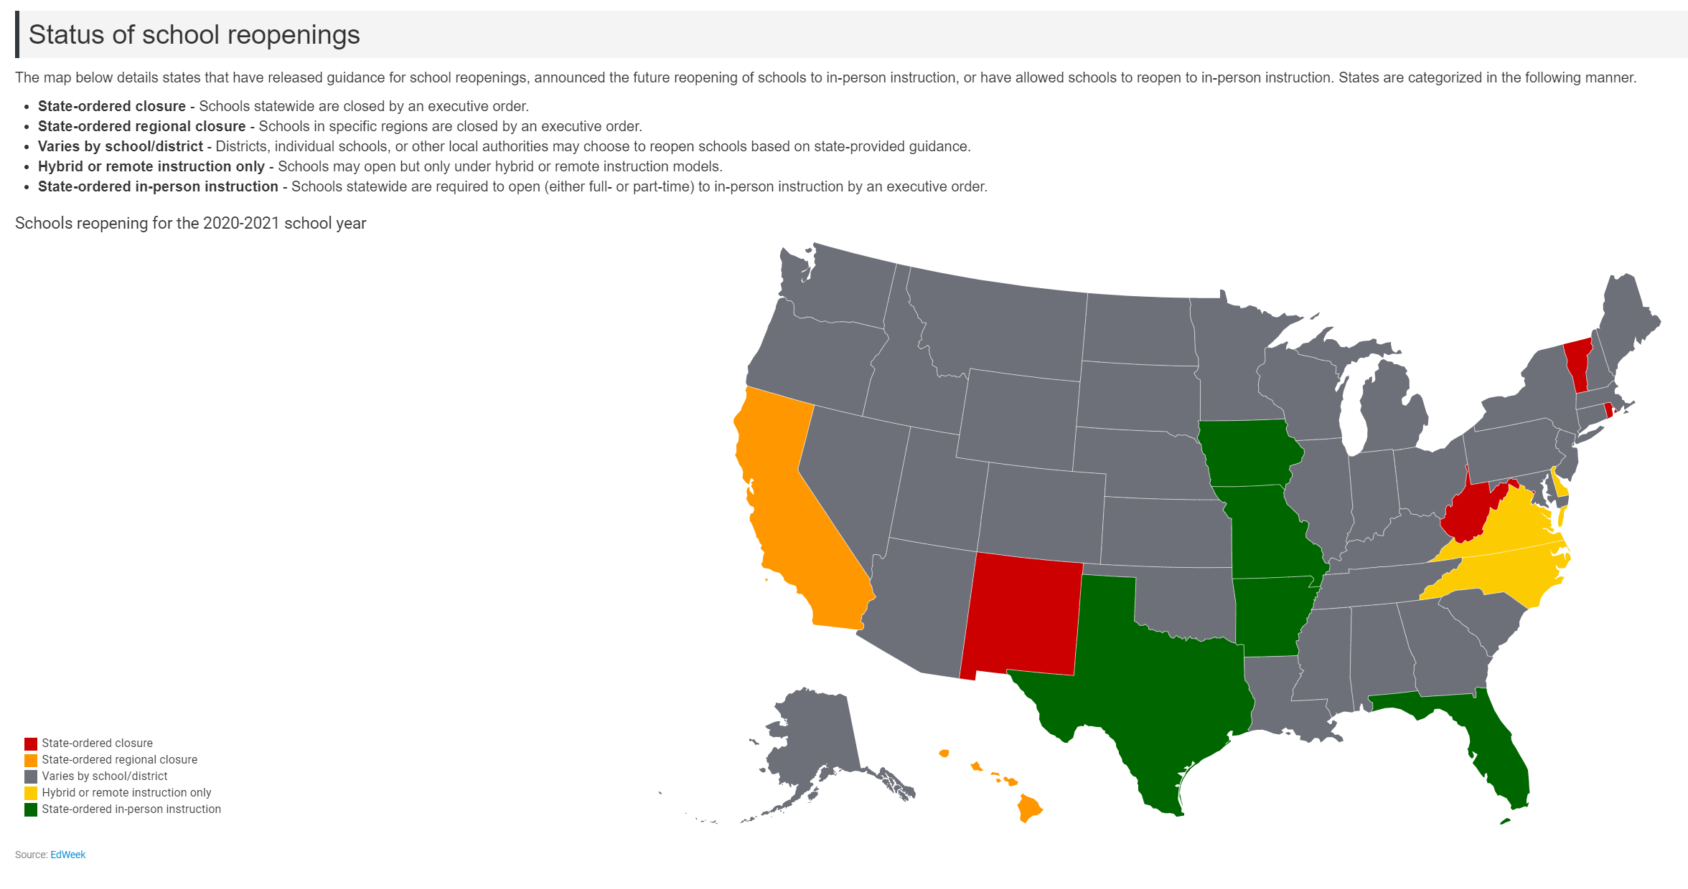
Tally of states from the above Ballotpedia map:
- 5 states require schools to open unless state grants closure (includes Iowa)
- 4 states require 100% virtual until certain benchmarks are met
- 5 states require hybrid or remote only or state-ordered regional closure
- 36 states vary by local school board decision with some states providing some parameters
Some examples from the Ballotpedia Information and the state plan original sources follow:
Individual State plans, metrics and links
Click here for the Excel file of state plan components regarding local authority versus state decision-making approval gleaned from our review: https://www.iowaschoolfinance.com/system/files/members/Public/Reopening%20School%20Plans%20Ballotpedia%208.24.2020.xlsx
Specific examples follow.
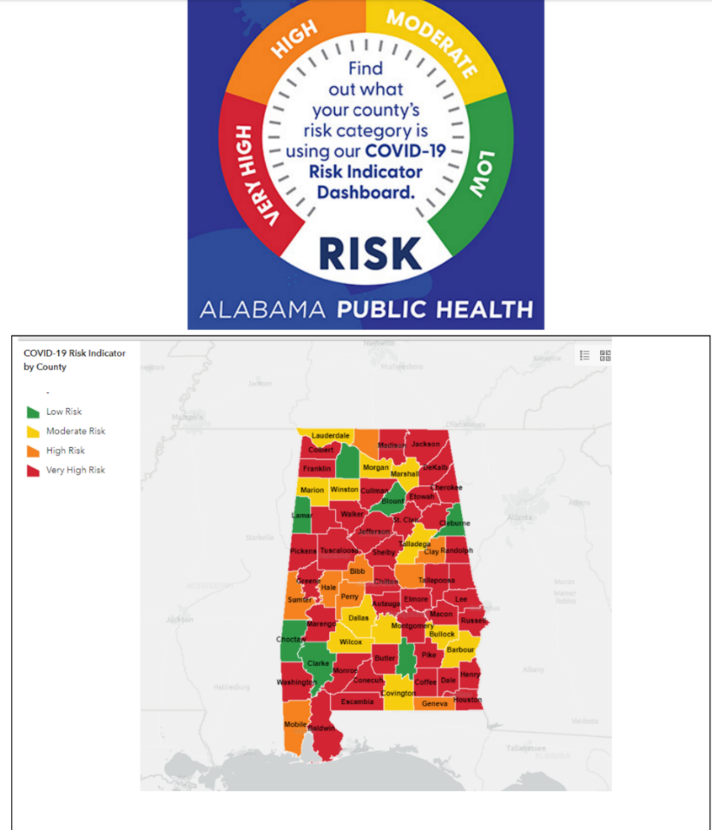
Alabama: County risk categories based on multiple data Link to Alabama DPH COVID Tool Kit

Data dashboard by county for Alabama: confirmed cases, tested positive, deaths, etc.
Link to Alabama COVID data dashboard

Arkansas: Data on incidence of active cases
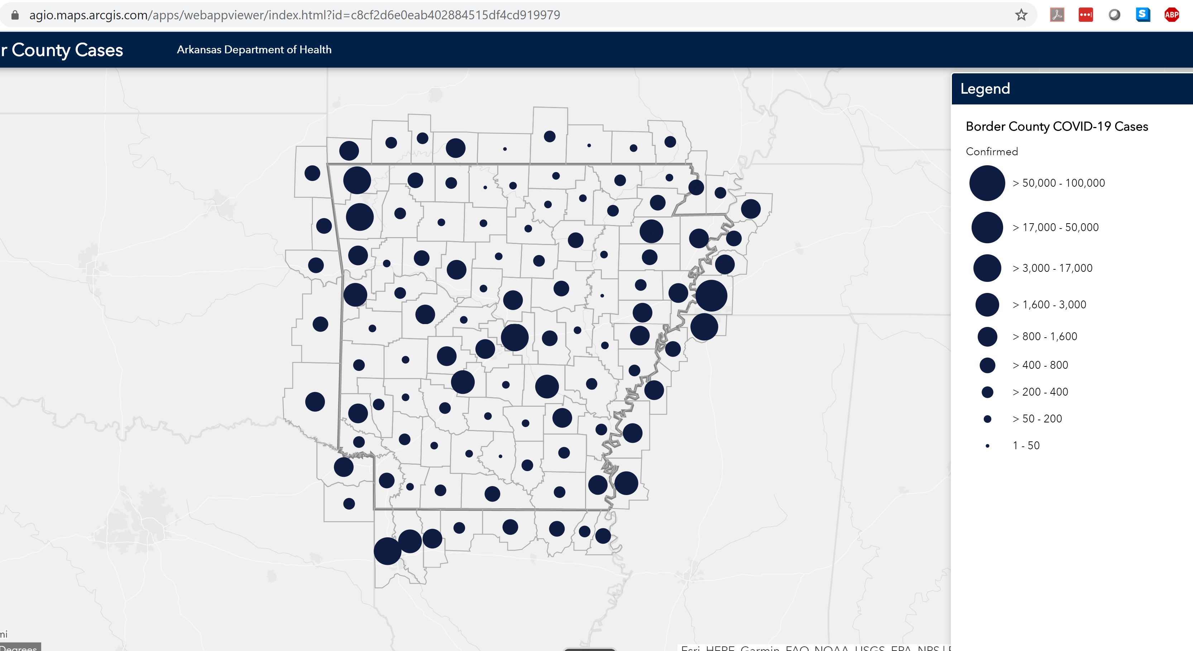

Arizona metrics https://www.azdhs.gov/documents/preparedness/epidemiology-disease-control/infectious-disease-epidemiology/novel-coronavirus/covid-19-safely-return-to-in-person-instruction.pdf Aug. 6, 2020 Arizona Dept. of Health Services
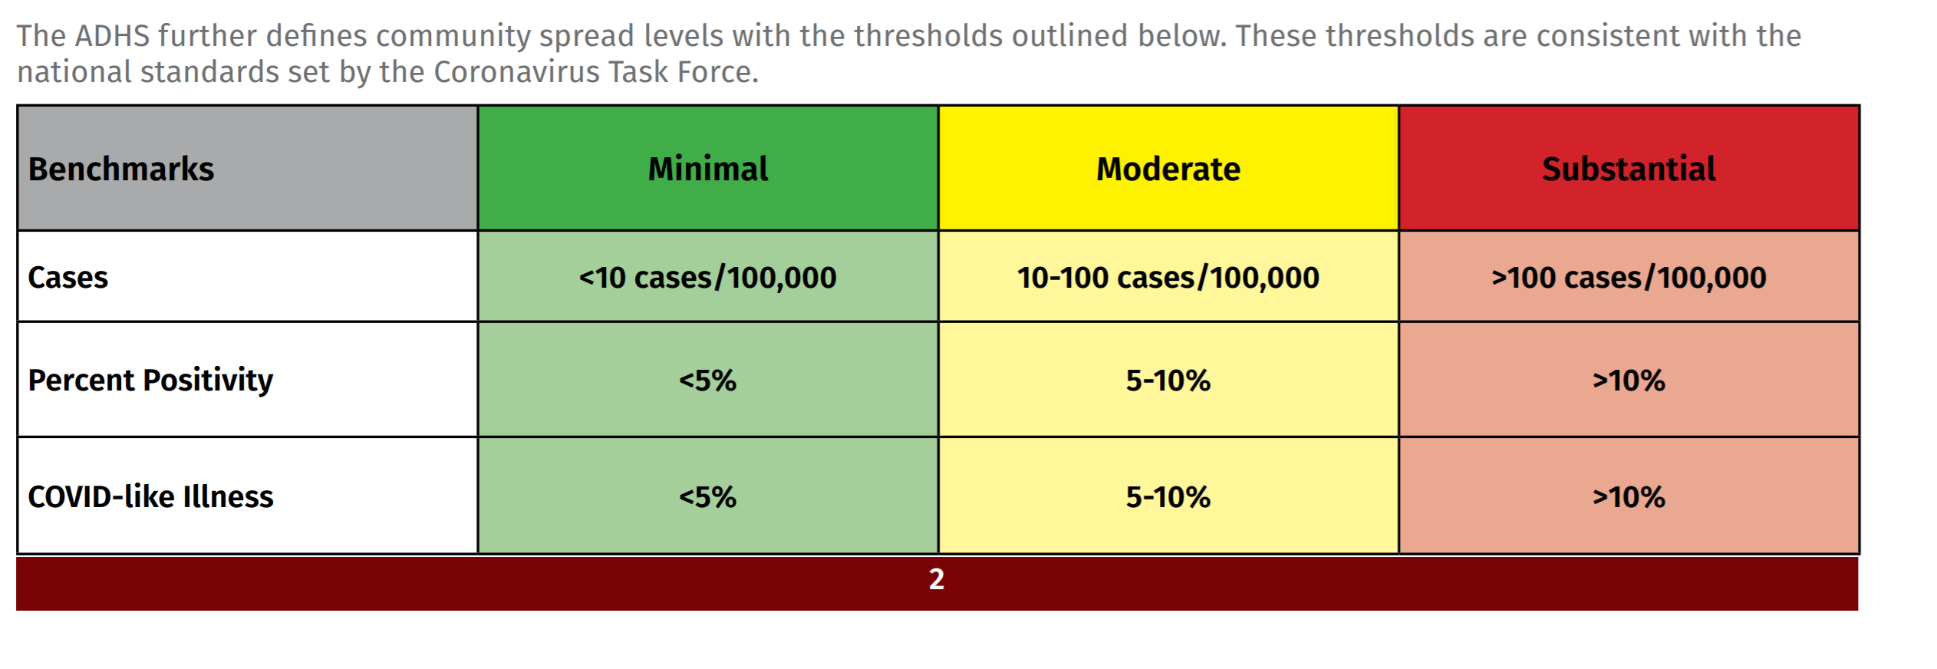
The Buckeye Elementary school district, which runs seven K-8 schools outside Phoenix, opened in full remote-learning mode Aug. 5, said Kristi Wilson, its superintendent. But an executive order by Gov. Doug Ducey requires schools to allow children to come to school starting on Aug. 17 if parents need a place for them to go. Here’s the data dashboard for Arizona schools which includes multiple measures by county.
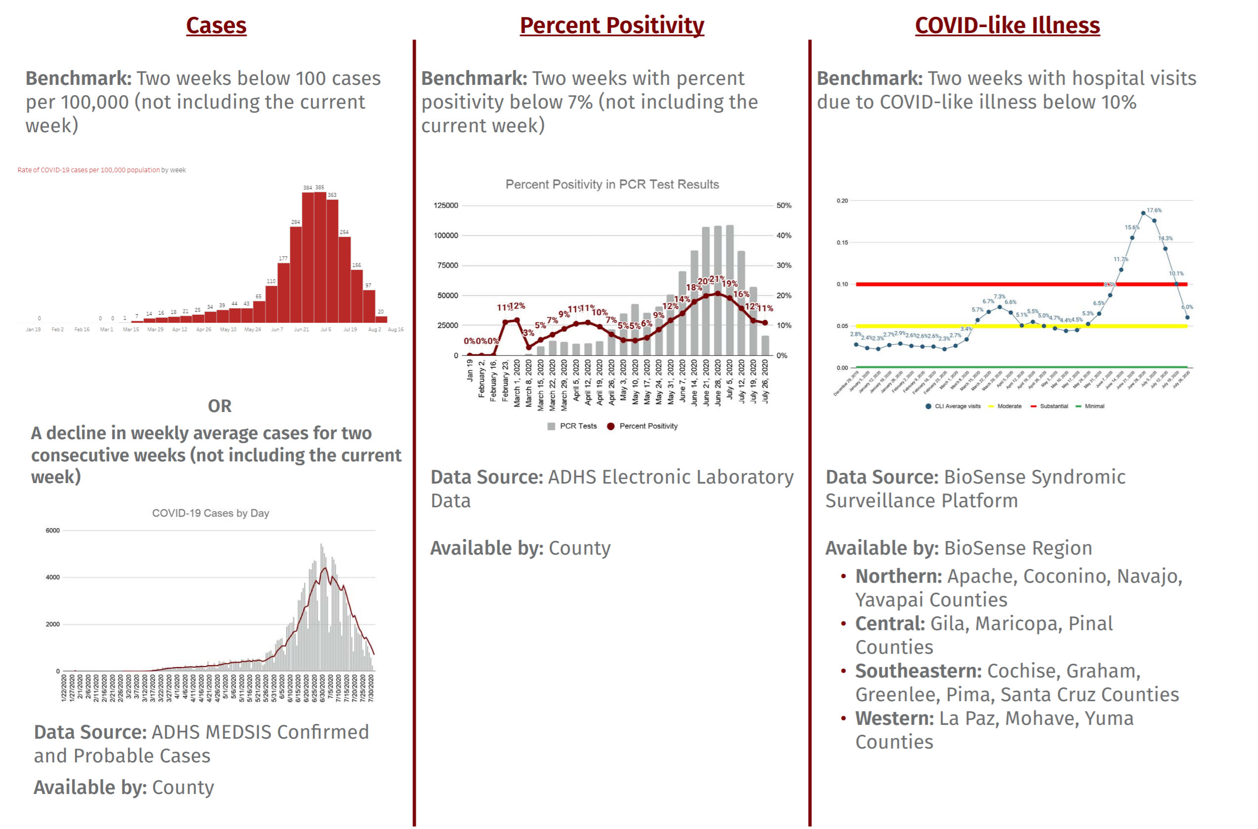
Maricopa County AZ https://www.maricopa.gov/5594/School-Metrics
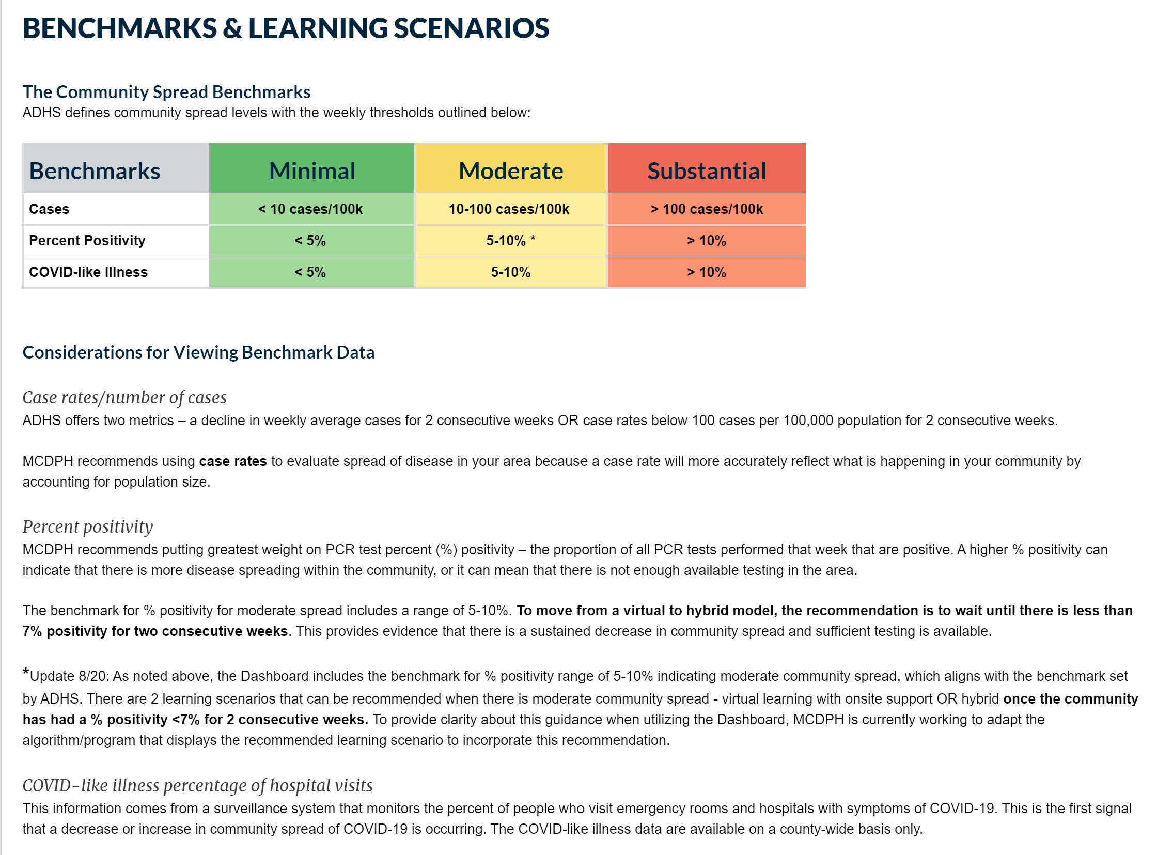
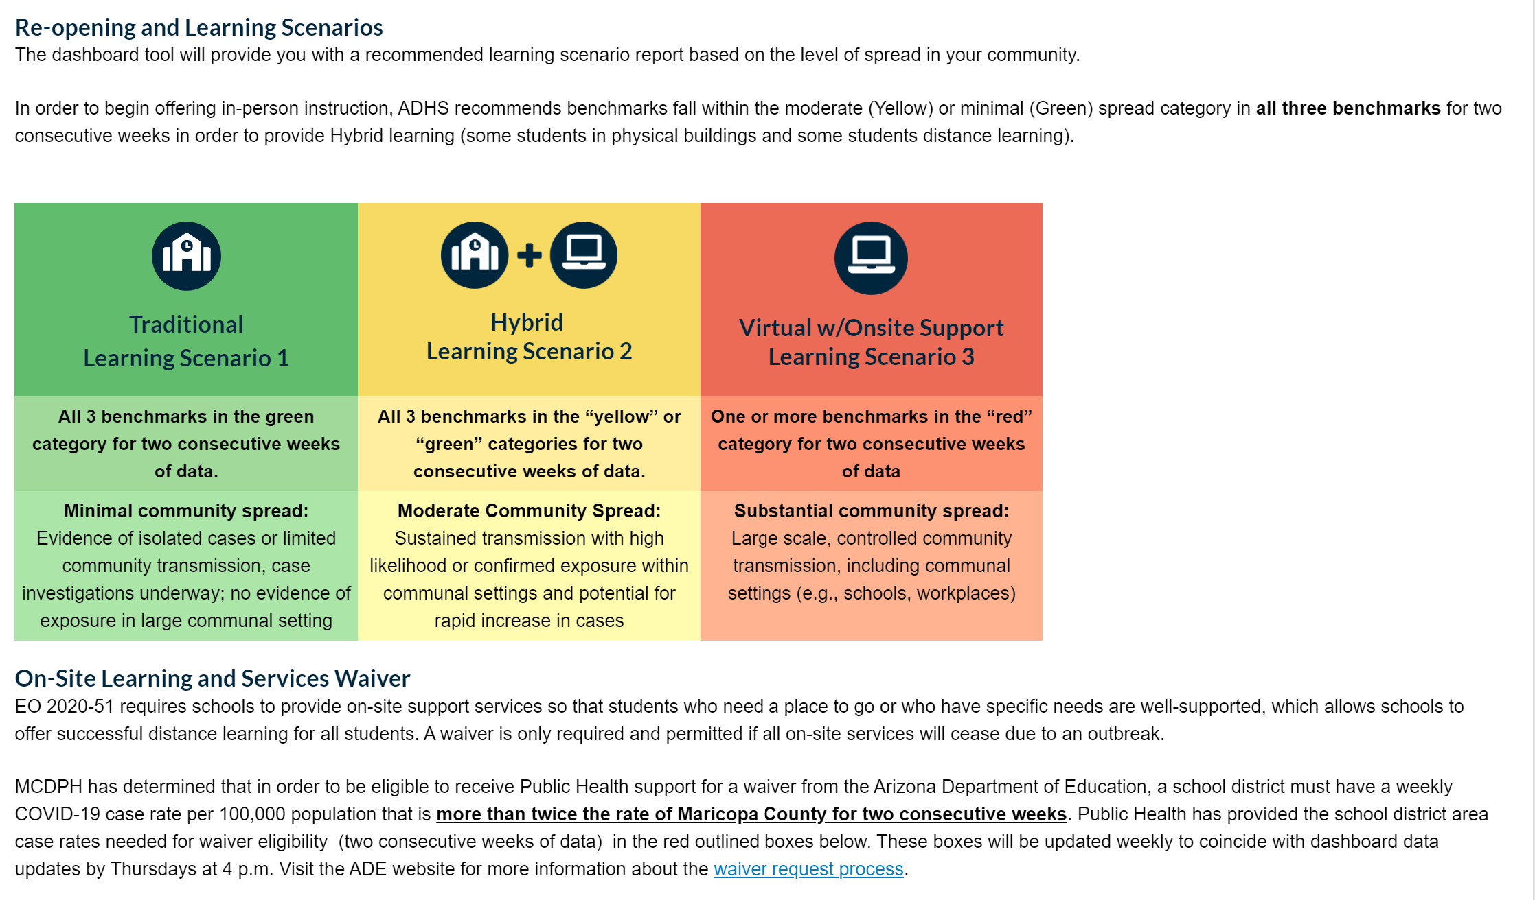
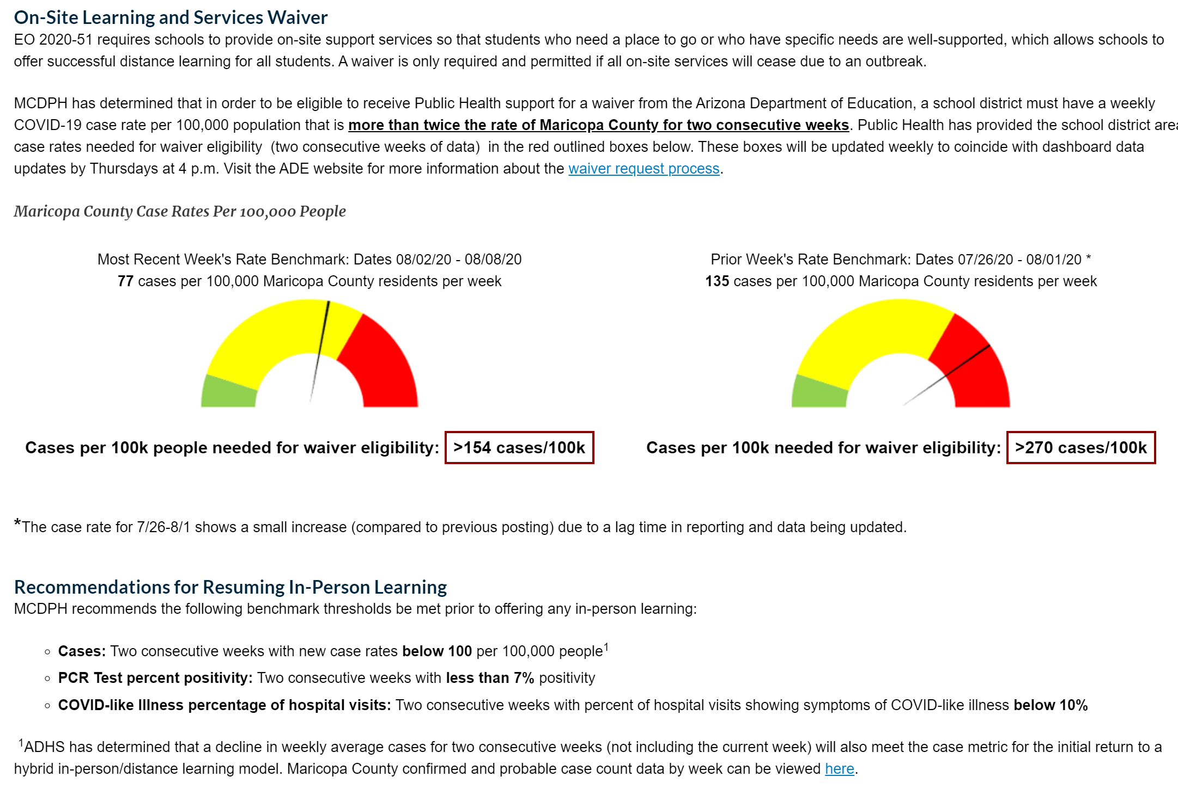

https://www.azed.gov/communications/on-site-learning-and-services-waiver-request/

Arizona Education Department waiver from having to provide some in person based on outbreak: District determines the start and end date of the waiver in the application (not limited to two weeks).
Waiver requests will be considered independently of the public health benchmarks. ADE will review submitted waiver requests and supporting documentation on a rolling basis.
Pennsylvania: https://www.post-gazette.com/news/education/2020/08/10/pa-reopen-schools-guidelines/stories/202008100089
A low risk of community transmission would mean there were fewer than 10 cases per 100,000 residents and a positivity rate of less than 5% during the most recent seven-day period. When there is a low risk, the state recommends schools reopen fully or in a blended model, a combination of in-person and online instruction.
A moderate risk would mean there were 10 to any number lower than 100 cases per 100,000 residents, or a 5% to less than 10% positivity rate. If there is a moderate risk, the state said instruction should be totally remote or blended.
And when there is a substantial risk — 100 or more cases per 100,000 residents or a 10% or greater positivity rate — instruction should be fully remote, according to the state.
Michigan: EdWeek 8/13/20 https://www.edweek.org/ew/articles/2020/08/13/schools-reopen-and-covid-19-cases-crop-up.html
In the Detroit area, where most schools won’t open until early September, Randy Liepa is advising schools to plan for “rolling closures”—he considers it likely that buildings with in-person instruction will have to close at some point, because students or staff test positive or because of virus patterns in their local communities. Liepa, who oversees support services for 33 districts and 100 charter schools in the area, is seeing more districts opt for all-remote instruction because they’re not confident they can keep students and staff safe, he said.

Georgia https://dph.georgia.gov/covid-19-daily-status-report
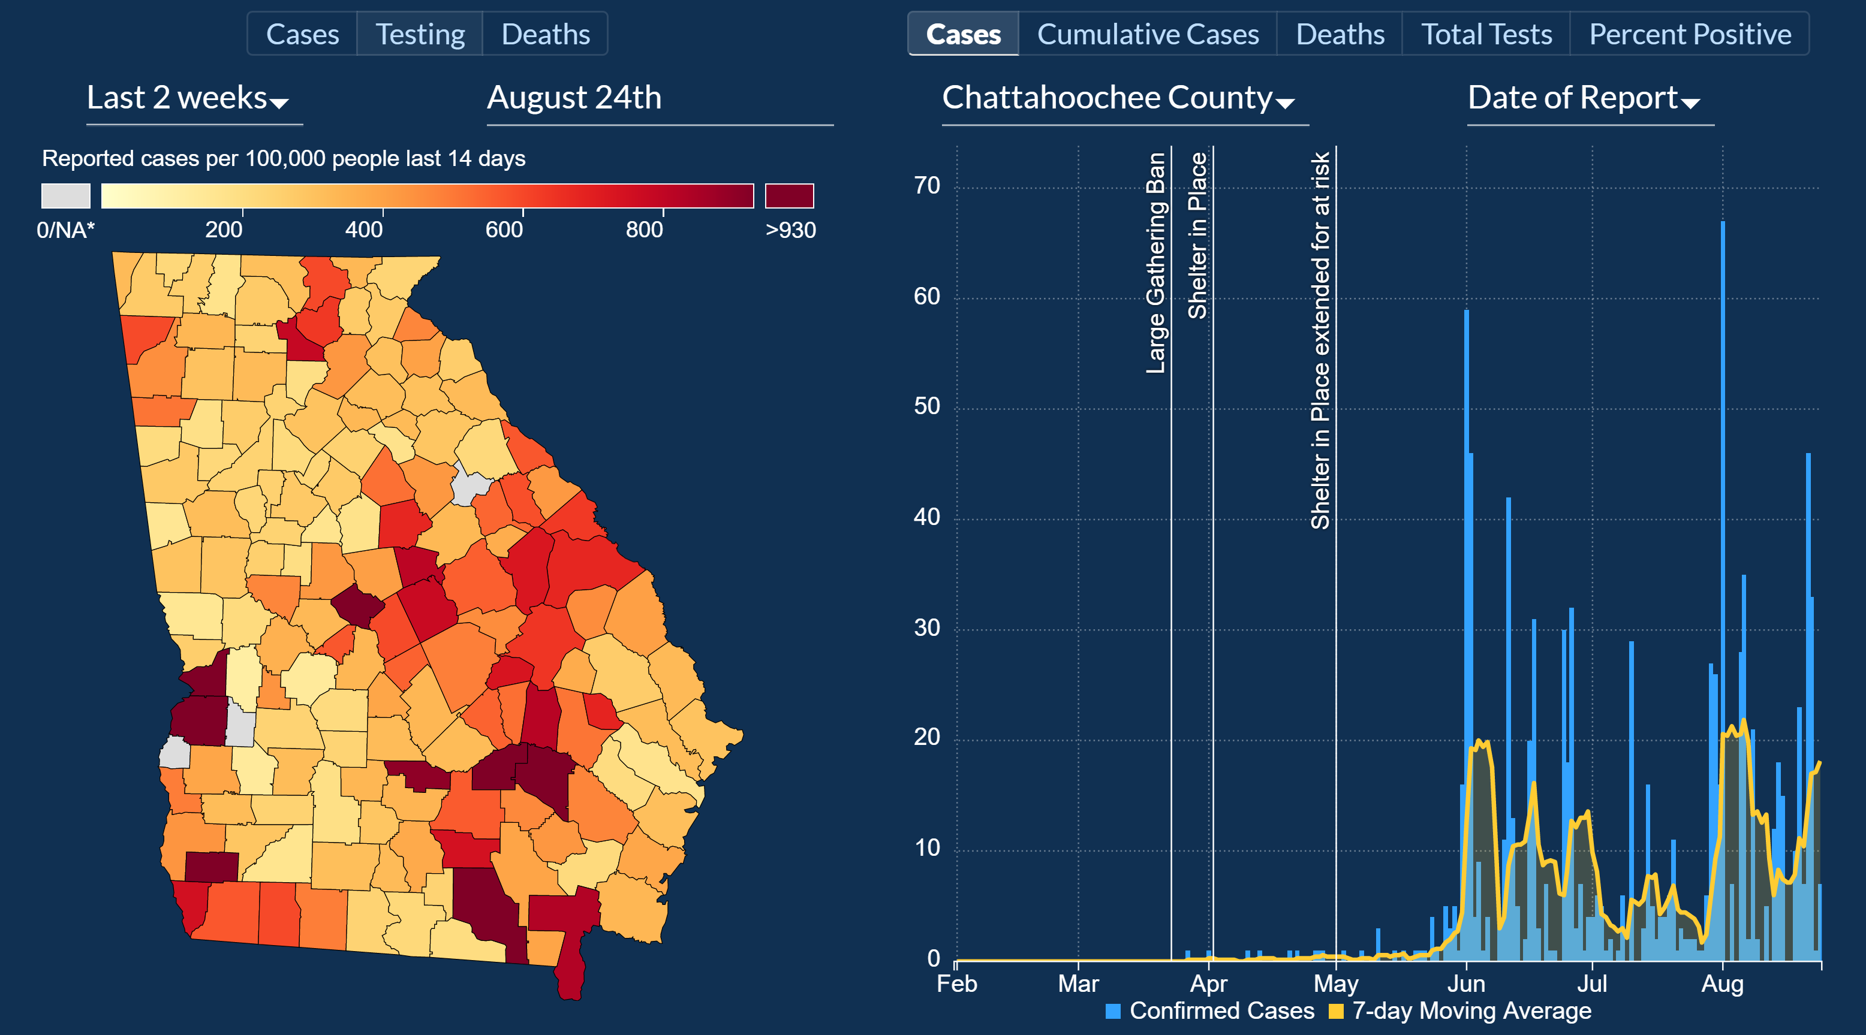
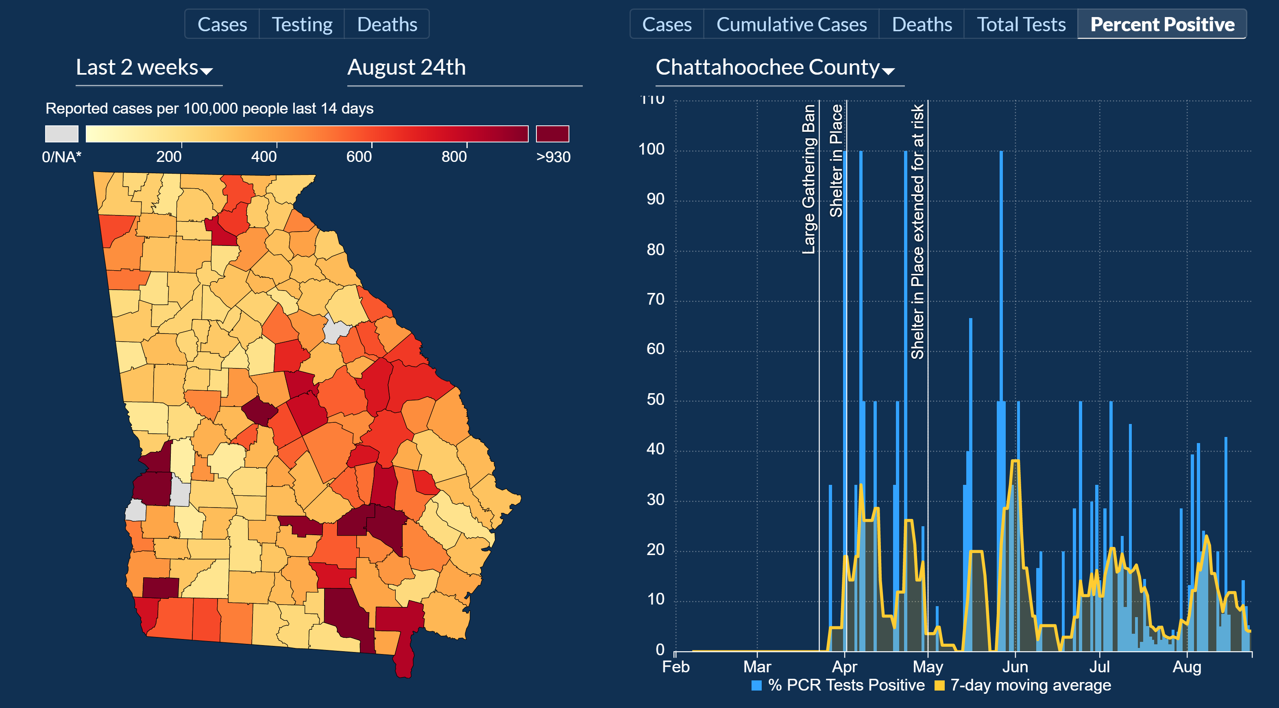

Massachusetts https://www.bostonglobe.com/2020/08/12/metro/when-should-districts-use-only-remote-learning-state-issues-new-metrics-help-districts-decide-based-covid-19-infection-rates/
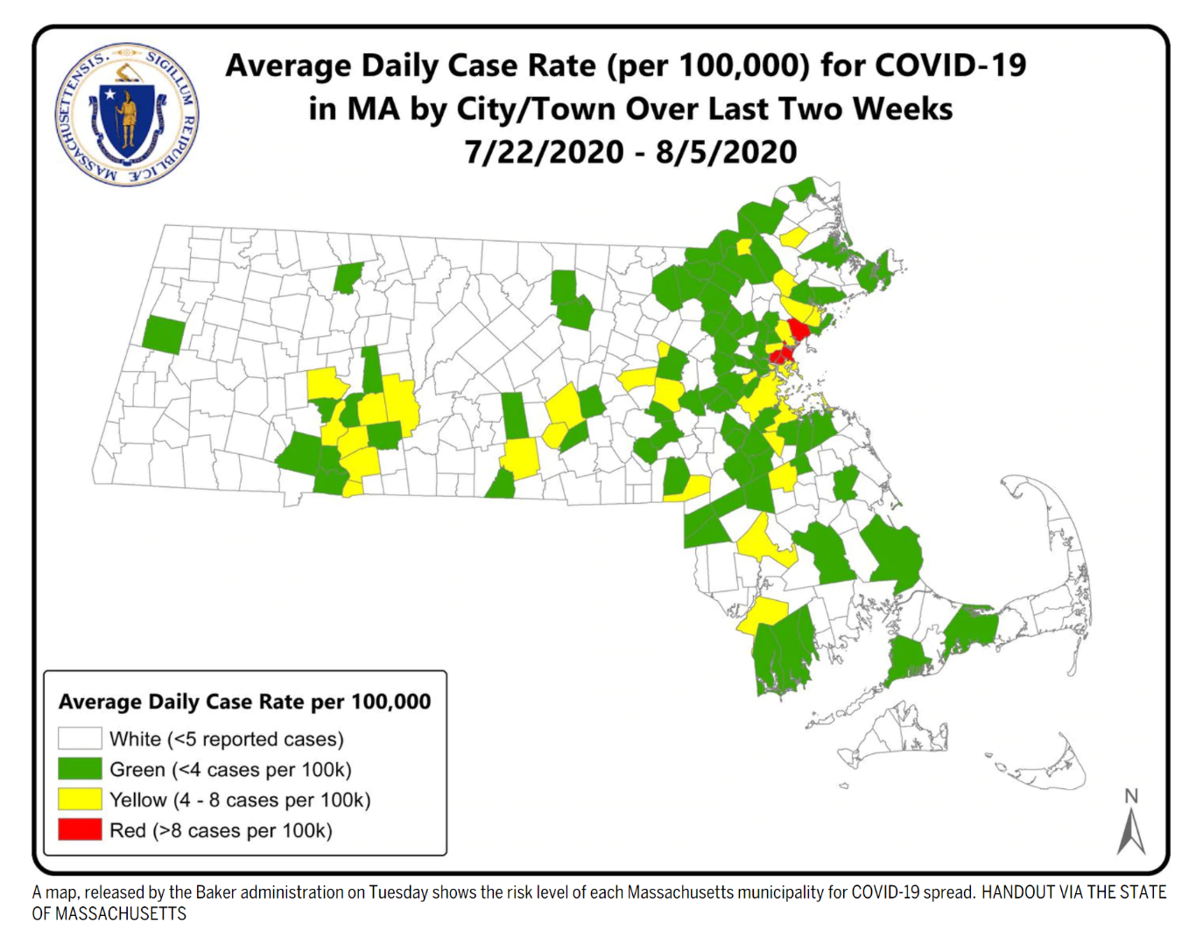
Locals decide but state provides this color coded map to inform based on case rate per 100,000 population
Kansas https://ballotpedia.org/Kansas%27_plan_to_reopen_schools_for_the_2020-2021_academic_year_after_closings_due_to_the_coronavirus_pandemic
The Kansas State Department of Education released school reopening guidance on July 13. The plan contains recommendations and consideration for schools and districts. It does not discuss requirements. The document’s introduction says, “The purpose of this document is not to prescribe what schools should do, but rather what considerations and discussions should happen in schools as they plan to support their students and communities as they navigate the uncharted waters of providing a quality education during the COVID-19 pandemic.”
In-person, hybrid, and online learning
The plan contains recommendations for schools conducting on-site, hybrid, and remote operations. Schools and districts are encouraged to consider which method is appropriate for their communities and make changes to their schedule throughout the school year as circumstances allow.
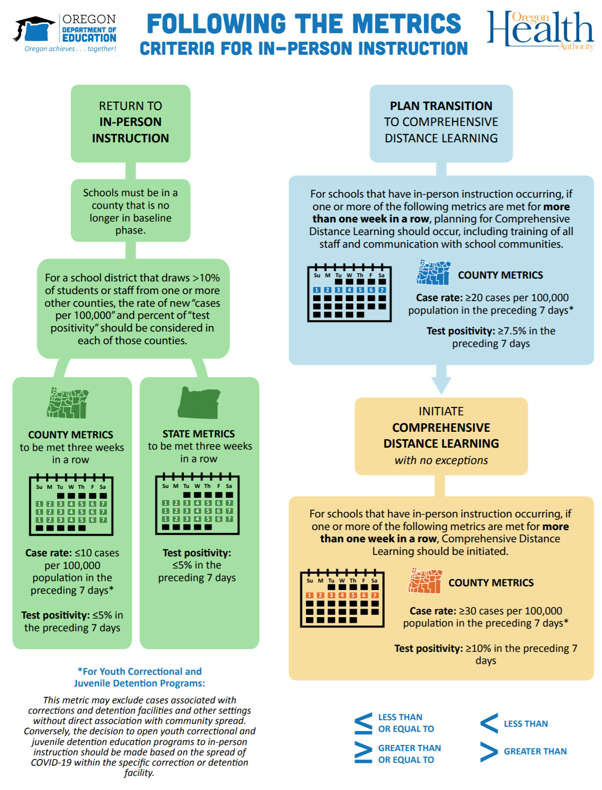
Oregon https://www.oregon.gov/ode/students-and-family/healthsafety/Documents/Following%20the%20Metrics%20Visual.pdf
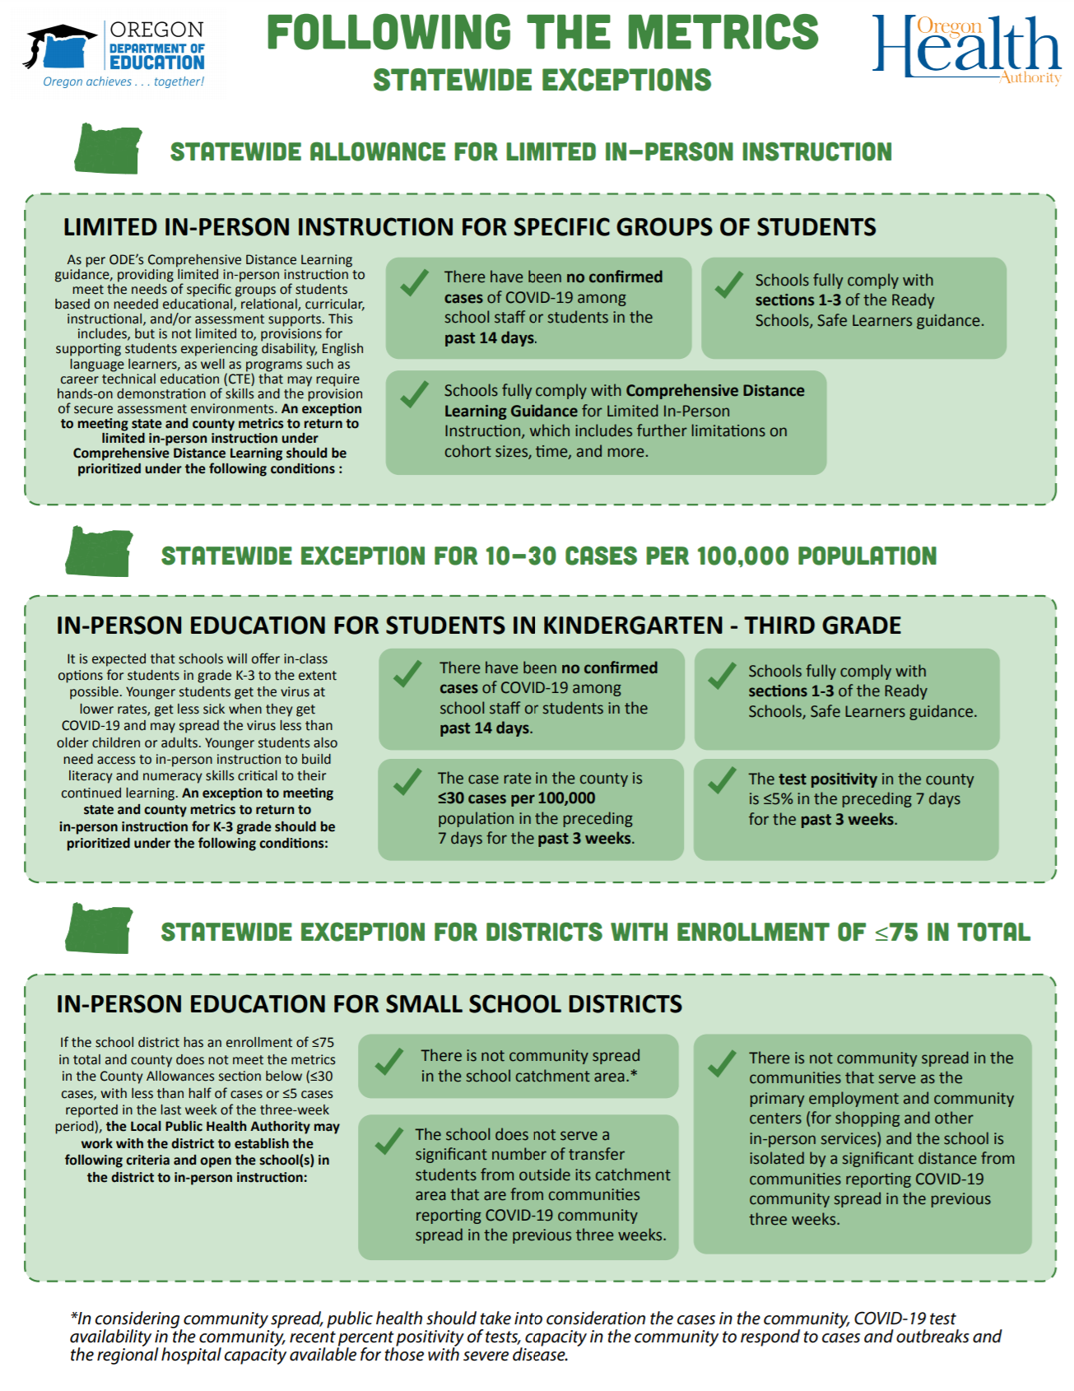

Pennsylvania https://www.education.pa.gov/Schools/safeschools/emergencyplanning/COVID-19/SchoolReopeningGuidance/ReopeningPreKto12/Pages/DeterminingInstructionalModels.aspx
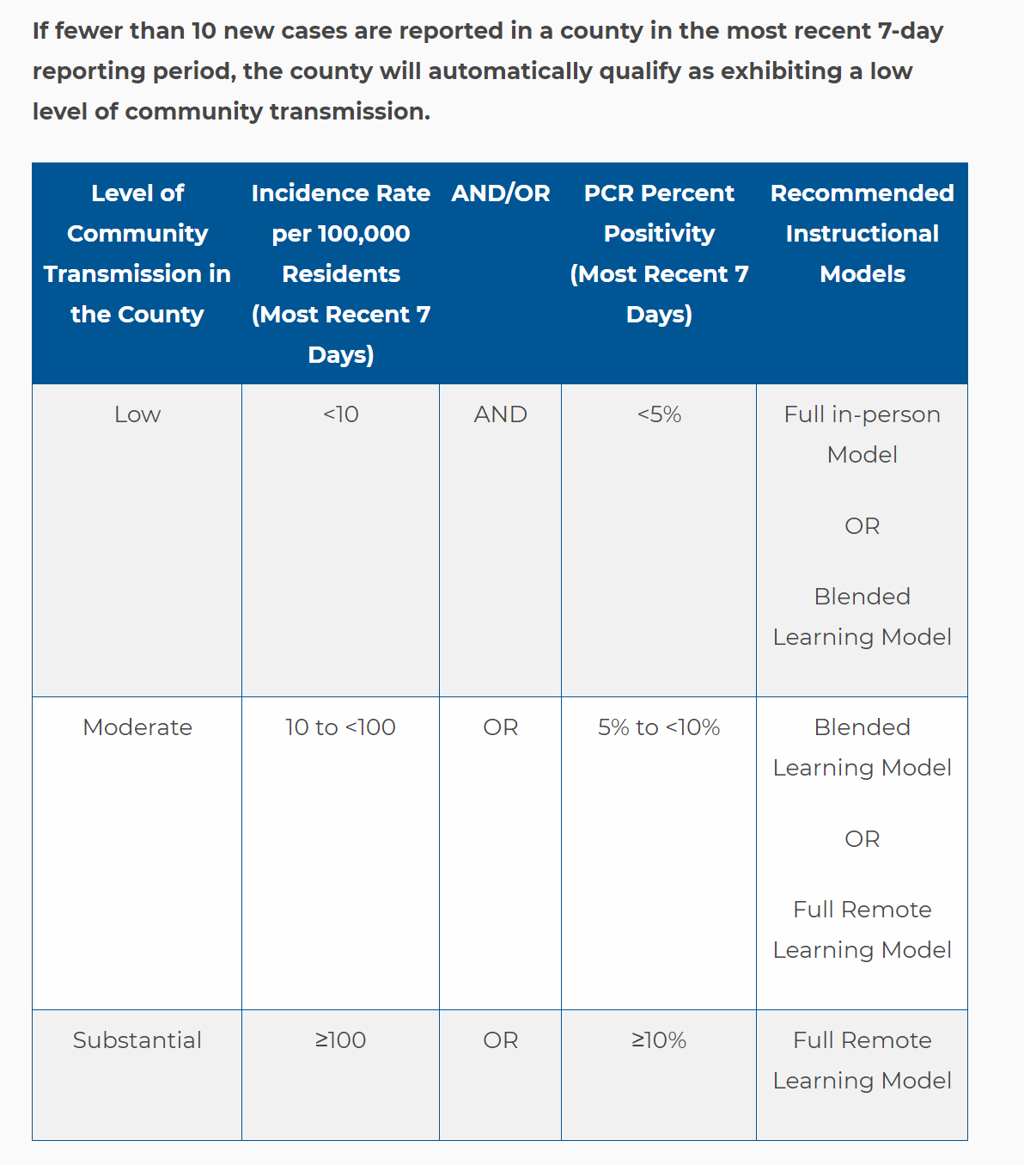

Transitioning Between Instructional Models (still PA)
A county’s corresponding threshold may change week-by-week as incidence and percent positivity rates rise and fall. In order to confirm stability of county transmission, when a county’s corresponding threshold changes, school entities should wait to see the results from the next 7-day reporting period before considering a change to their instructional models. To ensure the most effective transition for students, it may be appropriate for a school to wait even longer, up to a full marking period, to transition to an instructional model that increases in-person instruction.
It is important to note that a significant and/or widespread outbreak may require moving to a more remote-based model more quickly.
The Department of Health will provide proactive consultative assistance to school entities should such an outbreak occur.
https://www.education.pa.gov/Schools/safeschools/emergencyplanning/COVID-19/20-21FAQs/Pages/FAQs-on-Instruction-Model-Recommendations.aspx
From FAQ by PA DE:
Are the Recommendations for Pre-K to 12 Schools in Determining Instructional Models mandatory?
No. These recommendations from the Departments of Health (DOH) and Education (PDE) are intended to provide an additional tool for school entities to use when making local decisions, which will also require school leaders to consider numerous local factors, including size of the school entity, classroom size, school resources, proportion of staff and students with special needs and underlying health conditions, and the ability to accommodate remote learning with equal access for all students.

South Carolina https://www.scdhec.gov/infectious-diseases/viruses/coronavirus-disease-2019-covid-19/sc-cases-county-zip-code-covid-19 data by state, county or zip code 2-week incidence per 100,000 population, arrows showing up or down trend.
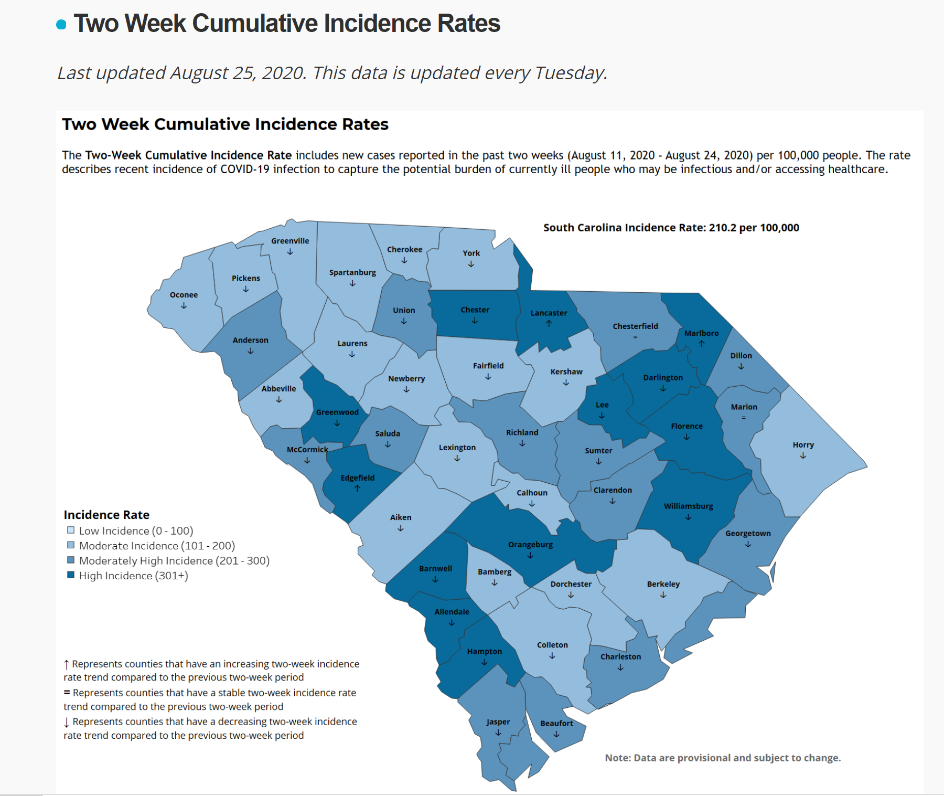

The text from the article mentioned above follows here in its entirety:
ABC News, August 10, 2020 https://fivethirtyeight.com/features/when-can-schools-safely-reopen-the-answer-is-part-science-part-guesswork/

In New York state, Governor Andrew Cuomo said schools could reopen if no more than 5 percent of local COVID-19 tests were coming back positive.¹ But in New York City, Mayor Bill de Blasio and Schools Chancellor Richard Carranza said schools couldn’t reopen unless the positivity rate was below 3 percent.² In Arizona, it’s 7 percent;³ in Minnesota, it’s 10 cases per 10,000 residents.⁴ And in Iowa, schools won’t be allowed to close for anything less than a 15 percent positivity rate.⁵

This wide array of thresholds makes clear that, as with everything else related to COVID-19, there’s no one right answer. Scientists and school administrators agree that school-reopening guidelines require a combination of science and, well, a bit of guesswork.
“The actual metrics represent expert opinion and modeling data,” said Dr. Thomas Tsai, a surgeon and health policy researcher at Harvard T.H. Chan School of Public Health.
In setting thresholds, the science — disease modeling and data from earlier in the pandemic — can help narrow the window. Many researchers agree, for example, that when the positivity rate in a community climbs higher than 10 percent, or prevalence increases higher than 25 new cases daily per 100,000, it’s a sign that testing might not be enough to curb the spread. At that point, cases could start to climb exponentially, faster than they can be caught, and schools would be a natural hotbed for an outbreak with so many people gathering in close quarters every day and then returning to the community in the evening and on weekends.
It’s a bit of a snowball effect; the higher the prevalence of disease, the harder it is to track and isolate new cases, leading to further spread. But what matters most is how a community responds once a threshold is breached, no matter what the threshold is. “It’s not so much the number, it’s what the corresponding action is,” Tsai said.
Tsai and a team of researchers at Harvard published guidelines for reopening schools in the U.S., and settled on a recommendation that community positivity rates should be below 3 percent before kids and teachers go back to school.

The level of community spread is a key metric for deciding whether to reopen since schools are, you know, schools. “If you think about schools, it’s even more of a bubble than reopening a restaurant or reopening a business,” said Dr. Tina Tan, an infectious-disease pediatrician at Northwestern Feinberg School of Medicine. “Schools really are their own microcosm where you have a lot of individuals from different areas in the community coming in.”
If a disease is prevalent in an area, it’s almost inevitable that schools would soon become breeding grounds for outbreaks.
But when it comes to establishing guidelines, science can take us only so far. What’s the difference between a 10 percent positivity rate and a 9 percent one? Enough to close schools in one scenario but open them in another? At some point, it becomes a judgment call, which is why jurisdictions’ rules vary so much.
“The test positive rate is sort of just common sense,” Tsai said. “It’s not like there’s a magic level for it, it’s directional. Three percent is better than 5 percent, which is better than 10 percent.”
That guesswork has prompted some jurisdictions to seek out more than just one metric. In Arizona, the state Department of Health Services published guidelines for reopening schools that take into account not only test positivity rate but also case prevalence and the number of hospital visits for COVID-like illnesses. For a community’s schools to reopen, there must be two consecutive weeks⁶ when the positivity rate is below 7 percent, the case prevalence is below 100 per 100,000 people, and hospital visits for COVID-like illness are under 10 percent.⁷
Dr. Cara Christ, director of the Arizona Department of Health Services, said she and her team considered other states’ metrics as well as the guidelines from Harvard, the White House coronavirus task force, the World Health Organization and the state’s own local data from earlier in the spread. But while all that research helped them establish the ranges for each metric, eventually they had to just pick a number.
“We just wanted to make sure that somebody didn’t reopen at 9.5 or 9 percent and then all of a sudden they’re back at a substantial level of spread,” said Christ. “There were some discussions like, ‘Why not 8? Why not 6?’ We were trying to find something that was relatively reasonable and based on our previous data.”
Looking to other countries that have successfully reopened schools reinforces those thresholds. Both Denmark and Finland were able to reopen schools without seeing a substantial spike in cases, but first they waited until local community spread was low. Schools in Finland reopened when there was a 3 percent positivity rate nationwide. In Denmark the positivity rate was at 6 percent when primary schools reopened, and under 1 percent when high schools reopened a month later.

Near Misses and Concerns

Near Misses and Concerns: Since the 2020 Session was the second year of the two-year biennium, all bills introduced must completely start over in the 2021 Session.
SF 199 Voluntary Diversity Plans/Open Enrollment; this bill was resuscitated from the 2019 session, approved on a very close vote, with 8 senators in favor and 7 opposed in the Senate Education Committee. (Yeas, 8: Sinclair, Behn, Edler, Johnson, Kraayenbrink, Rozenboom, Sweeney, and Zaun. Nays, 7: Cournoyer, Quirmbach, Celsi, Giddens, Lofgren, J. Smith, and Wahls.) RSAI registered in strong opposition, concerned that repeal of diversity plans will create poverty and minority concentrations in urban centers (Davenport, Des Moines and Waterloo) and two rural districts (Postville and West Liberty). There is much confusion about how the current plans work. Many students and families are allowed to open enroll both in and out of these districts, but the diversity plan regulates those requests with a goal of preserving and not worsening the low socioeconomic or non-English speaking concentrations of student needs in those districts. RSAI would advocate that other districts experiencing increasing poverty, increasing ELL, and increasing minority students should be allowed to develop and implement similar diversity plans. The bill died on the Senate Calendar as the Session adjourned.
SF 438 Elimination of Mandates/Education Omnibus; this bill was approved in the Senate in the 2019 Session on party lines died this session for failure to clear the House Education Committee. This bill eliminates several mandates on schools and cleans up irrelevant or redundant Code, but does not eliminate authority for school boards and administrators, staff, parents and families, to make decisions regarding the health and welfare of students. The bill includes the following provisions (a strike after amendment was proposed in a House Education Subcommittee meeting), but no action was taken in the Education Committee, so the bill as approved by the Senate does the following:
- Eliminates schools as the middle man for dental and vision screenings, lead testing, etc., reporting. Requires parents of both public and private students to ensure their child is appropriately screened. Allows schools to provide access to screenings. Requires providers who conduct screenings to submit data to DPH. Requires schools to provide information about screenings to parents. Allows DPH to release screening data to schools with parent consent. The implementation of these screening provisions is delayed until July 1, 2020 to allow DPH to set processes in place and request the resources necessary to take on this activity through the normal budget process. The Fiscal Note estimated a cost to the DPH of $1.2 million in the first year and $850,000 in the second year. Page 6 – strikes goal of 1 nurse for every 750 students.
- Eliminates requirements for schools to use environmentally friendly (green) cleaning products.
- Eliminates AEA public notice of budget in the newspaper to online with the intent of more appropriately reaching their broader audience not served by one newspaper.
- Eliminates a requirement for school districts to publish a notice before entering into a loan agreement for an equipment purchase.
- Eliminates a duplicative provision for loading and unloading buses.
- Allows a school board to deposit proceeds of the sale of a building or school site into any school fund other than the PPEL fund following a public hearing and board action. (about 37 districts for $1.2 million according to testimony to the Subcommittee 4.1.19)
- Slightly limits reporting requirements around preschool reporting, but maintains the requirement for districts to report preschool experiences of kindergarteners.
- Allows school districts to charge employees for DHS registry checks not to exceed the actual cost of the checks.
- Repeals energy audit reporting requirements
- Eliminates equipment purchase advance public notice.
RSAI was registered in support of the bill. Even though there were several subcommittee meetings and suggested amendment, the bill died without full House Education Committee consideration.
SF 547 Education Savings Accounts/Private School Vouchers: this bill establishes an education savings account (ESA) program for K-12 students who have an Individualized Education Program (IEP) or have a disability identified by a 504 plan and who are attending an accredited nonpublic school. It permits an ESA for students with IEPs or 504 plans who are paying tuition in a school district and have been denied open enrollment. The bill provides a list of allowable expenses and uses of unspent funds. Requires DE to develop the application for the education savings grant for parents and guardians to submit, and notify the Department of Management (DOM) of the number of students in each school district who are eligible. The DOM is responsible for the creation, management, and distribution of the ESAs. The bill creates the Education Savings Grant Fund under the control of the DOM and establishes a General Fund standing unlimited appropriation to the Grant Fund. The Bill is effective for school budget years beginning on July 1, 2020. The Fiscal Note estimates that grants will amount to $3,989 per eligible student in FY 2021, with a total state General Fund appropriations of $9.2 million for students already served in private schools. It does not estimate how many public school students may switch to private schools with the additional financial support. The bill also states that no private school is required to change their standards for admission or educational program as a result of this legislation. The bill also allows any amount remaining in the student’s account at graduation may be spent on higher education until the student reaches age 23. The bill was approved by the Senate Education Committee in the 2019 Legislative Session, sending it to the Senate Appropriations Committee where it remained available for debate in the 2020 Session. Additional, a similar bill, SF 2206 by Sen. Carlin was introduced in the 2020 Session. It would have provided an education savings grant for students assigned to a school identified as needing comprehensive support through ESSA. The bill was assigned to the Senate Education Committee that did not move it forward. RSAI was registered opposed to both bills.
SF 2009 Minor Drivers’ License by Education; this bill sets the same standard for public school students with minor drivers’ licenses as passed for nonpublic school students last year, allowing a student to drive up to 50 miles to extracurricular activities. The bill was approved 48:0 in the Senate and was assigned to the House Transportation Committee, where it remained when the legislature shutdown for COVID closure in March. RSAI was registered as undecided.
SF 2153 Student Health Screenings by Education; this bill prohibits school districts or school personnel from administering health screenings to students without parent permission. The bill creates an exception for emerging health issues, defines an emergent care situation as the need to screen students for symptoms during a disease outbreak, and prohibits invasive physical exams. The bill specifically states that it does not apply to an episodic, individual screening done in accordance with professional licensed practice. A Subcommittee of Reps. Shipley, Gaines and Hanusa met to consider the bill and recommended the concept move forward, but considered amending it on to SF 438 which also addresses health screenings and also in the House Education Committee. Both bills died there. RSAI was registered as undecided.
SF 2155 Instructional Support Levy Funding for School Resource Officers; this bill would have allowed school boards to exceed their ISL levy limit to pay for the salaries, benefits and equipment costs of one school resources officer (SRO). The bill was approved in the Senate Education Committee, was assigned to the Ways and Means Committee, but did not advance further. RSAI was registered in support.
SF 2184 Carrying on School Grounds by Public Safety; this bill allows a peace officer or reserve peace officer, whether certified or not, and federal peace officers whose duties include carrying a gun, to carry a gun on school grounds, whether the officer is in the performance of official duties or not. The bill was approved by the Senate, 48-0 and goes to the House Public Safety Committee, where a subcommittee of Reps. Holt, Klein and Wessel-Kroeschell recommended the bill move forward. It was on the House Public Safety Committee agenda, but that meeting was cancelled and never reconvened due to COVID closure. RSAI was registered as monitoring this bill.
SF 2298 Drivers’ Education Instruction by Transportation; this bill exempts retired peace office from DOT certification requirements in order to teach drivers’ education courses. The bill was approved in the Senate 48:0 and sent to the House Transportation Committee, where it remained at the close of the Session. RSAI was registered as undecided.
SF 2329 Occupational Therapist for Concussions by Education; this bill adds occupational therapists to the list of providers who can address concussions to detect during a sporting event or treat and release back into participation. The bill was put forward by ChildServe. The bill was approved by the Senate 49:0, and approved by the House Education Committee. The bill died on the House Calendar. RSAI was registered in support.
SF 2410 SAVE Athletic Facilities Changes: this bill which was approved 47:2 in the Senate and is currently on the House Calendar. The bill invalidates board resolutions to use SAVE for athletic facilities retroactively to May 1, 2020, sets a supermajority 60% voter approval if athletic facility proposal goes to the voter, caps the maximum number of petition signatures at the lower of 1000, or 30% of those voting in the last school board election. The House Ways and Means Committee passed an amendment, 23:1, to strike the entire senate bill and replace it with one action to define the 30% threshold of petition signatures to apply only to those voting in the school portion of the November election (not including those voting in the city election). RSAI strongly opposed the Senate bill and supported the House Ways and Means Committee amendment. In the end, the House did not act on the bill, so it died on the House Calendar.
HF 2308 Open Meeting Subjects by State Government; the bill defines the content subject to open meetings to include budgetary duties: “Meeting” means a gathering in person or by electronic means, formal or informal, of a majority of the members of a governmental body where there is deliberation or action upon any matter within the scope of the governmental body’s policy-making or budgetary duties. Meetings shall not include a gathering of members of a governmental body for purely ministerial or social purposes when there is no discussion of policy or budgetary duties or no intent to avoid the purposes of this chapter. The bill also defines “good cause” exemption from the 24-hour requirement of public notice includes a personnel or student matter. The bill was approved by the House, 96;0, approved unanimously by the Senate State Government Committee, and died on the Senate Calendar. RSAI was registered as undecided.
HF 2416 Complaint Timelines by State Government; this bill increases the timeline for filing complaints regarding open meetings/public records with the Iowa Public Information Board from 60 to 90 days. The bill was approved 95:0 in the House and was approved by the Senate State Government Committee, moving it to the Senate Calendar where it died. RSAI was registered as undecided.
HF 2419 ELL Weighting by Education; this bill establishes two categories for weighting to support students with limited English proficiency based on students’ scores on the state ELL test. The bill defines both categories (intensive and intermediate) and assigns a supplementary weighting of 0.3 to the English-language learners in the intensive category and a supplementary weighting of 0.25 to those in the intermediate category. The current weighting for all ELL students is .22. The bill does not change the 5-year limitation of state aid, but also does not limit the ability of districts to request SBRC authority for excess ELL costs above the weighting or for additional time beyond the 5 years. The bill was approved by House Appropriations Committee, sending it to the House Calendar where it died. A new fiscal note estimates the impact of increased weighting over time, beginning with $6.5 million in FY 2022. The House Appropriations Committee approved the bill unanimously, sending it to the House Calendar, where it remained at the end of the Session. RSAI was registered in support.
HF 2443 Senior Year Plus Proficiency: this bill strikes requirements for a student to show proficiency on the Iowa tests in core subjects to participate in the senior year plus program and expands the ability of community colleges and boards to agree on an alternative assessment for those students who are not proficient on the Iowa Tests. The bill was amended and approved by the Senate, 49:0, returning it to the House where it died on the House Calendar. RSAI was registered in support.
HF 2457 Bleeding Control Content by Education; although the bill originally required all students to take a course in bleeding control, the bill was amended to instead require the DE to add bleeding control content into the health educational requirements. With the amendment, RSAI changed our registration from opposition to undecided. The House Education Committee approved the bill as amended, 12:11. The bill died on the House Calendar.
HF 2490 Poverty Weighting by Education; was approved with strong bi-partisan support in the House Education Committee. The bill comes from the School Finance Interim Committee which unanimously recommended such a study. The bill describes the change in poverty among Iowa students, with 43% of students eligible for Free and Reduced Price Lunch in Iowa, FY 2019, and states that the costs of services and supports low-income students require for success are not well served by inequity in our Formula. The bill requires the DE to establish a work group (RSAI was included for membership on the committee). The bill requires the work group to study the services necessary to support student success, which will include looking at other state models, and make a recommendation to the Legislature by January, 2021. The bill was approved by the House Education Committee, assigned a subcommittee of the House Appropriations Committee which recommended it be amended and passed, but died in the Appropriations Committee. RSAI was registered in support.
HF 2497 Dropout Prevention Cap Equity by Education; this bill would allow school districts with dropout prevention capacity between 2.5% and 5.0% of regular program district cost to annual request of the SBRC modified supplemental amount equal to the difference between their Dropout Prevention (DoP) Cap and the 5% maximum. The bill does not change any other DoP rules (25% local match still required, carry forward amount still deducted from next year’s maximum authority, etc.). RSAI was registered in support since many RSAI districts are held to a ceiling below the 5% cap and have experienced significant demographic changes over the last 10 years. This bill was referred to the House Appropriations Committee where it did not receive further action.
HF 2521 Suicide Prevention Protocols by Education; this bill was amended to remove the requirement that DE develop suicide prevention and postvention protocols that districts must use and instead requires school districts to report annually as prescribed by DE (likely on Spring BEDS) which protocols they are implementing. The bill was approved by the House Education Committee 20:2 and moved to the House Calendar where it died. RSAI was originally registered opposed but changed our registration to undecided with removal of the mandate.
HF 2556 Government Purchase of Property; this bill would have required governmental entities, including school boards and others, in the course of selling real property, to award the bid to the highest responsive, responsible bidder unless the board, by at least a two-thirds vote, agrees to accept a different bidder for good cause, or agrees to proceed in a different manner. The bill had many other provision that would not have impacted school districts. The bill was approved by 33-14 in the Senate and 52-40 in the House. RSAI was not registered on this bill. The Governor vetoed the bill. Here is her veto message:
House File 2556 contains a number of provisions with which I have no objection. But Division 1 of the bill imposes new requirements on local governmental bodies and the State of Iowa prohibiting the sale of real property unless it is sold "to the highest responsive, responsible bidder" or the governmental body, by a two-thirds vote, approves a different bidder for "good cause" or a different process.
I understand the concern that a governmental body may occasionally make a decision to sell property with which many of its constituents disagree. But I am not convinced that this bill is the appropriate solution. Governmental bodies may reasonably conclude that factors other than price — such as a potential developer's jobs and economic impact, environmental cleanup, or improvements to the property and infrastructure — should determine to whom a property should be sold. And imposing a two-thirds vote requirement to make this choice would unnecessarily complicate a local government's decision making and could unintentionally hurt redevelopment and economic growth efforts in our state.
I am also concerned that the new language lacks clarity and could lead to litigation, confusion, and unintended consequences surrounding governmental real estate transactions even where a unanimous vote approves of the transaction. For these reasons, I respectfully disapprove of House File 2556 in its entirety.
HF 2621 PK Eligibility by Education; this bill expands 4-year-old preschool to include young 5-year-olds, born between March 15 and September 15, for a three-year pilot project. It allows students to repeat preschool rather than entering kindergarten. The bill requires school districts to prioritize 4-year-olds if there is a waiting list. The bill first applies to the 2021-22 school year. The bill was approved 15:7 in the House Education Committee, amended and approved by the House Appropriations Committee and died on the House Calendar. The Fiscal Note estimates an impact of $1.7 million state cost for every 500 additional students are served in PK and does not estimate any savings due to delay of students entering kindergarten. RSAI was registered as undecided.

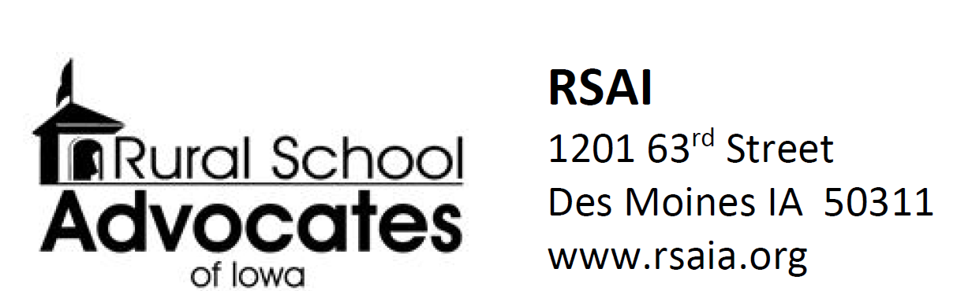

RSAI Priorities & Position Papers for the 2020 Legislative Session

The following position papers, also posted on the RSAI website, supported advocacy work during the 2020 Legislative Session. Use these resources as conversation starters with legislative candidates or to discuss with parent or other stakeholder groups.
If the priorities remain a focus of RSAI for the 2021 Session, new position papers will be provided with updated information. If new priorities are set, there will be new resources available soon. These position papers and other resources, including this Digest, are found on the RSAI web site www.rsaia.org

2020 Legislative Priorities
As approved by attendees of the RSAI Annual Meeting, October 16, 2019 and the
RSAI Leadership Group on November 13, 2019.
Click here to download Priority List and all Position Papers

​- Adequate School Resources: RSAI supports adequate base funding. The increased per pupil cost known as SSA is especially critical to rural students due to distance from school/opportunities, economies of scale, mandates, the need for AEA support, and the ability to attract and retain staff. Rural schools depend on an investment of meaningful new resources to prepare students for a successful future. The rate of increase in SSA should be no lower than anticipated growth in state revenue (adjusted for legislated tax cuts), should keep up with other economic factors such as personal income or state gross domestic product over the long term, should maintain a balance of state and local property taxes, provide predictability, and be set timely to assure adequate notice for budget planning and staffing. The SSA rate for the 2020-21 school year should be set no lower than 3.75%, if the revenue adjustment controlling for tax cuts is lower than 3.75%. Click here to download the Position Paper. Click here to download Census Data School Spending Ranks
- Student Mental Health: RSAI supports increased access to and funding for mental health services for children. In addition to adequate funding for AEA services and access to other service providers, an array of services should also include telehealth services received at school. The state, Medicaid and insurance providers should not pass on administrative or billing work to schools, and schools should not be mandated to be providers of mental health services for children. Click here to download the Position Paper.
- Educator Shortage and Quality Instruction: RSAI supports maximum flexibility to hire staff to provide great instruction and support to all Iowa students. RSAI supports: 1) district flexibility to meet offer and teach requirements, 2) teacher or other staff shortage loan forgiveness programs and incentives to encourage staff to work in rural schools, 3) a special education generalist credential to teach special education across all grades, 4) creation of a Public Service strand in Iowa’s CTE system to prepare Iowa’s future teaching workforce, 5) continued state support of Iowa Learning Online (ILO), 6) flexibility to hire retirees without a negative IPERS impact, and 7) elimination of barriers to licensure for teachers and administrators, and 8) allow associate degree for substitutes. The BOEE should accept evidence other than strict transcripts to show skill mastery for administrators from other states. Click here to download the Position Paper.
- Formula and Transportation Equity: RSAI supports formula and transportation equity. The Legislature should accelerate the commitment to close the $165 gap between the state and district cost per pupil within ten years and continue transportation equity support, bringing down all districts to no more than the state average per pupil transportation cost, without requiring burdensome reporting requirements from school districts. Click here to download the Position Paper on Formula Equity. Click here to download the Position Paper on Transportation Equity.
- Opportunity Equity for Low SES: RSAI supports resources for at-risk students. Resources should be based on need, such as the percentage of students eligible for Free and Reduced Price Lunch (FRPL), in addition to enrollment of the district. The current disparity in dropout prevention capacity, (some districts held to 2.5% and others up to 5% of regular program district cost) is arbitrary, based on history no longer relevant to supporting student needs. All school boards should be able to realize the full 5% dropout prevention funding. The formula must further recognize the disproportionate cost of providing equal educational opportunities to low-income students. School districts should be granted spending authority for FRPL eligible students’ fees mandated to be waived by state and federal law. Click here to download the Position Paper.
- Sharing Incentives and Efficiencies: RSAI supports extension of sharing and efficiency incentives. Rural students benefit from opportunities to achieve efficiencies, share capacity to operate, and redirect resources to educational programs. Whole Grade Sharing, Reorganization, and Operational Sharing Incentives should be extended and expanded. Click here to download the Position Paper.
- Quality Preschool: RSAI supports full funding of quality preschool. Due to changing demographics in rural Iowa, significant transportation costs, and lack of quality day care access, preschool should be fully funded at the regular student count at 1.0 per pupil cost. Click here to download the Position Paper.
- School Safety: RSAI supports school safety investments. Rural schools need the resources, training and support necessary for Iowa student and staff safety at school, including additional funding for security personnel and training to protect against active shooter and other emergency situations. Click here to download the Position Paper.

- Bonding Capacity: A simple majority vote for bond issue should be sufficient rather than 60% super majority.

RSAI Position Paper: School Choice

Current Reality: Iowa has a wide range of school choice for parents and students, including:
- Within District Transfer: A neighborhood public school or a public school in another neighborhood within the school district (transfers regulated by local school board).
- Open enrollment to public school in another district. 33,591 students exercised this option in 2018-19. This total includes: 1) Open enrollment to another school district if request meets the criteria set by the local school board in the five districts with voluntary diversity plans (total of over 2,500 students open enrolled out of those five districts in the 2016-17 school year) and 2) Open enrollment in an Iowa public virtual academy and other online programs.
- Strong nonpublic schools, with 33,365 students enrolled in 2018-19. Private schools and parents are supported by millions of state tax dollars for school tuition organization scholarships, tuition and textbook tax credits, transportation/textbook funds to private schools, public school and AEA support for special education in private schools, and public/private partnerships for private preschool tuition in the statewide voluntary preschool program. According to State Tax Subsidies for Private K-12 Education by the Institute for Taxation and Economic Policy, Oct. 2016, of the 17 states with either private school scholarships or private school tuition/expenses tax credit, Iowa is one of only five that have both (AL, IA, IN, LA, SC).
- Home School Options: competent private instruction or independent private instruction.
- All told, over $66 million in state tax dollars support the education of Iowa students in private and home school settings according to the Iowa Fiscal Policy Project analysis, Nov. 2018, found here http://www.iowapolicyproject.org/2018docs/181105-IFP-pvtschools-bgd.pdf
Vouchers or Education Savings Accounts Costs Outweigh Benefits: Increasing Iowa public investment in private schools will not add benefits and will negatively impact public school students:
- Voucher proponents suggest that competition will improve outcomes for students. First, in Iowa, there is already enough competition to pressure schools to perform, if competition provides positive pressure. But according to the Economic Policy Institute Report, Feb. 28, 2017, School vouchers are not a proven strategy for improving student achievement. “Research does not show that vouchers significantly improve student achievement.”
- That report concludes there are more effective ways to increase graduation and college attendance rates, that vouchers programs have hidden costs, including shrinking the pipeline into teaching, and that supports for privatization detract from more proven methods of improving student learning.
- Diverting funds to private education further stresses public school resources. From State Tax Subsidies for Private K-12 Education, Oct. 2016; “30 neovouchers across 20 states are draining over $1 billion in public revenues from state coffers every year. Every dollar of revenue diverted toward private schools is revenue that cannot be invested in the public education system.”
- In the 2018 Session, Tax Reform Legislation (HF 2489), increased the annual cap for the School Tuition Organization Tax Credit by $1.0 million, to $13.0 million. The income threshold for grant eligibility was increased from 300 to 400% of the federal poverty level (in 2020, 400% of the federal poverty level is $104,800 for a family of four). Section 529 Savings Plans were created to allow tax free income to pay for K-12 private school tuition. In 2019, HF 779 Tax Changes, raised the cap again to $15.0 million.
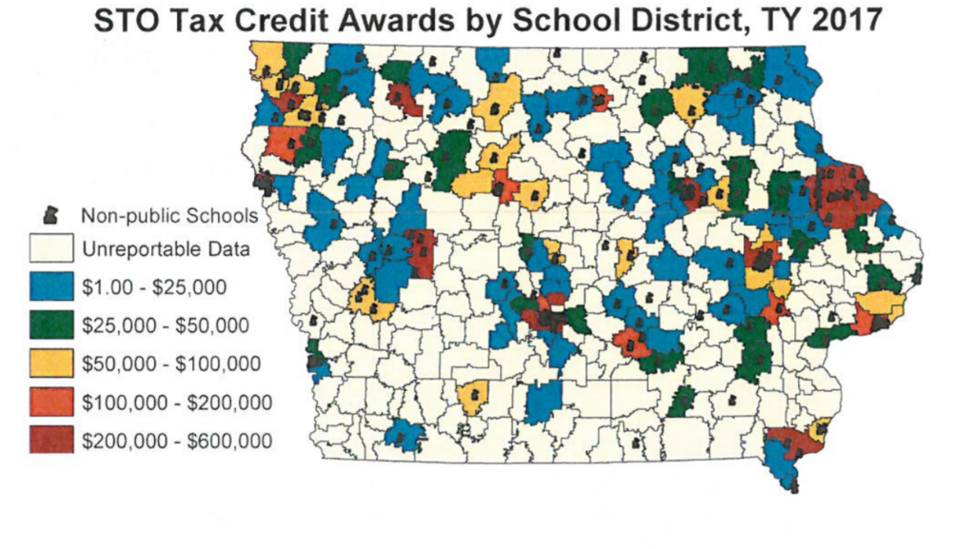
- Statewide complications occur: the survival of rural schools depends on adequate state funding, yet there are few private schools available for their parents to choose as an alternative. This map from the Department of Revenue presentation to the Tax Expenditure Committee measuring participation in STO tax credits, January 2019, shows the gaps in private school geography. According to the National Rural Education Association, investing in vouchers reduces resources to rural schools and saves money for parents in urban centers. Meanwhile, student poverty and minority concentration in the inner cities is exacerbated when families with means are encouraged to leave the public school for a private program, increasing the challenge of urban districts while decreasing resources.
- The Institute also finds insufficient budgetary oversight of voucher programs. There is no publicly elected school board or Department of Education regulating and reporting allowable expenditures. The public does not have access to records or public meetings. Good stewardship of tax dollars requires transparency and clearly articulated expectations.
- Public schools are accountable to taxpayers, parents, communities, i.e., the public and serve all students. Public schools cannot jettison students that are not meeting expectations or refuse enrollment based on specific student needs, such as disabilities, or students who are non-English-speaking, minority or low income. If additional state dollars are used to fund vouchers, it is only fair that the private schools receiving those tax dollars also comply with testing, reporting, and service requirements.

The Rural School Advocates of Iowa call on legislators and our governor to invest in Iowa’s public schools who educate 96% of Iowa students before creating even more private school and home school options unnecessary in Iowa’s already competitive education environment.
Margaret Buckton, RSAI Professional Advocate margaret@iowaschoolfinance.com
(515) 251-5970

Advocacy and Other Legislative Resources

Iowa Legislature www.legis.iowa.gov/
Iowa Department of Education Legislative Page including Bill Tracking, Legislative Reports and Guidance and Updates on Legislation
https://www.educateiowa.gov/resources/legislative-information
Iowa DE Letter to the Field 2020 Legislative Session Summary of Changes Affecting Schools https://educateiowa.gov/sites/files/ed/documents/2020LegistativeLetterToTheField.pdf
Rural School Advocates of Iowa (RSAI) Legislative Page (includes weekly reports and Capitol Recap Video, Position Papers, Advocacy Resources, Transportation and Formula Equity Toolkit, and RSAI legislative platform) www.rsaia.org/legislative.html
2020 Legislative Recap
See ISFIS 6/17/2020 Webinar recording and PPT
See ISFIS 6/24/2020 Webinar recording and PPT
Both also posted on ISFIS webinar page at www.iowaschoolfinance.com/webinars
Iowa’s Area Education Agencies (Iowa AEAs) Legislative Page
http://www.iowaaea.org/about/legislative-priorities/
Iowa Association of School Boards (IASB) Legislative Page
IASB Advocacy Center
Iowa State Education Association (ISEA) Lobbying Resources Page
https://isea.org/lobbying-resources/
Parents for Great Iowa Schools
http://parentsforgreatiowaschools.com/
School Administrators of Iowa (SAI) Legislative Page
http://www.sai-iowa.org/advocacy.cfm
Urban Education Network of Iowa (UEN) Legislative Page
http://www.uen-ia.org/legislation.htm
ISFIS Web Site: access to webinars on DE guidance, implementation of legislative expectations, Governor’s action and declarations, and district flexibility. www.iowaschoolfinance.com or contact Jen Albers at ISFIS for more information jen@iowaschoolfinance.com

Iowa Department of Education Reports to Legislature

2020
Adult Education and Literacy Annual Report
Anti-bullying Programming and Projected Expenditures Legislative Report
Charter and Innovation Zone Schools in Iowa Legislative Report
Child Development Coordinating Council Annual Report
Commission on Educator Leadership and Compensation
Community College Additional Information FY2019 Annual Report
Condition of Education 2019 Annual Report
Early ACCESS Legislative Report
Enrich Iowa Report Fiscal Year 2019
Gap Tuition Assistance Program FY2019
High-Need Schools Legislative Report
Iowa Autism Council Legislative Report 2020 Priorities
Iowa Community Colleges 260G ACE Infrastructure Funding FY2019
Iowa Department of Education Infrastructure Report
Iowa Dyslexia Task Force Report
Iowa Reading Research Center Legislative Report
Iowa Vocational Rehabilitation Legislative Report
Iowa Work-Based Learning Intermediary Network FY2019
Pathways for Academic Career and Employment (PACE)
School Association Reporting FY2019
Secure an Advanced Vision for Education (SAVE) Annual Report
Senior Year Plus STEM
Special Education Federal Reports
Virtual Schools in Iowa Annual Report
Workforce Training and Economic Development Fund Annual Progress Report 2019

2019
Adult Education and Literacy in Iowa Fiscal Year 2018 Annual Report
Anti-bullying Programming and Projected Expenditures Legislative Report
Charter and Innovation Zone Schools in Iowa Legislative Report
Child Development Coordinating Council Annual Report
Commission on Educator Leadership and Compensation Annual Report
Community College Additional Information FY2018 Annual Report
Early ACCESS Legislative Report
Early Childhood Assessment Legislative Report
Equal Opportunity and Affirmative Action Report
Gap Tuition Assistance Program
High-Need Schools Legislative Report
Iowa Autism Council 2019 Priorities
Iowa Community Colleges 260G ACE Infrastructure Funding Fiscal Year 2018
Iowa Department of Education Infrastructure Report 2018
Iowa Interstate Compact Commission for Military Children
Iowa Reading Research Legislative Report
Iowa Vocational Rehabilitation Legislative Report
Iowa Work-Based Learning Intermediary Network Legislative Report FY2018
Pathways for Academic Career and Employment (PACE)
School Association Reporting FY2018
Secure an Advanced Vision for Education (SAVE) Annual Report FY2018
Senior Year Plus STEM
Special Education Federal Reports
Student Health Screening Work Group
The Annual Condition of Education Report: 2018
The Annual Condition of Iowa's Community Colleges Report: 2018
Virtual School in Iowa Annual Report
Workforce Training and Economic Development Fund Annual Progress Report 2018

2018 DE Reports
Anti-bullying Programming and Projected Expenditures Legislative Report
Charter and Innovation Zone Schools in Iowa
Child Development Coordinating Council Annual Report
Closing Achievement Gaps Legislative Report
Competency-Based Education Legislative Report
Early ACCESS Legislative Report
Early Childhood Assessment
English Language Learner Legislative Report
Equal Opportunity and Affirmative Action Report
High Need Schools Legislative Report
Iowa Autism Council 2018 Priorities
Iowa Early Intervention Block Grant Program (Class Size) - 2017-2018
Iowa Reading Research Legislative Report
Iowa Vocational Rehabilitation Legislative Report
School Association Reporting FY2017
Secure an Advanced Vision for Education (SAVE) Report FY2017
Senior Year Plus STEM Legislative Report
Special Education Federal Reports
Student Achievement, Accountability and Professional Development Annual Report
Virtual Schools in Iowa Annual Report

2017 DE Reports
Adult Education and Literacy Program Year 2017 Annual Report
Anti-bullying Programming and Projected Expenditures
Career and Technical Education Redesign Implementation Report
Child Development Coordinating Council Annual Report
Closing Achievement Gaps Legislative Report
Commission on Educator Development and Compensation 2017 Annual Report
Competency-based Education Report
Computer Science Education Work Group Report
Condition of Education Report
Early ACCESS Legislative Report
Early Childhood Assessment
Educational Programs for Children's Residential Facilities Rules Progress Report
English Language Learners Report
Enrich Iowa Report Fiscal Year 2017
Equal Opportunity and Affirmative Action Report
Gap Tuition Program Fiscal Year 2017 Report
Home Base Iowa Postsecondary Education Reporting
Iowa Autism Council 2017 Priorities
Iowa Community College Additional Information Report 2017
Iowa Community Colleges 260G ACE Infrastructure Funding Fiscal Year 2017
Iowa Department of Education Infrastructure Report Fiscal Year 2017
Iowa Early Intervention Block Grant Program (Class Size) 2016-2017
Iowa Interstate Compact Commission for Military Children Progress Report for Academic Year 2016-2017
Iowa Reading Research Center Report
Pathways for Academic Career and Employment (PACE) Program Fiscal Year 2017 Report
School Association Reporting FY2016
Secure an Advanced Vision for Education (SAVE) Report FY2016
Senior Year Plus and STEM Report
Special Education Federal Reports
Student Achievement, Accountability and Professional Development Annual Report
Supplemental Assistance for High-Need Schools Report
Teacher Leadership and Compensation Status Report
The Annual Condition of Iowa's Community Colleges
Virtual Schools in Iowa Annual Report
Work-Based Learning Intermediary Network Fiscal Year 2017 Report
Workforce Training and Economic Development 2017 Annual Progress Report and 2018 Plan

Bill List – Index by Bill Number
Bill Number | Short Name | Legislative Digest Page(s)
SF 199 | Voluntary Diversity Plans/Open Enrollment | 60
SF 284 | School Resource Officers | 7
SF 438 | Elimination of Mandates/Education Omnibus | 60
SF 547 | Education Savings Accounts/Private School Vouchers | 61
SF 2009 | Minor Driver’s License | 61
SF 2082 | DE Technical Corrections | 30
SF 2142 | SSA/School Funding | 5, 10, 12, 20, 21, 22, 23
SF 2153 | Student Health Screenings | 61
SF 2155 | ISL Funds & School Resource Officers | 7, 61
SF 2164 | Formula & Transportation Equity | 5, 10, 20, 24
SF 2184 | Carrying on School Grounds | 62
SF 2206 | Iowa Student Opportunity Act (Education Savings Grant) | 61
SF 2261 | Telehealth Services | 6, 10, 30, 31, 32, 33
SF 2298 | Driver’s Education Instruction | 62
SF 2310 | Online Learning and COVID Flexibility | 6, 9, 31, 38, 39, 46
SF 2329 | Occupational Therapist for Concussions | 62
SF 2356 | Dyslexia Specialists, Training & Boards | 34, 35, 36
SF 2360 | Classroom Management/Therapeutic Classrooms | 6, 10, 29, 34
SF 2400 | Broadband Changes | 36, 37
SF 2408 | Standings Appropriations | 22, 28, 29, 39
SF 2410 | SAVE Athletic Facilities Changes | 62
HF 2308 | Open Meetings Subjects | 62
HF 2340 | Educational Plan Spending | 37
HF 2359 | Teacher Prep/Praxis Tests | 6, 37
HF 2416 | Complaint Timelines | 62
HF 2418 | School Budget Calculations | 37
HF 2419 | ELL Weighting | 62, 63
HF 2443 | Senior Year Plus Proficiency | 63
HF 2454 | Community Collect Instructors | 6, 37
HF 2457 | Bleeding Control Content | 63
HF 2460 | PK Eligibility | 7
HF 2490 | Poverty Weighting | 63
HF 2497 | Dropout Prevention Cap Equity | 63
HF 2521 | Suicide Prevention Protocols | 63
HF 2556 | Government Purchase of Property | 63, 64
HF 2565 | Setoff Procedures | 37
HF 2585 | Deaf/Hard of Hearing Terminology | 38
HF 2621 | PK Eligibility | 64
HF 2627 | License Qualifications | 6, 38
HF 2629 | Future Ready Iowa | 6, 7, 38, 39
HF 2641 | Omnibus Bill Dept of Revenue | 12, 19
HF 2643 | Omnibus Appropriations | 10, 24, 26, 27, 28

Notes

