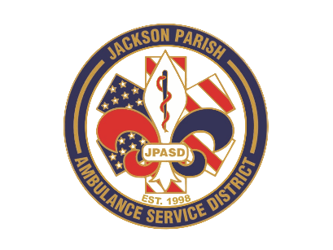
Aaron K. Johnson, Jr - EMS Director

Paula Parkerson, MD - Medical Director

Governing Board
Allen Lindsay, Conchita Doyle, Joe Vail, Alma Williams, Deidre Hollis
Jackson Parish Ambulance Service District
115 Watts Street
Jonesboro, LA 71251
Office: (318) 259-2877
Fax: (318) 259-2099

jacksonparishambulance@jpasd.com

Notice Posted: Tuesday, October 7, 2025 @ 4:30pm

NOTICE OF PUBLIC MEETING
A public meeting will be held as follows:
DATE: October 9, 2025
TIME: 12:00 PM
PLACE OF MEETING: Jackson Parish Ambulance Service District
115 Watts Street, Jonesboro, LA 71251
Public Meeting AGENDA
1. Call to Order
2. Roll Call
3. Invocation
4. Pledge of Allegiance
5. Recognition of Guests/Public Comments
6. Approval of Minutes from August 14, 2025 with September 11, 2025 meeting cancelled
7. Approval of Financials and payment of bills August and September 2025
8. EMS Director’s Report
9. Old Business
10. New Business
A) Surplus for public auction govdeals.com 2018 G4500 Ambulance VIN#00152
B) Accept the 2024 Annual Financial Report by TCBT Accounting Firm of No Findings
C) Proposal of the 2026 Financial Budget
11. Adjournment
Reminder: Next Meeting: November 13, 2025 @ 12 Noon
In accordance with the Americans with Disabilities Act, if you need special assistance, please contact Aaron Johnson, EMS Director at 318-259-2891 describing the assistance that is necessary. Due to the Covid-19 virus visitors are asked to not present to the meeting with fever, cough, diarrhea, or general weakness. Masks will be provided for visitors.

{ } Newspaper
{ } Minutes

