Membership Dues
Renew your membership for 2017 today!
Included in the membership:
1. 2 newsletters each year
2. Bills Musky Club Outings - Free to members, Lunch provided, also Attendance prices
3. Fish Registration - Awards for largest fish, many categories 4: Member of Musky Clubs Alliance of WI

Mail form and payment to:
BILL’S MUSKY CLUB, INC.
PO BOX 476
SCHOFEILD, WI 54476

Membership Type | Price | Quantity | TOTAL
Adult | $10.00
Junior (16 Yrs Old & Under)  *must be sponsored by an adult member, parent or guardian | $5.00
Joint (Husband & Wife) | $15.00
Lifetime Single | $150.00
Lifetime Joint (Husband & Wife) | $175.00
 |  | TOTAL:
Member Information (Print)
Name | Adult Junior Joint  Life Single Life Joint | New  Renewal

Street Address |  |  |  |  | Apt #
City |  | State |  | Zip
Main Phone ( ) | Year Born: |  | Email Address

Name | Adult Junior Joint  Life Single Life Joint | New  Renewal

Street Address |  |  |  |  | Apt #
City |  | State |  | Zip
Main Phone ( ) | Year Born: |  | Email Address

Name | Adult Junior Joint  Life Single Life Joint | New  Renewal

Street Address |  |  |  |  | Apt #
City |  | State |  | Zip
Main Phone ( ) | Year Born: |  | Email Address

Name | Adult Junior Joint  Life Single Life Joint | New  Renewal

Street Address |  |  |  |  | Apt #
City |  | State |  | Zip
Main Phone ( ) | Year Born: |  | Email Address
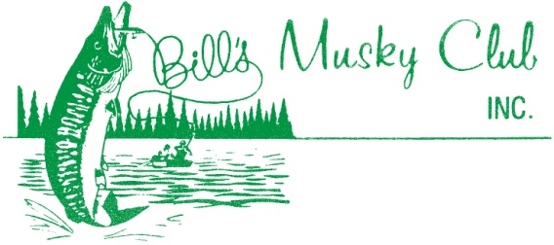
*Attach additional sheets if necessary*
Check here if you would like to receive email updates on upcoming Bill’s events

Check us out at www.billsmuskyclub.com

