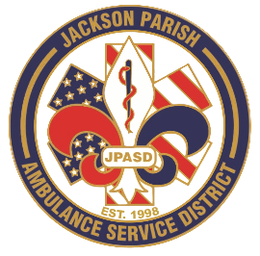
Aaron K. Johnson, Jr - EMS Director

Paula Parkerson, MD - Medical Director

Governing Board
Allen Lindsay, Conchita Doyle, Joe Vail, Alma Williams, Deidre Hollis
Jackson Parish Ambulance Service District
115 Watts Street
Jonesboro, LA 71251
Office: (318) 259-2877
Fax: (318) 259-2099

jacksonparishambulance@jpasd.com

Notice Posted: Tuesday, December 9, 2025 @ 12:00pm

NOTICE OF PUBLIC MEETING
A public meeting will be held as follows:
DATE: December 11, 2025
TIME: 12:00 PM
PLACE OF MEETING: Jackson Parish Ambulance Service District
115 Watts Street, Jonesboro, LA 71251
Public Meeting AGENDA
1. Call to Order
2. Roll Call
3. Invocation
4. Pledge of Allegiance
5. Recognition of Guests/Public Comments
6. Approval of Minutes from November 13, 2025
7. Approval of Financials and payment of bills November 2025
8. EMS Director’s Report
9. Old Business
A) Surplus 2018 G4500 Ambulance VIN#00152
10. New Business
A) Election of Officers
B) Approval of proposed 2026 Regular Scheduled Meeting dates
11. Adjournment
Reminder: Next Meeting: January 8, 2026 @ 12 Noon
In accordance with the Americans with Disabilities Act, if you need special assistance, please contact Aaron Johnson, EMS Director at 318-259-2891 describing the assistance that is necessary. Due to the Covid-19 virus visitors are asked to not present to the meeting with fever, cough, diarrhea, or general weakness. Masks will be provided for visitors.

{ } Newspaper
{ } Minutes

