8/31/2017 Apollyon 13

Apollo is the name of a Greek and Roman god, one of the most important of the Olympian deities in ancient greek and Roman culture.

Although Apollo was attributed with many "godly" attributes, the Greeks most often associated Apollo's name with the verb "apollymi" which means "to destroy". Apollo is the destroyer, and is mentioned in Revelation 9:11 as Apollyon, the angel of the bottomless pit, the king of the locusts who are loosed from the bottomless pit at the end of the age to torment mankind.

Revelation 9:10 And they had tails like unto scorpions, and there were stings in their tails: and their power was to hurt men five months.
11 And they had a king over them, which is the angel of the bottomless pit, whose name in the Hebrew tongue is Abaddon, but in the Greek tongue hath his name Apollyon.

It was shown in a previous article that the modern Olympic Games were re-vitalized in 1896 and have become a major global media event. The modern Olympic Games have paganized ceremonies that call for the return of the ancient Olympic gods.

Below is the Olympic torch for the 2016 Rio Olympic Games being lit in a pagan ceremony on Mt. Olympus in Greece. This Olympic torch was then hand carried through the nations of the world by various athletes to the Olympic stadium in Rio de Janeiro, Brazil, linking the site of the modern games with Mt. Olympus and its ancient gods.



Below is a graphic indicating that the midpoint date of the 1896 Olympic Games was 4/11/1896.

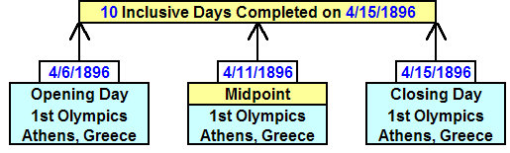
Be aware that precisely 100 years later on 4/11/1996, comet Hyakutake crossed the forehead of the severd head of Medusa, the devil, in the constellation of Perseus. The constellation Perseus is symbolic of Israel's Messiah known as "the Breaker" in the bible. "Messiah The Breaker" is the One who opens the door of the sheepfold and allows the sheep to leave.

Exactly one year after comet Hyakutake crossed the forehead of Medusa, a second comet arrived on 4/10/1997 and crossed the "ghoul's" forehead as indicated in the graphic below. An "X" had been placed on the ghoul's severed head by our Creator Elohim beginning exactly 100 years after the revitalization of the modern pagan Olympic Games in Greece.

At this point, the ceremonies of the modern Olympic Games had been calling for the return of the ancient pagan gods of Greece for exactly 100 years.

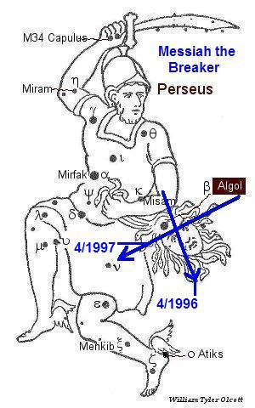

Apollo 13

NASA named its moon landing program Apollo, the name of the Greek Destroyer god.
We know that the moon is symbolic of the nation of Israel. The moon reflects the light of the sun, symbolizing the nation of Israel reflecting the light of the instructions of Israel's God, YaHuWaH Elohim, to the world.

The Apollo moon program contained a hidden anti-semitic picture of the destroyer god (symbolized by the name Apollo) coming to Israel (symbolized by the moon).
Note that the center point date of the first modern Olympic games was 4/11/1896.

Apollo 13 was launched from Kennedy Space Center in Florida on 4/11/1970 at 2:13 PM EDT. However the control center for the mission was in Houston, Texas. The launch time for Apollo 13 in Houston was at 13:13 CDT on 4/11/1970. I wonder who decided to attach the repetitive 13's to the mission.

4/11/1896 (midpoint date of first modern Olympics) + 27,027 days = 4/11/1970 (Apollo 13 launch date)

Note that the dramatic failure of the oxygen tank on the Apollo 13 mission took place on 4/14/1970 at about 03:06 UTC. However, at Master Control in Houston it was about 9:06 PM 4/13/1970. Another number 13 in the mix for Houston.

4/11/1970 (Apollo 13 launch) + 26 years (2 x 13 years) = 4/11/1996 (Comet Hyakutake crosses Medusa's forehead)

4/11/1896 + 27,027 days = 4/11/1970 + 26 years = 4/11/1996

Note our Creator's signature in the precise 26 years period mentioned above, as His Name equals 26 in the ancient Hebrew numbering system.

Houston, You've Got a Problem

After calling for the return of the ancient gods that descended upon Mt. Olympus, the Destroyer has visited Houston.

Note that Hurricane Katrina made first landfall in Florida on 8/25/2005 and Hurricane Harvey made first landfall in Texas on 8/25/2017. Hurricane Katrina moved across Florida into the Gulf of Mexico and the made 2nd landfall on Louisiana on 8/29/2005.

Hurricane Harvey returned to the Gulf and made another landfall on Louisiana overnight 8/29-30/2017. The similar occurrences for both hurricanes were 12 years apart, however the 12th anniversary date is actually the 1st day of the 13th year between the two hurricanes.

Apollyon 13 has visited Houston, and he's nasty.

Revelation 12:12 Therefore rejoice, ye heavens, and ye that dwell in them. Woe to the inhabiters of the earth and of the sea! for the devil is come down unto you, having great wrath, because he knoweth that he hath but a short time.

The basic biblical principals of water and fire baptisms remains true. First the waters of baptism, and then the fires of baptism. Please prepare for the worst.

