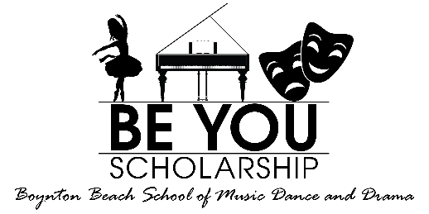
Scholarship Application 2019/2020
Name of Student:
Age of Student:
Students Date of Birth:
If a minor, parents name and contact information both Cell and email (if we do not have both phone and email, we are not able to process your request).
Cell: _____________________________ Email: ______________________________________
- What department of the studio are you interested in. Music, Dance or Drama_________________.
- What is your past experiences if you have any with lessons in music, dance or drama (its ok if you do not have any past experience):_______________________________________________________________________________________________________________________________________________.
- How do you feel this scholarship will benefit and change your life? _________________________________________________________________________________________________________________________________________________________________________________________________________________________________________.
Please attach a letter explaining any detail information about yourself and your family. Please express any hardships. Please express details about yourself or your child that would help us understand why you should be chosen for a Scholarship. Be detailed and specific so we may learn and understand your ultimate goals, passions and feelings to wanting to be part of our BE YOU Scholarship program.
All applications should be emailed to BBSMDDmarketingdepartment@gmail.com All applications are confidential and only viewed by the Management team. All applications will be reviewed, and you will receive a letter that your application was received within 7 days.
