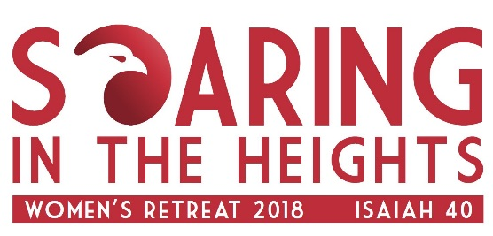
FAQ’s
- What do I need to bring with me?
  - Toiletries and personal items for showering and daily dressing.
  - If you would like a blanket or cover please bring along with you.
Linens, Bath/Wash towels and Pillow ARE provided.
  - Bible, Pen and any other writing/journal material that you personally use. Retreat workbooks will be provided.
  - Cool clothing for the daytime. It’s April and the seminar will be held outside under a covered tent. Please note all inside rooms are air-conditioned so you might want to be prepared to layer on and off if needed with a sweater or light jacket.
  - It is a 14 Acre Planation, so if you feel the need bring some bug spray (Mosquito repellent) please do so. There has not been an issue before- but better to be prepared!
  - Personal Snacks or Food if you have special dietary needs. The food will not be gluten or nut free. If you do have a food allergy please make note that it’s a buffet style eating venue.
  - Covered shoes if you are going to participate in the Early Morning Walking ministry, Volleyball or Basketball.
  - Swimsuit and Beach Towel if you decide to sign up (For an Extra Fee) to go on the snorkel boat ride or visit the beach on your own during the Saturday free time.

- Is there Childcare at the Retreat?
  - Sorry, no childcare is provided this weekend. Please make arrangements for time away from your family, as this is a Weekend Retreat for Women only. Young teen girls may attend if they are responsible, respectful and you think they can handle adult retreat content.

FAQ’s
- How do I reserve my space/Bed?
  - When you register online for the conference it will ask you to pick an available sleeping location.
  - For all beds you have a choice of an upper or lower bunk. (There are a few single twins in the middle of the K Cottages.
  - Availability is on a first come first serve basis.

- What if cant stay the whole weekend?
  - You can choose to join us for only part of the weekend HOWEVER the pricing is the same due to the facility requirements.

- What does the facility look like?
  - Maps and information will be provided at the Retreat. For a preview and directions please go to www.PKCC.org

- Is there parking?
  - Yes, there is on Grounds parking. The facility is gated and you will be provided a gate code after registration before the retreat via email.
  - Car-pooling is highly recommended but not mandatory.
  - Saturday there is a “Free-Time” slot in the afternoon. You may leave the facility to go freely and return for the evening dinner/speaker. The same gate code would apply.

FAQ’s

- Is there a place to lock up my belongings?
  - It is highly recommend that you leave all valuables at home. This is like camping and there will be multiple people in and out of the bunk housing. You are responsible for all your possessions at all times.

- Is there air-conditioning?
  - Yes, there is air-conditioning in the sleeping quarters. HOWEVER, the retreat will be held outside under the main tent.
  - Water, tea, and coffee will be provided in the main areas.

- Are the bathrooms private?
  - All bathrooms are shared depending upon the facility you choose to stay in. All are clean, running and have shower facilities. You must bring your own toiletries.

- Can I share a room with my friends?
  - Yes, if you reserve in enough of an advanced time frame. We recommend that you look on line and register together. Sleeping arrangements are on a first come first serve basis.

FAQ’s
- What is the Itinerary of the weekend?
  - The Itinerary of the weekend is subject to change – but will generally be as follows:

FRIDAY 4/27
4pm Retreat Check In
6pm -7pm Dinner
7pm - 9pm Evening Session with Dr. Lori Salierno-Moldonado
9:15pm Snack and fire pit (If weather permits.)

SATURDAY 4/28
7:00am Optional Prayer Walk
8:00am Breakfast
9am -10:30 am Morning Session with Dr. Lori Salierno-Moldonado
10:30 -11:30 am Prayer and Reflection
12 Noon lunch
Afternoon activity options:
Dolphin Star Boat Tour (early sign-up required TBD)
12-3 pm includes lunch /carpooling
Crafting: 1-3 pm
Hula/sign-dance class 1-3 pm
Boot Camp: 1-230PM
Free time options - Volley Ball, Basketball, Games etc.
5:00pm - 6:00pm Dinner
6pm- 9pm Evening Session with Dr. Lori Salierno-Moldonado
9:15pm Snacks and Fire pit
Optional movie –Night (Title TBD)

SUNDAY 4/23
7:30am Breakfast
8:00 – 930am Morning Session and Communion
10:00am-11am Checkout

