Mars UP Church

Apostles’ Creed
I believe in God the Father Almighty, Maker of heaven and earth; and in Jesus Christ His only Son our Lord; who was conceived by the Holy Ghost, born of the Virgin Mary, suffered under Pontius Pilate, was crucified, dead and buried; He descended into hell; the third day He rose again from the dead; He ascended into heaven, and sitteth on the right hand of God the Father Almighty; from thence He shall come to judge the quick and the dead. I believe in the Holy Ghost, the holy catholic church; the communion of saints; the forgiveness of sins; the resurrection of the body; and the life everlasting. Amen.

Gloria Patri
Glory be to the Father, and to the Son, and to the Holy Ghost. As it was in the beginning, is now and ever shall be,
world without end.
Amen. Amen.

Come Holy Spirit, Come
Before the Service – Speak to God!
During the Service – Let God speak to you!
After the Service – Speak to each other!

(*Please stand, if able)
Welcome and Mars Messages

Prelude

Call to Worship

Leader: Soft summer rain falling on parched earth

People: Waters of God, flow down upon us.

Leader: Torrential floods ripping lives into pieces

People: Waters of God, have mercy upon us.

Leader: Soaking waters which nourish the seed

People: Waters of God, replenish us.

Leader: Holy Spirit, wash over us.

People: Claim us in the water of Your Baptism

Opening Prayer

*Hymn 426
“Blest Be the Tie That Binds”

Scripture Romans 6:1b-11

Children’s Chat
The
Lord’s Prayer

Our Father,
who art in heaven,

hallowed be Thy
name,

Thy kingdom come,
Thy will be done,
on earth
as it is in heaven.

Give us this day
our daily bread;

and forgive us
our debts,
as we forgive
our debtors;

and lead us not
into temptation,
but deliver us
from evil.

For Thine
is the kingdom,
and the power,
and the glory,
forever. Amen.

The Doxology

Praise God
from whom
all blessings flow;
praise Him
all creatures
here below;
praise Him above,
ye heavenly host;
praise Father, Son,
and Holy Ghost.
Amen.

Morning Message Rev. Brian Hauser
“New Life”

*Hymn 406
“Wonderful Words of Life”

Baptism of Valerie Grace Galliger

Affirmation of Faith Apostles Creed

Prayers of the People and Lord’s Prayer

Communion Hymn 462
“Come, Share the Lord”

Celebration of Communion

*Hymn (v. 1-2)
“Go, My Children, With My Blessing”

*Benediction

*Postlude

Being baptized this morning is Valerie Grace Galliger, daughter of Jason and Jamie (Wonderly) Galliger. Valerie was born on December 24, 2022. Grandparents are Greg and Debbie Galliger and Amy and the late Jim Wonderly. Valerie is the Great-Granddaughter of Amy Mellor.

Church Staff
Rev. Brian Hauser
Pastor
pastor@mars-up.org
724-689-3412

Mrs. Shelly Bocheff
Administrative Assistant
marsup@mars-up.org

AV TEAM
Alma Staskiewicz, Lisa Barbour, Marie Matthews, Bill Guesman, John Ivory, Mike Bocheff, Herb Wellman

Mars United Presbyterian Church

232 Crowe Ave
PO Box 805
Mars, Pennsylvania 16046
724-625-1365
www.mars-up.org
marsup@mars-up.org

Church Office Hours:
Mon -Thurs from 9 a.m. -2:30 p.m.
MUP Session

Class of 2025 Class of 2024 Class of 2023
John Ivory Alma Staskiewicz Lisa Barbour
Susan Cox Louise Fox Mary Ann Croop
Jay Wilson Marie Matthews Don Lewis
Herb Wellman

Clerk of Session: Herb Wellman
Morning Worship:
10:00 am

5th Sunday after Pentecost

Prayer of Preparation
Lord, we come to you today with so many things on our hearts.

You call us to be in relationship of trust and love with you and you offer healing to us for those portions of our lives that are broken and injured.

Help us to be open to your mercy and healing love. For we ask this in Jesus’ Name.
AMEN.

MUP Deacons

Class of 2025 Class of 2024 Class of 2023
Jill Cooper Steve Martin Sharon Gibb
Robyn Beckwith Marge Nicklas Carol Kopar
Missy Wells Pat Auld Alice Leonberg

Moderator: Steve Martin

MUP Music Committee
Keith Nichols – Chair
Sally Olsen – Clerk
Alma Staskiewicz
John Ivory
Linda Lees
Karl Kennedy

Mars United Presbyterian Church
Welcome!

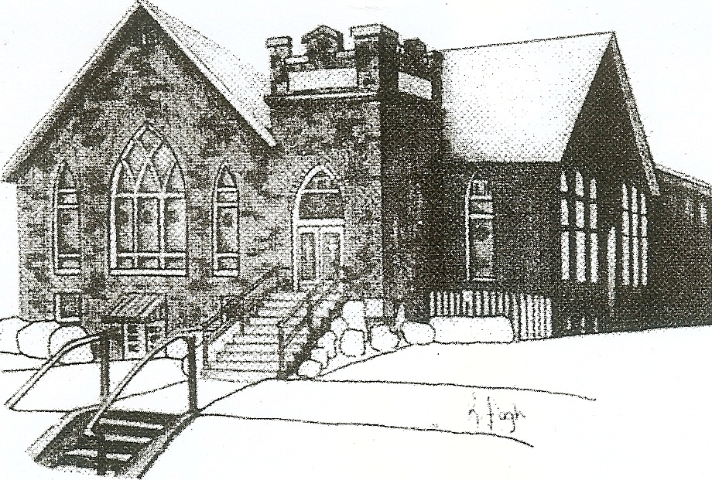
We are your hometown church: Faithful to Tradition, Loving in Fellowship, & Reaching for Tomorrow!

July 2, 2023

We welcome you and we are glad you’ve chosen to Worship with us today!

CALENDAR: July 2nd – July 9th

Church Office Hours: Monday -Thursday from 9 a.m. – 2:30 p.m.

Today, July 2, 2023 Communion/Baptism
VOLUNTEERS☺

LAST SUNDAY’S In-House ATTENDANCE: 62

LAST SUNDAY’S OFFERING:
Operating Funds: $2680.00
Kindness: $50.00
Mission: $60.00
Total: $2790.00

Tarry N Talk Hosts
Deacons

10:00 a.m. THE MORNING WORSHIP SERVICE
Monday, July 3, 2023
Tuesday, July 4, 2023
OFFICE CLOSED
Wednesday, July 5, 2023
9:00 am Material Girls
Thursday, July 6, 2023
Friday, July 7, 2023
Saturday, July 8, 2023
Sunday, July 9, 2023
10:00 am THE MORNING WORSHIP SERVICE
5:00 pm Vacation Bible School “Kick-Off”

Welcome to all who are Worshiping with us today!

Guests
We sincerely hope our service is a blessing to you. We ask that our guests please take a few minutes to complete one of the Connect Cards found in the pew holder.

Should you have questions regarding any aspect of our church, including membership, please contact Pastor Brian or the church office during the week at 724-625-1365. Thank you for being with us today.

PRAYER – JOYS & CONCERNS
Lou Beckwith Paige Lauten
Paige Barbour (daughter of Andrew and Steph Barbour) Sandy Wahl
Reid Christopher Hall (June Stirling’s nephew) Sue Morris
Lindy McCartney (Lisa Barbour’s Sister)

ANNOUNCEMENTS
Bulletins are printed Thursday mornings; let us know if you have an announcement…

VACATION BIBLE SCHOOL “STELLAR” Registration for VBS is available now online at www.mars-up.org. July 9th thru July 13th 6:00 to 8:30 pm. SPECIAL OPENING SUNDAY AFTERNOON- Families join us for a HOT DOG BEAN kickoff at 5:00 pm in MUP Fellowship Hall
GRIEFSHARE SUMMER MEETINGS Griefshare will continue to hold one monthly meeting during the summer. Meetings will be held on July 17th, and August 21st. The fall session will resume on September 18th at 6:30 For more information, please contact Denise @ ddemarco5@yahoo.com
VOLUNTEER OPPORTUNITIES Please join other MUP friends as we volunteer at one of our mission partners this summer --- Pine Valley Bible Camp (near Ellwood City). On Sunday, July 23rd from 4:00 – 6:00 pm we will be helping with “Luggage and Lemonade”-helping incoming campers get their luggage to their cabin and serving lemonade to campers and their parents. On. Wednesday August 9 from 5:30-7:30 pm we will be serving dinner and dessert to the campers. Anyone volunteering is invited to stay for dinner at the camp if interested, we just need to let them know how many are staying. So, hopefully at least one of those dates works for you! Ask a friend and let’s send lots of folks to help…pretty sure car pools can be arranged, too.
Sign-up sheets are in the Tarry ‘n Talk area or see Rev. Brian or any Christian Ed/ Mission & Outreach committee member (John Ivory, Susan Cox, Lisa Barbour, Herb Wellman, Carol Kopar, Jill Cooper) to volunteer or for questions.
GOLFERS NEEDED! South Butler Community Meals on Wheels 25th Annual Golf Outing at Conley Resort on FRIDAY, July 28th./sign-up by JULY 12TH
New this year---25% Discount for high school and college students.
Please sign up early and tell all your golf buddies. This is a "Best Ball Scramble." More information on flier in the back hallway bulletin board or contact 724-898-0080/email sbcmow@nauticom.net

