1/28/2017 The Significance of U.S. Presidents

YaHuWaH Elohim is continually revealing things to His people. Thoughts often come to me "out of the blue", out of heaven from YaHuWaH Elohim. Here the results of the thought that came today to investigate the conception dates of United States Presidents.

Life begins at conception, but much attention is given to the birth event with its accompanying pain and tribulation. The date of conception is dismissed as irrelevant, as it is a more secretive and highly personal experience. This emphasis on the actual birth event itself, and the celebration of subsequent birthdays in the life of the human, has blurred the vision of modern society. The emphasis on birth and birthdays has helped society to ignore the fact that human life begins at conception. The emphasis on the birth experience and birthdays helps society to accept pre-birth abortion.

A few days ago the thought came to me to look at Donald Trump's conception date. The conception date is about 280 days prior to the birth date, with anything within a week or two either side of the calculated conception date being a normal pregnancy and birth. It turned out that Donald Trump's conception date figured at 280 inclusive days prior to his birth date was the Hebrew Day of Trumpets, 9/8/1945.

So here is a man, President of the United States, who's name is Trump being conceived on or around the Day of Trumpets in 1945. Isn't that just a little bit odd? Perhaps a coincidence? It's a good idea to turn aside and investigate strange things, like a bush that's on fire but isn't being consumed.

The conception date isn't usually considered because society only looks at the birth date today, both in legal documents and family celebrations of birth. But our bibles tell us that people are knit in the womb by YaHuWaH Elohim, and He knows all about us. He knows when we will be born and when we will die.

The Conception Dates of U.S. Presidents

Here's a graphic below that shows the birth and conception dates of some U.S. Presidents. In each case either 280 days or 280 inclusive days was subtracted from the birth date to arrive at the conception date.

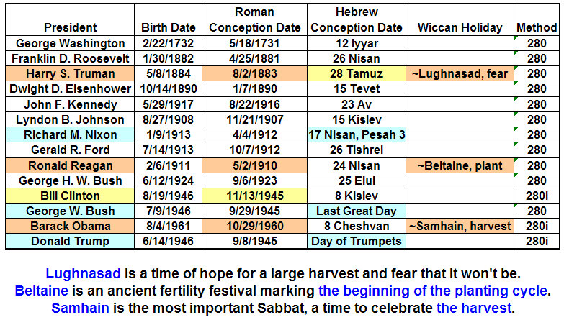

President Harry Truman, the North Pole Region, and the Atom B0MB

Notice the Hebrew conception date of Harry Truman as being on (or around) 28 Tamuz, 1883. Harry Truman became President on 4/12/1945. He was the President who made the decision to drop the first atomic device on Hiroshima, ushering in a new era in which mankind now has the ability to annihilate himself.

Harry Truman's conception date on or around 28 Tamuz is important because in a graphic I released just a week or so ago it was related how our Creator Elohim had set apart the North Pole using 3, 1st Av eclipses. Although they are identified as 1st Av solar eclipses, each of eclipses actually occurred on 28 or 29 Tamuz on the Hebrew Hillel calendar. They're called 1st Av eclipses because the eclipses mark the precise sun-moon time of conjunction to the exact second of time when the month Tamuz ends and the month of Av begins.

Below is the graphic showing the solar eclipses of 28-29 Tamuz in various years marking the precise astronomical beginning of 1st Av.
Remember that President Truman's conception date was on or around 28 Tamuz, linking the beginning of his life with these particular rare solar eclipses by his Creator, YaHuWaH Elohim.

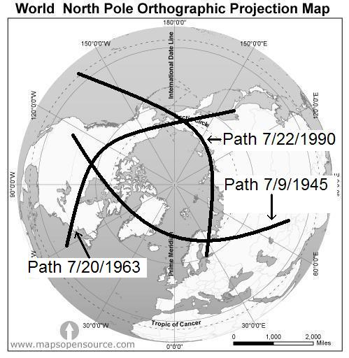

1. President Harry Truman was conceived on or about 28 Tamuz, 1883

2. Harry Truman was sworn in as President on 4/12/1945.

3. The first solar eclipse in the series that sanctified or "set apart" the North Pole region for our Creator Elohim occurred on 28 Tamuz, 7/9/1945.

4. The very first atomic device, the Trinity test, was detonated 7 days later on 7/16/1945.

Isaiah 46:9 Remember the former things of old: for I am Elohim, and there is none else; I am Elohim, and there is none like Me,
10 Declaring the end from the beginning, and from ancient times the things that are not yet done, saying, My counsel shall stand, and I will do all My pleasure:

YaHuWaH Elohim declares the end from the beginning. This is an important concept that will help us understand the cyclical patterns of prophecy.

Ecclesiastes 3:15 That which hath been is now; and that which is to be hath already been; and Elohim requireth that which is past.

President Bill Clinton and 11/13/2017

Notice on the graphic far above concerning the Presidents that there was an abrupt change when Bill Clinton became president. Three of the last four Presidents began their lives at conception in 1945, a special year that saw the beginning of the 1st Av solar eclipses and the Atomic Age. Almost immediately came the United Nations, a proliferation of UFOs, and Israel became a sovereign State again after over 2,000 years.

President Bill Clinton's conception date was on or around 11/13/1945. Note that Bill Clinton's presidency signaled a change, a new beginning, in the Presidential line as shown in the graphic far above.

"Just as the Feast of Trumpets began in Israel in 2008, the stock market in the USA collapsed 777.7 points. Seven years and 777 days later is the Jupiter-Venus Conjunction of November 13, 2017, which looks to be 7 days before the 70th Week of 2,520 days. Follow the sevens!" from Daniel Matson's interesting website: http://watchfortheday.org/thesign.html

As was mentioned in previous articles, 11/12,13,14/2017, include the completion of 50 days from the birth of the man child on 9/23/2017, the completion of 69 years from birth in the life of Prince Charles of England, the Prince of Wales, who is empowered by the Red Dragon, and the 1st day of the 70th year of the life of Prince Charles, along with other signs in the heavens mentioned by Daniel Matson above.

President Bill Clinton is therefore linked with the Red Dragon of Revelation by YaHuWaH Elohim through his Roman conception date of 11/13/1945. Remember that Prince Charles is a Roman Prince through the lineage of his father.

It was President Bill Clinton who is responsible for the deaths of approximately 76 men, women, and children, in their church compound in Waco, Texas, on April 19,1993. April 19, 1993 was the date reserved for ancient pagan child sacrifice and was also Yom HaShoah, Holocaust Remembrance Day, in Israel that year.

The Last Three Presidents

The last 3 U.S. Presidents were conceived on or near the days reserved for religious observances.

President George W. Bush was conceived on or about 9/29/1945, the observance of the Hebrew Last Great Day, a special day set apart on the Hebrew calendar at the end of the Feast of Tabernacles each year. The Last Great Day is linked with the concept of eternity, and eternal life with YaHuWaH Elohim.

President Barack Obama was conceived on or around 10/29/1960, near the pagan Satanic observance of Samhain on October 31 / November1 each year. Samhain is a day reserved for pagan sexual activity. President Obama's grandparents were Wiccans and attended a Wiccan congregation known as "the little red church" near Seattle, Washington.

President Donald Trump was conceived on or around September 8, 1945, the Hebrew Day of Trumpets. It's significant, a bit odd, that Donald Trump, who's name is "Trump" was conceived on the Day of Trumpets. We need to take notice.

Summary

Because YaHuWaH Elohim declares the end from the beginning, we need to notice that the date 11/13 that appears in the first President's conception, also appears in 2017 at the end of a timeline of 969 days from the solar eclipse of 3/20/2015. That special situation was addressed in a previous article.

We have many "end" indicators pointing to 11/13/2017. They range from Bill Clinton's conception date, to the solar eclipse of 3/20/2015 and the 969 years of Methuselah's life, to the indications mentioned on Daniel Matson's website in the link above.

We're into a period of time where YaHuWaH Elohim is showing us that He is in complete control of the leadership of the United States, even from the time of the conception of future Presidents in the womb. We must never underestimate the mighty powers and abilities of a YaHuWaH Elohim who is big enough to inscribe messages on the earth with the shadow of the moon and small enough to knit the human in the womb.

More info: http://www.joybysurprise.com/

