10/01/2016 Three Events of 9/30/2016

At least three events of significance occurred on 9/30/2016.

An Event of Political Significance

The Leaders of many nations gathered in Jerusalem on 9/30/2016 to honor Israel's past President Shimon Peres at his funeral ceremony.

It is of note that the word “peres” is a word found in the famous “Handwriting on the Wall” that was deciphered by Daniel the prophet on October 11, 539 BC. The Handwriting on the Wall foretold the fall of ancient Babylon to the Medes and Persians which occurred later that night on October 11, 539 BC. The word “peres” means “to divide”.

Above: The "Handwriting on the Wall", Mene Mene Tekel Upharsin, written in the ancient pictorial Hebrew from the time of Moshe. The Ten Commandments would probably have been written in this ancient pictorial font, not the Babylonian Aramaic called Modern Hebrew today.

This ancient font is offered here because only Daniel was able to decipher the message on the wall. Being an educated Hebrew, Daniel would probably have been familiar with the ancient writing, whereas the others in Babylon may not have been.

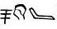
The word "Peres" extracted from the "Handwriting on the Wall" in the ancient pictorial Hebrew font.

It may be significant that a man who’s name, Peres, that was present in the Handwriting on the Wall, and who’s name means “divide” would end up signing a document that would result in the division of the land promised entirely to the descendants of Jacob.

Israeli President Shimon Peres and PLO representative Mahmoud Abbas signed the Oslo Accords documents of the Oslo I peace agreement between Israel and the PLO on 9/13/1993 in the presence of PLO chairman Yasser Arafat and Israeli Prime Minister Yitzak Rabin and U.S. President Bill Clinton.

The methodology resulting from the Oslo Accords was to divide (peres, English – parse, parcel) the land of Israel in exchange for peace with the Palestinian State. The land of Israel was eventually divided to obtain peace with its enemies. Wars and deaths have been the results through the years since.
Further, the nation of ancient Persia that conquered ancient Babylon derived its very name from the word “peres”. Ancient Persia is now the modern nation of Iran, an avowed deadly enemy of modern Babylon the Great, the United States of America.

Be aware that Adolph Hiltler’s supposed “Aryan” race of Nordic supermen are in truth Iranians (Aryans). The name of the nation of Iran is the Persian word for Aryan, from which comes our English word “iron”.

Iron and clay are the constituents of the ten toes of Nebuchadnezzar’s image of Daniel chapter 2. The iron and the clay signify strong and weak nations that have been sectioned into 10 parts at the end of the age who bind together in a united government, yet don’t get along with each other (a description of the current United Nations). Messiah the Rock strikes and destroys the united government. Be aware that the Club of Rome has sectioned the earth into 10 economic parts, of which Canada, the USA, and Mexico are combined to form one of the 10 parts.

A Rare Astronomical Event of Significance

We’re told that the sun, moon, and stars have been ordained by our Elohim to be signs, or distinguishing marks, in Genesis 1:14.

The European Space Agency mission named "Rosetta" that began in 2004 came to an abrupt end when the spacecraft was deliberately crashed by ESA technicians into comet 67P.
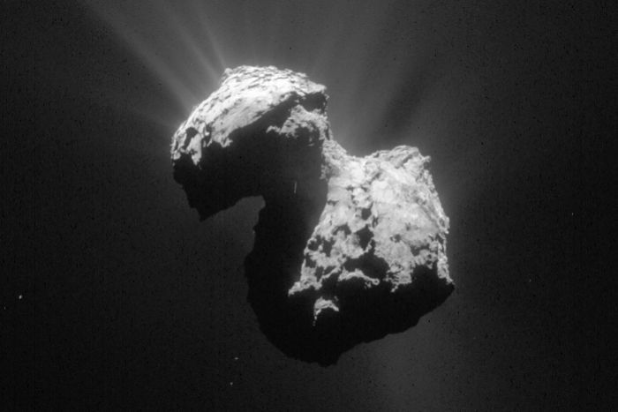
Comet 67P is about 2 miles x 2 miles in size Photo Courtesy ESA/Rosetta/NAVCAM

Comet 67P was visually located in the heart of the constellation Virgo the Woman when the Rosetta spacecraft was smashed into it on 9/30/2016. The red line in the graphic is the comet’s path in the sky.
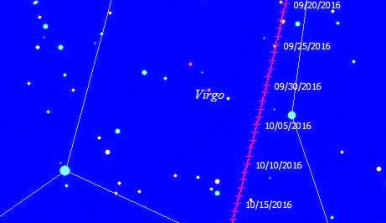

The ESA Rosetta mission was named for the famous Rosetta Stele which was found in Egypt in 1799 AD bearing an inscription in three ancient languages. The Rosetta Stele was the key to deciphering and understanding the ancient Egyptian Hieroglyphic writings.

It may be that the Rosetta spacecraft mission ending in a constellation that signifies Israel (Virgo) on the same day that President Shimon Peres is laid to rest in the presence of many foreign dignitaries carries a significance orchestrated by our Elohim, perhaps a key (like the Rosetta stone was a key) to the understanding of other end time events.

The Rosetta spacecraft was driven by ESA technicians to a collision with comet 67P near a pit on the comet known as Deir el-Medina.

Another Rare Astronomical Event of Significance

Earth’s moon passed in front of the planet Jupiter on 9/30/2016, hiding (occulting) the planet, as seen from Jerusalem beginning at 8:25 pm local Jerusalem time. The sun, moon, and Jupiter were all in the constellation of Virgo the Woman (signifying Israel) at the time.

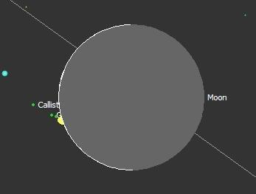
Our moon begins to pass in front of Jupiter and its moons in the constellation of Virgo the Woman on 9/30/2016 as seen from Jerusalem beginning at 8:25 pm local time.

The next occultation of Jupiter by the moon will be about 3 years from now on Celtic pagan Samhain, October 31, 2019. https://en.wikipedia.org/wiki/Samhain

Our moon signifies the nation of Israel as a reflector of light. Our moon reflects the light of the sun as the nation of Israel is to reflect the spiritual light (Torah, the instructions) of YaHuWaH Elohim.

The planet Jupiter signifies the Great King, the Messiah of Israel.

Summary

So we have the moon (signifying Israel) and Jupiter (signifying Israel's King, the Messiah) directly in line with Jerusalem (the only city on the face of the earth chosen by YaHuWaH Elohim our Creator as His own) as they move through the constellation Virgo (again signifying Israel) on the day that the Leaders of the world's nations have gathered in Jerusalem to honor the death of the man who was instrumental in the process of dividing Israel's land and giving that land to Israel's enemies in disregard of the specific instructions of YaHuWaH Elohim.

Along with this, the ESA Rosetta space mission coming to its 12 year conclusion also in the constellation Virgo (signifying Israel) near a pit on comet 67P (think 1967 and the taking of Jerusalem by Israel from Jordan during the Six Days War) named Deir el-Medina. http://www.answering-islam.org/Authors/Arlandson/qurayza_jews.htm

All of the above events occurred within a 12 hour period on 9/30/2016.

