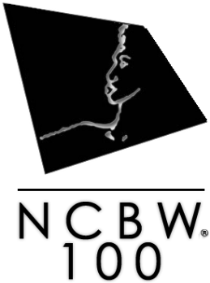
The National Coalition of 100 Black Women, Inc. Harrisburg Chapter
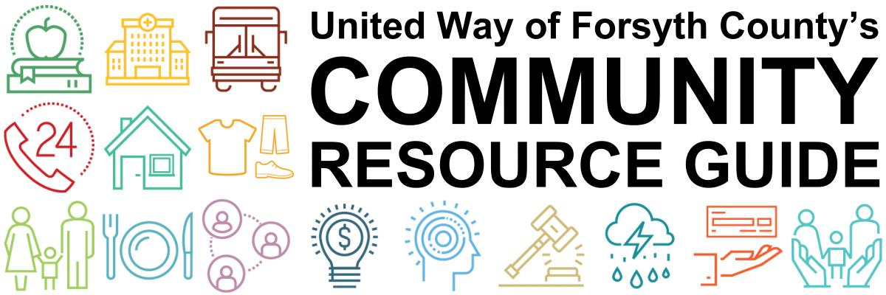

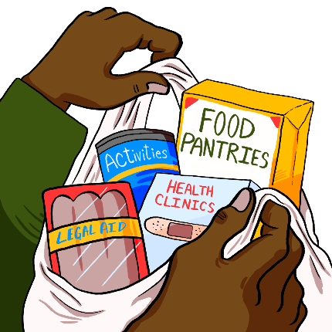

NEED HELP? DIAL 211 COMMUNITY HELPLINE
for Community Resources

CONTACT HELPLINE Information and referral service
1-800-932-4616

Local Community Numbers

717-545-1083 Ambulance (non-emergency)
717-255-6419 Building & Housing Development 717-255-6419
717-255-3070 City Controller 717-255-3070
717-558-6800 Emergency Management 717-558-6800
717-255-3091 Engineer 717-255-3091
717-657-5600 Finance and Personnel 717-657-5600
717-255-3040 Fire (non-emergency) 717-255-3040
717-255-3004 Harrisburg Administration Office 717-255-3004
717-255-6475 Harrisburg Human Resources 717-255-6475
717-652-9380 Library-East Shore Library 717-652-9380
717-255-3040 Mayor's Office 717-255-3040
717-255-6514 Operations & Revenue 717-255-6514
717-255-3020 Parks & Recreation Department 717-255-3020
717-558-6900 Police (non-emergency) 717-558-6900
717-236-4802 Public Works 717-236-4802
717-657-5650 Senior Citizen Van Service 717-657-5650
717-255-3065 Solicitor 717-255-3065
717-255-6513 Tax Office

Community Services & Hotlines

1-888-687-2277 AARP
717-234-5390 Alcoholics Anonymous-Harrisburg
1-800-272-3900 Alzheimer's Association
1-800-227-2345 American Cancer Society
1-800-342-2383 American Diabetes Association
1-800-548-8252 American Lung Association
717-763-0900 Arthritis Foundation-Central PA Chapter
1-800-843-5678 Center for Missing & Exploited Children
1-800-422-4453 Child Abuse
1-800-654-1211 Community Responders Network-PA
1-800-769-3571 Consumer Credit Counseling Service
1-888-312-3296 Crisis Intervention
717-652-9380 East Shore Library
717-657-5635 Friendship Center
1-800-522-4700 Gambling Addiction Hotline
717-564-3320 Harrisburg Humane Society
717-232-7509 Keystone Human Services
1-818-773-9999 Narcotics Anonymous
1-800-843-5678 National Center for Missing & Exploited Children
1-800-472-8477 PA Crime Stoppers
1-800-753-8827 PA Link to Aging and Disability Resource Center
1-800-222-1222 Poison Control Center
1-888-426-4435 Poison Control Center-Pet
1-800-786-2929 Runaway Hotline-National
1-800-656-4673 Sexual Assault 24 HR Hotline
1-800-662-4357 Substance Abuse Helpline-National
1-800-273-8255 Suicide Prevention Hotline
1-800-697-7007 The National Kidney Foundation
717-238-2531 Tri-County Association for the Blind

Hospitals

717-652-3000 Community General Osteopathic Hospital
717-652-9555 Frederickson Outpatient Center
717-652-9555 Frederickson Outpatient Center
717-782-3131 Harrisburg Hospital
717-763-2100 Holy Spirit Hospital
717-531-8521 Penn State Milton S. Hershey Medical Center
717-782-4141 Polyclinic Hospital
717-272-6621 Veterans Administration Medical Center

Transportation

1-800-872-7245 AMTRAK - Harrisburg Station
1-800-872-7245 AMTRAK National Railroad Passenger Corporation
717-238-8304 Capitol Area Transit Authority-CAT
1-800-231-2222 Greyhound Bus Lines-Harrisburg
1-888-235-9442 Harrisburg International Airport-HIA
717-255-3099 Harrisburg Parking Authority

Utility Companies

1-800-222-0300 AT&T
888-510-0606 Capital Region Water
1-800-366-8201 CenturyLink
804-743-1150 Comcast
1-800-934-6489 Comcast Cable
1-888-515-7799 DIRECTV
1-800-823-4929 Dish Network
1-800-342-5775 Electric-PPL Electric Utilities
1-888-544-4877 FirstEnergy Corp
1-800-376-6843 Frontier Communications
1-800-276-2722 Gas Company-UGI Utilities & UGI Penn Natural Gas
1-800-565-7292 PA American Water Company
1-866-866-7509 Sprint
717-564-3662 Suez Water Company
1-877-453-1304 T-Mobile
1-877-300-4498 Verizon FiOS TV, Internet & Phone
1-800-922-0204 Verizon Wireless

AMERICAN RED CROSS OF THE SUSQUEHANNA VALLEY
1-866-311-3832
1804 N. Sixth St., Harrisburg, PA 17102
www.redcross.org/centralpa

HELP MINISTRIES OF CHRISTIANCHURCHES UNITED
717-238-2851
413 S. 19th Street, Harrisburg, PA 17104
www.ccuhbg.org

The Salvation Army Harrisburg Capital City Region
(717) 233-6755
506 S 29th Street. Harrisburg, PA 17102
www.pa.salvationarmy.org

NEW DIGS MINISTRY
717-620-9735
5 Pleasant View Drive. Mechanicsburg, PA 17050
www.newdigsministry.org

CENTRAL PA FOOD BANK
717-564-1700
3908 Corey Road. Harrisburg PA 17109
www.centralpafoodbank.org

BETHANY CHURCH OF THE NAZARENE FOOD PANTRY
717-545-1633
1605 Parkway West. Harrisburg, PA 17112

ALLISON HILL COMMUNITY MINISTRY FOOD PANTRY
717-233-6441
1508 Derry Street. Harrisburg, PA 17104

THE CROSSPOINT FOOD PANTRY
717-580-1048
6570 Mifflin Avenue. Harrisburg, PA 17111
www.xpointumc.org

ECUMENICAL FOOD PANTRY
717-233-6889
Messiah Lutheran Church
901 North Sixth Street. Harrisburg, PA 17102
www.ecumenicalfoodpantry.wordpress.com

MACEDONIA MISSIONARY BAPTIST CHURCH
717-232-8946
2339 N. Sixth Street. Harrisburg, PA 17110

KINGDOM EMBASSY FOOD PANTRY
717-236-8600
2111 N. 4th Street. Harrisburg, PA 17110

HAMILTON HEALTH CENTER
717-232-9971
110 S. 17th St., Harrisburg, PA 17104
www.hamiltonhealthcenter.com

CASE MANAGEMENT UNIT
717-232-8761
1100 S. Cameron Street. Harrisburg, PA 17104
www.cmu.cc

BOYS AND GIRLS CLUB OF HARRISBURG
717-234-3268
1227 Berryhill Street, Harrisburg
1700 Hanover St., Harrisburg
1313 Monroe St., Harrisburg
www.bgchbg.org

DOWNTOWN DAILY BREAD
717-238-4717
234 South Street. Harrisburg, PA 17104
www.downdailybread.org
BRETHREN HOUSING ASSOCIATION
717-233-6016
219 Hummel Street. Harrisburg, PA 17104
www.bha-pa.org

TRI-COUNTY COMMUNITY ACTION
717-232-9757
1514 Derry Street. Harrisburg, PA 17104
www.cactricounty.org

YMCA Camp Curtain Branch
(717) 238-9622
2135 N 6th Street. Harrisburg, PA 17110
www.ymcaharrisburg.org

