Hong Kong Respiratory Mini Library Book List

Book Name | Author | Publisher | Book Image
Respiratory Notes Resp. Therapist's Pocket Guide | Gary C. White | FA Davis Company | 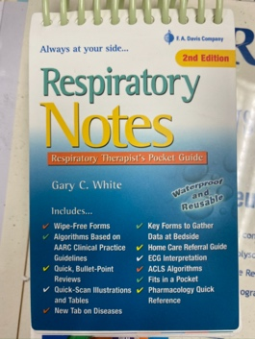
Understanding Mechanical Ventilation | Ashaq Hasan | Springer | 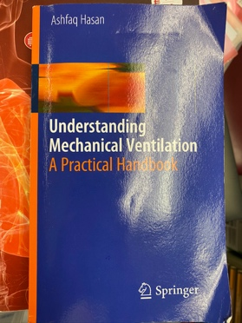
Respiratory Medicine 3rd Edition | Paolo Palange Gernot Rohde | ERS/handbook | 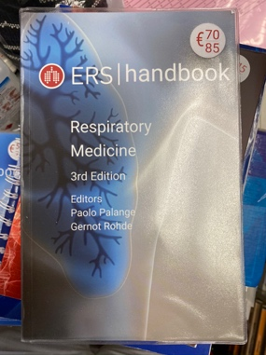
Nosocomial and Ventilator-Associated Pneumonia | A. Torres S. Ewig | European Respiratory monograph | 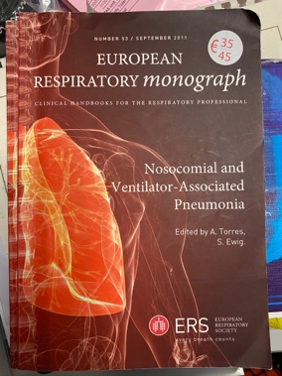
Respiratory Sleep Medicine | Anita K. Simonds Wilfried de Backer | ERS/handbook | 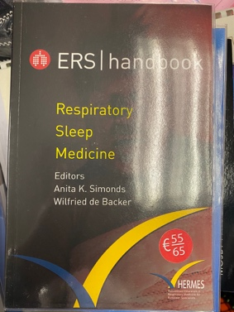
Severe Asthma | Kian Fan Chung Eilliot Israel and Peter G. Gibson | European Respiratory monograph | 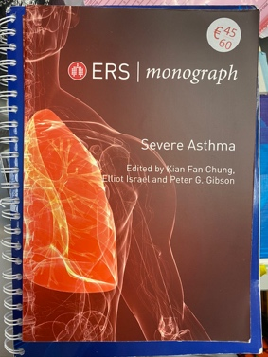
Difficult- to - Treat Severe Asthma | K.F. Chung, E. H. Bel, S. E. Wenzel | European Respiratory monograph | 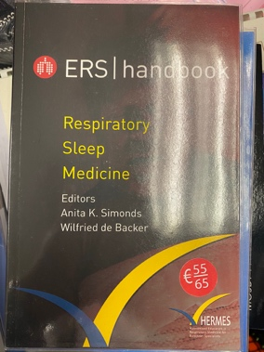
COPD and Comorbidity | Klaus F. Rabe, Jadwiga A. Wedzicha, Emiel F. M. Wouters | European Respiratory monograph | 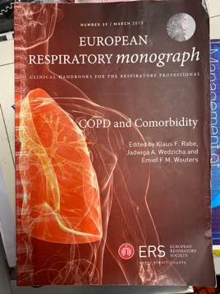
Clinical Exercise Testing | Paolo Palange, Pierantonio Laveneziana, J. Alberto Neder and Susan A. Ward | European Respiratory monograph | 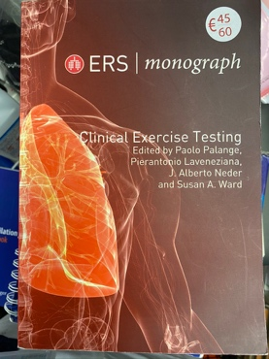
Noninvasive Ventilation | Anita K. Simonds | European Respiratory monograph | 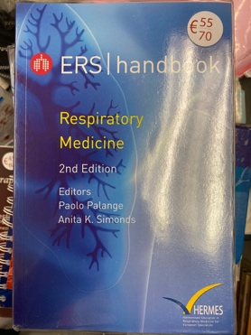
Practical Handbook of Spirometry | Brendan Cooper  Jodie Hunt  Adrian H Kendrick  Vicky Moore  Trefor Watts | Association for Respiratory Technology and Physiology (ARTP) | 