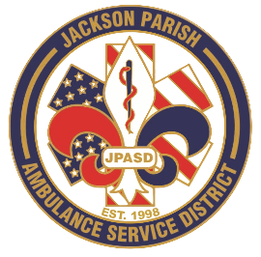
Aaron K. Johnson, Jr - EMS Director

Paula Parkerson, MD - Medical Director

Governing Board
Allen Lindsay, Conchita Doyle, Joe Vail, Alma Williams, Deidre Hollis
Jackson Parish Ambulance Service District
115 Watts Street
Jonesboro, LA 71251
Office: (318) 259-2877
Fax: (318) 259-2099

jacksonparishambulance@jpasd.com

Meeting Minutes for Public Budget Hearing: Thursday, November 13, 2025 @ 12:00 Noon

Present: Allen Lindsay, Joe Vail, Deidre Hollis, Alma Williams, Aaron Johnson, Amber Swanner, and JoLynn Smith

Absent: Conchita Doyle

Guests: Vicki Vail and Myron Curry

Meeting was called to order by Allen Lindsay. Roll call by Aaron Johnson: Present: Allen Lindsay, Joe Vail, Deidre Hollis, and Alma Williams Absent: Conchita Doyle. Guest present: Vicki Vail and Myron Curry. Quorum noted. Invocation was led by Deidre Hollis. Pledge of Allegiance led by Joe Vail. The floor was opened to the public for comments, questions, and concerns regarding the proposed 2026 budget. Floor open for comments. No guest comments. The meeting was turned back over to the board. Deidre made a motion to adjourn public hearing. All in favor motion carried.

