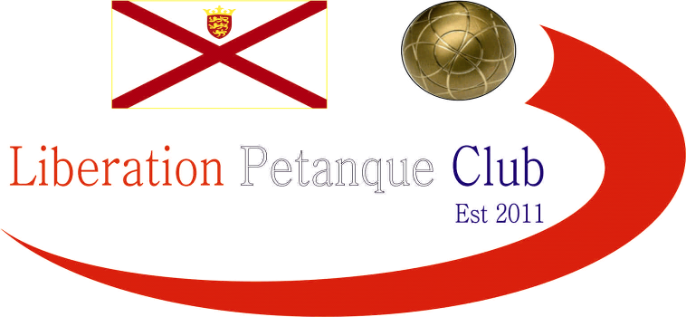

2024
Charity Triples Open
In aid of Jersey Children’s Charity & Ronald McDonald House

Just 4 teams took part in this year’s competition, the lowest entry numbers in a long time, however four very high quality teams. Entries and donations though helping raise £140 towards supporting the Charity.

Round one was probably the closet round in history as champions Geoffroy, Laurent and Toby just edged out Callum, Ross and Andrew 12 – 11 on the last end whilst Gary, Wendy and Brian also lost on the last end 13 – 12 to Matt, John and James.

In Round two Geoffroy, Laurent and Toby won slightly more comfortable, at least by scoreline 13 – 7 over Gary, Wendy and Brian whilst Matt, John and James also won 13 – 9 over Callum, Ross and Andrew.

This meant we already had two teams on two wins so it was decided to go straight to the final and third place play-off.

In a close final, just a few points separated the teams with Matt Pinel, James Rondel and John Lane coming out on top 13 – 10.

Gary, Wendy and Brian took third place with a 13 – 8 win over Callum, Ross and Andrew.

WINNERS

John Lane, James Rondel and Matthew Pinel

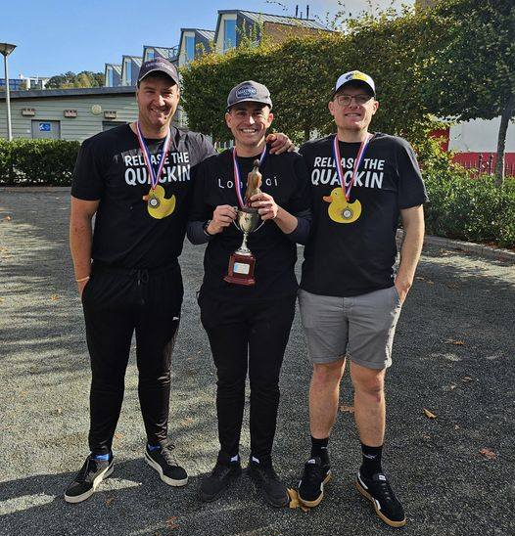

Special thanks to everyone who took part in the competition and helped raise money for a good cause and also those who donated and helped organise the competition.

Kind Regards

Toby Northern

Chairman

Liberation Petanque Club

