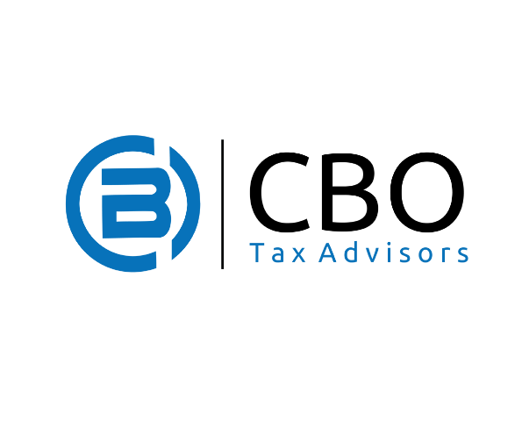

*Disclaimer: CBO Tax Advisors, LLC disclaims any liability for any damages resulting from the use of the information contained in this document. CBO Tax Advisors, LLC has expressed its opinions in this document based an experience and research on the matters covered. The information and content provided is for informational purposes only and does not constitute legal advice, nor does it constitute written advice as described in IRS Circular 230. Changes may occur in the applicable laws and regulations that could have an impact on your rights and liabilities. The reader bears the burden of assuring the information contained in this document is current as of the time of intended use. In addition, the IRS forms and publications are regularly updated by the United States Treasury. The reader bears the burden of assuring that the forms used to engage the IRS are the most current forms available.*

***IRS Audits, Back Taxes, and You. What you need to know.***

Taxes, and especially back taxes, can make your life extremely difficult, particularly if you are not experienced in handling this area. If you are facing tax debt or are worried that you may be audited by the IRS, it is important to be proactive and, in some cases where you feel you need it, seek the assistance of a skilled tax advisor.

1. **Why would the IRS audit me?**

The IRS uses audits as a means to analyze tax returns. You could be selected at random, or the IRS may have noticed questionable activity on your tax return. Questionable activity can include errors on your tax return, failure to include additional income, claiming excessive business expense deductions, rounding up on your expense calculations, or a host of other reasons.

1. **If I haven’t filed a tax return in years, is it better to start filing now or wait until the IRS figures it out and asks for a return?**

The best thing you can do is file your tax return as soon as possible. At some point, the IRS will find out that you haven’t paid taxes through employers, contractors, mortgage holders or other documents. The longer you wait without filing or paying taxes, the more fines and/or penalties you’ll have to pay.

1. **I owe back taxes; will the IRS place a lien on my assets, or garnish my wages through a levy?**

While these are related, they’re really all different things. First, a tax lien is a legal claim to an asset as security for your back tax debt. It gives the IRS (or state) a claim to the property. In some instances, the IRS will file a Notice of Federal Tax Lien (NTFL), recorded according to state law, generally with the County Recorder of Deeds, Secretary of State’s office, or other agencies. If this happens, the tax lien may prevent your from selling assets, lower your credit score (and may make it hard for you to borrow money, open new bank accounts, or in some instances, qualify for a new job if a credit check is mandated).

A levy will actually enforce an asset lien and the IRS (or state) takes possession of that property to help pay back your back taxes. A garnishment is a continuing levy on your wages, salary, and other income to pay your back taxes.

While most forms of income are subject to levy, the following items are not:

* Unemployment benefits
* Workmen’s compensation
* Certain public assistance payments
* Certain service-connected disability payments
* Tools of your trade

If the IRS (or state) has taken money from your check or bank account, a release may be needed. This can only occur when a tax resolution is reached with the IRS (or state), such as an installment agreement or offer in compromise. In some cases, the IRS will temporarily release the levy if you can prove financial hardship. If this works, you are still required to reach tax resolution with the IRS, and they will expect it very soon after the hardship release. Otherwise, another levy may take place.

Under the following circumstances, the IRS is required to release your levy:

* Your tax debt has been paid, or collection time statutes have passed
* The taxpayer has negotiated a formal Installment Agreement
* It has been proven that the levy is creating an economic hardship on the taxpayer
* The fair market value (FMV) of the levied property is greater than the tax debt owed (part of the asset may be released in these circumstances)
* The release of the levy will make tax debt collection easier

1. **Ok, I want to resolve my back taxes, but what if I can’t pay what I owe?**

While this may seem overwhelming and frightening, you do have options. You can:

1. **Negotiate an Offer in Compromise**. With this option, you obtain tax relief by settling your taxes for less than you owe. If the IRS accepts your offer, you can pay the amount agreed upon, and all federal tax liens are removed. Offers in Compromise are eligible for acceptance only if there is:

* Doubt as to liability – There is doubt that your tax is correct.
* Doubt as to collectability – There is doubt that you could pay what you owe.
* Effective tax administration – Your offer can be accepted even if your tax is correct and can be collected under rare circumstances if you can prove that the tax would be unfair or create an economic hardship.

Please remember that negotiating an Offer in Compromise can be very complicated and can last 6-18 months. Also, only about a quarter of all offers are accepted. Therefore, it is highly recommended that you get a competent tax advisor to help with any offer.

A final note about any Offer in Compromise: If your offer is accepted, you must file your tax returns and pay all taxes for the next five years, or you’ll once again be responsible for all taxes and fines.

1. **Negotiate an Installment Agreement.** With this option, an Installment Agreement (or IA) may be available to delinquent taxpayers to satisfy a back tax debt over time. There are several types of IAs to accommodate most taxpayer's needs.

* Guaranteed Installment Agreement
* Streamlined Installment Agreement
* Non-Streamlined Installment Agreement
* Fresh Start Installment Agreement
* Partial Payment Installment Agreement
* Direct Debit Installment Agreement
* Payroll Deduction Installment Agreement

The IRS Installment Agreement you qualify for depends on several factors, including the amount of back taxes you owe, the type of taxes you owe, your ability to pay monthly, your equity in assets, etc.

Once you’ve established an IRS Installment Agreement, please know that it will go into default if:

* You do not pay your minimum monthly payment in full when it is due.
* You do not file all required tax returns timely with full payment.
* You do not pay all taxes you owe in full and on time.
* You accrue a new tax liability.
* You do not provide financial information when requested.

1. **Be declared “Currently Not Collectible” (CNC) by the IRS**. With this option, the IRS voluntarily agrees not to collect the debt owed for about a year or so, and release any levy. Since the CNC status simply suspends the process, it generally does not resolve the taxpayer’s underlying tax issue, and further resolution such as an installment agreement or offer in compromise is usually recommended.
2. **File for bankruptcy**. While generally not recommended for a variety of reasons, in some instances, individuals who owe back taxes can file for bankruptcy. However, please know:

* You must file all required tax returns for tax periods ending within four years of your bankruptcy filing.
* During your bankruptcy you must continue to file, or get an extension of time to file, all required returns.
* During your bankruptcy case you should pay all current taxes as they come due.
* Failure to file returns and/or pay current taxes during your bankruptcy may result in your case being dismissed.

***If you want our help …***

If you’d like help with your IRS and/or State audit or back tax issues, we utilize these flat rates:

IRS only:

One-time payment of $1500 (a $300 discount) - includes IRS tax relief and up to 3 back tax returns (additional back returns are billed at $100 each).

**OR**

3 monthly installments of $600 each for a total of $1800 – includes IRS tax relief and up to 3 back tax returns (additional back returns are billed at $100 each).

IRS and State:

One-time payment of $1800 (a $300 discount) - includes IRS tax relief and up to 3 back tax returns (additional back returns are billed at $100 each).

**OR**

3 monthly installments of $700 each for a total of $2100 – includes IRS tax relief and up to 3 back tax returns (additional back returns are billed at $100 each).