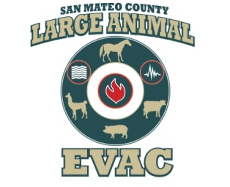
SAN MATEO COUNTY
Large Animal Evacuation Group

FACT SHEET
Established January 2009

Mission Statement
The mission of the San Mateo County Large Animal Evacuation Group is to provide qualified large animal handlers and horse trailers in emergency situations; to evacuate large animals in any degree emergency, to lessen the burden on Emergency Services.

The group also provides preparedness workshops upon request.

LAEG is an all volunteer group (501c3 status pending) that activates when called upon by the San Mateo County Office of Emergency Services or other emergency county agency.

Member Stats
- 20 Active Members
- 13 Licensed Ham Radio Operators
- 9 Active Trailers – varied sizes
- 2 Reserve Member w/Trailers – varied sizes

LAEG members are
- FEMA ICS 700 & 100 (Incident Command System) certified
- CERT Trained
- CPR / First Aid certified
- Experienced equine / large animal handlers
- HAM Radio Certified

Ongoing member training/workshops include
- Trailer maneuvering and loading
- Trailer safety and maintenance
- Large animal handling
- CPR / First Aid training
- Ham radio operation
- Regularly scheduled activation drills

Team Resources
- Monthly General Meetings since early 2009 – held at the Half Moon Bay Firehouse Station 40
- SOP (Standard Operating Procedures) covering activation protocol and operation
- Organized notification system to mobilize members quickly – County BLUE Alert List
- Quarterly meetings with OES/CALFire
- Ongoing communication and shared training with neighboring county equine evacuation teams

CONTACT INFORMATION

Sharon Montoya Bretz Cell: 650.740.0724 Email: sharonmontoyabretz@gmail.com
Lee Copeland Cell: 650-279-0737 Email: copelan9@gmail.com
Robin Camozzi Cell: 650.450.0516 Email: hmbfeednfuel@sbcglobal.net
Kris Thoren Cell: 605.773.9590 Email: kthoren@NuGENinc.com
