APRIL 1, 2020 @ 6:30 PM - Online HOA BOD MEETING – email CreeksideHOA@tampabay.rr.com for meeting link

HOA Fees are due 03/31/2020
Late fees are assessed for all payments received after this date.

Postponed –  CREEKSIDE SEMI-ANNUAL GARAGE SALE  Due to both the road closure and the protocol put in place to deal with the Corona virus, we think it would be best to hold off on the event until April/May. | We wish all our residents a  happy and safe Easter.  During this time of social  distancing, to keep  everyone safe, we must  cancel the kid’s event.  Watch for another family  event in  the upcoming months.
FRIENDLY REMINDER  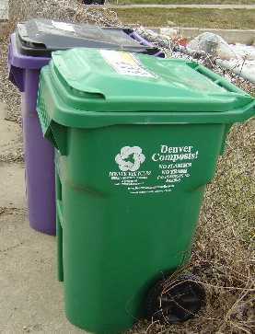  Please move trash cans out of view on non-trash days.  Help keep our neighborhood looking organized! | FRIENDLY REMINDER  Spring is the time to check the exterior of your property for fading paint, mildew, dirty sidewalks, bare patches in grass, and for trimming dead plants and low hanging tree limbs.  This Photo by Unknown Author is licensed under CC BY-NC-ND

