11/29/2016 November 29, 2016 Clarification

I need to clarify something included in the previous email of 11/28/2016 concerning November 29, 2016.

November 30, 2016, was listed in that email as being 2520 days from 1/6/2010 when the strange comet P2010 A2 was discovered. November 30, 2016 is in fact 2520 days from 1/6/2010.

However, November 29, 2016 is the 2520th inclusive day from 1/6/2010. In other words, counting 1/6/2010 as the first day, 2520 days (360 weeks) are completely filled up at midnight on 11/29/2016.

Inclusive numbering is used to number events in the bible, such as the term lengths of Kings. We in the West call a child one year old after his 1st birthday, but the child is actually in his 2nd year of life at that time.

So, there are now at least 3 astronomical events pointing exactly to 11/29/2016, the 1st day of the 70th year from the UN partitioning the land allotted entirely to Jacob's descendants by YaHuWaH Elohim.

1. The midpoint date between the last total lunar eclipse of 9/28/2015 and the next total lunar eclipse of 1/31/2018 is 11/29/2016.

2. The midpoint date between the total solar eclipse of 8/11/1999 and the total solar eclipse of 3/20/2034, both of which help to place an "X" on Islamic regions, is 11/29/2016.

3. The strange "Tav" comet P2010A2 was discovered on 1/6/2010, with exactly 7 prophetic years being filled on 11/29/2016.

YaHuWaH Elohim is using solar Eclipses to mark off His turf:

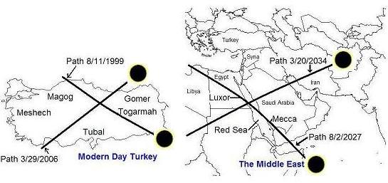

Above is a graphic showing the solar eclipse Tavs placed by YaHuWaH Elohim on the Islamic regions. The solar eclipse of 8/2/2027 passes directly over the Kaaba in Mecca. The Kaaba is the central temple of Islam. On 8/2/2027 the King star Regulus, the sign of Israel's King Messiah, will appear as a warning in the middle of the day next to the totally eclipsed sun to the Islamic worshippers at the Kaaba in Mecca.

Those special solar eclipses in the graphic above mark off the land promised to Jacob and his descendants.

The central date is 11/29/2016, and the central country in the graphic is Israel.

Zechariah 12:1 The burden of the word of YaHuWaH for Israel, saith YaHuWaH , which stretcheth forth the heavens, and layeth the foundation of the earth, and formeth the spirit of man within him.
2 Behold, I will make Jerusalem a cup of trembling unto all the people round about, when they shall be in the siege both against Judah and against Jerusalem.
3 And in that day will I make Jerusalem a burdensome stone for all people: all that burden themselves with it shall be cut in pieces, though all the people of the earth be gathered together against it.

The United Nations first in 1947, and afterward the United States, have taken upon themselves the burden of partitioning and giving to others the land that YaHuWaH Elohim has promised entirely to Jacob and his descendants. YaHuWaH Elohim has marked off His turf and given instructions concerning it. Those who venture to ignore His instructions risk their own destruction.

Hurricane Katrina immediately struck the United States in 2005 after Jews living in Gaza were evicted from their homes and their land given to the Palestinians.

Babylon the Great is now being partitioned, cut into pieces of political and ideological division, as ancient Babylon was divided by the confusion of languages when Elohim came down to see the Tower (think Trump Tower) the people were building.

