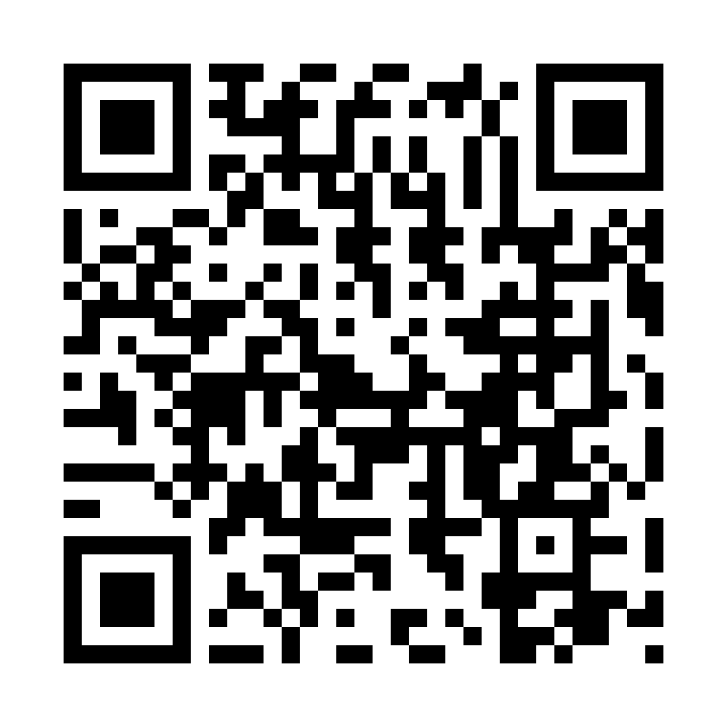

Catholic Church *cluster* of Davenport

St. Francis of Assisi – Harrington

Immaculate Conception Catholic Church – Davenport

St. Michael Catholic Church – Reardan

St. Kateri Tekawitha Catholic Church – Ford

Sacred Heart Catholic Church – Wellpinit

***Mailing Address***: Immaculate Conception Catholic Church - Davenport

1310 Adams St., Davenport, WA 99122-9454

(509)725-1761

***Office manager***: Jackie – [icdavenport@dioceseofspokane.org](mailto:icdavenport@dioceseofspokane.org)

Immaculateconceptiondavenport.org

Any information for the bulletin needs to be to Jackie by Tuesday 10 am.

***Pastor*** - Fr. Sean Thomson  [sthomson@dioceseofspokane.org](mailto:sthomson@dioceseofspokane.org)

Sacramental requests:Call Fr. Sean (509)688-5784

**The Holy Sacrifice of the Mass**

**Daily** Postponed until further notice…

**Saturday**  Harrington mass will be suspended until early December **Sunday** Rosary at 8am in Davenport

Davenport at 8:30am**,** Reardan at 10:30am, Ford 12:30pm (1st-2nd-3rd Sunday in Ford) (4th Sunday in Wellpinit)

**Confessions** - by appointment only via visiting priest.

**Tuesday** Davenport 5:30pm Eucharistic Adoration.

**Catechism of the Catholic**

**2011** The charity of Christ is the source in us of all our merits before God. Grace, by uniting us to Christ in active love, ensures the supernatural quality of our acts and consequently their merit before God and before men. the saints have always had a lively awareness that their merits were pure grace.

Anyone who wants to help with coffee and donuts after mass, there is a signup sheet on the back bulletin! We are hoping for twice a month but more would be great! Christmas potluck on the 15th of Dec. **Sign-up sheet in the back.**

**Faith formation:**  On-line classes for 10 yrs and up, including adults, meets Tuesdays at 7pm via Webex on line. **We are studying the Gospel of John. Very intriguing so far! Try it out? E-mail Michael Crow to get the link sent to you!** [**crowme@comcast.com**](mailto:crowme@comcast.com) **The link for the Webex meeting will be in the on line bulletin each week. Join us!**

**ACA collection is still open. There are envelops in the pews if you did not receive one in the mail!**

Please fill out name and address etc. info on the sheets in the pews. Put them in the collection or box where they will be collected and input in church computer! Thanks!

Parish counsil meeting at Reardan is Nov 12 at 6pm.

Daily devotional suggestions: Divine Mercy Chaplet, Rosary, 12 yr pray of St Bridget, 7 Sorrows prayer. Don’t forget to pray for the souls in purgatory this month!

**Mass Intentions:** Nov. 9 Sat. (5:00pm) For Fr Sean’s recovery Nov. 10 Sun. (8:30am) For Fr Sean’s recovery (10:30am) For Fr Sean’s recovery (12:30pm) For Fr Sean’s recovery Nov. 12 Tues. (9:00am) For Fr Sean’s recovery Nov. 13 Wed. (9:00am) For Fr Sean’s recovery Nov. 14 Thur. (9:00am) For Fr Sean’s recovery Nov. 15 Fri. (9:00am) For Fr Sean’s recovery