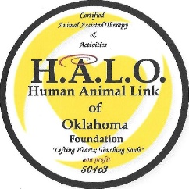
Human Animal Link of Oklahoma Foundation
Member Application Form

Personal Information:
Primary Handler Name __________________________ Secondary Handler Name ___________________________
Junior Handler Name____________________________ Age and Gender _________________________________
A Junior Handler must be your child, must live in your residence, and must be at least 14 years of age.
Special Needs of Handler______________________________________________________________
Address _________________________________________________________________
Home ____________________ Cell _____________________
Volunteer Availability (Circle) Weekdays Evenings Weekends - Time Preference (Circle) AM PM
Current Work Status (Circle) Student Employed Retired Unemployed Receiving Disability
Have you ever been convicted, pled guilty to a crime, or received a deferred sentence? (Circle) Yes No
Pet Information:
Name______________________________________Breed___________________________________
Age ____________Weight _____________
Special Needs________________________________________________________________________
Rescue _______Number of years as a family member_________________ Dual Residence (circle) Yes No
Level of Obedience Training (CIRCLE) BASIC INTERMEDIATE ADVANCED
H.A.L.O. Therapy Dogs may not have participated in training for personal protection and search and rescue.
American Kennel Club (AKC) Canine Good Citizen awarded? Yes_____ No_____ Date of test________________

This form must be submitted to Terri Smith at halo@yourhalofoundation.org at least three weeks prior to scheduling your performance evaluation.

