High Protein Banana Muffins

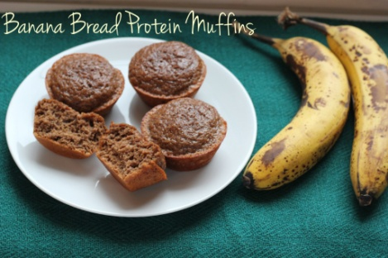
Print
Prep time
5 mins
Cook time
12 mins
Total time
17 mins

At just 60 calories each, these muffins are a perfect low calorie snack!
Author: Liz Thomson
Recipe type: Breakfast
Cuisine: Muffin
Serves: 15 muffins
Ingredients
- 1 large ripe banana
- ¾ cup of egg whites
- ¾ cup whole wheat flour
- ½ cup plain Greek yogurt
- 2 scoops of vanilla protein powder (I use whey protein)
- 1 tsp baking soda
- 1 tsp baking powder
- ½ tsp cinnamon
- Optional: walnuts, chocolate chips, etc.
Instructions
- Preheat the oven to 350.
- Add all the ingredient to a food processor and blend until smooth.
- Spray a muffin tin with non-stick spray.
- Scoop about ⅓ cup of batter into each muffin tin.
- I made 15 muffins which is an awkward amount of muffins to make so if you prefer, you can make them a bit larger and just make a dozen. That'll only add about 10 calories to each muffin, so no big deal.
- Bake for 11-13 minutes or until a toothpick comes out clean. Mine took 12 minutes exactly

Pumpkin Muffins
Minutes to Prepare: 5
Minutes to Cook: 15
Number of Servings: 6

Ingredients
1 C oat bran (can use whole wheat flour)
3 scoops Protein Powder (I used Designer Whey)
1/2 C pumpkin
1 TBSP cinnamon
1.5 TSP baking powder
.5 TSP baking soda
2 egg whites
3 TBSP flaxseed meal (ground up flaxseed)

Directions
Mix all ingredients in 1 bowl. Make sure to break up any clumps that appear. Pour out in muffin tins till 3/4 full. Bake at 350 degrees for about 15 minutes. This makes 6 muffins.

