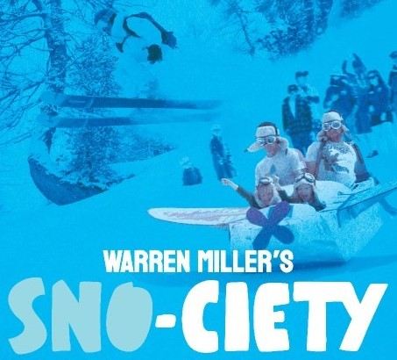
NEWS RELEASE
For Immediate Release ERIE SKI CLUB, ERIE, PA.

It’s time to get fired up for ski and snowboard season! The Erie Ski Club presents Warren Miller’s newest ski film SNO-CIETY on Saturday, November 22nd, 2025 at the Tom Ridge Environmental Center, 301 Peninsula Drive. All profits benefit the Lounsbury Adaptive Ski Program at Holiday Valley Ski Resort in nearby Ellicottville, NY. Last year the club donated over $3,000!

Warren Miller Entertainment has been producing films for over seven decades, and this year’s film once again features amazing skiers and snowboarders on adventures throughout the world! From California and Colorado, to Austria, Finland, Scotland and places in between, this is a must-see film for anyone looking to get their juices flowing for enjoying winter outdoors! And featuring
all-new, original segments with Olympians, urban riders, and local legends.

With paid admission of $15, movie goers receive BOGO coupons to Peek'n Peak, Mount Pleasant and Holiday Valley Ski Resorts, and discount coupons for regional ski/snowboard related vendors! Attendees are entered to win local door prizes which include free lift tickets, and can enter the national drawing from
Warren Miller for trips, gear and more!

Doors open at 6PM with the newest equipment on display from ski and snowboard vendors, along with regional resort reps, and a snack bar. Tickets are available at the door. The movie starts at 7PM.

The Lounsbury Adaptive Ski Program offers lessons to persons with virtually all disabilities, both physical and cognitive. Each student is instructed individually with full focus on his or her ability, rather than disability.

The Erie Ski Club is a proud independent promoter of SNO-CIETY!

Movie trailer: https://warrenmiller.com/film-tour

Lounsbury Adaptive Ski Program: https://lounsburyadaptive.org

For more information or purchasing tickets in advance of the show,
contact Vince Ross at 814-873-8287 or vpross56@gmail.com

