
JERSEY International Open
International 2026 Open Competition Weekend 24th to 26th July
Minimum Guaranteed Prize Fund for the Weekend over £2000
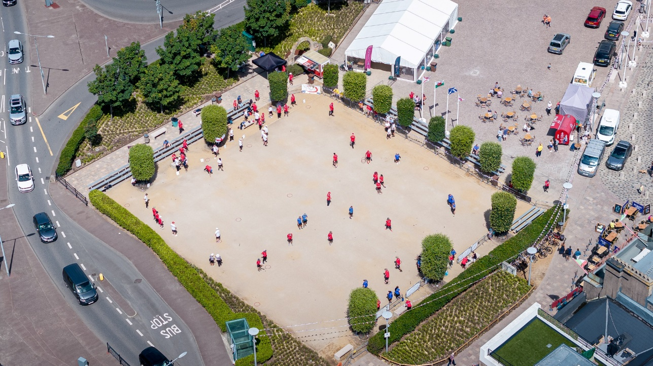

We are based in the Heart of Jersey’s Capital, St Helier surrounded by Bars, Restaurants, and the main shopping centre.
Following the success of our first International Open in 2022 and even greater success since we have been encourage to put on another event in 2026. The event will be spread over the three days with a different competition to be held each day.

Friday - Open Singles Competition
Saturday - Open Doubles Competition
Sunday - Open Triples Competition

Entry Fees and Prize Fund Breakdown

Entry Fees are as follows: £20 per person
Singles - £20 per person
Doubles - £40 per team (£20pp) (1 Substitute allowed additional £20)
Triples - £60 per team (£20pp) (1 Substitute allowed additional £20)

Singles First Prize – Minimum starting amount of £250
Doubles First Prize – Minimum starting amount of £400 per team
Triples First Prize – Minimum starting amount of £375 per team

Once minimum entries have been met the prize fund will increase with each entry received thereafter.
Competition Format’s

We will be using the Swiss System for all three competitions (As used in the European and World Championships).

Start Time is 8.30 (tbc)

Maximum Entries 52 Teams / Players (Maybe increased)
4 Qualifying Rounds (tbc) (5 Rounds for Singles tbc)
Timed Matches Singles 35 Minutes, Doubles 50 Minutes and Triples 50 Minutes. All + additional 1 end
Qualifying Criteria - Wins
- BHN (Opponents Wins)
- Points Difference

*Example with 32 Players / Teams
Top 16 Teams / Players through to Main Competition
Teams / Players finishing 17th to 32nd through to the Plate Competition.
If more than 32 Players / Teams they will go through to the consolage up to 48 Players or Teams
Remaining Teams / Players eliminated from the competition

*Note: This is an example only and the exact format will be confirmed once final entry numbers are known.
Knockout stages - Last 16
Last 16 Match 1 - 1st v 16th
Last 16 Match 2 - 2nd v 15th
Last 16 Match 3 - 3rd v 14th
Last 16 Match 4 - 4th v 13th
Last 16 Match 5 - 5th v 12th
Last 16 Match 6 - 6th v 11th
Last 16 Match 7 - 7th v 10th
Last 16 Match 8 - 8th v 9th

Knockout Stages - Quarter-Finals
Winner - Match 1 v Winner - Match 8
Winner - Match 2 v Winner - Match 7
Winner - Match 3 v Winner - Match 6
Winner - Match 4 v Winner - Match 5

Knockout Stages - Semi-Finals
Winner - Match 1 v Winner - Match 4
Winner - Match 2 v Winner - Match 3

ALL TEAMS WEARING MATCHING KIT WILL BE PUT INTO A FREE PRIZE DRAW

NOTE: LIVE STREAMING OF THE EVENT AND PHOTOS WILL BE PUBLISHED ONLINE:

Links and Travel Information
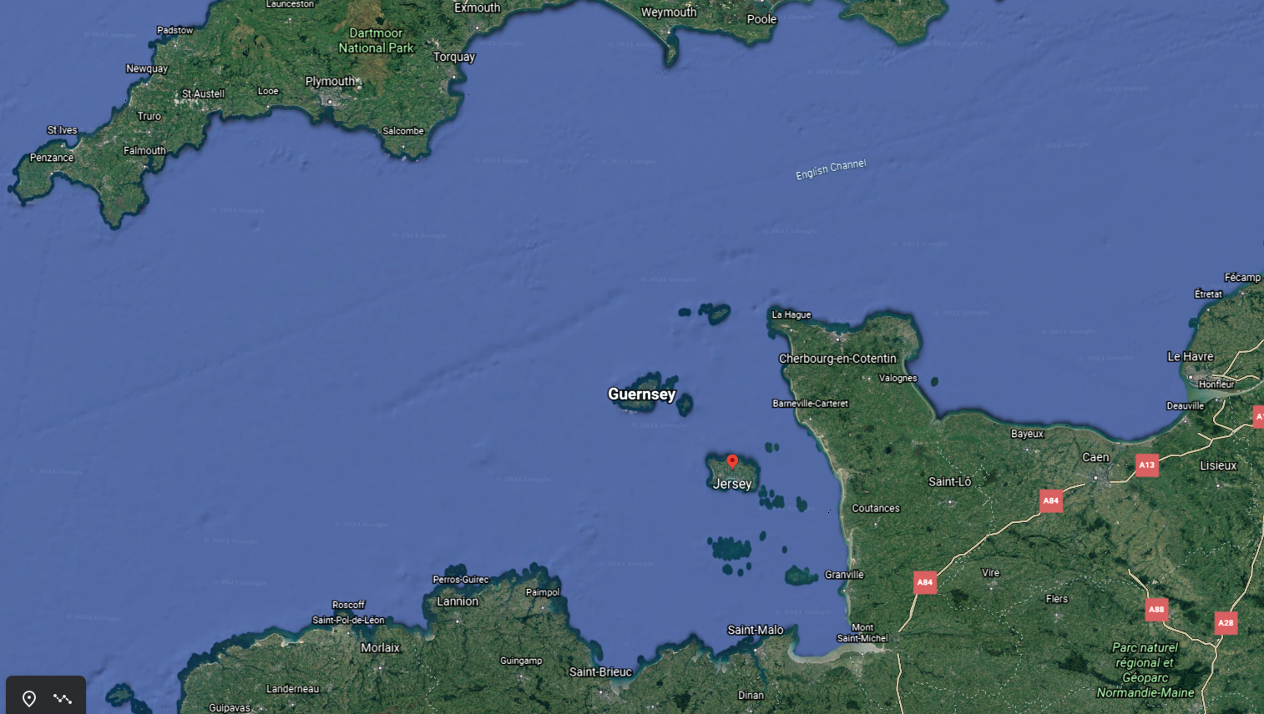
https://www.jersey.com/getting-here
Two Hotels right next to the terrains
The Royal Yacht
https://www.guestreservations.com/the-royal-yacht/booking?msclkid=8baf2515ce0910ef1311441871889839
Pomme D’Or
https://www.seymourhotels.com/pomme-dor-hotel/
or try https://www.booking.com/
There are also 2 Premier Inn in Jersey. - www.premierinn.com

Club Contacts
Email: liberationpc@gmail.com
Website: http://www.liberationpetanque.co.uk/
Phone: (Toby) 01534 723442 or Mobile 07700 330537

Any Questions please let us know.

Kind Regards
Toby Northern
Chairman
Liberation Petanque Club

*Please note the club holds the right to cancel the competition if there is an Insufficient number of teams who enter.



International 2026 Open Competition - Weekend 24th to 26th July
Entry Form

Friday (24th July) - Open Singles Competition

Player 1 _______________________________________________________

CLUB: ____________________ Country. ____________________

Email: ____________________ Contact No. ____________________

Friday (24th July) - Open Singles Competition

Player 2 _______________________________________________________

CLUB: ____________________ Country. ____________________

Email: ____________________ Contact No. ____________________

Friday (24th July) - Open Singles Competition

Player 3 _______________________________________________________

CLUB: ____________________ Country. ____________________

Email: ____________________ Contact No. ____________________

Saturday (25th July) - Open Doubles Competition

Player 1 ________________________________________________________

CLUB: ____________________ Country. ____________________

Email: ____________________ Contact No. ____________________

Player 2 ________________________________________________________

CLUB: ____________________ Country. ____________________

Email: ____________________ Contact No. ____________________

Player 3 (Sub)_______________________________________________________

CLUB: ____________________ Country. ____________________

Email: ____________________ Contact No. ____________________

Saturday (25th July) - Open Doubles Competition

Player 1 ________________________________________________________

CLUB: ____________________ Country. ____________________

Email: ____________________ Contact No. ____________________

Player 2 ________________________________________________________

CLUB: ____________________ Country. ____________________

Email: ____________________ Contact No. ____________________

Player 3 (Sub)_______________________________________________________

CLUB: ____________________ Country. ____________________

Email: ____________________ Contact No. ____________________

Sunday (26th July) - Open Triples Competition

Player 1 ________________________________________________________

CLUB: ____________________ Country. ____________________

Email: ____________________ Contact No. ____________________

Player 2 ________________________________________________________

CLUB: ____________________ Country. ____________________

Email: ____________________ Contact No. ____________________

Player 3 ________________________________________________________

CLUB: ____________________ Country. ____________________

Email: ____________________ Contact No. ____________________

Player 4(Sub) ________________________________________________________

CLUB: ____________________ Country. ____________________

Email: ____________________ Contact No. ____________________

Please email entry forms to liberationpc@gmail.com

The clubs preferred method of payment is BACS which should be sent once entry has been confirmed. Sort Code 30-94-61 - Account Number 15475463
Alternatively, you can send this form and payment to Flat 5, Zeeland House, 6 Midvale Road, St Helier, JERSEY JE2 3TY

