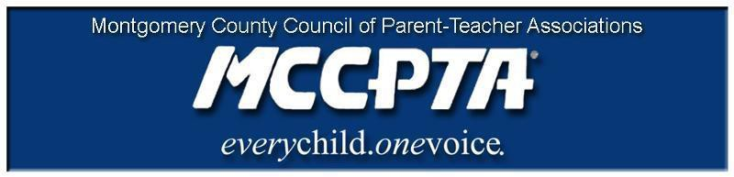

DELEGATES’ ASSEMBLY MEETING AGENDA
Tuesday, October 26, 2021
Meeting Held on Zoom

7:00 pm WELCOME

- Approve Agenda; Approve September 28, 2021 minutes

7:05 pm INFORMATIONAL UPDATES

- National/Free State Update
- Superintendent Search Update
- MCCPTA Representation – MCPS Committees; Montgomery County Committees

7:20 pm OLD BUSINESS

7:20 pm OFFICER REPORTS

- Cynthia Simonson, President
- Rodney Peele, Vice President- Educational Issues
- Rochelle Fink, Vice President- Administration
- Charisse Scott, Vice President- Programs
- Laura Mitchell, Vice President- Advocacy
- Francesco Paganini, Treasurer
- All Reports - https://mccpta-my.sharepoint.com/:f:/g/personal/office_mccpta_org/EoWKA69O4aJBtOw_FUONFs8BoHiJoeDcRETkBQkxLSWL0A?e=0xItct

7:45 pm COMMITTEE REPORTS

- Membership
- CIP
- All Reports – https://mccpta-my.sharepoint.com/:f:/g/personal/office_mccpta_org/EgW_KEKs55tKqqd7k2OGqbwB9i1hxDTQpuoGSyi2rPBkNQ?e=ggFnTB

7:55 pm NEW BUSINESS

- Advocacy Priorities

8:55 pm ANNOUNCEMENTS & ADJOURNMENT

DATES:

- October 27th - MCCPTA- MCPS CIP
- October 28th – BOD to BOE (available to Delegates to view via mcpstv)
- November 2nd & 4th - CIP Hearings
- November 10th - BOD Meeting on Zoom
- November 15th – MCCPTA Training
- November 30th – Delegates Assembly
- December 8th – BOD Meeting on Zoom

